Financial Engineering – 1
- Palak Nagdev
1.
(i)
- Arbitrage opportunity refers to a strategy constructed by the arbitrageur by taking positions in more than one financial market to earn a guaranteed profit.
- Arbitrage exists to exploit the mispricing/inefficiency in the markets.
- It is exploitable and fleeing in nature.
- There are two types of arbitrages:
  - Type I arbitrage – Immediate profit with zero probability of future loss.
  - Type II arbitrage – Zero cost with zero probability of future loss and some non-zero probability of future profit.
(ii)
Law of one price (no arbitrage principle) states that if two securities/portfolios have the same profit or loss profile then their prices should be equal for arbitrage to not exist.
(iii)
$$Given:3 month European put option$$
$$S_{0}=Rs 125 and K=Rs 120$$
$$c_{t}=Rs 30 and r=5\% p.a.$$

$$q=15\% p.a.$$
$$Using put call parity,$$
$$p_{t}+S_{0}*e^{-qt}=c_{t}+K*e^{-rt}$$
$$p_{t}=30+120*e^{-5\%*\frac{3}{12}}-125*e^{-15\%*\frac{3}{12}}=Rs 28.11$$

Arbitrage opportunity if put option price is Rs 23
The put option is cheap as it is selling at Rs 23 whereas as per the put-call parity, it should by Rs 28.11. Thus, we buy the cheap side and sell the other side i.e., buy 1 put option and share and sell 1 call option and borrow (sell) cash.

2. $Given that:dX_{t}= α*μ*\left(T-t\right)dt+ σ*\sqrt{\left(T-t\right)} dZ_{t}$
By Ito’s lemma
$$dF=\frac{df}{dx}σ*\sqrt{\left(T-t\right)}dZ_{t}+\left(\frac{df}{dt}+\frac{df}{dx}* α*μ*\left(T-t\right)+\frac{1}{2}*\frac{d^{2}f}{dx^{2}}*\sqrt{\left(T-t\right)}\right)dt$$
$$dF=f\left(\frac{dm}{dt}\left(T-t\right)-α*μ*\left(T-t\right)+\frac{1}{2}*{\left(σ*\sqrt{\left(T-t\right)}\right)}^{2}\right)dt -f*σ*\sqrt{\left(T-t\right)}*dZ_{t}$$
For f to be a martingale, drift will be equal to 0
$$\frac{dm}{dt}\left(T-t\right)-α*μ*\left(T-t\right)+\frac{1}{2}*{\left(σ*\sqrt{\left(T-t\right)}\right)}^{2}=0$$
$$\frac{dm}{dt}\left(T-t\right)= α*μ*\left(T-t\right)- \frac{1}{2}*{\left(σ*\sqrt{\left(T-t\right)}\right)}^{2}$$
Cancelling out (T – t)
$$\frac{dm}{dt}= α*μ-\frac{1}{2}σ^{2}$$

3.
$$Given:f\left(t,x\right)=e^{-t}*x^{2}$$
$$\frac{df}{dt}= -e^{-t}*x^{2}= -f$$
$$Now,\frac{df}{dx}=2e^{-t}*x$$
$$\frac{df}{dx^{2}}=2e^{-t}$$
Using Ito’s lemma,
$$dY_{t}=\frac{df}{dt}*dt+\frac{df}{dx}*dX_{t}+\frac{1}{2}*\frac{d^{2}f}{dx^{2}}*σ^{2}X_{t}^{2}dt$$
$$dY_{t}= -fdt+2*e^{-t}X_{t}dX_{t}+e^{-t}*σ^{2}X_{t}^{2}dt$$
$$dY_{t}=-Y_{t}dt+2*e^{-t}X_{t}^{2}*\frac{dX_{t}}{X_{t}}+e^{-t} σ^{2}X_{t}^{2}dt$$
$${dY}_{t}=-Y_{t}dt+2*Y_{t}\left(0.25dt+ σ*dW_{t}\right)+ σ^{2}Y_{t}dt$$
$$Taking Y_{t} out common,$$
$$\frac{dY_{t}}{Y_{t}}=\left(2*0.25-1+ σ^{2}\right)dt+2σdW_{t}$$
$$\frac{dY_{t}}{Y_{t}}=\left( σ^{2}-0.5\right)dt+2σdW_{t}$$
Therefore,
$$dY_{t}=\left( σ^{2}-0.5\right)Y_{t}dt+2σY_{t}dW_{t}$$

The process is a martingale only if the drift is 0. Thus,
$$σ^{2}-0.5=0$$
$$σ^{2}=0.5$$

- Let ‘n’ ex-dividend dates are anticipated for a stock and t1 < t2 < … <tn are the time before which the stock goes ex-dividend. Dividends are denoted by d1,….,dn.
If the option is exercised prior to the ex-dividend date then the investor receives S(tn) – K.
If the option is not exercised, the price drops to S(tn) – dn.
The value of the American option is greater than $S\left(t_{n}\right)-d_{n}-K*e^{-r\left(T-t_{n}\right)}$
It is never optimal to exercise the option if $S\left(t_{n}\right)-d_{n}-K*e^{-r\left(T-t_{n}\right)}≥S\left(t_{n}\right)-K , i.e. d_{n}< =K*\left(1-e^{-r\left(T-t_{n}\right)} \right)$
Using the given data,
$$K*\left(1-e^{-r\left(T-t_{n}\right)} \right)=350*\left(1-e^{-0.95*\left(0.8333-0.25\right)}\right)=18.87$$
And
$$65*\left(1-e^{-0.95*\left(0.8333-0.25\right)}\right)=10.91$$
Hence, it is never optimal to exercise the American option on the two ex-dividend rates.

Required probability: Probability of the stock price being greater than Rs. 258 in 6 months’ time.
The stock price follows Geometric Brownian motion i.e., $S_{t}=S_{0}*r^{μ-\frac{σ^{2}}{2}t}+ σW_{t}$
Therefore,
$$\ln\left(S_{t}\right)follows normal distribution with mean\ln\left(S_{0}\right)+\left(μ-\frac{σ^{2}}{2}\right)t and variance σ^{2}t$$
Using the given data,
$$\ln\left(S_{t}\right)\sim \left(ln254+\left(0.16-\frac{{0.35}^{2}}{2}\right)*0.5,0.35*{0.5}^{\frac{1}{2}}\right)=\left(5.59,0.247\right)$$
Thus,
$$\frac{lnS_{t}- μ\left(S_{t}\right)}{σt^{\frac{1}{2}}} follows dtandard normal doistribution$$
The probability that stock price will be higher than the strike price of Rs 258 in 6 months’ time = 1 – N(5.55,5.59)/0.247 = 0.5542 … (from Tables)
The put option is exercised if the stock price is less than Rs 258 in 6 months’ time. The probability of this event = 1- 0.5542 = 0.4457

6.
The given relationship can be written as:
$$S_{t}=S_{0}*e^{μt+ σBt}$$
Using Ito’s lemma,
$$dB_{t}=0dt+1dB_{t}$$
$${Let G\left(t,B_{t}\right)= S}_{t}=S_{0}*e^{μt+ σBt}$$
Finding the derivatives,
$$\frac{dG}{dt}= μS_{0}*e^{μt+ σBt}= μS_{t}$$
$$\frac{dG}{dB_{t}}= σS_{0}e^{μt+ σBt}= σS_{t}$$
$$\frac{d^{2}G}{dB_{t}^{2}}= σ^{2}*S_{0}*e^{μt+ σBt}=σ^{2}S_{t}$$
$$dG=\left(0S_{t}+\frac{1}{2}*1*σ^{2}S_{t}+μS_{t}\right)dt+ σS_{t}dB_{t}$$
$$i.e. dS_{t}=\left(μ+\frac{1}{2}σ^{2}\right)S_{t}dt+ σS_{t}dB_{t}$$
Thus,
$$\frac{dS_{t}}{S_{t}}= σdB_{t}+\left(μ+\frac{1}{2}σ^{2}\right)dt$$
Therefore,
$$c_{1}= σ and c_{2}= μ+\frac{1}{2}σ^{2}$$

The expected value of St is:
$$E\left[S_{t}\right]=E\left[S_{0}*e^{μt+ σdB_{t}}\right]=S_{0}*e^{μt}E\left[e^{σdB_{t}}\right]$$
Since,
$$B_{t} \sim N\left(0,1\right), Using it^{'}s MGF$$
$$E\left[S_{t}\right]=S_{0}*e^{μt}*e^{\frac{1}{2}σ^{2}t}= S_{0}*e^{μt+ \frac{1}{2}σ^{2}t}$$
The variance of St is:
$$Var\left[S_{t}\right]=E\left[S_{t}^{2}\right]-{\left(E\left[S_{t}\right]\right)}^{2}$$
$$Var\left[S_{t}\right]=S_{0}^{2}*e^{2μt}\left(e^{2σ^{2}t}-e^{σ^{2t}}\right)$$

The covariance
$$Cov\left[S_{t_{1}},S_{t_{2}}\right]=E\left[S_{t_{1}},S_{t_{2}}\right]-E\left[S_{t_{1}}\right]E\left[S_{t_{2}}\right]$$
Solving each term,
$$E\left[S_{t_{1}}\right]=S_{0}*e^{μ*t_{1}+\frac{1}{2}σ^{2}t_{1}}$$
$$E\left[S_{t_{2}}\right]=S_{0}*e^{μ*t_{2}+\frac{1}{2}σ^{2}t_{2}}$$
$$E[S_{t_{1}}, S_{t_{2}}] = E\left[S_{0}* exp\left(µt_{1}+σ B_{t_{1}} \right),S_{0} exp \left(µt_{2} + σ B_{t_{2}}\right)\right]$$
$$= S_{0}^{2}*e^{µ\left(t_{1}+ t_{2}\right)} E[exp(σB_{t_{1}}+ σB_{t_{2}} )]$$
Splitting $B_{t_{2}}$ into two independent components,
$$B_{t_{2}}=B_{t_{1}}+\left(B_{t_{2}} -B_{t_{1}}\right) where B_{t_{2}}-B_{t_{1}}\sim N\left(0,t_{2}-t_{1}\right)$$
Hence,
$$E\left[S_{t_{1}},S_{t_{2}}\right]=S_{0}^{2}*e^{μ\left(t_{1}+t_{2}\right)}*e^(\frac{3}{2}σ^{2}t_{1}+\frac{1}{2}σ^{2}t_{2})$$
Substituting in the formula of covariance,
$$Cov\left[S_{t_{1}},S_{t_{2}}\right]=S_{0}^{2}*e^{μ\left(t_{1}+t_{2}\right)}*{(e}^{\frac{3}{2}σ^{2}t_{1}}- e^(\frac{1}{2}σ^{2}t_{1}))* e^(\frac{1}{2}σ^{2}t_{2})$$

7.

Constructing the binomial tree with ‘u’ as up move and ‘d’ as down move. Considering ‘p’ as the probability of up move.
Thus, the probability of down move is (1 – d).
Then E(Ct) = So[pu+(1-p)d], and
Var(Ct) = E(Ct 2)- E(Ct) 2
= So^2 [pu2+(1-p)d2]- So^2[pu+(1-p)d]2
= So^2 [pu2+(1-p)d2-(pu+(1-p)d)2]
= So^2 [p(1-p)u2+ p(1-p)d2-2p(1-p)]….(∵d= 1/u)
= So^2 p(1-p)(u-d)2
Equating moments:
Soe^r^t = S0[pu+(1-p)d] ______________(A)
And
σ^2*So^2t = So^2p(1-p)(u-d)^2______________(B)
From (A) we get p = (e^rt -d)/(u – d) ________________________(C)
Substituting p into equation (B), we get
σ^2t = (𝑒^rt −𝑑)/(𝑢−𝑑) (1 – 𝑒^rt −𝑑)/(𝑢−𝑑 )(u-d)^2
= - (𝑒^rt – 𝑑)( 𝑒^rt – 𝑢)
= (u+d) 𝑒^rt -(1+ 𝑒^2rt )
Putting d = 1/u, and multiplying through by u we get
U^2𝑒^rt - u (1+ 𝑒^2𝑟t + σ^2t) + 𝑒^rt = 0
This is a quadratic in u which can be solved in the usual way.

The given and calculated data is sigma = 0.15, t = 0.25 and u = 1.077884, d = 0.92774
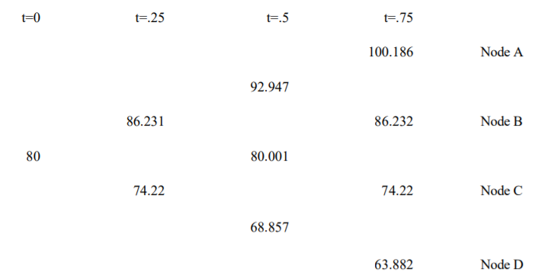

r = 0 and p using the formula is 0.48126
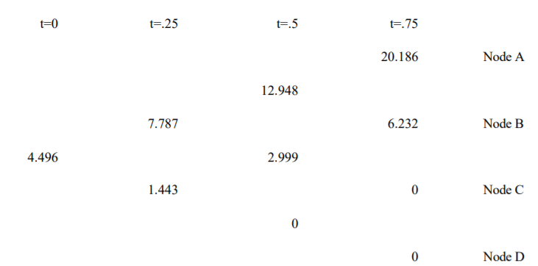
Hence, the value of the call option is 4.496

The lookback call pays the difference between the minimum value and the final value. Notate paths by U for up and D for down, in order
We get the payoffs
UUU (100.186 - 80) = 20.186 Node A
UDU (86.232-80)= 6.232 Node B
UUD (86.232- 80) =6.232 Node B
UDD (74.22-74.22) = 0 Node C
DUU (86.232- 74.22) = 12.012 Node B
DUD (74.22-74.22) = 0 Node C
DDU (74.22-68.857) = 5.363 Node C
DDD (63.882-63.882)= 0 Node D
The lookback payoffs are, for each successful path (i.e., with a non- zero result) Probabilities of arriving at each node are:
Node A= p3 = 0.11147
Node B= p2(1-p) = 0.12015
Node C= p(1-p)2 = 0.12950
Node D= p(1-p)3 = 0.13959
Hence the tree value of lookback option is:
(0.11147*20.186)+ (0.12015*[6.232+ 6.232+ 12.012]) + (0.12950*5.363) = 5.8854

8.

Consider a stock whose current price is S0 and an option whose current price is f. Assuming the option lasts for time T and that during the life of the option, the stock price can either move up from S0 to a new level S0u or move down to S0d where u > 1 and d < 1.
Let the payoff be Cu if the stock price becomes S0u and Cd if stock price becomes S0d.
Let us construct a portfolio which consists of a short position in the option and a long position in Δ shares. We calculate the value of Δ that makes the portfolio risk-free.
Now if there is an upward movement in the stock, the value of the portfolio becomes ΔS0u - fu and if there is a downward movement of stock, the value of the portfolio becomes ΔS0d – fd.
The two portfolios are equal if ΔS0u - fu = ΔS0d - fd
Or
Δ = (Cu – Cd)/(S0u – S0d) so that the portfolio is risk-free and hence must earn the risk free rate of interest.
This means the present value of such a portfolio is (ΔS0u - fu)exp(-rT).
The cost of the portfolio is ΔS0 – f.
Since the portfolio grows at a risk-free rate, it follows that
(ΔS0u - fu)exp(-rT) = ΔS0 – f
or f = ΔS0 – (ΔS0u - fu)exp(-rT)
Substituting Δ from the earlier equation simplifies to:
f = e^(-rt) [p fu + (1-p) fd ] where p =[e^(rt) – d]/[u-d]

The option pricing formula does not involve probabilities of stock going up or down although it is natural to assume that the probability of an upward movement in stock increases the value of call option and the value of put option decreases when the probability of stock price goes down.
This is because we are calculating the value of option not in absolute terms but in terms of the value of the underlying stock where the probabilities of future movements (up and down) in the stock already incorporates in the price of the stock. However, it is natural to interpret p as the probability of an up movement in the stock price. The variable 1-p is then the probability of a down movement such that the above equation can be interpreted as that the value of option today is the expected future value discounted at the risk-free rate.

The expected stock price E(St) at time Tt = pS0u + (1-p) S0d 0.5
or
E(ST) = p S0(u-d) + S0d
Substituting p from above equation in (i) i.e. p = [e^rt – d]/[u-d]---1
We get E(ST) = e^(rt)*So ,i.e., stock price grows at a risk-free rate or return on a stock is risk free rate

In a risk neutral word individuals do not require compensation for risk or they are indifferent to risk. Hence expected return on all securities and options is the risk-free interest rate. Hence value of an option is its expected payoff in a risk neutral discounted at risk free rate.
Question 9
Ans

The forward price is given by 𝐹 = 𝑆 *(𝑟t) where S is the stock price, t is the delivery time and r is the continuously compounded risk-free rate of interest applicable up to time t.
Put-call parity states that:
𝑐 + 𝐾 *𝑒(−𝑟t) = 𝑝 + 𝑆 where c and p are the prices of a European call and put option respectively with strike K and time to expiry t and S is the current stock price.
To compute F, we need to find S and r. t is given to be 0.25 years.
Substituting the values from the first two rows of the table in the put-call parity, we get two equations in two unknowns (S and r):
$$13.334+70*\exp\left(-0.25r\right)=0.120+S$$
$$8.869+75*\exp\left(-0.25r\right)=0..568+S$$
Solving the simultaneous equations for S and r, we get:
S = 82 and r = 7%
Therefore, we get the forward price F = 82 *𝑒^(0.07 ∗ 0.25) = 83.45

Let the (continuously compounded, annualized) rate of interest over the next k months be rk. Then the required forward rate rF can be found from:
exp(r6*0.5) = exp(r3*0.25)*exp(rF*0.25) or 2*r6 = r3 + rF
We know that r3 = 7%.
To find r6, we substitute values from the last row in the put-call parity relationship and S = 82:
2.569 + 90*exp(-0.5*r6) = 7.909 + 82
Therefore, r6 = 6% and rF = 5%

Using the put-call parity for each row in the given table, we get:
6.899 + a*exp(-0.07*0.25) = 1.055 + 82
b + 80*exp(-0.07*0.25) = 1.789 + 82
2.594 + 85*exp(-0.07*0.25) = c + 82
Solving individually, we get:
a = 77.5 b = 5.177 c = 4.119

10.

Since interest rates are assumed zero, the risk-neutral up-step probability is given as:
𝑞 = (1 − 𝑑) / (𝑢 − 𝑑)
where ‘u’ and ‘d’ are the sizes of up-step and down-step respectively
For a recombining tree, d = 1/u.
Substituting d = 1/u in the expression for q and simplifying, we get:
q = (1-1/u) / (u – 1/u) = 1 / (u+1)
For no-arbitrage to hold, we must have u > 1 > d.
Then, u > 1 u + 1 > 2 q = 1 / (u+1) < ½. Hence proved.

Since each step is one month and the expiry of the derivative is one year from now. Therefore, a 12-step recombining binomial tree needs to be created, i.e., n = 12.
Further, at time T = 12 months, the stock price will be So*u^k*d^(n-k) with risk-neutral probability nCk*q^k*(1-q)^(n-k) where q, the up-step probability is 1/3, u, the up-step size is 2, and d = 1/u = ½.
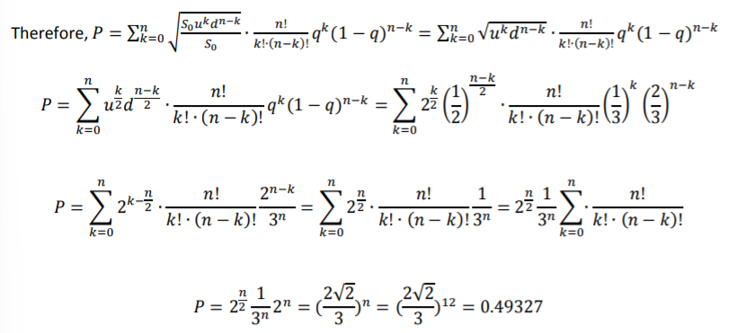

11.

A recombining binominal tree or binominal lattice is one in which the sizes of the up-steps and down-steps are assumed to be the same under all states and across all time intervals. i.e., u t (j)=u and d t (j)=d for all times t and states j, with d < exp(r) < u
- It therefore follows that the risk neutral probability ‘q’ is also constant at all times and in all states e.g., q t (j)=q
- The main advantage of a ‘n’ period recombining binominal tree is that it has only [n+1] possible states of time as opposed to 2n possible states in a similar non-recombining binominal tree. This greatly reduces the amount of computation time required when using a binominal tree model.
- The main dis-advantage is that the recombining binominal tree implicitly assumes that the volatility and drift parameters of the underlying asset price are constant over time, which assumption is contradicted by empirical evidence.

The risk-neutral probabilities at the first and second steps are as follows:
q1 = (exp(0.0175) - 0.95)/(1.10-0.95)
= (0.06765)/0.15
= 0.4510
q2 = (exp(0.025) - 0.90)/(1.20-0.90)
= 0.41772
Put payoffs at the expiration date at each of the four possible states of expiry are 0,0,0 and 95.
Working backwards, the value of the option V1 (1) following an up step over the first 3 months is
V1 (1) exp(0.025) = [0.41772* 0] + [0.58228*0]
i.e., V1 (1) = 0
The value of the option V1 (2) following a down step over the first 3 months is:
V1 (2)exp(0.025) = [0.41772* 0] + [0.58228*95]
i.e., V1 (2) = 53.9508
The current value of the put option is:
V0 exp(0.0175) = [0.4510*0] + [0.5490*53.9508]
i.e., V0 =29.105
(b)
While the proposed modification would produce a more accurate valuation, there would be a lot more parameter values to specify. Appropriate values of u and d would be required for each branch of the tree and values of ‘r’ for each month would be required.
The new tree would have 2^6 = 64 nodes in the expiry column. This would render the calculations prohibitive to do normally, and would require more programming and calculation time on the computer.
An alternative model that might be more efficient numerically would be a 6-step recombining tree which would have only 7 nodes in the final column.

12.

dU(t) = 2dZ(t) − 0
= 0dt + 2dZ(t).

dV(t) = d[Z(t)]2 − dt
d[Z(t)]2 = 2Z(t)dZ(t) + 2/ 2 [dZ(t)]2
= 2Z(t)dZ(t) + dt by the multiplication rule
Thus, dV(t) = 2Z(t)dZ(t). The stochastic process {V(t)} has zero drift.

dW(t) = d[t2 Z(t)] − 2t Z(t)dt
Because d[t2 Z(t)] = t2 dZ(t) + 2tZ(t)dt, we have
dW(t) = t2 dZ(t).
Thus, the process {W(t)} has zero drift

13.

Let St/So follow lognormal distribution with parameters $\left(μ-\frac{1}{2}σ^{2}\right)t, and σ^{2}t$such that the expected return on a stock is $μ and volatility is σ.$
This means expected value of stock price at the end of first-time step = So*exp(mu*delta*t). The expected value after 1 time step is qSou + (1-q)*Sod
In order to match the expected return on the stock with the tree’s parameters we have
q = (exp(mu*dela*t – d))/(u – d)
Volatility sigma of a stock price is defined so that sigma*sqrt(delta*t) is the standard deviation of the return on the stock price in a short period of time delta*t
Variance of stock price return is sigma^2*delta*t

Given data: S = 200, r = 10%, sigma = 35%, T = 2 months, t = 1 month = 1/12 = 0.0833
u = 1.1063, d = 0.9039, q = 0.5161, (1 – q) = 0.4839
K = 200
Using the binomial approach (Calculations in rough)
The value of put option = 6.05

14.

Given data: So = Rs 500. Time step is of 3 months each. u = 1.6 and d = 0.95.
r = 5% p.a.
After constructing the binomial tree in rough and plotting the payoff wherein S > K,
The value of 6-month European call option = Rs 16.35

From the above constructed binomial tree, the payoff was changed and plotted as per put option where K > S.
The value of 6-month European put option = Rs 13.76
Using the put call parity
$$p+S_{0}=c+Ke^{-rt}$$
$$13.76+500=513.76=16.35+510e^{-5\%*0.5}$$

The valuation of American option is somewhat similar to that of the European option except at the intermediary nodes we consider the expected and the exercise payoff and go ahead with whichever is the highest one.
After solving,
Value of American put option is Rs 16.46

Expected payoff in 3 months’ time is calculated by using real rate of return of 9%. p=0.6614. Hence expected payoff = 20*0.6614= 13.228.Unfortunately, it is not easy to know the correct discount rate to apply to the expected payoff in real world to be able to compute the value of the option. Risk neutral valuation solves this problem as under risk neutral valuation all assets are expected to earn the risk-free rate.
Question 15
Ans

Let f = f(St,t) = S^k
$$\frac{df}{ds}=kS^{k-1},\frac{d^{2}f}{dS^{2}}=k\left(k-1\right)*S^{k-2},\frac{df}{dt}=0$$
$$f=S^{k} follows Geometic brownian motion, with drift mu^{'}=kmu+\frac{1}{2}*k*\left(k-1\right)*sigma^{2} and volatility sigma^{'}=k*sigma$$
Hence, $f_{t}=f_{0}*e^{\left(mu*t-\frac{1}{2}sigma^{t}\right)t+sigma*W_{t}}$
This means ft/fo follows lognormal distribution.

$$Let f=f\left(t,S_{t}\right)=e^{-rt}*S_{t}$$
$$\frac{df}{dt}= -r*e^{-rt}*S_{t},\frac{df}{ds}=e^{-rt},\frac{d^{2}f}{ds^{2}}=0$$

Combining the results,
For given values of r, sigma, and k, it can be solved for the value of mu for which discounted S^k will be a martingale.

