Business Finance Assignment-1

- B
- C
- C
- A
- Realization- Income is recognized as and when it is earned. It is not, therefore, necessary to wait until the customer settles his or her bill. This avoids the fluctuations in reported income which might arise if everything was accounted for on a cash basis. Accrual- Expenses are recognized as and when they are incurred, regardless of whether the amount has been paid.
Insurance company will account for income received through premiums throughout the year – realization concept and claims will be accounted as and when incurred

- 1) increase
2) decrease
3) increase
4) decrease
5) increase

8. 1) Regulatory bodies are established by governments or other organizations to oversee the functioning and fairness of financial markets and the firms that engage in financial activity. The goal of regulation is to prevent and investigate fraud, keep markets efficient and transparent, and make sure customers and clients are treated fairly and honestly
2) IRDAI, SEC, SEBI, RBI, Compétition Commission, PMRDA, EXIM, FMC, NFA, CFTC
3)
a) Banks- RBI
b) Superannuation Products-IRDAI / PMRDA
c) General Insurance companies-IRDAI
d) Stock brokers-SEBI
e) Mutual Funds-SEBI
f) Market for listed securities-SEBI
g) Foreign exchange dealers-NFA /CFTC
h) Money changers-RBI

9. i) Cost Concept: non-current assets generally appear in the statement of
financial position at their original cost less depreciation to date, subject to a
possible impairment write-down.
Going Concern Concept: Assumed that a business will continue indefinitely in its present form to support the cost concept of accounting.

ii) Key guiding principles for setting accounting policies for unusual transactions are –
a) There is a general requirement that the financial statements give a true and fair view. Amongst other things, that any treatment gives a realistic and representative treatment of the transaction.
b) The guidance provided by Accounting Regulations Board in this regard should be considered. For example, the objectives of relevance, reliability, comparability and understand ability should be applied.
c) The directors might consider looking at the treatment laid down by standards for similar balances, even though those standards might not be strictly applicable. That would ensure that the logic underlying the chosen treatment was consistent with good accounting practice.

iii) Most of the optimism in making accounting choices is quite visible to the analysts and market participants. For example, companies publish their accounting policies and so it is possible to tell whether a particular approach has been followed and accordingly opinions formed about the price. The stock market examines information carefully to ensure that it does not misprice securities. If shares are overpriced, then there will be opportunities for astute market participants to make profits by identifying the overpriced companies and selling shares. Market forces would push the shares down and these activities would also draw attention to the distortion. Markets usually reward companies with good corporate governance which is also reflected from the conservativeness of estimates and accounting policies. Conservative policies also provide ability to the company to present more smooth results in volatile times which can work in favour of its stock price.

10.
 | ROLE | SOURCE | APPLICATION OF FUNDS
Investment bank | . The primary role of an investment bank is to advise government and businesses on how to meet their financial needs and help procure their finances | Investment banks primarily help clients raise money through debt and equity offerings. This includes raising funds through Initial Public Offerings (IPOs), credit facilities with the bank, selling shares to investors through private placements, or issuing and selling bonds on behalf of the client
Pension | pension schemes can provide protection in the form of lump sums and pensions to dependants in the event of a member's death | Pension funds are pooled monetary contributions from pension plans set up by employers, unions, or other organizations to provide for their employees' or members' retirement benefits. Pension funds are the largest investment blocks in most countries and dominate the stock markets where they invest. | A pension fund is a fund that accumulates capital to be paid out as a pension for employees when they retire at the end of their careers.
Life insurance | Life insurance is important, as it protects your family and lets you leave them a non-taxable amount at the time of death. It is also used to cover your mortgage and your personal loans | Most of the revenue received by insurance companies consists of premiums, but revenue from investing the premiums forms an important source of profit for most life insurance companies. | Life insurers invest premiums that they receive from customers. They generally choose assets with features that are aligned with the characteristics of the insurance products that they sell. For example, proceeds from a long-term insurance product would be invested in a long- duration asset.

11. The challenges and limitations faced by insurance companies are:
- The underlying liabilities fall outside the accounting year and are uncertain in size
- Premature transfer of profits may endanger financial stability and the ability to meet future liabilities
12. It is difficult to prepare insurance companies accounts compared to normal accounts because:
- The underlying liabilities fall outside the accounting year and are uncertain in size
- Premature transfer of profits may endanger financial stability and the ability to meet future liabilities
ii.
13.i Advantages of complying with IASB:
- They eliminate, reduce variations between companies in the way they prepare accounts.
- They oblige company to disclose more information than other laws
- They allow some degree of flexibility that legislation doesn’t
- The discussion process leading up to a standard being issued focuses attention on a particular area for debate about accounting practice
Disadvantages of complying with IASB:
- The sets of rules mayn’t be appropriate for all companies in all circumstances
- Standard setting may not be entirely objective
- Standards often allow more than one treatment that negates the attempts to ensure conformity between companies
- Some standards are so general as to be meaningless some are too detailed.

ii. 1 IFRS
2 National company laws
3 Principles, concepts and conventions
4 Stock exchange requirements
5 Good practice leading companies
iii. The cash flow statement provides following information that is not available in statement of financial position and comprehensive income:
- Detailed information on Bank Overdraft – why it increased in spite of a profitable year
- Is the company able to generate cash as opposed to profit, from trading activities
- What was done to the loan taken during the year
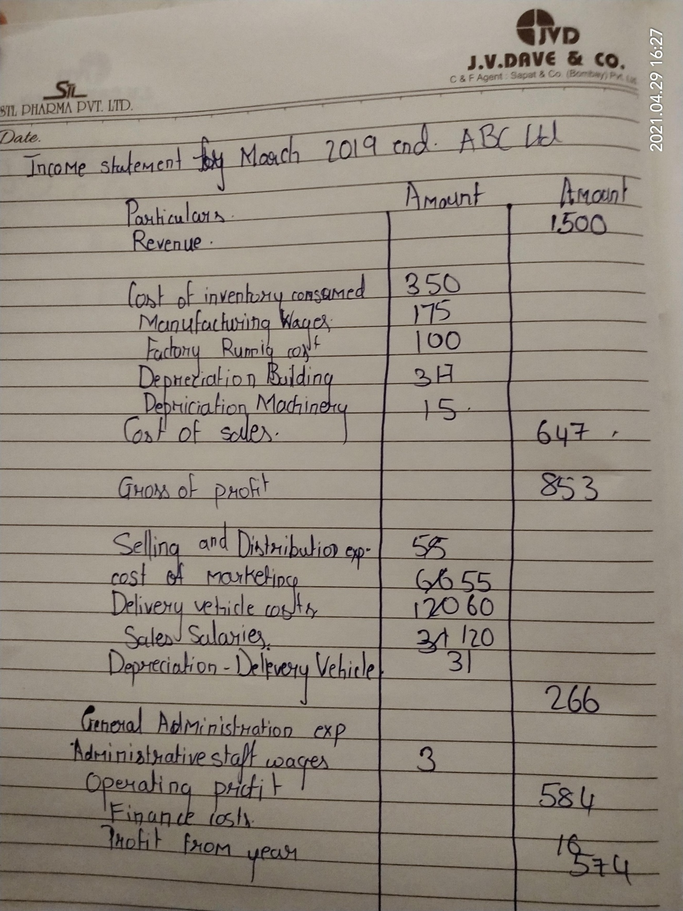
14

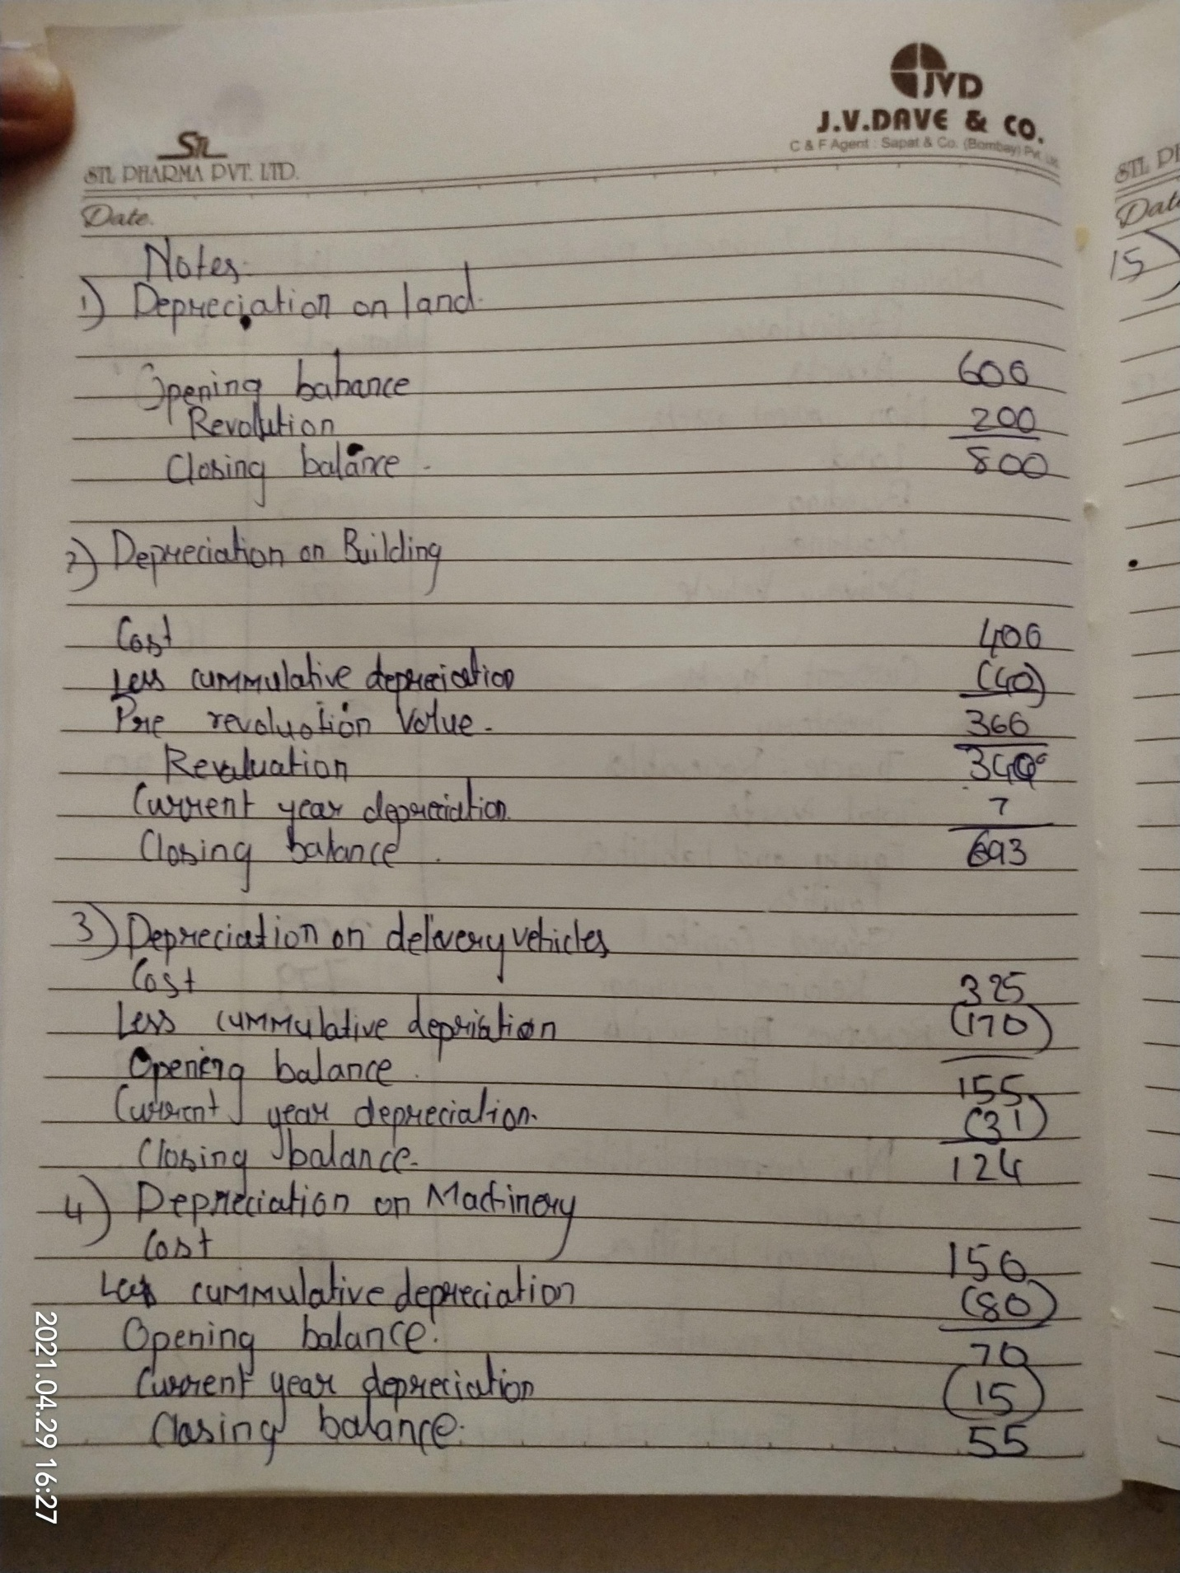

15

