Name: Darshan Lodha
Roll No.: 18
Note: This word document consists of R code along with the outputs from R. It also consists of just the R code at the end of the document.

##____________________ Statistical Modelling in R Assignment ___________________##
##_______________________ Chicago Food Inspections ______________________##

##_______ Name: Darshan Lodha ________##

setwd("D:/Darshan/Darshan Docs/Semester 3/Statistical Modelling in R/CSV Files")
getwd()
Output:
[1] "D:/Darshan/Darshan Docs/Semester 3/Statistical Modelling in R/CSV Files"

##Question 1]
##Loading the food inspections data set in R
df_food_insp = read.csv("Chicago Food Inspection_New.csv")
View(df_food_insp)
##Performing EDA

##Question 2]
##View the first 6 records
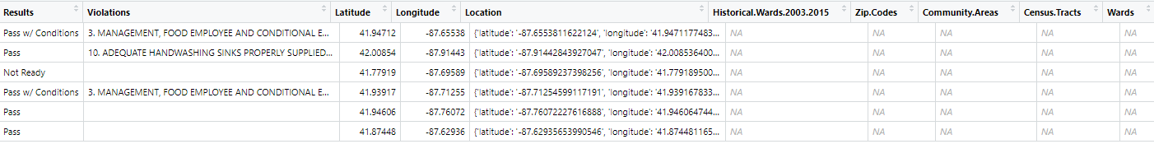
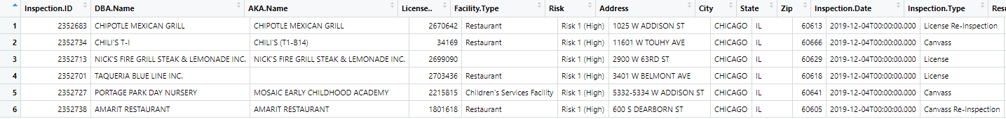
View(head(df_food_insp,6))
##Question 3]
##View the last 10 records
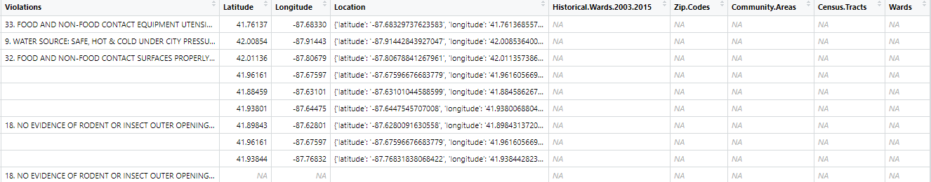
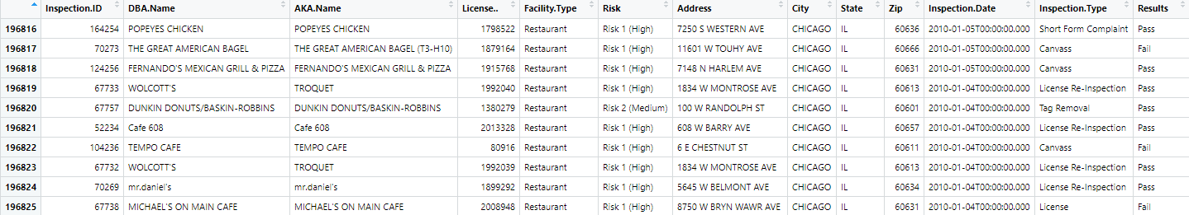
View(tail(df_food_insp,10))

##Question 4]
##Dimensions of the data set
dim(df_food_insp)
Output:
[1] 196825 22

##Question 5]
##View the structure of the data set
str(df_food_insp)
Output:

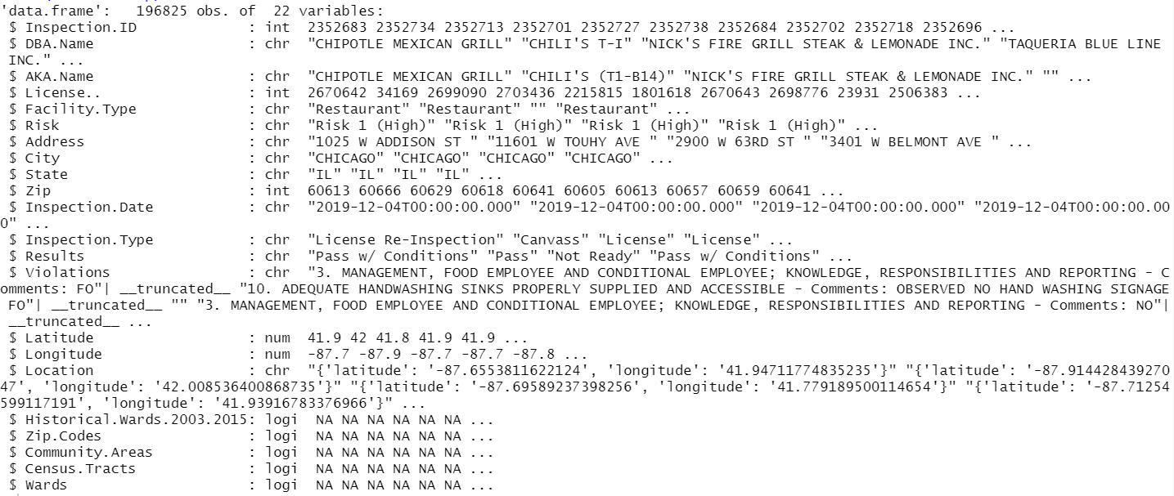
##Using glimpse
library(tidyverse)
glimpse(df_food_insp)
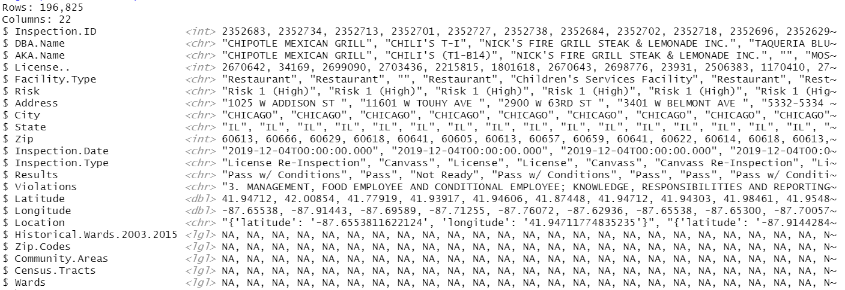
Output:

##Question 6]
##View the names of the columns
col_food_insp = colnames(df_food_insp)
col_food_insp
Output:

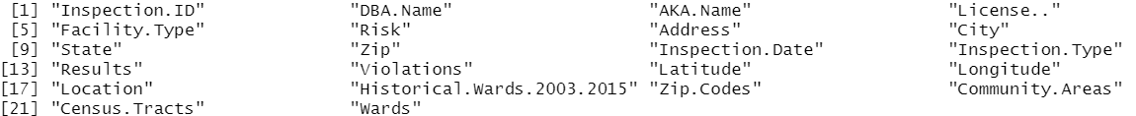
##Question 7]
##Five number summary for the numeric columns
for(i in 1:ncol(df_food_insp)) {
+ if(is.numeric(df_food_insp[,i])==TRUE) {
+ print(colnames(df_food_insp)[i])
+ ans = summary(df_food_insp[,i])
+ print(ans)
+ }
+ }
Output:
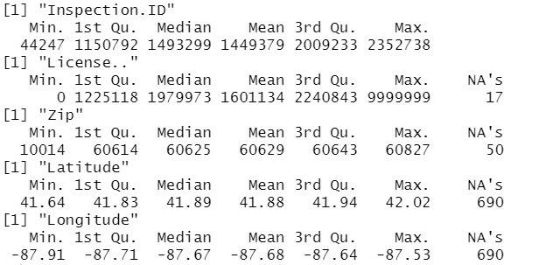

##Question 8]
##Displaying the column with specific index number 3
View(data.frame(df_food_insp[,3]))

##Question 9]
##Selecting rows where license no. is between 20L to 30L
df_lic_range = df_food_insp[df_food_insp$License..2000000 & df_food_insp$License..<3000000,]
View(df_lic_range)
summary(df_lic_range$License..)
Output:

##Question 10]
##Selecting rows where DBA.Name = "Blue Line"
df_dbaname_range = df_food_insp[df_food_insp$DBA.Name=="BLUE LINE",]
summary(df_dbaname_range)
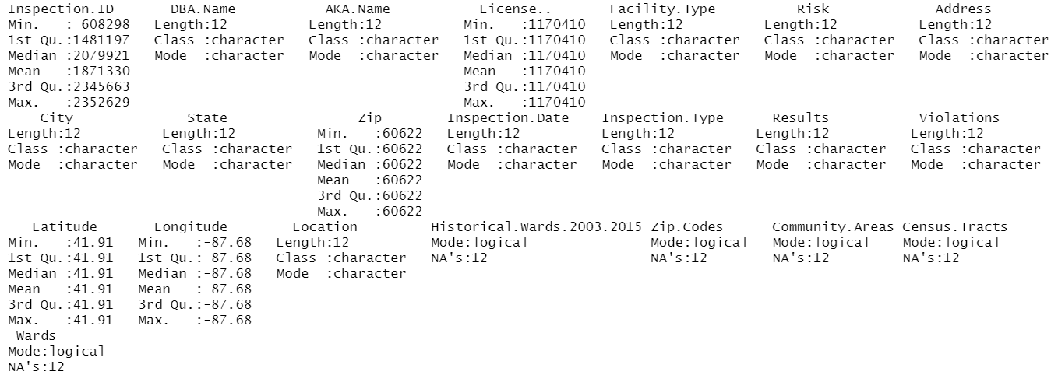
Output:

View(df_dbaname_range)

##Question 11]
##Displaying only inspection.id and facility.type
df_filtered_col = df_food_insp[,c("Inspection.ID","Facility.Type")]
View(df_filtered_col)

##Question 12]
##Selecting the names of DBA where risk is high
df_risk_high = df_food_insp[df_food_insp$Risk=="Risk 1 (High)","DBA.Name"]
##Displaying the names
names_high_risk = unique(df_risk_high)
View(data.frame(names_high_risk))

##Question 13]
##Selecting the first two columns where result of inspection is fail
fail_comp = df_food_insp[df_food_insp$Results=="Fail",1:2]
View(fail_comp)

##Question 14]
##Checking the total number of rows in the dataframe
nrow(df_food_insp)
Output:
[1] 196825

##Question 15]
##Finding the number of missing values column wise
any(is.na(df_food_insp))
Output:
[1] TRUE
null_food_insp = sapply(df_food_insp, function(x) sum(is.na(x)))
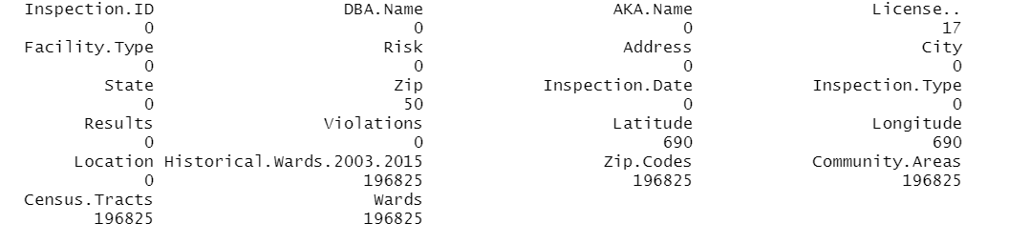
null_food_insp

##Question 16]
##Deleting the columns which have only null values
names(null_food_insp[null_food_insp==nrow(df_food_insp)])
Output:
[1] "Historical.Wards.2003.2015" "Zip.Codes" "Community.Areas"
[4] "Census.Tracts" "Wards"
df_food_insp_without_na = df_food_insp[,-c(18:22)]
View(df_food_insp_without_na)

##Question 17]
##Drawing a histogram of latitude and longitude columns
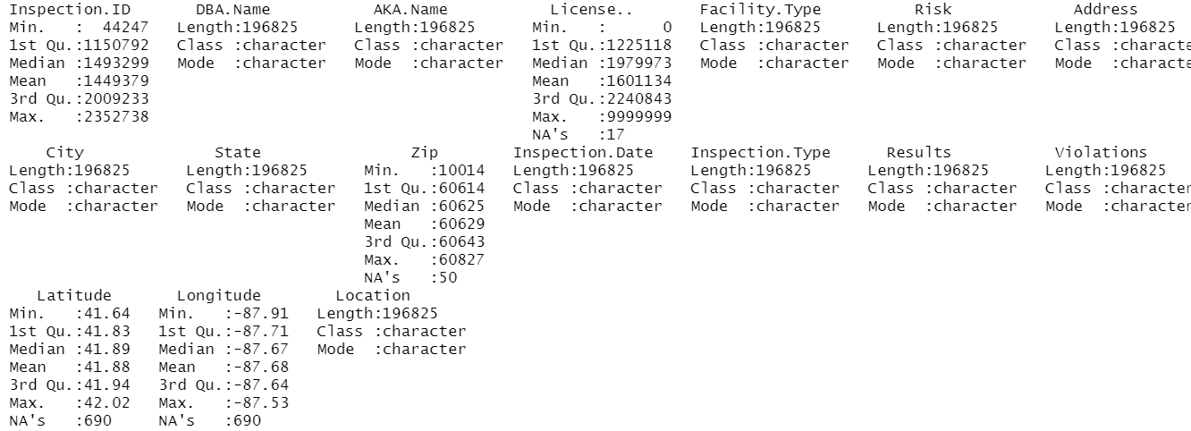
summary(df_food_insp_without_na)

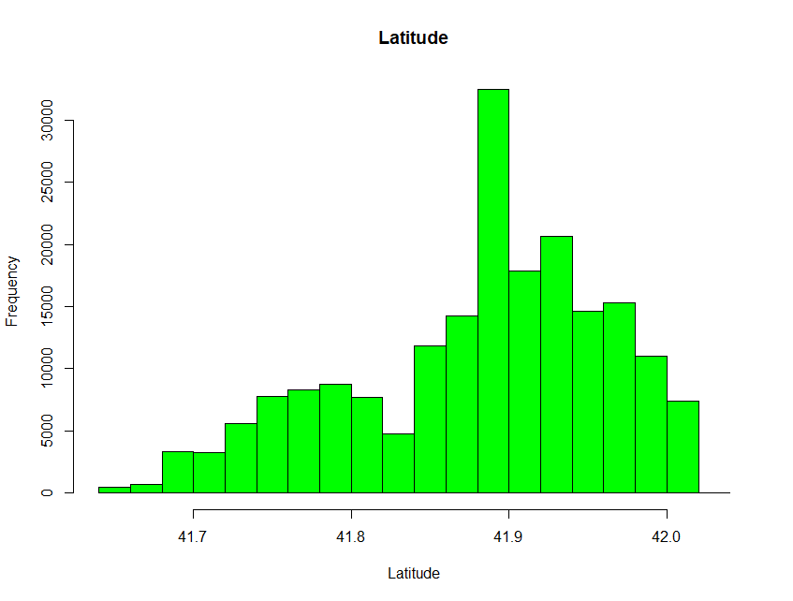
hist(df_food_insp_without_na$Latitude,main = "Latitude",col = "green",xlab = "Latitude")

hist(df_food_insp_without_na$Longitude,main = "Longitude",col = "red",xlab = "Longitude")
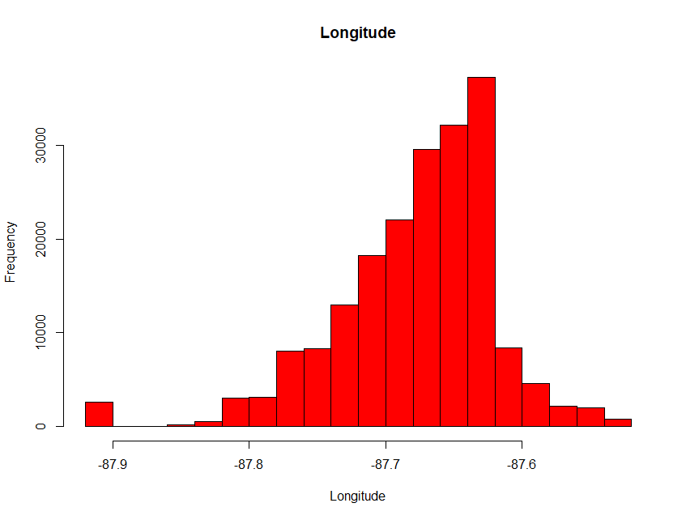

##Question 18]
##Replacing the missing values in Latitude and longitude with means
df_out_mean_rep = df_food_insp
df_out_mean_rep[is.na(df_out_mean_rep$Latitude)==TRUE,"Latitude"] = mean(df_out_mean_rep$Latitude,na.rm = TRUE)
df_out_mean_rep[is.na(df_out_mean_rep$Longitude)==TRUE,"Longitude"] = mean(df_out_mean_rep$Longitude,na.rm = TRUE)
sapply(df_out_mean_rep, function(x) sum(is.na(x)))
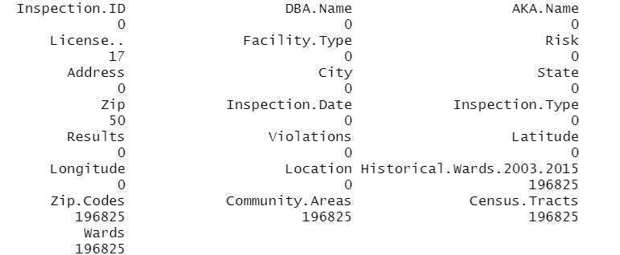
View(df_out_mean_rep)

##Question 19]
##Printing the total number of duplicate values column wise
sapply(df_food_insp_without_na,function(r) (nrow(df_food_insp) - length(unique(r))))
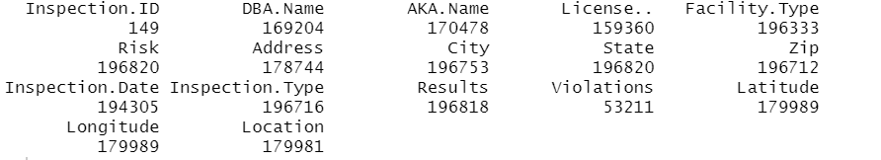

##Question 20]
##Displaying the count of PASS results grouped by type of risk
library(dplyr)
df_reults_pass = df_out_mean_rep[df_out_mean_rep$Results=="Pass",c("Results","Risk")]
summary(df_reults_pass)
Output:
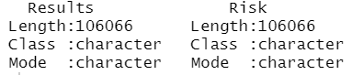

df_reults_pass$Results = as.factor(df_reults_pass$Results)
df_reults_pass$Risk = as.factor(df_reults_pass$Risk)
df_reults_pass_nona = na.omit(df_reults_pass)
head(df_reults_pass_nona)
Output:
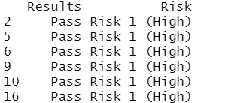
summary(df_reults_pass_nona)
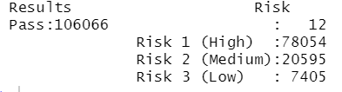

df_reults_pass %%
+ group_by(Risk) %%
+ count(Results)
Output:
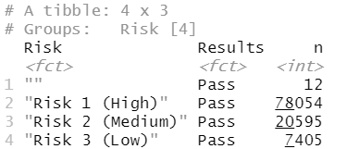

##Question 21]
##Separating the inspection date into 3 columns
df_food_insp_old = read.csv("Food_Inspections_Old.csv")
df_insp_dates = data.frame(df_food_insp_old$Inspection.Date)
typeof(df_insp_dates$df_food_insp_old.Inspection.Date)
Output:
[1] "character"
colnames(df_insp_dates) = c("Inspection_Dates")
head(df_insp_dates)
Output:
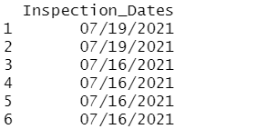
df_insp_dates$Inspection_Dates = as.Date(df_insp_dates$Inspection_Dates,format = "%m/%d/%Y")
df_insp_dates$Day = format(df_insp_dates$Inspection_Dates,"%d")
df_insp_dates$Month = format(df_insp_dates$Inspection_Dates,"%m")
df_insp_dates$Year = format(df_insp_dates$Inspection_Dates,"%Y")
head(df_insp_dates)
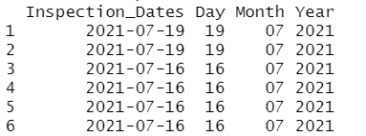
View(df_insp_dates)

The same R Code as the rest of the document just for reference (Without Output)

##________________ Statistical Modelling in R Assignment _____________________##
##___________________ CHICAGO FOOD INSPECTIONS __________________________##

##_______ Name: Darshan Lodha ________##

setwd("D:/Darshan/Darshan Docs/Semester 3/Statistical Modelling in R/CSV Files")
getwd()

##Question 1]

##Loading the food inspections data set in R
df_food_insp = read.csv("Chicago Food Inspection_New.csv")
View(df_food_insp)

##Performing EDA

##Question 2]

##View the first 6 records
View(head(df_food_insp,6))

##Question 3]

##View the last 10 records
View(tail(df_food_insp,10))

##Question 4]

##Dimensions of the data set
dim(df_food_insp)

##Question 5]

##View the structure of the data set
str(df_food_insp)
##Using glimpse
library(tidyverse)
glimpse(df_food_insp)

##Question 6]

##View the names of the columns
col_food_insp = colnames(df_food_insp)
col_food_insp

##Question 7]

##Five number summary for the numeric columns

for(i in 1:ncol(df_food_insp)) {
if(is.numeric(df_food_insp[,i])==TRUE) {
print(colnames(df_food_insp)[i])
ans = summary(df_food_insp[,i])
print(ans)
}
}

##Question 8]

##Displaying the column with specific index number 3
View(data.frame(df_food_insp[,3]))

##Question 9]

##Selecting rows where license no. is between 20L to 30L
df_lic_range = df_food_insp[df_food_insp$License..>2000000 & df_food_insp$License..<3000000,]
View(df_lic_range)
summary(df_lic_range$License..)

##Question 10]

##Selecting rows where DBA.Name = "Blue Line"
df_dbaname_range = df_food_insp[df_food_insp$DBA.Name=="BLUE LINE",]
summary(df_dbaname_range)
View(df_dbaname_range)

##Question 11]

##Displaying only inspection.id and facility.type
df_filtered_col = df_food_insp[,c("Inspection.ID","Facility.Type")]
View(df_filtered_col)

##Question 12]

##Selecting the names of DBA where risk is high
df_risk_high = df_food_insp[df_food_insp$Risk=="Risk 1 (High)","DBA.Name"]
##Displaying the names
names_high_risk = unique(df_risk_high)
View(data.frame(names_high_risk))

##Question 13]

##Selecting the first two columns where result of inspection is fail
fail_comp = df_food_insp[df_food_insp$Results=="Fail",1:2]
View(fail_comp)

##Question 14]

##Checking the total number of rows in the dataframe
nrow(df_food_insp)

##Question 15]

##Finding the number of missing values column wise
any(is.na(df_food_insp))
null_food_insp = sapply(df_food_insp, function(x) sum(is.na(x)))
null_food_insp

##Question 16]

##Deleting the columns which have only null values
names(null_food_insp[null_food_insp==nrow(df_food_insp)])
col_food_insp
df_food_insp_without_na = df_food_insp[,-c(18:22)]
View(df_food_insp_without_na)

##Question 17]

##Drawing a histogram of latitude and longitude columns
summary(df_food_insp_without_na)
library(ggplot2)
hist(df_food_insp_without_na$Latitude,main = "Latitude",col = "green",xlab = "Latitude")
hist(df_food_insp_without_na$Longitude,main = "Longitude",col = "red",xlab = "Longitude")

##Question 18]

##Replacing the missing values in Latitude and longitude with means
df_out_mean_rep = df_food_insp
df_out_mean_rep[is.na(df_out_mean_rep$Latitude)==TRUE,"Latitude"] = mean(df_out_mean_rep$Latitude,na.rm = TRUE)
sapply(df_out_mean_rep, function(x) sum(is.na(x)))
df_out_mean_rep[is.na(df_out_mean_rep$Longitude)==TRUE,"Longitude"] = mean(df_out_mean_rep$Longitude,na.rm = TRUE)
sapply(df_out_mean_rep, function(x) sum(is.na(x)))
View(df_out_mean_rep)

##Question 19]

##Printing the total number of duplicate values column wise
sapply(df_food_insp_without_na,function(r) (nrow(df_food_insp) - length(unique(r))))

##Question 20]

##Displaying the count of PASS results grouped by type of risk
library(dplyr)
df_reults_pass = df_out_mean_rep[df_out_mean_rep$Results=="Pass",c("Results","Risk")]
summary(df_reults_pass)
df_reults_pass$Results = as.factor(df_reults_pass$Results)
df_reults_pass$Risk = as.factor(df_reults_pass$Risk)
df_reults_pass_nona = na.omit(df_reults_pass)
head(df_reults_pass_nona)
summary(df_reults_pass_nona)
df_reults_pass %>%
group_by(Risk) %>%
count(Results)

##Question 21]

##Separating the inspection date into 3 columns
df_food_insp_old = read.csv("Food_Inspections_Old.csv")
df_insp_dates = data.frame(df_food_insp_old$Inspection.Date)
typeof(df_insp_dates$df_food_insp_old.Inspection.Date)
colnames(df_insp_dates) = c("Inspection_Dates")
head(df_insp_dates)
df_insp_dates$Inspection_Dates = as.Date(df_insp_dates$Inspection_Dates,format = "%m/%d/%Y")
df_insp_dates$Day = format(df_insp_dates$Inspection_Dates,"%d")
df_insp_dates$Month = format(df_insp_dates$Inspection_Dates,"%m")
df_insp_dates$Year = format(df_insp_dates$Inspection_Dates,"%Y")
head(df_insp_dates)
View(df_insp_dates)

