Application of Bloomberg Terminology

- Money Control Newsletter (Q1 and Q2)
The newsletter is at the end of the trading day dated 6th April 2022

Market Action
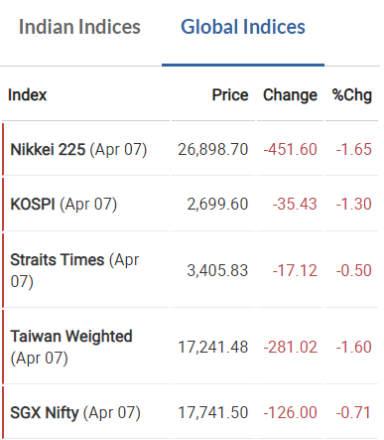
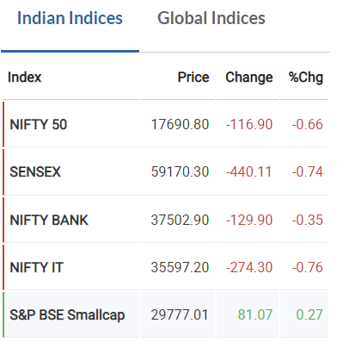

We can observe that Indian as well as Global Indices are having negative fluctuations.
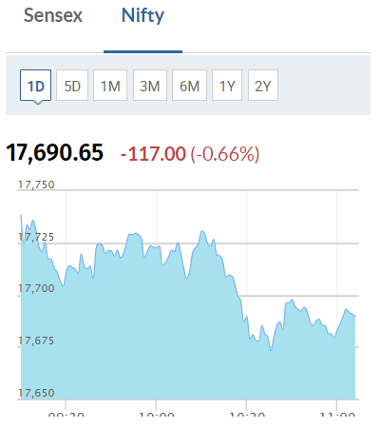

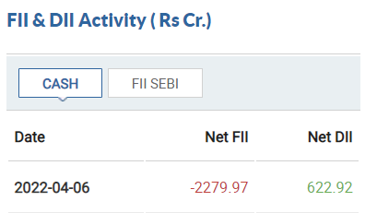
The market movement was dictated by net outflow from Foreign Institutional Investors where the securities sold amounted to Rs 2279.97 crores. Whereas, Domestic Institutional Investors purchased securities amounting to Rs 622.92 crores.

Stock Action
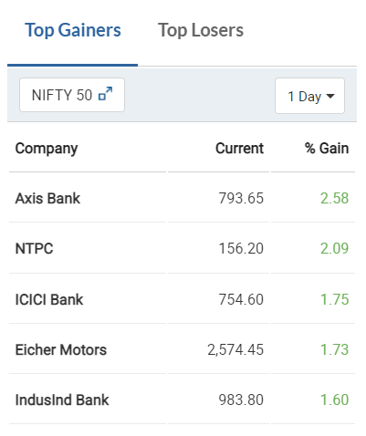
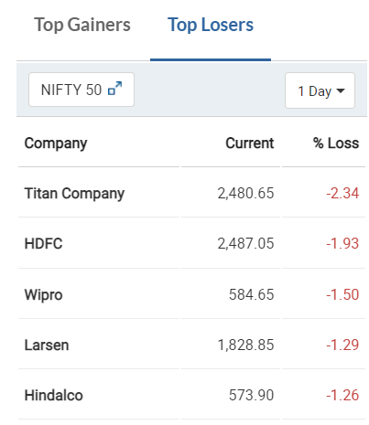

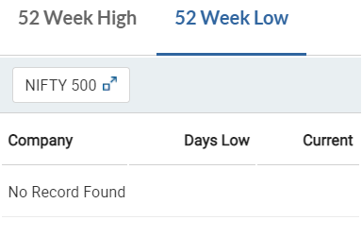
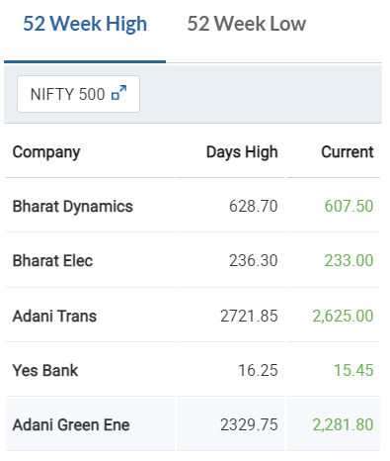

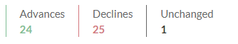
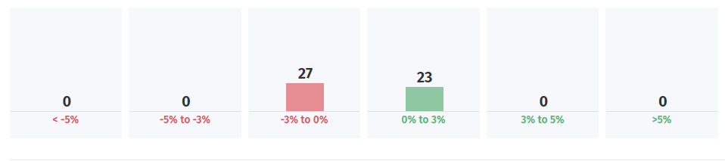

Out of the 50 components, 27 saw a price decline and 23 saw a price rise.

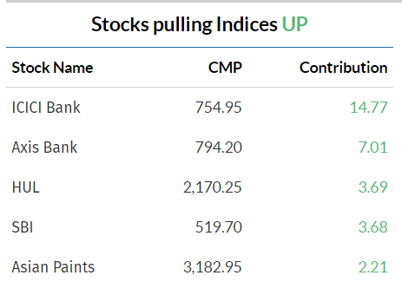

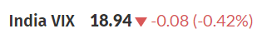

Answers:

- According to the institutional fund flow data, FII’s are driving the market.

- The change in fear index which is India VIX is a decrease of 0.42% which indicates there are not many significant price changes in the market and the market is not highly volatile as compared to the previous day.

- The stocks in the Nifty 50 Index that influenced the move in the markets are Axis Bank, NTPC, ICICI Bank, Eicher Motors, IndusInd Bank, HUL, SBI, HDFC, Wipro, Larsen, etc

- The top performing sectors are Pharmaceuticals, Cement and Paints, Chemicals, Consumer Non-durables.

- The worst performing sectors are Banking (stocks from Nifty 50 include Axis Bank, SBI, etc), Mining, Automotive, Oil and Gas

Q3 B
- On screening the 52wk high stocks, the stocks that match all qualification criteria are:
- Oil & Natural Gas (ONGC) – NSE
- Sun Pharmaceutical – NSE
- Tata Power Co LTD – NSE
- Tata Elxsi - NSE
- Page Industries LTD - NSE
- Solar Industries I – NSE
The qualification criteria for 52-week high stocks are as follows:
- The price chart must begin from the bottom left corner of the screen and go to the top right corner
- The candles should be small
- There should not be any circuit (blank candles) in the chart
- There should not be a major downward fall or dip in the price of the stock
- Smooth upward trend of the chart

- The following is the P&L for the company Bata
