PORTFOLIO THEORY AND SECURITY ANALYSIS – Assignment 1
UNIT 2,3 & 4
UNIT 2
Q1. Compared to exchange – traded funds (ETFs), open-end mutual funds are typically associated with lower:
C
Q2. Private equity and venture capital funds:
D
Q3. Hedge funds most likely:
C
Q4. Low risk tolerance and high liquidity requirements best describe the typical investment needs of:
D
Q5. A long time horizon and low liquidity requirements best describe the investment needs of:
D
Q6. Which of the following is least likely an example of a portfolio constraint?
C
Q7. For asset allocation purposes, asset classes should be specified such that correlations of returns are relatively:
B
Q8. In determining the appropriate asset allocation for a client’s investment account, the manage should:
C
Q9. A young investor is asking you to use derivatives and leveraged products in his portfolio. Distinguish between the willingness and the ability (capacity) to take risk in analysing an investor's financial risk tolerance.
ANS: Ability to bear risk:
The ability to bear risk is measured mainly in terms of objective factors, such as time horizon, expected income, and the level of wealth relative to liabilities.
For example, an investor with a 20-year time horizon can be considered to have a greater ability to bear risk, other things being equal, than an investor with a 2-year horizon. This difference is because over 20 years there is more scope for losses to be recovered or other adjustments to circumstances to be made than there is over two years.
Similarly, an investor whose assets are comfortably in excess of their liabilities has more ability to bear risk than an investor whose wealth and expected future expenditure are more closely balanced.
Willingness to take risk:

The willingness to take risk, or risk attitude, is a more subjective factor based on the client’s psychology and perhaps also his or her current circumstances. Although the list of factors that are related to an individual’s risk attitude remains open to debate, it is believed that some psychological factors, such as personality type, self esteem, and inclination to independent thinking, are correlated with risk attitude.

Q10. A new Client has approached your fund house; He is confused about what are components of an IPS. Describe the major components of an IPS?
ANS: Major Components of an IPS –
- Introduction. This section describes the client.
- Statement of Purpose. This section states the purpose of the IPS.
- Statement of Duties and Responsibilities. This section details the duties and responsibilities of the client, the custodian of the client’s assets, and the investment managers.
- Procedures. This section explains the steps to take to keep the IPS current and the procedures to follow to respond to various contingencies.
- Investment Objectives. This section explains the client’s objectives in investing.
- Investment Constraints. This section presents the factors that constrain the client in seeking to achieve the investment objectives.
- Investment Guidelines. This section provides information about how policy should be executed (e.g., on the permissible use of leverage and derivatives) and on specific types of assets excluded from investment, if any.
- Evaluation and Review. This section provides guidance on obtaining feedback on investment results.
- Appendices: (A) Strategic Asset Allocation (B) Rebalancing Policy. Many investors specify a strategic asset allocation (SAA), also known as the policy portfolio, which is the baseline allocation of portfolio assets to asset classes in view of the investor’s investment objectives and the investor’s policy with respect to rebalancing asset class weights. This SAA may include a statement of policy concerning hedging risks such as currency risk and interest rate risk.

Q11. Describe the investment constraints of liquidity, time horizon, tax concerns, legal and regulatory factors, and unique circumstances and their implications for the choice of portfolio assets.
Liquidity:
The IPS should state what the likely requirements are to withdraw funds from the portfolio. Examples for an individual investor would be outlays for covering healthcare payments or tuition fees. For institutions, it could be spending rules and requirements for endowment funds, the existence of claims coming due in the case of property and casualty insurance, or benefit payments for pension funds and life insurance companies.
When the client does have such a requirement, the manager should allocate part of the portfolio to cover the liability. This part of the portfolio will be invested in assets that are liquid—that is, easily converted to cash—and have low risk when the liquidity need is actually present, so that their value is known with reasonable certainty.

Time Horizon:
The IPS should state the time horizon over which the investor is investing. For example, a 55-year-old pension plan investor hoping to retire at age 65 has a ten-year horizon. The portfolio may not be liquidated at age 65, but its structure may need to change, for example, as the investor begins to draw an income from the fund.
The time horizon of the investor will affect the nature of investments used in the portfolio. Illiquid or risky investments may be unsuitable for an investor with a short time horizon because the investor may not have enough time to recover from investment losses, for example. Such investments, however, may be suitable for an investor with a longer horizon, especially if the risky investments are expected to have higher returns.

Tax concerns:
Tax status varies among investors. Some investors will face a different tax rate on income (dividends and interest payments) than they do on capital gains (associated with increases in asset prices). Typically, when there is a differential, income is taxed more highly than gains.
In many cases, the portfolio should reflect the tax status of the client. For example, a taxable investor may wish to hold a portfolio that emphasizes capital gains and receives little income. A taxable investor based in the United States is also likely to consider including U.S. municipal bonds (“munis”) in his or her portfolio because interest income from munis, unlike from treasuries and corporate bonds, is exempt from taxes. A tax-exempt investor, such as a pension fund, will be relatively indifferent to the form of returns.

Legal and Regulatory Factors:
The IPS should state any legal and regulatory restrictions that constrain how the portfolio is invested.
In some countries, such institutional investors as pension funds are subject to restrictions on the composition of the portfolio. Pension funds also often face restrictions on the percentage of assets that can be invested in securities issued by the plan sponsor, so called self-investment limits.
When an individual has access to material nonpublic information about a particular security, this situation may also form a constraint. The IPS should note this constraint so that the portfolio manager does not inadvertently trade the stock on the client’s behalf.

Unique Circumstances:
This section of the IPS should cover any other aspect of the client’s circumstances, including beliefs and values, that is likely to have a material impact on the composition of the portfolio. A client may have considerations derived from his or her religion or ethical values that could constrain investment choices.

Q12. Describe how environmental, social, and governance (ESG). considerations may be integrated into portfolio planning and construction.
ANS:
A client may have personal objections to certain products (e.g., weapons, tobacco, gambling) or practices (e.g., environmental impact of business activities, human impact of government policies, labour standards), which could lead to the exclusion of certain companies, countries, or types of securities (e.g., interest-bearing debt) from the investable universe as well as the client’s benchmark. Such considerations are often referred to as ESG (environmental, social, governance), and investing in accordance with such considerations is referred to as SRI (socially responsible investing).
There are several implementation approaches in which ESG considerations can be expressed in an investment portfolio. The oldest form is negative screening (or exclusionary screening), which refers to the practice of excluding certain sectors or excluding companies that deviate from accepted standards or norms.
Another common approach is best-in-class, whereby investors seek to identify companies within an industry that rank (or score) most favourably based on ESG considerations. Under this approach, investor portfolios would include only securities of those companies that exceed a certain threshold when evaluating ESG considerations. Shareholder engagement (sometimes call active ownership) is the practice of entering into a dialogue with companies (including with respect to ESG issues).
While exclusionary screening and best-in-class eliminate investment options, thematic investing and impact investing focus on investment in objectives, themes, and trends that relate positively to ESG issues. An example of a thematic investment (i.e., related to a business theme or societal trend) that considers ESG would be investments in alternative energy providers. In impact investing, an investment is selected primarily on its expected social or environmental benefits with measurable investment returns.
Q13. Calculate diversification ratio. The Variance of an equally weighted portfolio is 324%% Whereas Average variance for n stocks is 625%.
Diversification ratio = SD of equally weighted portfolio/SD of randomly selected security
= sqrt(324%%)/sqrt(625%%)
= 18/25
= 0.72

Q14. Fill the table
Characteristics of different type of Investors
Investor | Risk Tolerance | Investment Horizon | Liquidity Needs | Income needs
Individuals | Varies by investor | Varies by investor | Varies by investor | Varies by investor
Banks | Low | Short term | High to meet repayments of depositors | To pay interest on deposits and operational expenses
Endowments | High | Long term | Low | To meet spending requirements
Insurance | Low | Short term for P&C, Long term for life insurance | High to meet claims | Low
Mutual funds | Varies by fund : Debt, Equity, Hybrid | Varies by fund | Open ended – high  Close ended - low | Low
Defined Benefit pensions | High | Long term | Depends on maturity of plan | High for mature funds, low for growing funds

Q15. Describe defined contribution and defined benefit pension plans
Ans: Many employees of public and private companies invest for retirement through defined contribution pension plans (DC plans). DC plans are retirement plans in the employee’s name usually funded by both the employee and the employer. With DC plans, individuals will invest part of their wages while working, expecting to draw on the accumulated funds to provide income during retirement or to transfer some of their wealth to their heirs. The key to a DC plan is that the employee accepts the investment and inflation risk and is responsible for ensuring that there are enough assets in the plan to meet their needs upon retirement.
Defined benefit pension plans (DB plans) are company-sponsored plans that offer employees a predefined benefit on retirement. The future benefit is defined because the DB plan requires the plan sponsor to specify the obligation stated in terms of the retirement income benefits owed to participants.
UNIT 3
Q1. P Ltd and Q Ltd have low positive correlation coefficient of +0.5. Their respective return and risk profile is as under:
Rp = 10%
Rq = 15%
Sp = 20%
Sq = 25%
Compute the portfolio of P & Q to minimize risk.

Q2. L Ltd and M Ltd have the following return and risk estimates,
Rl = 20%
Sm = 22%
Sl = 15%
Sm = 18%
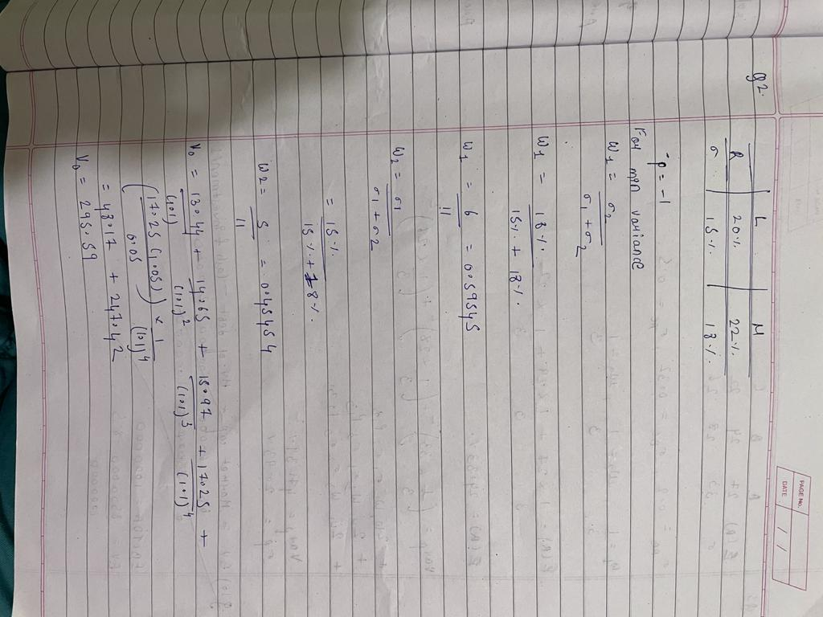

(Correlation coefficient) = COR lm = -1
Calculate the proportion of investment in L Ltd and M Ltd to minimize the risk of portfolio.

Q3. A portfolio consists of three securities A, B and C with the following relevant information.
 | A | B | C
Expected Returns | 27 | 24 | 22
Standard Deviation | 33 | 28 | 26
Correlation coefficient between
A&B 0.20
B&C 0.32
A&C 0.50
If the weights of securities are equal, find out the risk and expected return of the portfolio.

UNIT 4
Q1. Firms and industries are most appropriately classified as cyclical or non – cyclical based on:
B
Q2. An analyst should most likely include two firms in the same peer group for analysis if the firms:
C
Q3. The industry experience curve shows the cost per unit relative to:
A
Q4. Which of the following is least likely an element of an industry strategic analysis?
A
Q5. Two of the five competitive forces in the Porter framework are:
B
Q6. Greater pricing power is most likely to result from greater
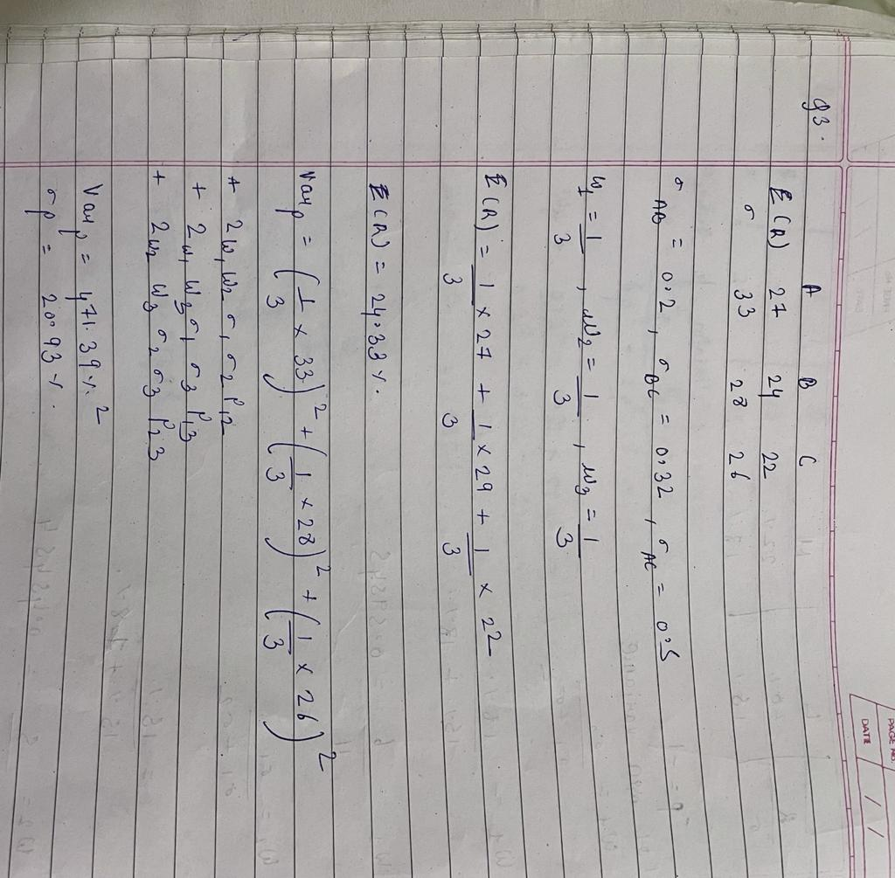B
Q7. Which of the following statements best describes the relationship between pricing power and ease of entry and exit? Greater ease of entry:
A
Q8. Industry overcapacity and increased cost cutting characterize which stage of the industry life cycle?
C
Q9. Which of the following firms would most appropriately be valued using an asset-based model?
B
Q10. Which type of valuation model is viewed as having the disadvantage of producing results that may not be comparable across firms?
B
Q11. Novice Analyst is planning to evaluate Telecom sector with reference to its pricing power and cost advantages. Describe Michael Porter 5 forces that determine industry competition.
ANS: Porter’s five forces:
- The threat of entry to the industry, which depends on barriers to entry, or how difficult it would be for new competitors to enter the industry. Industries that are easy to enter will generally be more competitive than industries with high barriers to entry.
- The power of suppliers, which may be able to raise prices or restrict the supplyof key inputs to a company. For example, workers at a heavily unionized company may have greater bargaining power as suppliers of labor than workers at a comparable non-unionized company. Suppliers of scarce or limited parts or elements often possess significant pricing power.
- The power of buyers, which can affect the intensity of competition by exerting influence on suppliers regarding prices (and possibly other factors such as product quality). For example, auto parts companies generally sell to a small number of auto manufacturers, which allows those customers, the auto manufacturers, to be tough negotiators when it comes to setting prices.
- The threat of substitutes, which can negatively affect demand if customers choose other ways of satisfying their needs. For example, consumers may trade down from premium beers to discount brands during recessions. Low-priced brands may be close substitutes for premium brands, which, when consumer budgets are constrained, reduces the ability of premium brands to maintain or increase prices. Substitutes do not have to be similar but can satisfy a need with a very different product.
- The rivalry among existing competitors, which is a function of the industry’s competitive structure. Industries that are fragmented among many small competitors, have high fixed costs, provide undifferentiated (commodity-like) products, or have high exit barriers usually experience more intense rivalry than industries without these characteristics.
Q12. Describe macroeconomic, technological, demographic, governmental, and social influences on industry growth, profitability, and risk.
ANS:
Macroeconomic Influences
Cyclical or structural trends may have significant effects on the demand for an industry’s products or services. An industry’s sales and profitability may be impacted by gross domestic product, interest rates, credit availability, and/or inflation.

Technological Influences
New technologies create new or improved products that can radically change an industry and change how other industries use the products to conduct their operations.

Demographic Influences
Changes in population size, the distribution of age and gender, and other demographic characteristics may have significant effects on economic growth and the amount and types of goods and services consumed.

Governmental Influences
Governments may have a significant influence on industries through their ability to control tax rates and their status as major purchasers of goods and services from a range of industries. Governments may also exert their influence indirectly by empowering other regulatory or self-regulatory organizations to govern the affairs of an industry.

Social Influences
Societal changes involving how people work, spend their money, enjoy their leisure time, and conduct other aspects of their lives can significantly affect the sales of various industries.

Q13. A newbie investor is too excited about Wipro story of cash dividend, stock dividend, stock split and buybacks. Describe stock splits, reverse stock splits, and share repurchases. cash dividends, extra dividends, stock dividends?
- A stock split involves an increase in the number of shares outstanding with a consequent decrease in share price.
- A reverse stock split involves a reduction in the number of shares outstanding with a corresponding increase in share price.
- Share repurchases are an alternative to cash dividend payments. A share repurchase (or buyback) is a transaction in which a company uses cash to buy back its own shares.
- Cash dividends are typically paid out regularly at known intervals; such dividends are known as regular cash dividends.
- an extra dividend or special dividend is a dividend paid by a company that does not pay dividends on a regular schedule or a dividend that supplements regular cash dividends with an extra payment.
- A stock dividend (also known as a bonus issue of shares) is a type of dividend in which a company distributes additional shares of its common stock (typically, 2%–10% of the shares then outstanding) to shareholders instead of cash

Q14. Explain Free cash flow to equity?
The calculation of FCFE starts with the calculation of cash flow from operations (CFO). CFO is simply defined as net income plus non-cash expenses minus investment in working capital. FCFE is a measure of cash flow generated in a period that is available for distribution to common shareholders.
The entire CFO is not available for distribution; the portion of the CFO needed for fixed capital investment (FCInv) during the period to maintain the value of the company as a going concern is not viewed as available for distribution to common shareholders. Net amounts borrowed (borrowings minus repayments) are considered to be available for distribution to common shareholders. Thus, FCFE can be expressed as

FCFE = CFO – FCInv + Net borrowing
Q15. Last Dividend paid by ITC is ₹12 per share its currently traded at 215 ₹/share. Required return calculation is 10%
Year | Growth rate in dividends
1 | 12%
2,3 | 9%
4 | 8%
Year 5 onwards growth is 5%
You as an analyst have to find intrinsic value per share using DCF model.
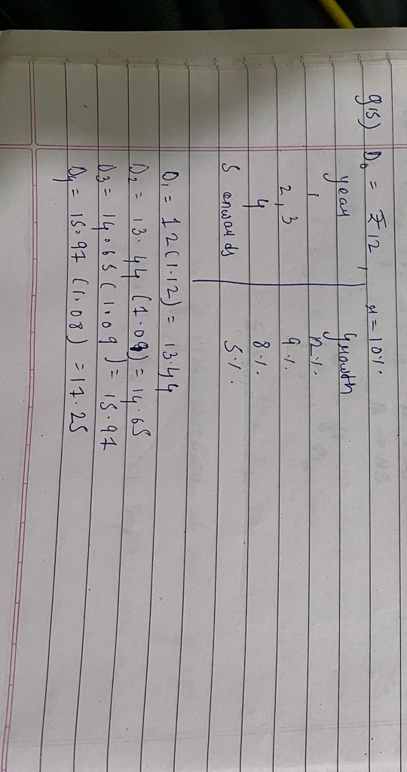

Q16. Calculating EV/EBITDA multiples
Fiem LTD is a manufacturer of small electric vehicle components. The following figures are from Fiem’s most recent financial statements except for the market value of long-term debt, which has been estimated from financial market data
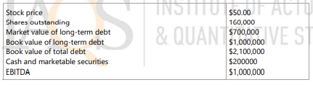
Calculate the EV/EBITDA multiple
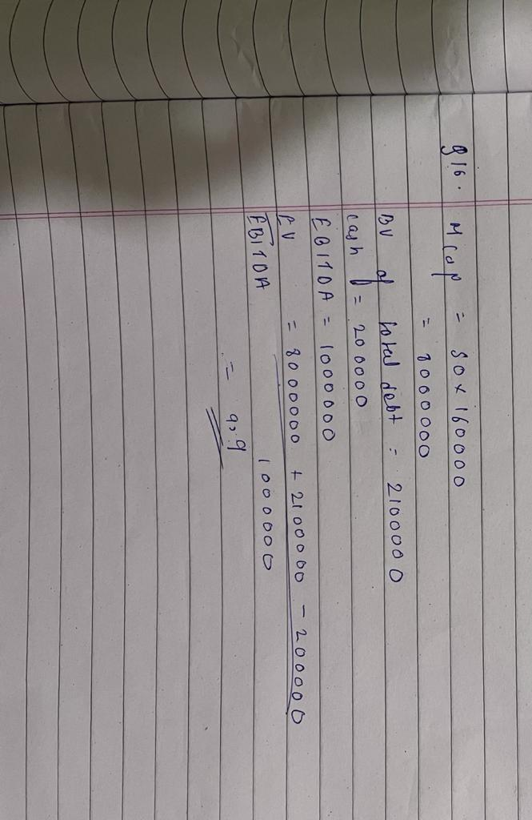Q17. Expected Dividend payout is 40%, ke is 12% and expected growth is 4%, Using the above data find the fundamental P/E?



