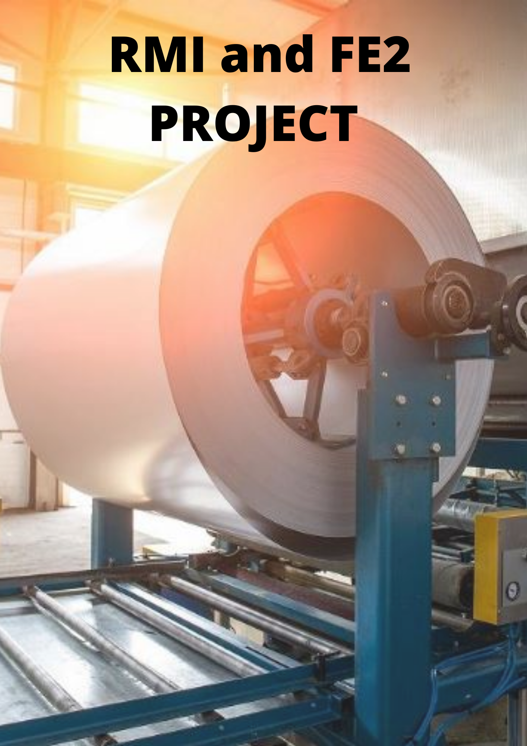

What is hedging?
Hedging is basically when one protects themselves from a risky situation this can easily be understood by looking at it as type of insurance since it will protect you from any losses that can be occurred. Hedging is typically used to offset losses investments by taking opposite position in a related asset. However, since hedging causes reduction in risks it also typically reduces the potential of gaining profits. It is basically understanding the dangers that can be faced by any activity and one can choose to protect themselves from these risks if they choose to hedge them. Hedging is typically done with derivatives such as options and futures.
Advantages of Hedging:
- Reduces the chances of losses
- Increases liquidity which offers companies greater flexibility with other investments and activities.
- Best risk management strategy for investors and companies with low risk tolerance
- Using hedging companies can lock in their profit
- Hedging can safeguard companies against commodity price changes, foreign exchange fluctuations and interest rate changes

Disadvantages of Hedging:
- While hedging reduces volatility, it also reduces the potential for higher gains
- If the transaction is not properly planned (size and timing), the transaction costs can be more than the returns gained and can eat up the returns
- Lack of knowledge and gap in communication regarding hedging strategies between the Board and the management can lead to conflicts
- It can be unnecessary when the market is performing well.
- Mismanaged strategy can lead to liquidity crunch which may eventually lead to bankruptcy

Moving forward let’s look at what a commodity price risk and later on how and what a company can do to avoid these risks
What is Commodity Price Risk?
Commodity price risk is when changes of prices can cause financial loss to either the buyer or the seller of the specific commodity which in our case is gas. If the commodity price rises it is a risk for the buyers while a fall in prices is a risk for sellers. Various factors that influence the commodity prices are politics, seasons, weather, technology and market conditions. Futures and options are the most widely and commonly used instrument used to hedge for commodity prices while there are many more which we will look in detail in the later part of the report.
What is the ideal plan for implementation of the Hedging program in a time bound manner?
According to the brief given the company currently follows a Silo based risk management system where every department is focused on the risks faced by that particular department this can cause a lot of problems since in Silo based approach departments do not share information as mentioned that the steel company does not maintain proper documentation of the processes, priorities, goals etc with other departments. This means no correlation of risks can take place. Moreover, failure of one department to tackle their risk can cause failures overall which can result in operations of the company, reduction in morale of employees and can also cause overall failure of the company. To tackle all the above problems the company should follow Enterprise risk management framework for mitigating all the risk that the company can face. The treasury should talk to the board of directors to understand the risk appetite of the company and set up ERM that best fits the business scope and complexity. Moreover, ERM will help the company to integrate all the risk and hence the company can have a central risk management unit by this the guidelines given by the industry regulator will also be followed i.e.) undertaking the appropriate commodity price risk hedging approved by the board and investment committee. This will also help the company to have proper documentation of the roles and responsibilities of senior management and the stakeholders since it allows managers to focus on the largest threats to the firm rather than day to day threats to specific units and business lines. Managers understand crossover risks and as well as correlations between specific risk types better with ERM like in our case realising other risks that correlate with price fluctuations. Moreover, with ERM the firm can also perform value chain analysis which in our case for commodity price risk management prior to the hedging activities it is important for the company to understand its exposure to commodity price fluctuations that can be in respect of procurement and storage of gas and the sale of finished goods i.e.) steel.
Hedging in a time bound manner means that the hedging strategy used by the company should be carried out in a specific period of time. This is important for the company for them to be prudent since it will suggest that the revenue for the particular period should be equal to its costs.
Hedging commodity price risks can be done with various instruments like Swap Contracts, Option Contracts and Fixed price physical Contracts and various others which will be explained later.
FUTURES CONTRACT
A futures contract is a legal agreement, generally prescribed by a futures exchange, to buy or sell a particular commodity or financial instrument at a predetermined price at a specified time in the future. Futures contract executed in commodity exchanges can be physically settled upon contract maturity or is cash settled (as mandated by the commodity exchange).
The company can also hedge the risk using futures contract since these are not over the counter contracts, they have full transparency.
Let’s understand how the futures contract will work for our company, the company will enter in the futures contract with a long position this means that the company will sign for the right of buying gas at the particular price at the specific future date. Tn futures contract the futures price, expiration, number of contracts is fixed. Here the company will be protecting itself from the potential of prices increasing in the futures. If the price of gas rises, the loss incurred in buying gas at a higher price will be zeroed by our gains with settling our long position in the future contracts. Moreover, if the price decreases the loss incurred due to the long position in the futures contract will be zeroed by our gains earned due to purchasing gas at a lower price. However, we can be exposed to heavy margin calls in the later situation.
Some of the advantages of futures contract are:
- Futures are exchange traded and hence the company will not face any counter party risk exposure.
- Since they are traded on market the contracts are standardised and are same for all the market participants.
- Transparent pricing as per exchange quotes.
Some of the disadvantages of the futures contract are:
- Standardization of contract may not align well with the Company’s exposure profile with respect to tenor of hedge
- May create basis risk where there is a difference in the pricing benchmark used in the future contract against the pricing benchmark considered for physical trade by the Company with its suppliers.
- Involves continuous monitoring on margin maintenance

FIXED-PRICE PHYSICAL CONTRACTS
As the name suggests fixed price physical contract means deciding the buying and selling price well in advance for each delivery period. This will eliminate all the risk related to the uncertainty in the prices.

Since our company has little to no knowledge about hedging and complex derivatives it is better for us if we use fixed price physical contracts to hedge gas that is used for the manufacturing of steel. Moreover, since gas is only a part of manufacturing steel it will not be the best of options to get in a complex hedging strategy which the board can disagree on. Moreover, the fixed price physical contracts will ensure that price fluctuations do not affect the steel production.
Although the fixed price physical contracts eliminate the price risk other risks can be faced by the company since these contracts involve the actual delivery of gas. Some of the risks that the company can face are:
- What if the seller of the gas does not stick to the contract when the prices are very high? This risk is known as mark to market risk.
- Moreover, there is a possibility of the gas purchased not being enough for the production of steel if this occurs than the steel company will have to purchase gas at the market price.
What type of derivatives can be used for commodity price risk management and why?
FORWARD CONTRACTS
Forward contracts are very similar to that of the futures contract that basically suggests that they are based on the agreement of a future sale of a commodity. The difference between the futures and forwards are that forwards are not standardized and are traded over the counter and not on exchanges. Which can also mean that the transaction costs for hedging the commodity price risk using forwards can be more than that of futures. Moreover, the over-the-counter market is not centralized and transactions occur between two parties. However, forwards contracts are customizable and can fit specific needs of the companies involved in the contract. As there is no clearing house involved, forward contracts carry the risk of default by one of the contract parties. The market for commodity forward contracts is very heterogeneous

SWAP OPTIONS
Swap contracts are bilateral contracts that provide for the exchange or swapping of a series of cash flows at defined intervals known as settlement periods. These price swaps involve swapping, at defined intervals for a specified period into the future, a floating price for a fixed price based on an agreed notional quantity of oil or gas. These gas price swaps are financially settled by comparing, on agreed periodic dates, the floating price of the gas as published by an index selected by the parties to the fixed price agreed on in the swap contract.

OPTION CONTRACTS
Option contracts provide the holder of the option the right, but not the obligation, to either purchase (a call option) or sell (a put option) a specified quantity and quality of an underlying commodity at a specific location and on a specific date (or series of dates) in the future at a price specified for each such date (the strike or exercise price). A call option is an option contract between two parties where the buyer of the call option earns a right (not an obligation) to exercise the option to buy a particular asset from the call option seller for a stipulated period of time. Once the buyer exercises his option, the seller has no other choice than to sell the asset at the strike price at which it was originally agreed. The buyer expects the price to increase and thus earns capital profits. Options are traded both on exchanges and on the over-the-counter market. Exchange-traded commodity options often have a commodity futures contract, rather than a physical commodity, as the underlying asset.

What are the points to be considered when deciding on the derivatives to hedge commodity price risk?

COST OF THE INSTRUMENT
Cost of the derivative used is one of the main factors to consider while hedging and which instrument should be used for hedging the costs of the instruments used should also include taxes. Cost of hedging is particularly very important since if the cost of hedging through a particular method is very high it can offset the gains that can experienced from hedging. Therefore, a company should always use an instrument which is appropriate for a particular problem while also having the least cost when compared to the other methods available.
RISK
Derivatives used are not risk free therefore the company should always consider the risk that they can face while using a specific instrument to hedge the commodity.
Payoff of the Instrument
Instrument selected by the company should be compatible with the commodity that is being hedged.
Liquidity of the derivative
If the instrument used is highly liquid it will be cheaper in terms of cost and can be easily completed.
How will you explain to the stakeholders that Hedging is indeed beneficial for the company rather than keeping its position open?
Hedging helps in mitigating the risk that can cause due to rise in prices. It also helps the company to manage all the risks than can be associated with an increase in price of gas which may not just limit to one department a rise in price of gas will cause the rise in cost of final price and if our company is in a contract of selling stell at a fixed price than the company can incur huge losses. Moreover, if an appropriate hedging strategy is used it can also cause our company to be the industry leaders since we can still charge the same price for steel while the other companies that didn’t hedge might sell their products at a higher cost.
Hedging will also help the company to manage its cashflows since this is major challenge for the company. If the commodity price keeps on fluctuating it will cause a problem in cashflow management for the business but with hedging the company can obviously avoid any adverse situation.
If gas is not hedged it can cause our company to be exposed to price fluctuations that can be experienced if the position is kept open which can lead to liquidity concerns.

Conclusion
Company should hedge its position since it is a very competitive market of steel production and price fluctuations can cause the company to lose its market share which can do major harm to the company’s profit and its reputation.

THANK
YOU

