- D
- C
- B
- A
- C
- C
- B
- C
- D
- D
- C
- D
- C
- B
- D
- A
- B
- Net domestic income = GDP – Capital Depreciation
= (9000+1800+28000+10000+24000) – 1700
= 71100
Gross domestic income = (9000+1800+28000+10000+24000)
= 72800
Net national income = gross national income - depreciation of fixed capital assets
= (72800 - 300)) – 1700
= 70800
- ..
- The short run aggregate supply curve shows positive relationship between the aggregate price level and amount of aggregate output supplied in an economy. The curve shows that a higher price level leads to more output. Key indications of the curve,
  - it represents a short-run relationship between price level and output supplied. Aggregate supply slopes up in the short-run because at least one price is inflexible.
  - The curve also tells us there is a short-run trade-off between inflation and unemployment. Because higher inflation leads to more output, higher inflation is also associated with lower unemployment in the short run.
In the market model, supply slopes up because of the profit motive of individual firms. If a firm gets a higher price, they will make a higher profit by selling more, so quantity supplied increases when price increases.
- .
- A negative externality is a cost that is suffered by a third party as a consequence of an economic transaction. In a transaction, the producer and consumer are the first and second parties, and third parties include any individual or organisation facing negative impact. For a more social efficient outcome the government could tax the good, i.e the consumer pay the amount equal to full social cost.
- Command approaches – includes legislation, regulations and advertising that aim directly reducing emissions or environmental damage.
Market based policies change the price incentives faced by the firms example an indirect tax on pollutants.
- 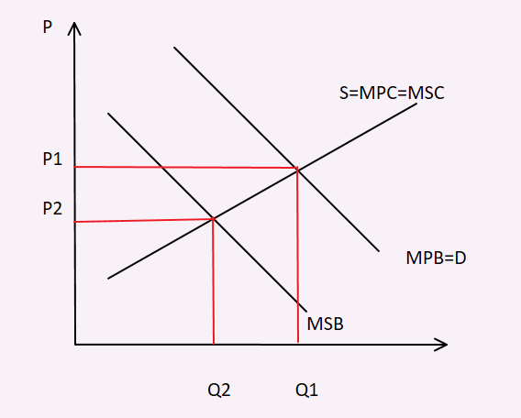

- Actual economic growth is measured by the annual percentage change in a country’s real national output (GDP).
Potential economic growth is also known as trend growth and is measured by the estimated annual change in a country’s potential level of national output.

- Ways of measuring GDP:
  - Product method:
This adds up the value of each good and service (P*Q) produced in the economy within a year, thus obtaining the value of all final goods and services.
The value of goods and services is calculated for each sector in the economy. Eg: goods in agricultural sector, services in health sector

  - Expenditure method:
Adds up total spending to buy final goods and services within a year.
GDP = C + G + I + (X-M)

  - Income method:
This method adds up all income earned by the factors of production in the course of producing total output within a year.
Since GDP is the sum of all expenditures, it must also be the sum of all incomes generated.
GDP at basic prices = rent + wages + interest + profit

