ASSSIGNMENT 2
-DRASHTI SHAH (30)

1. A put option has a strike price of $35. The price of the underlying stock is currently
$42. The put is:
A. In the money
B. At the money
C. Out of the money
D. Near the money

2. A call option with a strike price of $55 can be bought for $4. What will be your net
profit if you sell the call and the stock price is $52 when the call expires?
A. 3
B. 4
C. 0
D. -4

3. Which of the following is potentially obligated to sell an asset at a predetermined
price?
A. A call buyer
B. A put buyer
C. A put writer
D. A call writer

4. Which of the following investment strategies has unlimited profit potential?
A. Protective put
B. Bull spread
C. Covered call
D. Writing a call

5. The price of a non-dividend paying stock is 30 and the strike price of one year
European call option on the stock is 25. The risk free rate is 4% compounded
continuously. Which of the following is the lower bound for the option such that there
are arbitrage opportunities if the price is below the lower bound and no arbitrage
opportunities if the price is above the lower bound?
A. 5.00
B. 5.98
C. 4.98
D. 3.98

6. You are given the following:
• The current price to buy one share of XYZ stock is 500.
• The stock does not pay dividends.
• The continuously compounded risk-free interest rate is 6%.
• A European call option on one share of XYZ stock with a strike price of K that expires
in one year costs 66.59.
• A European put option on one share of XYZ stock with a strike price of K that expires
in one year costs 18.64.
Using put-call parity, calculate the strike price, K.
A. 449
B. 452
C. 480
D. 559

7. Stock ABC has the following characteristics:
• The current price to buy one share is 100.
• The stock does not pay dividends.
• European options on one share expiring in one year have the following prices:
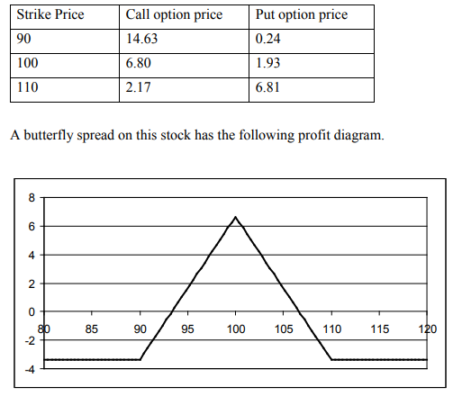
The continuously compounded risk-free interest rate is 5%.
Determine which of the following will NOT produce this profit diagram.
A. Buy a 90 put, buy a 110 put, sell two 100 puts
B. Buy a 90 call, buy a 110 call, sell two 100 calls
C. Buy a 90 put, sell a 100 put, sell a 100 call, buy a 110 call
D. Buy one share of the stock, buy a 90 call, buy a 110 put, sell two 100 puts

8. An investor has written a covered call.
Determine which of the following represents the investor's position.
A. Short the call and short the stock
B. Short the call and long the stock
C. Short the call and no position on the stock
D. Long the call and short the stock

9. The current price of a stock is 80. Both call and put options on this stock are
available for purchase at a strike price of 65.
Determine which of the following statements about these options is true.
A. Both the call and put options are at-the-money.
B. Both the call and put options are in-the-money.
C. Both the call and put options are out-of-the-money.
D. The call option is in-the-money, but the put option is out-of-the-money.

10. A trader buys 2 June expiry call options each at a strike price of Rs. 200 and Rs. 220
and sells two call options with a strike price of Rs. 210, this strategy is a ____.
A. Bull Spread
B. Bear call spread
C. Butterfly spread
D. Calendar spread

11. The combination of buying a call and a put option at the different exercise prices
then it would be a
A. Straddle
B. Strangle
C. Hedge
D. Bull Spread

12. Samy is bullish on Reliance Industries and buys ten one month Reliance futures
contracts at Rs. 2,96,00. On the last Friday of the month, Reliance Industries closes at
Rs. 271 per shares. Samy makes a ______.
A. profit of Rs. 15,000
B. profit of Rs. 25,000
C. Loss of Rs. 15,000
D. Loss of Rs. 25,000

13. Suppose the stock price of Intel is $63, and the call price is $4 with a strike price of
$65. If you write a covered call option, and Intel stock rises to $71, the profit or loss of
your strategy is:
A. 8
B. 6
C. -6
D. -4

14. An investor is most likely to consider adding alternative investments to a traditional
investment portfolio because of their:
A. Low sharpe ratio
B. High correlation with traditional investments
C. Diversifying potential

15. Which of the following is least likely to be a characteristic of a hedge fund?
A. It is an aggressively managed portfolio of investments across asset classes.
B. Investors may be required to keep their money in the hedge fund for a minimum
period known as lock-up period.
C. It is an investment opportunity available to the public and requires hefty
investment.

16. Risks in infrastructure investing are most likely greatest when the project involves:
A. Construction of infrastructure assets.
B. Investment in existing infrastructure assets.
C. Investing in assets that will be leased back to a government.

----x----

