INTRODUCTION TO DERRIVATIVES AND FINANCIAL MARKET
PROJECT
JASH POONATAR 418
DRASHTI SHAH 430

Statement 1: Hedging using futures can potentially eliminate volatility for any movement in underlying hedged item

What are futures?
Futures are derivative financial contracts that obligate the parties to transact an asset at a predetermined future date and price. The buyer must purchase or the seller must sell the underlying asset at the set price, regardless of the current market price at the expiration date. Underlying assets include physical commodities or other financial instruments. Futures contracts detail the quantity of the underlying asset and are standardized to facilitate trading on a futures exchange. Futures can be used for hedging or trade speculation
Advantages and Disadvantages of future:
Futures also called futures contracts allow traders to lock in the price of the underlying asset or commodity. These contracts have expiration dates and set prices that are known upfront. Futures are identified by their expiration month. For example, a December gold futures contract expires in December. Their advantages and disadvantages are:
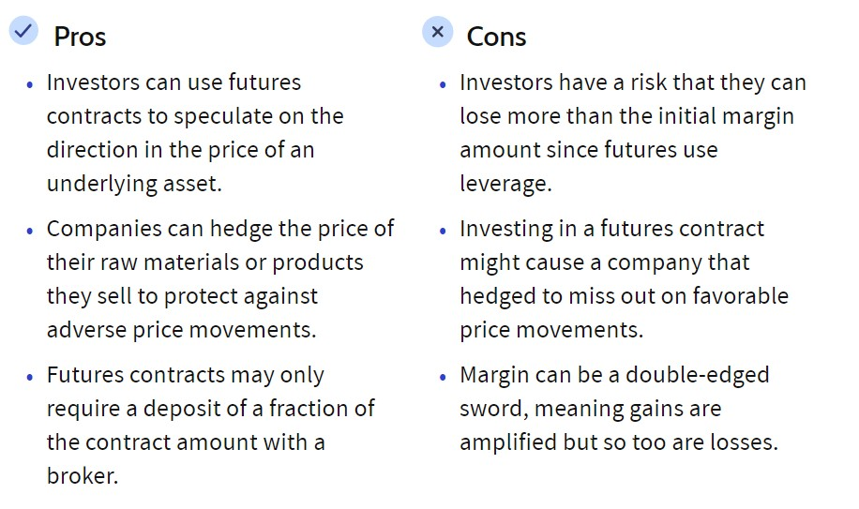

Hedging using futures:
Futures contracts were initially invented and popularized as a way for agricultural producers and consumers to hedge commodities such as wheat, corn, and livestock. A hedge is an investment made to reduce the risk of adverse price movements in another asset. Normally, a hedge consists of taking an offsetting position in a related security and so futures contracts on corn, for example, could be sold by a farmer at the time that he plants his seed. When harvest time comes, the farmer can then sell his physical corn and buy back the futures contract.
This strategy is known as a forward hedge, and effectively locks in the farmer's selling price for his corn at the time he plants it - it doesn't matter if the price of corn rises or falls in the interim, the farmer has locked in a price and therefore can predict his profit margin without worry.
Likewise, when a company knows that it will be making a purchase in the future for a particular item, it should take a long position in a futures contract to hedge its position. For example, suppose that Company X knows that in six months it will have to buy 20,000 ounces of silver to fulfil an order. Assume the spot price for silver is $12/ounce and the six-month futures price is $11/ounce. By buying the futures contract, Company X can lock in a price of $11/ounce. This reduces the company's risk because it will be able to close its futures position and buy 20,000 ounces of silver for $11/ounce in six months.
Risk involved in futures
Futures contracts can be very useful in limiting the risk exposure that an investor has in a trade. Just like the farmer or company above, an investor with a portfolio of stocks, bonds, or other assets can use financial futures to hedge against a drop in the market. The main advantage of participating in a futures contract is that it removes the uncertainty about the future price of an asset. By locking in a price for which you are able to buy or sell a particular item, companies are able to eliminate the ambiguity having to do with expected expenses and profits. Because of the leverage used in futures trading, it is possible to sustain losses greater than one's original investment. Conversely, it is also possible to realize very large profits. Again, it is not that the actual asset a trader is investing in carries more inherent risk; the additional risk comes from the nature and process of how futures contracts are traded.
Minimising Loss
To handle the additional leverage wisely, futures traders have to practice superior money management by using prudent stop-loss orders to limit potential losses. Good futures traders are careful not to over-margin themselves, but instead to maintain enough free, uncommitted investment capital to cover draw-downs in their total equity. Trading futures contracts requires more trading skill and hands-on management than traditional equity investing. Thus, by using stop loss orders the traders can reduce the loss incurred while safeguarding their interests.
Final conclusion
Thus, futures are a great way for investors/traders to hedge their position with the motive to reduce the risk faced by them but it is not possible to completely eliminate the risk/volatility from adverse price changes in the underlying asset since at minimum there is always the loss of a margin call and a stop order limit if placed alongside the future contract. Therefore, future can be used as an instrument to reduce risk and not completely eliminate it.
Example for the same is given below:
An oil producer plans to produce one million barrels of oil over the next year. It will be ready for delivery in 12 months. Assume the current price is $75 per barrel. The producer could produce the oil, and then sell it at the current market prices one year from today. Given the volatility of oil prices, the market price at that time could be very different than the current price. If the oil producer thinks oil will be higher in one year, they may opt not to lock in a price now. But, if they think $75 is a good price, they could lock in a guaranteed sale price by entering into a futures contract.
Assume that the one-year oil futures contracts are priced at $78 per barrel. By entering into this contract, in one year the producer is obligated to deliver one million barrels of oil and is guaranteed to receive $78 million. The $78 price per barrel is received regardless of where spot market prices are at the time.
At the end of year, if the price per barrel is above $78 say $80, irrespective of the spot price the producer will receive $78 per barrel. But if the prices go down i.e., around $75 the producer is safeguarded by the future contracts and receives $78 per barrel as agreed thus helping in reducing the risk faced by adverse price movements in the prices of oil. Even though it guarantees $78 it may be ineffective in the case price increases since the producer makes a loss by selling at a lower price than the prevailing one. Thereby there is always exists a risk of loss.

Statement 2: Hedging using options can eliminate the downside volatility of the price movement in the underlying asset at an associated cost.

What is a Call Option?
Buying call options is a bullish strategy using leverage and is a risk-defined alternative to buying stock. Call options assume that the trader expects an increase in stock price following the purchase of the options contract. For the trader to profit, the stock price has to increase more than the strike price and the options premium combined.

How Do Call Options Work?
Here’s an example of buying a call option:
A trader is very bullish on stock XYZ trading at $50.
The trader is either risk-averse, wanting to know beforehand their maximum loss, or wants greater leverage than simply owning shares of XYZ.
The trader expects XYZ to move above $53.10 per share in the next 30 days.
The trader selects the $52.50 call option strike price which is trading for $0.60.
For this example, the trader will buy only 1 option contract (Note: 1 contract is for 100 shares) so the total cost will be $60 ($0.60 x 100 shares/contract).
Call Options Have Clearly Defined Risk
When a call option is purchased, the trader instantly knows the maximum amount of money they can possibly lose. The max loss is always the premium paid to own the option contract. Whether the stock falls to $5 or $50 a share, the call option holder will only lose the amount they paid for the option. This is the risk-defined benefit often discussed about as a reason to trade options.

Trading Strategies Involving Options
- A long position in a futures contract plus a short position in a call option (covered call) (a) The long position “covers” the investor from the payoff on writing the short call that becomes necessary if prices increase. Downside risk remains if prices drop.
- A short position in a futures contract plus a long position in a call option (b)
- A short position in a put option with a short position in a futures contract (c)

Spreads
- Bull Spreads
- Long and Short positions on a call option where strike price is higher on the short position (K2 > K1).
– Investor collects when prices increase somewhere between K1 and K2
– This strategy limits the investor’s upside and downside risk – In return for giving up some upside risk, the investor sells a call option
– Both options have the same expiration date
– The value of the option sold is always less than the value of the option bought
– There are three types of bull spreads:
1. Both calls are initially out of the money (lowest cost, most aggressive)
2. Only One call is initially in the money
3. Both calls are initially in the money (highest cost, most conservative)

- Bear Spreads
- An investor hoping that the price will decline may benefit from a bear spread. Basic strategy is to buy and put with strike price (K1) and sell another put with strike price (K2), where K1 > K2.
– In contrast, the strike price of the purchased put will cost more than the option that is sold.
– Limit upside protfit potential and downside risk
– Another type of bear spread involves buying a call with a high strike price and selling a call with a lower strike price.

Combinations
- Straddle
- Involves buying a call and put with the same strike price and expiration date
– The bundle leads to a loss when the price is close to the strike price
– The bundle leads to a gain when the price moves sufficiently in either direction
- Strips and Straps
– Both of these strategies reward prices that deviate far from the strike price
– Strip - a long position in a call and two puts with teh same strike price and expiration date A strip is a bet on a big move where a decrease in price is more likely
– Strap - a long position in two calls and one put with teh same strike price and expiration date A strap is a bet on a big move where an increase in price is more likely
- Strangles
- A put and a call with the same expiration date and different strike prices, with put strike price K1 and a call strike price K2, where K2 > K1.
– Similar shape compared to straddle, however prices need to deviate more in a strangle in order for gains to be found
– The farther apart the strike prices, the less the downside risk and the farther the price has to move for a gain to be realized
- Box Spreads
- A combination of a bull call spread with strike prices K1 and K2 and a bear put spread with the same two strike prices
– The total payoff is always K2 −K1. The value of the spread is always the present value of that gap, (K2 − K1)e^{-rt}
– If there is a different value (not equal to the present value), then there is an arbitrage opportunity

What Are The Downsides Of Call Options?
The pricing of derivatives is related to the downside risk in the underlying security. Downside risk is an estimate of the likeliness that the value of a stock will drop if market conditions change. An investor would consider this measure to understand how much they stand to lose as the result of a decline and decide if they are going to use a hedging strategy like a put option.
By purchasing a put option, an investor is transferring the downside risk to the seller. In general, the more downside risk the purchaser of the hedge seeks to transfer to the seller, the more expensive the hedge will be.
Downside risk is based on time and volatility. If a security is capable of significant price movements on a daily basis, then an option on that security that expires weeks, months or years in the future would be considered risky and would thus would be more expensive. Conversely, if a security is relatively stable on a daily basis, there is less downside risk, and the option will be less expensive

