Task 6(i)

SINGLE ASSET AND TWO ASSET PORTFOLIO ANALYSIS

Executive Summary
This report covers the portfolios of six investors, in which three of them are holding stocks of three individual companies while the rest are holding stocks of two companies each. Investors A, B and C are investing in HDFC Ltd, ONGC Ltd and SpiceJet Ltd respectively while investor D holds a combination of HDFC and ONGC; E owns stocks in ONGC and SpiceJet. On the other hand investor F has shares of HDFC and SpiceJet in his portfolio.
To understand and analyse which investor has higher returns per risk, we considered high prices of each company’s stocks.

High prices of HDFC, ONGC and SpiceJet
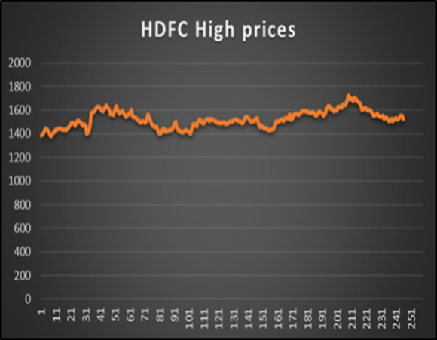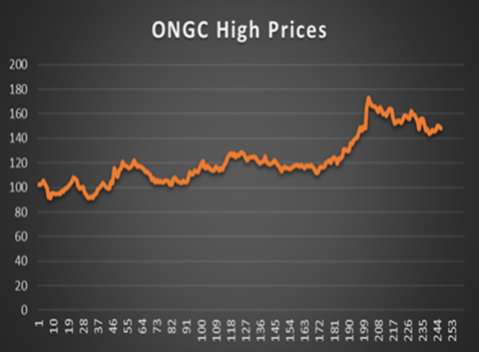

The prices are less volatile and does not flutuate The prices are more volatile and increasing in nature.
much.

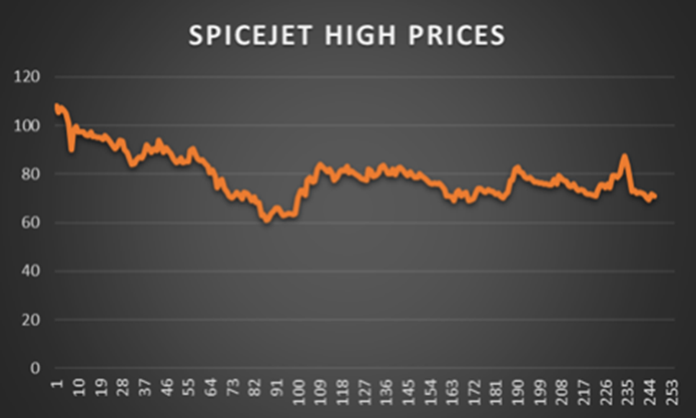
The prices are volatile and decreasing .

The following table showcases the expected returns and volatility of the investor portfolios

INVESTORS | EXPECTED RETURN ON SHARES | VOLATILITY OF THE PORTFOLIOS  (STANDARD DEVIATION)
A (HDFC) | 0.000392228 | 0.0139913
B (ONGC) | 0.001497395 | 0.022926
C (SICEJET) | -0.001722663 | 0.0259036
D(HDFC & ONGC) | 0.000944811 | 0.0146628
E (ONGC & SPICEJET) | -0.000112634 | 0.088312
F (SPICEJET & HDFC) | -0.000665217 | 0.015975

We know that, higher returns are good but we also have to consider other factors like standard deviation. Taking into consideration the returns of the risk-free assets along with the standard deviation, we see that the higher the standard deviation, the more risk it bears.
Thus, the investment in which we have high returns and less standard deviation is suitable.
To understand this further, Sharpe Ratio is calculated which is the measure of risk-adjusted return of a financial portfolio.
The risk-free rate was assumed to be 5% and the Sharpe ratio of the shares were calculated.

INVESTORS | SHARPE RATIO
A (HDFC) | -3.545609944
B (ONGC) | -2.115608366
C (SPICEJET) | -1.996517026
D(HDFC & ONGC) | -3.345553987
E (ONGC & SPICEJET) | -0.567449882
F (SPICEJET & HDFC) | -3.171531581

Usually, a Sharpe ratio greater than 1.0 is considered acceptable by investors. It is better to have a ratio of 2.0 or more and that which is greater than 3.0 is considered excellent. It can be negative only when the excess return is negative, that is the expected return is less than the risk-free rate, as the denominator that is standard deviation is always positive.
From the table, we can infer that all the ratios are negative and less than the acceptable Sharpe ratio. On the contrary, while comparing all the stocks, the investor investing in the two-asset portfolio of ONGC Limited and SpiceJet Limited will get highest return per share comparatively.
With the data available, we also inferred that the two asset portfolios were more diversified that is, the investment across various markets. The investors who invested in two-asset portfolios has an upper hand than the investors holding single asset portfolios because it minimizes the risk of loss to the overall portfolio and provides more opportunities for return. It also safeguards the investors against adverse market cycles and reduces volatility.
As seen above the investor investing in the ONGC and SPICEJET Limited is enjoying the diversification benefits the most as compared to the other investors. This is because the expected return of these two companies respond differently and is not perfectly correlated and hence have the potential to balance out the losses thereby neutralizing each other’s risks.

TASK 6 (ii)

The entire project was equally divided amongst the three of us. The distribution of the individual work to be done was discussed on a zoom meet and the six tasks were done as follows:
- Task 1 and the calculation of Expected return and Variance of return and correlation calculation for the combination HDFC and ONGC was done by Avantika Arvind (3).
- Task 2 and the calculation of Expected return and Variance of return and correlation calculation for the combination ONGC and SpiceJet was done by Amalu Manu (45).
- Task 3 and the calculation of Expected return and Variance of return and correlation calculation for the combination HDFC and SpiceJet was done by Akshita Bajpai (6).
- The Sharpe ratio analysis (Task 4) was done individually for the companies allotted to each member.
- The report was collectively written by each member of the group after individual analysis of the companies was done.
Overall, all the team members were very cooperative during the entire project and the tasks were done well before hand.
__________________________________________________________
Group Members:
Avantika Arvind (3)
Akshita Bajpai (6)
Amalu Manu (45)

