Statistical Risk Modeling – 1
Jash Dattani
Roll No.: 427

# Importing Data
> Data = read.csv(file.choose())
> str(Data)
'data.frame': 51 obs. of 7 variables:
$ AGE : int 25 26 27 28 29 30 31 32 33 34 ...
$ ETR : int 78500 80425 81975 83725 84875 85075 85275 86250 87250 88300 ...
$ DEATHS : int 24 24 24 24 72 48 120 24 72 72 ...
$ CRUDE : int 0 0 0 0 0 0 0 0 0 0 ...
$ GRADUATED: int 0 0 0 0 0 0 0 0 0 0 ...
$ EXPECTED : int 0 0 0 0 0 0 0 0 0 0 ...
$ ZX : int 0 0 0 0 0 0 0 0 0 0 ...

> # Calculating CRUDE Values
> Data$CRUDE = Data$DEATHS/Data$ETR

> # Fitting Gompertz Law
> Gompertz = lm(log(Data$CRUDE)~Data$AGE)
> Gompertz

Call:
lm(formula = log(Data$CRUDE) ~ Data$AGE)

Coefficients:
(Intercept) Data$AGE
-11.0009 0.1063

> B = exp(as.numeric(coef(Gompertz)))
> C = exp(as.numeric(coef(Gompertz)))
> c(B,C)
[1] 1.668727e-05 1.112153e+00
> Data$GRADUATED = round(B*C^Data$AGE,5)
> head(Data)
AGE ETR DEATHS CRUDE GRADUATED EXPECTED ZX
1 25 78500 24 0.0003057325 0.00024 0 0
2 26 80425 24 0.0002984147 0.00026 0 0
3 27 81975 24 0.0002927722 0.00029 0 0
4 28 83725 24 0.0002866527 0.00033 0 0
5 29 84875 72 0.0008483063 0.00036 0 0
6 30 85075 48 0.0005642081 0.00040 0 0
> plot(Data$AGE,Data$CRUDE, xlab = "Age", ylab = "Mortality rate",
+ main = "Crude and Graduated Death Rates" , pch = 16)
> lines(Data$AGE,Data$GRADUATED , col='blue')
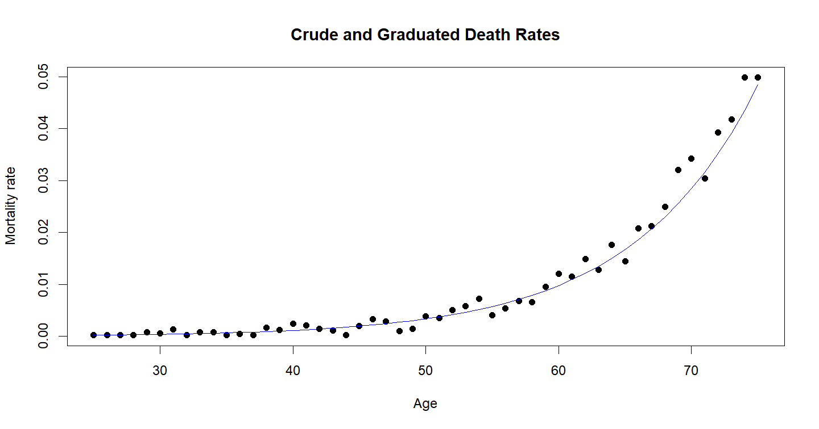

> # Checking for smoothness
> diff1 = function(v)v[-1]-v[-length(v)]
> diff_crude = round(diff1(diff1(diff1(Data$CRUDE)))*10^6,1)
> diff_grad = round(diff1(diff1(diff1(Data$GRADUATED)))*10^6,1)
> smoothness_df = data.frame("Age" = Data[Data$AGE <= 72,"AGE"],diff_crude,diff_grad)
> smoothness_df
Age diff_crude diff_grad
1 25 -2.2 0
2 26 568.3 -20
3 27 -1413.5 20
4 28 1972.9 0
5 29 -3099.1 -10
6 30 3647.9 10
7 31 -2232.7 -10
8 32 17.3 10
9 33 1341.7 0
10 34 -1322.4 -10
11 35 2240.9 20
12 36 -3675.8 -20
13 37 3675.7 20
14 38 -3182.7 -10
15 39 947.0 10
16 40 1004.0 -10
17 41 -1142.3 10
18 42 3332.7 0
19 43 -3123.8 10
20 44 -1295.4 -10
21 45 398.3 0
22 46 3528.2 20
23 47 -273.6 -10
24 48 -4533.0 10
25 49 4447.3 10
26 50 -2588.4 -10
27 51 1433.0 10
28 52 -5286.2 10
29 53 9025.6 10
30 54 -4183.2 0
31 55 -1951.2 10
32 56 4992.4 10
33 57 -3862.7 10
34 58 -2369.5 10
35 59 6961.6 20
36 60 -9541.9 0
37 61 12420.9 30
38 62 -14897.6 0
39 63 17650.4 40
40 64 -15582.9 0
41 65 9139.1 40
42 66 267.2 20
43 67 -8292.5 30
44 68 -1302.7 30
45 69 18881.7 30
46 70 -19023.5 60
47 71 11722.9 30
48 72 -13391.9 50

> # Calculate Expected and ZX
> Data$EXPECTED = round(Data$GRADUATED*Data$ETR,2)
> Data$ZX = round((Data$DEATHS - Data$EXPECTED)/sqrt(Data$EXPECTED),2)
> head(Data)
AGE ETR DEATHS CRUDE GRADUATED EXPECTED ZX
1 25 78500 24 0.0003057325 0.00024 18.84 1.19
2 26 80425 24 0.0002984147 0.00026 20.91 0.68
3 27 81975 24 0.0002927722 0.00029 23.77 0.05
4 28 83725 24 0.0002866527 0.00033 27.63 -0.69
5 29 84875 72 0.0008483063 0.00036 30.56 7.50
6 30 85075 48 0.0005642081 0.00040 34.03 2.39
> plot(Data$AGE, Data$ZX, type="b", xlab="Age (x)", ylab="zx", main =
+ "Individual Standardised Deviations")

> # Chi-Square Test
> Data$prob = Data$EXPECTED/sum(Data$EXPECTED)
> head(Data)
AGE ETR DEATHS CRUDE GRADUATED EXPECTED ZX prob
1 25 78500 24 0.0003057325 0.00024 18.84 1.19 0.0003057710
2 26 80425 24 0.0002984147 0.00026 20.91 0.68 0.0003393668
3 27 81975 24 0.0002927722 0.00029 23.77 0.05 0.0003857843
4 28 83725 24 0.0002866527 0.00033 27.63 -0.69 0.0004484317
5 29 84875 72 0.0008483063 0.00036 30.56 7.50 0.0004959852
6 30 85075 48 0.0005642081 0.00040 34.03 2.39 0.0005523029
> Chi_test = chisq.test(Data$DEATHS,Data$prob,rescale.p = TRUE)
> Chi_test

Pearson's Chi-squared test

data: Data$DEATHS and Data$prob
X-squared = 1734, df = 1700, p-value = 0.2774

> binning_var = c(-Inf, -3, -2, -1, 0, 1, 2, 3, Inf)
> testing_table = data.frame(Data$ZX, bin = cut(Data$ZX, binning_var, include.lowest=TRUE))
> prop.table(table(testing_table$bin))

[-Inf,-3] (-3,-2] (-2,-1] (-1,0] (0,1] (1,2] (2,3]
0.19607843 0.07843137 0.03921569 0.05882353 0.03921569 0.07843137 0.11764706
(3, Inf]
0.39215686
> stand_dev_test = data.frame(Bins = levels(unique(testing_table$bin)), Expected =
+ c(0, 0.02, 0.14, 0.34, 0.34, 0.14, 0.02, 0),
+ Observed = round(as.numeric(prop.table(table(
+ testing_table$bin))), 4))
> stand_dev_test = stand_dev_test %>% mutate(Expected = Expected * 51, Observed =
+ Observed * 51)
> chisq.test(stand_dev_test$Expected, stand_dev_test$Observerd, correct = T)

Chi-squared test for given probabilities

data: stand_dev_test$Expected
X-squared = 59.65, df = 7, p-value = 1.773e-10

> stand_dev_test
Bins Expected Observed
1 [-Inf,-3] 0.00 10.0011
2 (-3,-2] 1.02 3.9984
3 (-2,-1] 7.14 1.9992
4 (-1,0] 17.34 2.9988
5 (0,1] 17.34 1.9992
6 (1,2] 7.14 3.9984
7 (2,3] 1.02 5.9976
8 (3, Inf] 0.00 20.0022

b)
> Data$signs = ifelse(Data$GRADUATED > Data$CRUDE,1,0)
> head(Data)
AGE ETR DEATHS CRUDE GRADUATED EXPECTED ZX prob signs
1 25 78500 24 0.0003057325 0.00024 18.84 1.19 0.0003057710 0
2 26 80425 24 0.0002984147 0.00026 20.91 0.68 0.0003393668 0
3 27 81975 24 0.0002927722 0.00029 23.77 0.05 0.0003857843 0
4 28 83725 24 0.0002866527 0.00033 27.63 -0.69 0.0004484317 1
5 29 84875 72 0.0008483063 0.00036 30.56 7.50 0.0004959852 0
6 30 85075 48 0.0005642081 0.00040 34.03 2.39 0.0005523029 0
> sum(Data$signs)
[1] 19
> Signs_test = 2*pbinom(20,51,0.5)
> Signs_test
[1] 0.1607796

c)
> (sum(Data$DEATHS) -sum(Data$EXPECTED))/(sqrt(sum(Data$EXPECTED)))
[1] 18.85102

d)
> z1 = Data$ZX[1:length(Data$ZX)-1]
> z2 = Data$ZX[2:length(Data$ZX)]
> Series_cor = cor(z1,z2)
> Series_cor
[1] 0.1488846
> Series_cor*sqrt(51)
[1] 1.063249

