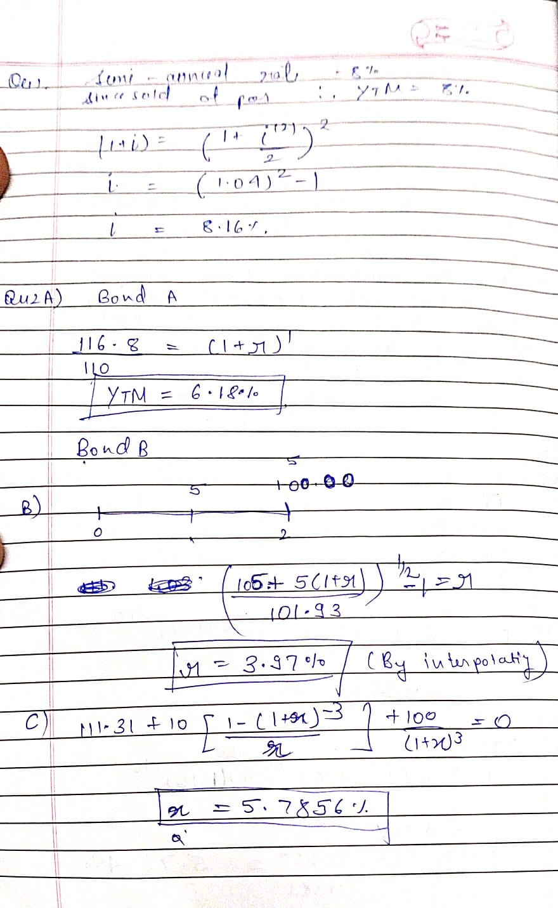

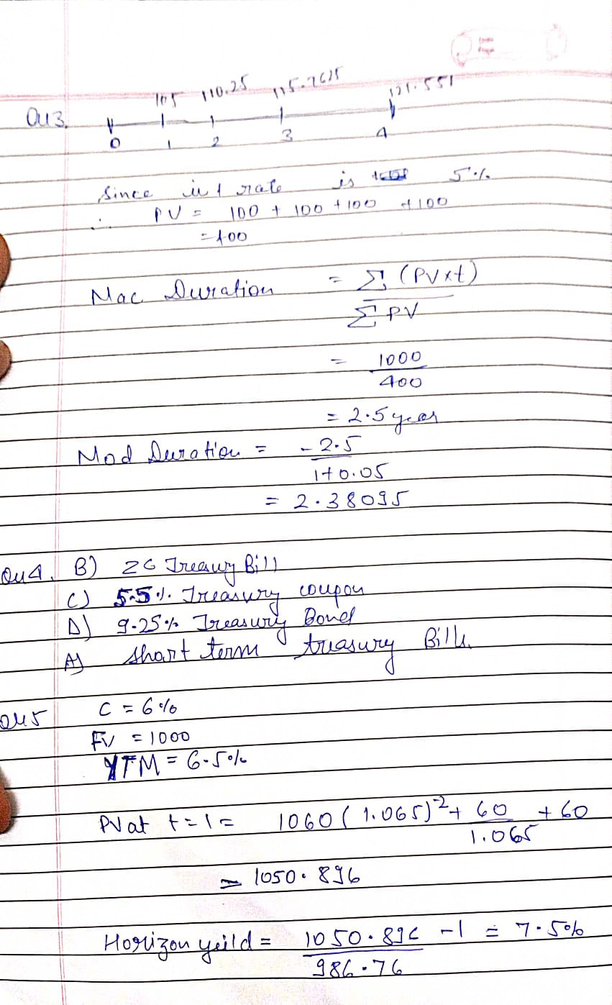

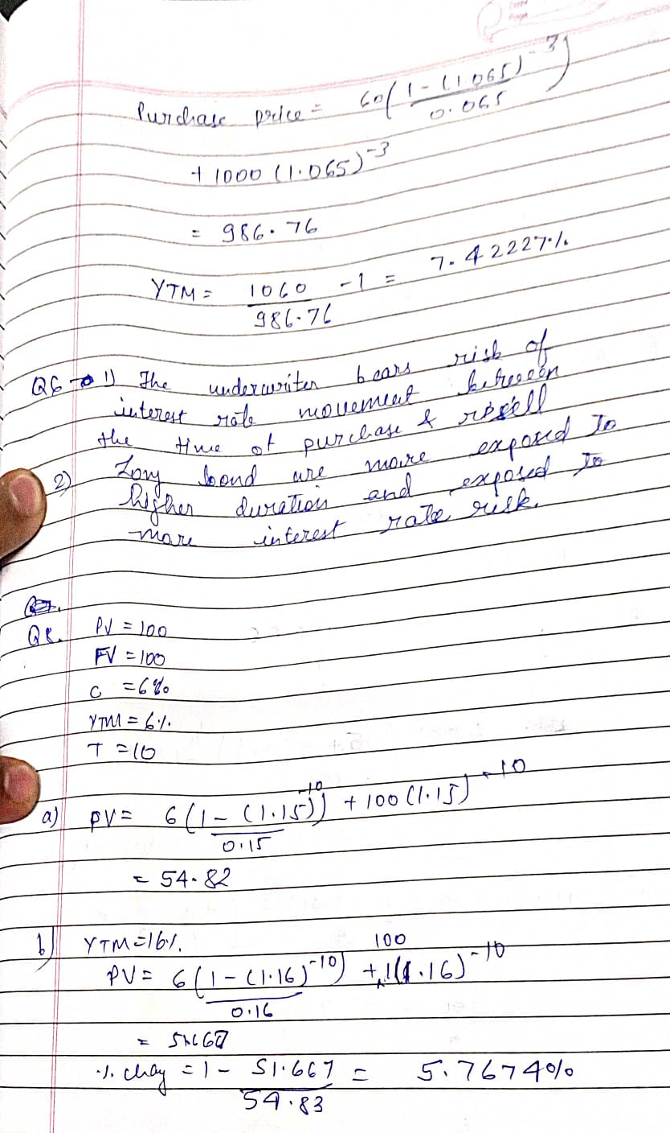

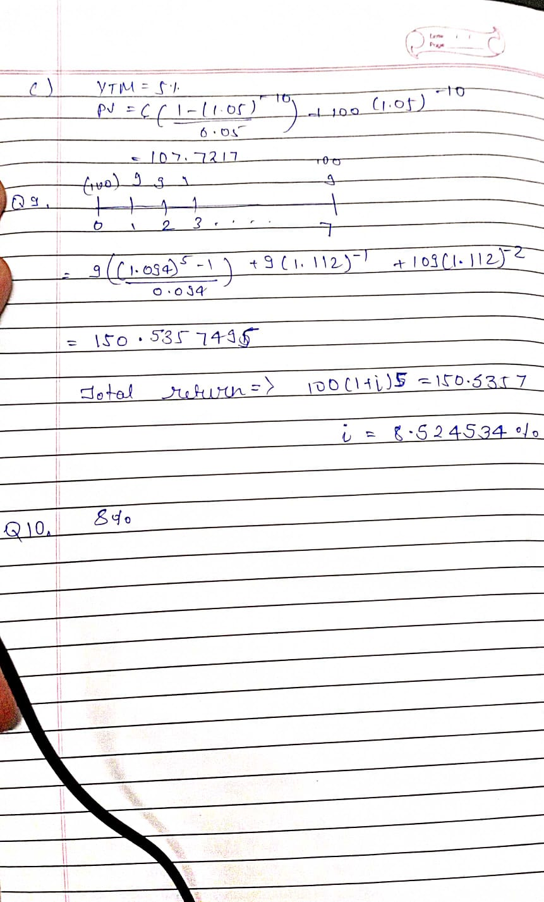
Q11
FThe price of a floater will always trade at its par value.GEirst, the coupon rate of a floatin<rate security (or
floater
) is equal to a reference rate plus some spread or mark in. for example, the coupon rate of a floater can reset at the rate on a three<monthTreasury bill (the reference rate) plus '# basis points (the spread). the price of a floater depends on two factors: (1) the spread over the reference rate and (&)any restrictions that may be imposed on the resettin of the coupon rate. For example, a floater may have a maximum coupon rate or a minimum coupon rate called a floor
. The price of a floater will trade close to its par value as lon as (1) the spread above the reference ratethat the marBet requires is unchaned and (&) neither the cap nor the floor is reached.However, if the marBet requires a larer (smaller) spread, the price of a floater will trade below(above) par. !f the coupon rate is restricted from chanin to the reference rate plus the spread because of the cap, then the price of a floater will trade below par

Q13
(1) While 2 portfolios can have the same duration, their convexities may differ so that even for a parallel shift in the yield curve, the % change in price may differ.
(2) For non-parallel shift in the yield curve, portfolio of differing convexities may perform very differently even if they have the same duration

