BASEL
ASSIGNMENT -1

Q1)
Solution :
Risk assessment is part of the risk management process and it aims to identify, model and evaluate the risk. the risk assessment process as a set of logical, systemic, and well-defined activities that provide the decision makers with a sound of identification, measurement, quantification, and evaluation of the risk associated with certain natural phenomena or man-made activities .
the risk assessment and management processes include the following: Risk Assessment Process:
• Risk identification (what can go wrong?).
• Risk modelling, quantification (What is the likelihood that it would go wrong?).
• Risk evaluation (What are the consequences?).

Methodology:
The proposed risk assessment methodology will start with studying the card transactional payment system (EMV systems ). We will first identify the stakeholders and study the payment transaction process. After that, we will build a conceptual model to represent the payment transaction processes using Business Process Management models to link each process to a particular stakeholder. Then, all the potential risks that might occur during a payment transaction will be identified. The conceptual model and the identified risks will then be translated into an executable model using Performance Evaluation Process Algebra (PEPA). Finally, the risk will be evaluated and linked to each stakeholder by applying the risk expression.
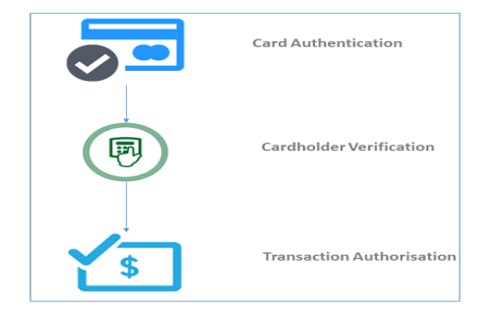

1>Identify Stakeholders:
The first step of the proposed methodology is stakeholder identification. Stakeholders are a key element of the risk assessment and management process. stakeholders are involved in different processes during payment transactions. Thus, this step will inform the business process of the payment system as well as the question who should pay? There are four main stakeholders involved in transactional payment systems:
issuer banks (the cardholders bank), customers, merchants, and acquiring banks (the merchants bank)

2> Risk Identification:
risk identification is a major step in the risk assessment process. Moreover, this step will examine the sources of failure and their causes and answer the question what can go wrong?
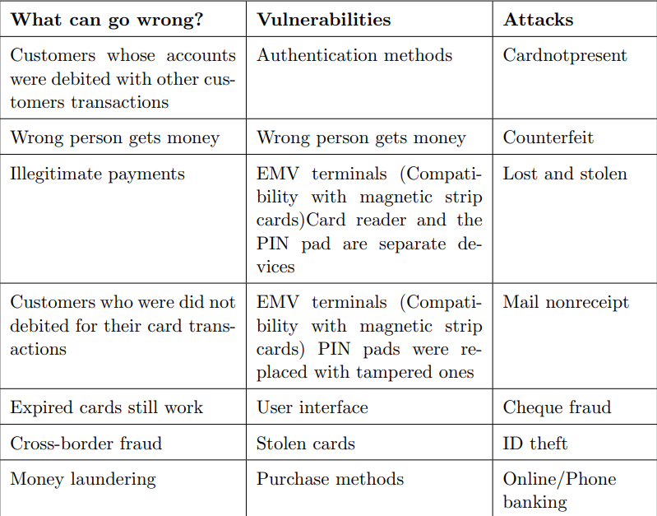

3>Risk Modelling, Quantification, and Measurement:
the risk modelling of payment systems will help to enhance banks decision-making processes. This step will implement an executable model to investigate the likelihood of the various risks occurring. It will also establish probabilities, and model the sources of risks and their impacts.

4>Risk Expressions:
Risk expression identification will be based on particular stakeholders and for each stakeholder we will list events X cost for instance, what can go wrong? vs. cost. Different stakeholders will have different expressions but the model will be the same. Actually what can go wrong? is for the whole system and who pays? is a means risk expression for that particular stakeholder. The aim of this step is to link risk expression with the findings from the risk assessment processes so that we know what could go wrong?, who should pay?, and how much?

Q2)
Solution:

Sample Gap Analysis Questions :
The following questions, grouped according to Environmental Management System (EMS) element, are examples of the types of questions that you might include in your gap analysis.

Commitment and Policy:
- Do you have an environmental policy?
- Is the policy appropriate to the business?
- Does the policy include commitments to prevention of pollution, use of cleaner technologies, compliance, and continual improvement in environmental performance?
- Does the policy make a commitment to reducing risk to human health and the environment, specifically reducing exposures to workers and the surrounding community?

Planning:
- Do you identify your significant environmental aspects?
- Do you identify the legal requirements pertinent to your environmental aspects?
- Have you set environmental objectives and targets?
- Do you ensure that your product designs are reviewed for their environmental implications throughout the life cycle of the product?
- Do you evaluate the human health and ecological risks of the chemicals and products you use and/or produce? If so, does your company incorporate this information into its process for setting environmental priorities?
- Do you identify and evaluate alternative processes and materials that potentially have a lower worker safety and environmental risk than those currently employed?

Implementation:
- Have you defined roles and responsibilities of your employees in the EMS?
- Have you identified training needs? Do you communicate adequately internally and externally about your EMS?
- Are you documenting the key features of your EMS?
- Have you established operational control procedures related to the significant environmental aspects you identified? Do you have an emergency plan?

Evaluation:
- Do you measure and monitor your environmental performance?
- Do you have a process for ensuring compliance?
- Do you audit your EMS?
- Do you take corrective action when you find a “hit” in your compliance or EMS audits?

Review:
- Does your management regularly review your EMS?

As your company assesses its environmental management practices by answering the questions in a gap analysis, be sure to include people who have direct knowledge of as many relevant functions as possible. This inclusion is important so that employees from different departments within your company are exposed to the Environmental management system development process, and because each employee brings specific knowledge about environmental practices in his or her functional area.

