STATISTICAL RISK MODELLING
SEMESTER-3 PROJECT REPORT
- PALAK NAGDEV (419)

1)
After setting the working directory, we read the data using read.table ( using “,” and keeping header as “TRUE”)

Checking head and tail of the data:
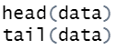

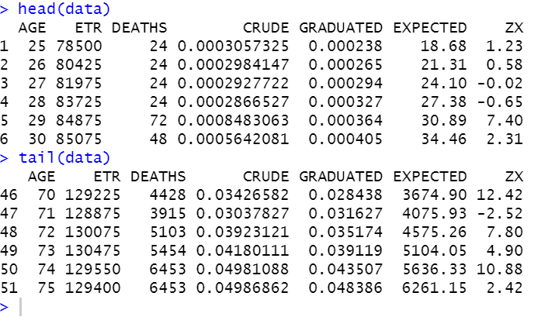

2)
Filling the graduated column using gompertz law, finding parameters B and C by using the functions “coef” and “as.numeric” and Using round function to rounding off the graduated column to 5 decimal palces.
B = 1.668727e-05
C = 1.112153e+00

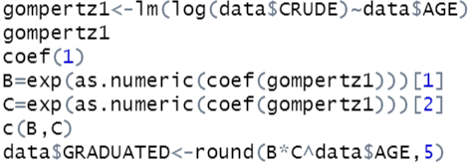
Results:
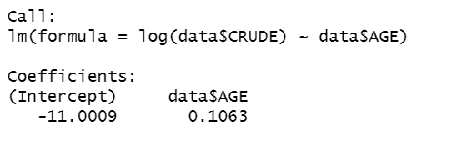
Visualizing:
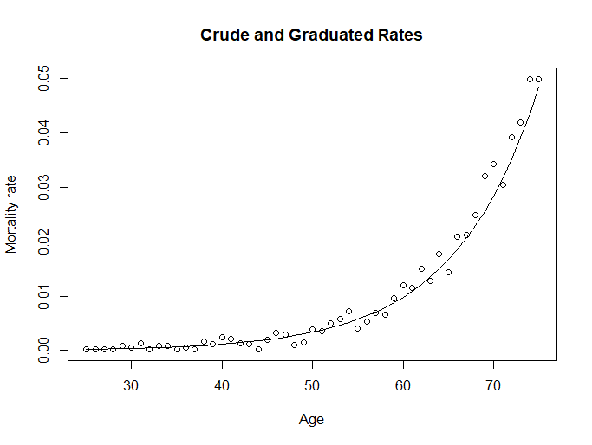

3) Checking for smoothness by applying 3rd differences to graduated and crude rates using the diff function.
3rd differences should be small in magnitude and progress regularly to check smoothness. In our data frame the 3rd differences of crude rates are much larger in magnitude and progresses erratically.However the magnitude of 3rd differences of the graduated rates are very small and progress regularly.
Therefore, the desired graduated rates computed by fitting Gompertz Law are smooth.
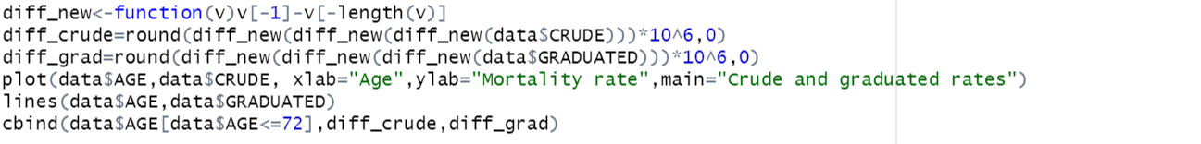
Visualizing :
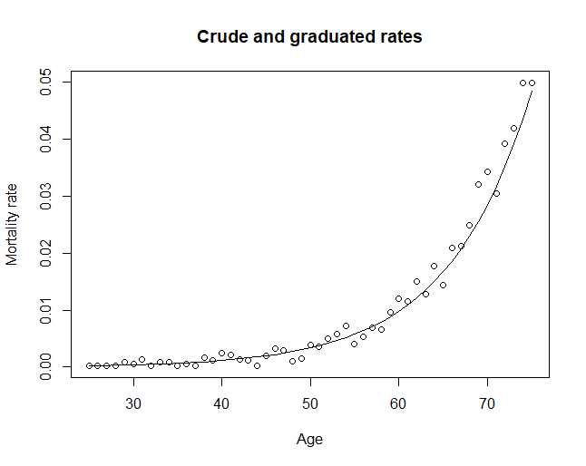
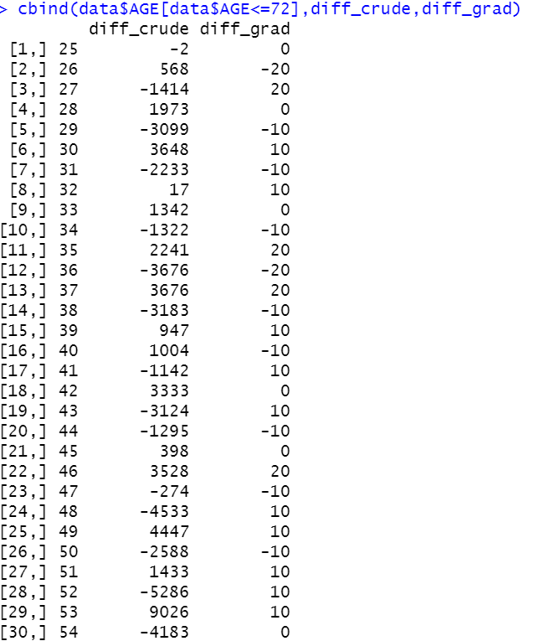
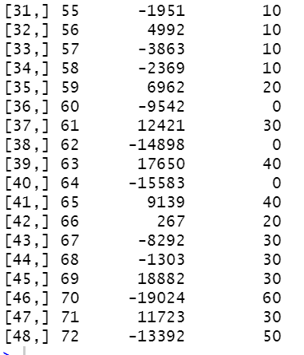

4)
Calculating expected rates and Zx and rounding both the numbers to 3 decimal places. Conducting a chi-square test using chisq.test function.
Interpretation :
- Graduation is not Okay
H0: Graduation is Okay
H1: Graduation is not Okay
Since the p-value is greater than 0.05, H0 is rejected.
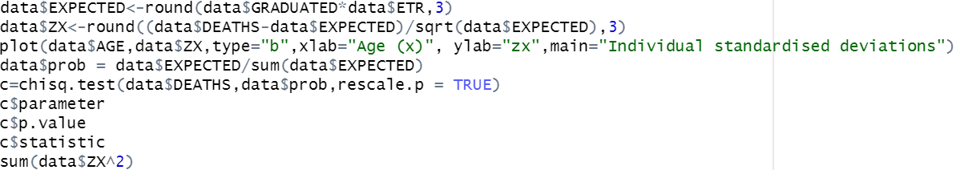

Visualizing:

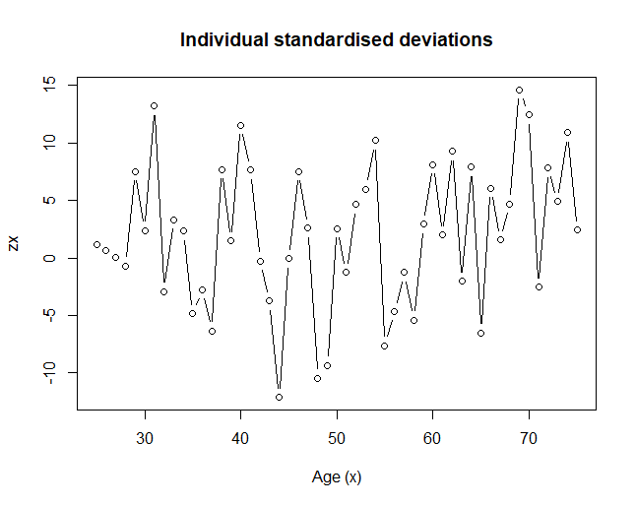

5)
a)
STANDARDISED DEVIATIONS TEST
Creating intervals of 1 from -3 to +3 under binning_var 1. Creating a testing table and a probability table using prop.table function.
Finally, creating a new dataframe with observed and expected probability in the columns.
Conducting a χ^2test using chisq.test function.

OVERALL SHAPE - The data shows that it is negatively skewed and has more values on the tail.
ABSOLUTE DEVIATIONS – The data is over graduated and shows existence of duplicates as the absolute deviations are too big ( shown by proved by the fact that there are less than 50% values lying in the (-2/3 to 2/3) bin )
OUTLIERS – Too many outliers are present as close to 20% of the data lies in the (-infinity to -3) bin and 40% of the data lies in the (3 to Infinity) bin. Showing that the data has approximately 60% outliers.
SYMMETRY – The number of positive and the number of negative deviations are not close to 50% rather there are only 20 negative and 31 positive deviations. This shows that observed mortality rates do not conform to the model with the rates assumed in the graduation. The data shows nature of discrepancy.
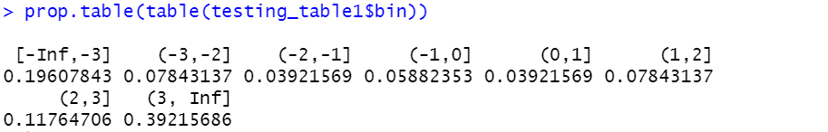
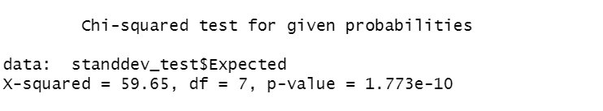

H0: Graduation is Okay
H1: Graduation is not Okay
χ^2 test gives a p.value of less than 0.05 and as mentioned above as the p.value was very low we have insufficient evidence to reject H0 and therefore the Graduation is OK.

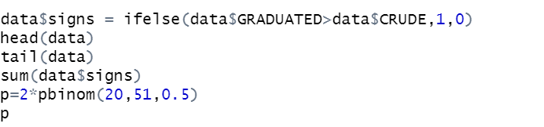
Signs test checks for defect (b) of χ^2 test.
H0 : Data is biased
H1 : Data is not biased
As the p.value = 0.16 which is greater than 0.05 we have insufficient evidence to reject H0 . Hence data is not biased.

CUMULATIVE DEVIATIONS TEST

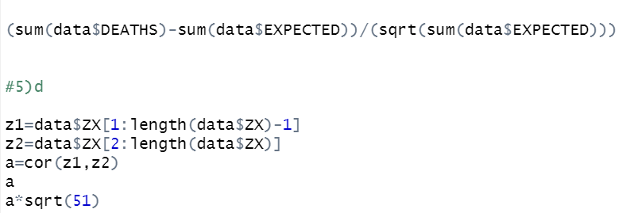

It checks cumulations of positive and negative groups.
Test statistic = 18.831
H0: Graduation rates are OK
H1: Graduation rates are too low
As test statistic is greater than 1.96 we have sufficient evidence to reject H0 and conclude that Graduation rates are too low.

“z1=data$ZX[1:length(data$ZX)-1]
z2=data$ZX[2:length(data$ZX)]
a=cor(z1,z2)
a
a*sqrt(51)”

SERIAL CORRELATIONS TEST

It detects clumping of signs of deviations
As a= r_j =0.1477 we can conclude that Z_x has similar values.
H0 : No grouping of signs
H1 : Grouping of signs
As test statistic is 1.05 which is less than 1.649 we have insufficient evidence to reject H0. Therefore there is no evidence of grouping of signs .

