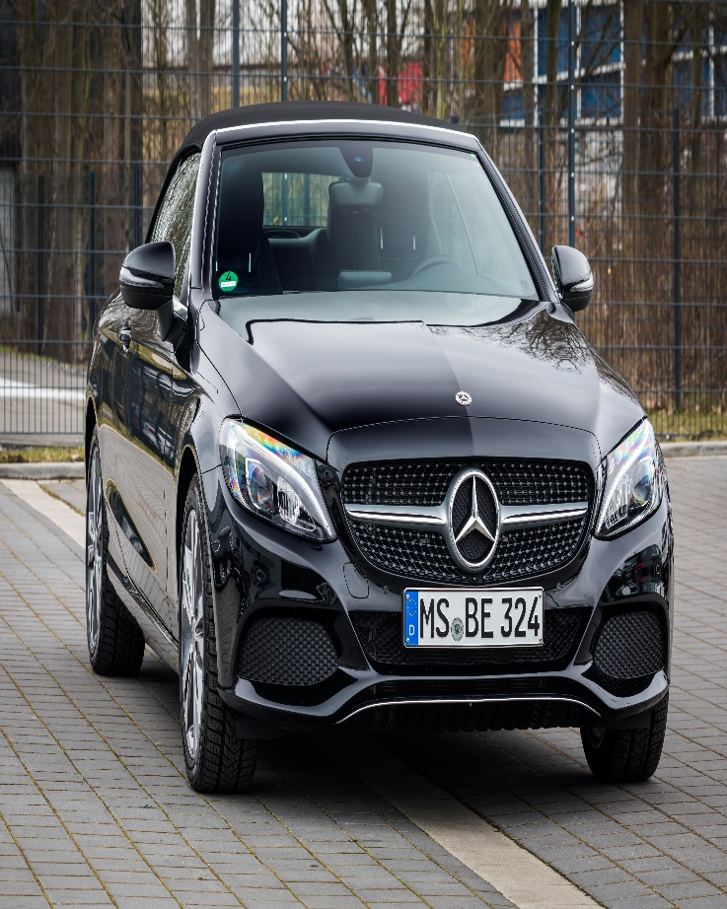  Bem Project SEM III  Product :- Mercedes Benz | Research Area - MUMBAI  Sahil minocha  Roll No.-44

Index


Introduction
Objective :- Performing detailed analysis of Mercedes Benz with help of Statistical and Economics tools.
Survey method is used for data collection.
Primary data is collected from Mumbai from luxury car owners.
40 responses were collected in out of which 27 owns Mercedes Benz (including second and
third hand owners).

Data Collection

According to the data collected it is observed most of luxury car owners are quite younger in age ranging between 18 years to 34 years. However the professional qualifications are quite close among all categories
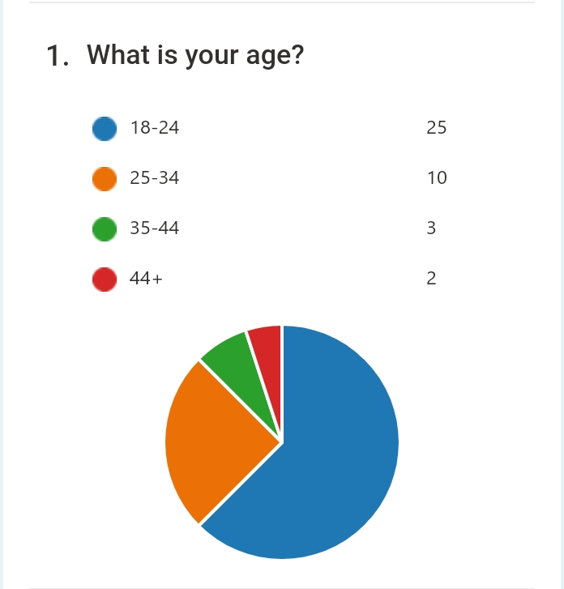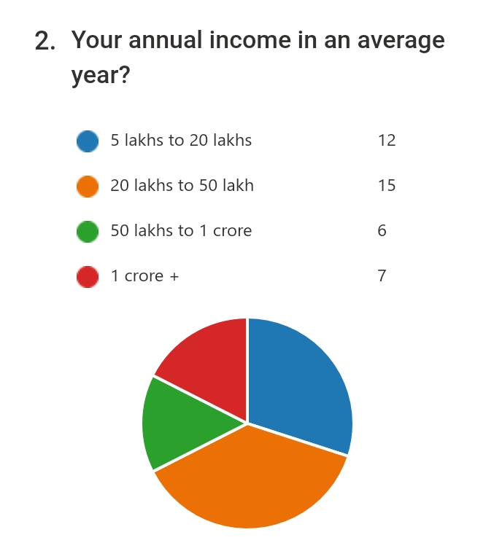.
However out of all 40 responses collected 27 are owners of Mercedes Benz.
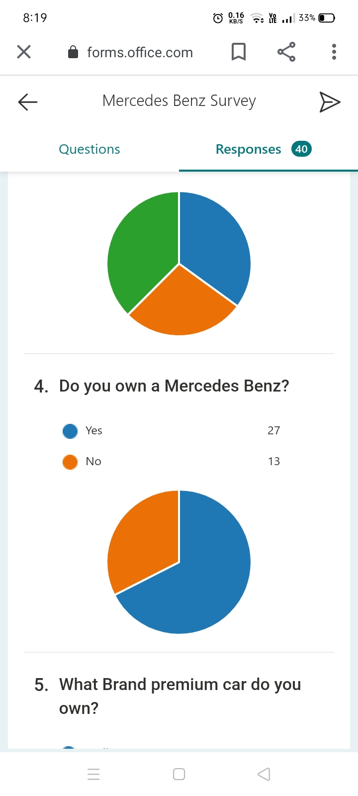

Product Analysis:-
Mercedes Benz

Type of Good :-
Mercedes Benz is a rivalrous and luxury good.

Features (provided by the brand):-
- Connectivity (mBrace, Bluetooth+)
- Luxury (Leather Seating, Heat front seats, Panorama roof)
- Safety (Attention and blind spot assist, Rearview camera etc.)
- Style (Interior/Exterior)
- Technology (Collision prevention assist)
Features Consumers considered:-
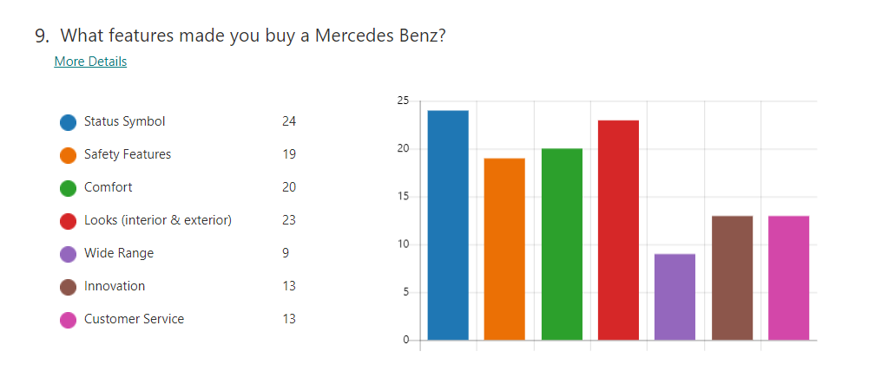
According to the survey, Status Symbol (luxury), safety/comfort and looks are the dominating factors for buying a brand new Mercedes benz.

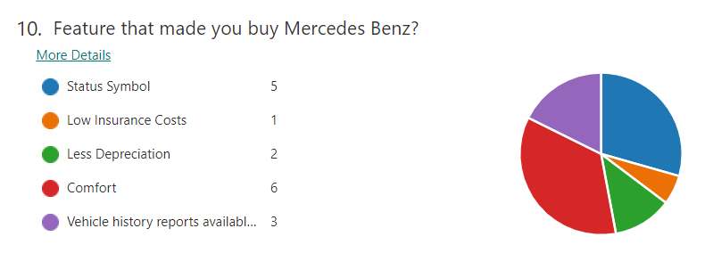

However, status symbol and comfort still remains the guiding features for second and third hand owners.

Pricing:-
35 lakh to 50 lakh :- 5 models
50 lakhs to 1 crore :- 8 models
1 crore + :- 17 models

Availability:-
Out of 30 models Mercedes-Benz offers 26 car models in India, including 9 cars in SUV category, 10 cars in Sedan category, 4 cars in Coupe category, 2 cars in Convertible category, 1 car in MUV category. Mercedes-Benz has 2 upcoming cars in India, EQS and E-Class Cabriolet Facelift.

SWOT Analysis:-
- Strengths
Financial Stability
Continuous Product Innovation
Product Portfolio
Hold in developing nations
- Weakness
Expensive after sale service and maintenance
- Opportunity
Technological advancement
Capturing market in Asian Countries
Strategic Alliance
- Threats
Volatile fuel prices
Government regulation
Competition in segment

Utility:-
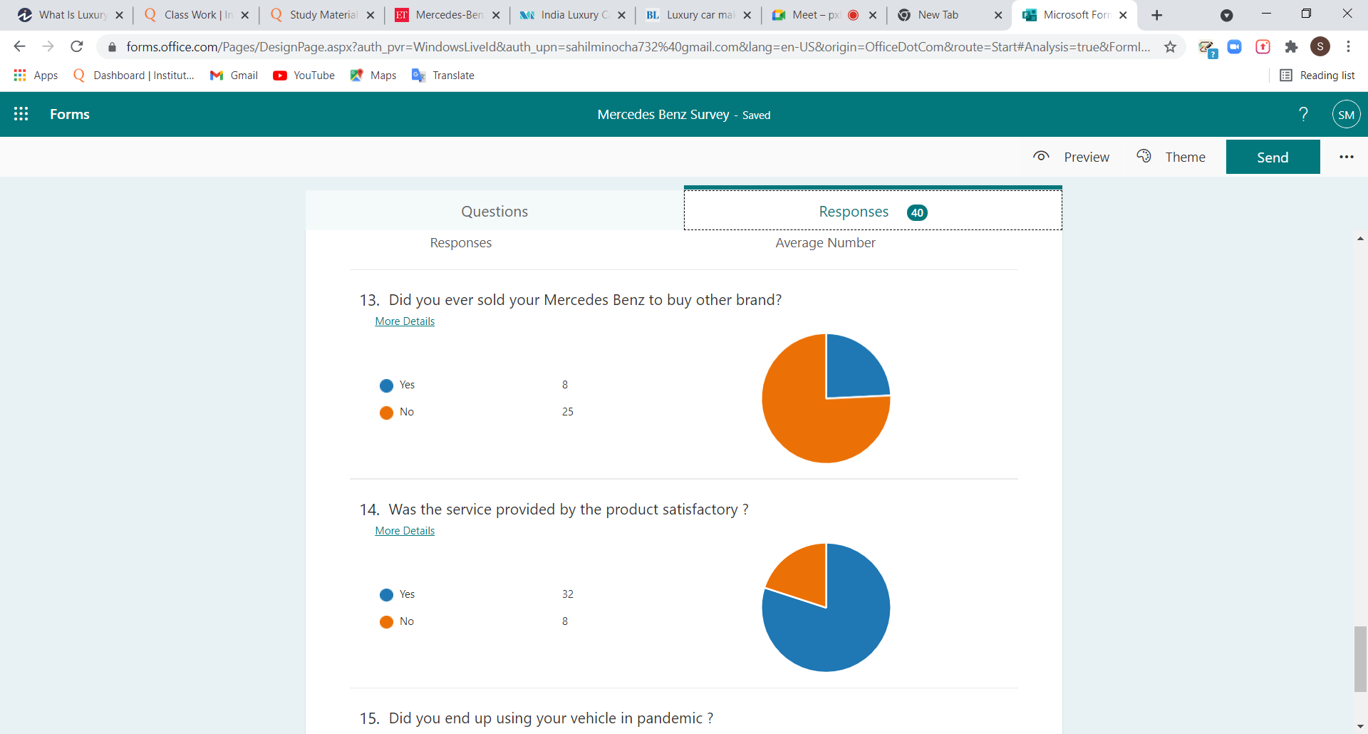

Mercedes Benz being a premium car is more a symbol of status, rich life style/wealth and your belongingness to high income group. A Mercedes owner will not use it more often like for daily usage and some models are even not fuel efficient which might act as a hindrance and make owner to shift the brand. The same thing can also be known from the response above that 8 Mercedes owners shifted brand and these were 20 lakhs to 50 lakhs income group consumers.
However a large group of consumers find the product satisfactory

Demand for Product:-
Demand for Brand new car
Price Range | No. of owners
1 crore + | 4
35 lakh to 50 lakh | 8
50 lakh to 1 crore | 7
Grand Total | 20
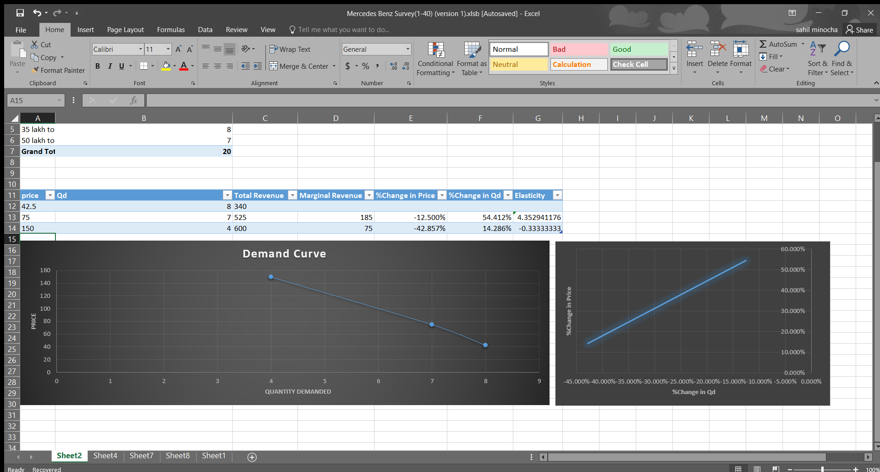

The demand for brand new Mercedes Benz decreased from 8 to 7 and then further 5; as the price grew to 50 lakh and I crore + range. However the change is quantity demand is way less with respect to increase in price. Which clearly define it as a luxury good because as the income grp shifts upward it is found they are owner of more expensive unit. However the Quantity is quite similar for all ranges of second/third hand cars.
{AVG PRICES ARE USED IN PRICE ON Y–AXIS}
Demand for Second and Third hand Mercedes Benz
Price Range | Qd second and Third hand cars
10 lakh to 30 lakh | 2
30 lakh to 50 lakh | 2
50 lakh + | 3
Grand Total | 7

Market Analysis
Market Condition
The Indian luxury car market studied was valued at more than USD 1 billion in 2020, and it is expected to reach a value of over USD 2 billion by 2026, registering a CAGR of more than 6% during the forecast period. With the spread of COVID-19, the sales of luxury cars were affected due to lower footfalls in the showrooms. Various automobile manufacturers were forced to temporarily shut their production as the supply chain was disrupted by the country-wide lockdown imposed by the government, which restrained the market growth. As luxury car manufacturers are launching multiple models with various price ranges, along with user-friendly financing schemes, the demand for luxury cars is expected to rise in the country. Moreover, the demand for luxury SUVs has been growing rapidly in the country and is expected to continue during the forecast period, as they offer extra space and comfort. Major luxury car manufacturers, like Audi, BMW, and Mercedes are planning to launch new luxury models in the country at a competitive price. The sales of pre-owned vehicles in India have witnessed a sharp increase over the past few years, as the demand for luxury vehicles continues to increase. In 2019, the sales of pre-owned luxury vehicles saw a growth of more than 16%. In order to cater to the growing demand, the pre-owned luxury vehicle market is getting more organized with easy access to finance, annual maintenance contracts, and lower entry prices.
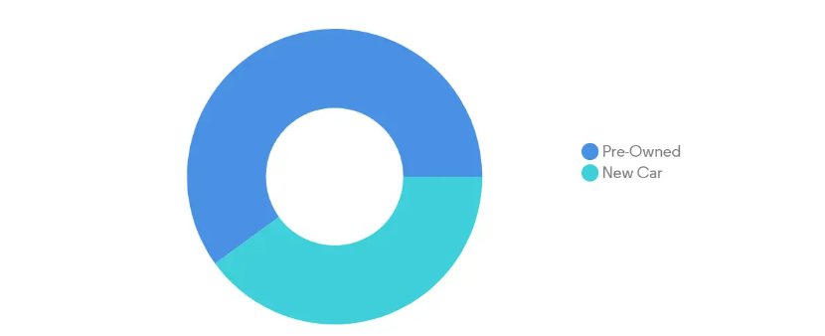

Government Policies and Tax:-
- GST on electric cars reduced to 5% from 12%
- Maharashtra is offering demand incentives of Rs 5,000/khw on 10,000 electric cars with the maximum incentive per vehicle being capped at Rs 1.5 lakh besides exemption of road tax and registration charges.
- Delhi had announced a purchase incentive of Rs 10,000/ kWh of battery capacity per electric four-wheeler with a maximum incentive of Rs 1.5 lakh per vehicle for the first 1,000 e-cars to be registered in the Capital state. It has also offered a waiver of road tax and registration fees on all EVs.
- Luxury vehicles currently attract the top GST slab of 28%, coupled with an additional cess of 20% on sedans and 22% on SUVs, taking the total tax incidence to 48% and 50%, respectively.
- India is currently imposes 100% import duty and 15% registration tax.

Supply:-
There are 68 authorized showrooms of Mercedes Benz in India i.e. they are available in most parts of country through nearby city’s showrooms but still there remains several regions where these are inaccessible those can be the mountainous regions and several parts of underdeveloped states like Orissa, MP, Several states in North India.
Substitutes:-
Volvo, BMW, Audi, Jaguar, Land Rower, Range Rower, Porsche
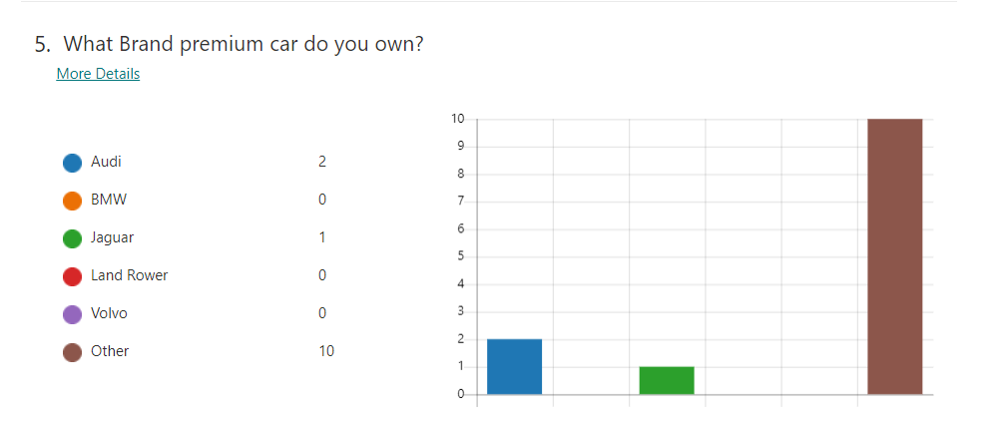
However two of the responses in the other category does not belong to the category of premium cars. Both of them are highlighted in the excel sheet of responses.
Complementary Good:-
Gasoline, Insurance, Infrastructure, Tires, Electricity.

Price Elasticity of Demand:-
Brand New cars
{Here the price are the average price for each price range
Ranges are as follows: 35-50 lakhs
50-100 lakhs/1crore
1 crore+
The average price of the last range is taken as 100 lakhs because the specific models were not known of the owners. So the average price is assumed to be 150 lakhs}

Demand for Mercedes Benz Highly elastic while the price good increase from range 35 – 50 lakhs to 50 – 100 lakhs, whereas it turns inelastic as the price further goes up to 1 crore +
Thus the higher price range of 1 crore and more does not the follow the natural price elasticity of luxury cars i.e. being Highly Elastic. But it is followed by the pre-owned cars.

Impact of Income:-

Here X-axis is the income groups and Y-axis is the Quantity of cars bought.

Luxury Cars and Income of consumers are highly related because the growth in sale of luxury goods is greater than increase in income. Here also , as the income of new car owners increase from 50-100 lakhs to 1 cr+ the price of car also get increased to 150 lakhs average price that is 1cr+ price range.

However the most luxury car owners are from age 18-34 years and income group 20-50 lakhs
Which defines the younger generations are more attracted to these opulence.

Conclusion:-
INSIGHTS:-
The idea of whole project was to apply micro economic concept in real life situations.
It was time taking to find population who owns Mercedes Benz and more difficult to find honest responses but due to wide reach of online platforms I could find 40 responses just in time.

Due to limited true responses some findings didn’t actually went according to nature of Luxury Goods in Economics , which is also a drawback of short run and limited reach particularly when the target city was unfamiliar to me.
However the project help me know about the topic I was completely unaware of and has no knowledge about it LUXURY CARS.

Summary:-
India being a developed country has its most of market captured by SUVs and that even of Mercedes Benz particularly. Mercedes being a brand of Dailmer has several luxury car brands and it often creates intra brand competitions and rivalries, but that’s not the case in research area MUMBAI or even whole India for now.

Mercedes is also moving towards EVs and has several exemptions from Government (including state govts.) , Tesla is also one of those which are highly exempted but the oppositions of Three wheeler EV producers might stand a bit problematic.

Luxury Car is hard hit as Unemployment was high in Covid-19 times and there sales turn down to 7800 app for whole 2020 year. But the increasing growth of sector is expecting to turn sales back to 2022.

Mercedes is progressing in India because is that its 80% of manufacturing in India only reducing the high import duties and GST which use to make them pay almost the equal price of car to Govt. but these are expenses are reduced, which in turn reduced prices for the buyers.

Suggestions:-
The major reason that makes one buy a luxury car is the status symbol / goodwill, but still increasing the range of cars between 40-80 lakhs might help to recover the loss in growth in sales of pre-owned cars which is also aided by the central Govt.

Impact of Covid-19 & Future of Mercedes Benz:-
The HARD hit: (News article back Jul 2020)
Mercedes Benz India Pvt ltd- country’s largest premium passenger vehicle manufacturer – on Friday announced sales of only 2,948 vehicles in the January to June period due to disruptions related to the Covid-19 pandemic. The sales numbers are not comparable with the corresponding period in the last fiscal since production and retail operations were hampered by lockdown measures taken by the union and the state governments to contain the spread of the virus.

2021 to remain a transition year for Mercedes Benz India:

Mercedes has been in the process of reintroducing key models and building up its India portfolio since last year. Commenting on the company’s product strategy, Schwenk said, “We launched 10 models in 2020 and we will launch 15 models in 2021. So the overall benefit of the new range will then only come in 2022. This means that 2021 will remain a transition year.” Moreover, the expected launch of the A-Class sedan and GLA SUV will give the automaker a much needed presence in the entry-level luxury segment, something it has been missing for over a year. And though both the products are not expected to be “substantial game changers” due to their premium positioning, Schwenk believes that they can add to Mercedes’ volumes by attracting new customers into the fold. Subsequently, the automaker has also planned to bring in the new S-Class flagship, facelifted E-Class and the AMG GT Black Series to our market this year.

Improvement in economic factors to be crucial:

The auto industry has posted a faster-than-expected rebound from last year’s slump, which the Mercedes head attributes to a consistent unlock strategy for the country. “What helped is the relative stability that unfolded month-over-month. We didn’t have any lockdowns again. So we had a consistent opening and that was followed by a reduction in new cases of infections.”
Though the economy is projected to contract this fiscal year, Schwenk noted that the various indicators are not as bad as they were forecast to be six months ago. This has helped create “a positive trend in the industry”.
However, a steady improvement throughout 2021 will be crucial for Mercedes to realise its targets next year. “So it depends. Will the demand be as stable as we have in our current projections? Will there be any additional impact of the pandemic? At the moment, we would assume it stays under control, in the same way as it is at the moment,” he said.

Other challenges
Of the other traditional challenges that are expected to limit the scope of the luxury segment, Schwenk believes high costs to be the biggest hurdle. “The cost to the customer is not only of the vehicle, it also includes GST and cess on top. That is a big issue in my view,” he said.
For luxury carmakers whose volumes are too small for localisation, punitive import duties add to the existing tax burden of GST and registration charges, leading to inflated prices. “It is very difficult to have a wider audience at this price point. It’s just a very expensive offering for some of the models and that is definitely limiting market development. It limits what models come to India. At the end, if you don’t have volumes, you don’t have local production and that has a lot of ripple effects,” said Schwenk.
Moreover, Mercedes will also have to fend off growing competition. BMW is planning its own product offensive and Audi’s India portfolio is expected to reach full strength in 2021. Tesla is also slated to join the fray this year and up the heat in the luxury vehicle segment.

Mercedes expects sales to return to pre-COVID normal by 2022

Bibliography:-
These websites include news articles, research reports, seconds dealerships etc.
https://economictimes.indiatimes.com/industry/auto/cars-uvs/mercedes-benz-expects-substantial-growth-in-india-this-year-martin-schwenk/articleshow/80463102.cms?from=mdr
https://www.mordorintelligence.com/industry-reports/india-luxury-car-market

https://www.thehindubusinessline.com/companies/luxury-car-makers-pitch-for-lower-taxes-stable-policy/article33619617.ece

https://www.autocarindia.com/car-news/mercedes-expects-sales-to-return-to-pre-covid-normal-by-2022-419681

https://www.mercedes-benz.co.in/passengercars.html?group=all&subgroup=see-all&view=BODYTYPE

https://www.carwale.com/mercedes-benz-cars/

Appendix:-
Link to Response sheet
https://1drv.ms/x/s!Ago4TYduBsqqq3G45I4owqGBtvSH

