BUSINESS ECONOMICS RESEARCH PROJECT – SEMESTER 3

Name: Rachita Moondra
Roll No: 21
Product: Vicks VapoRub

INDEX
SR. NO. | CONTENTS | PAGE NO.
1. | Introduction | 1
2. | Body
a) | Product Analysis | 2
b) | Demand for the product | 6
c) | Market/Industry Analysis | 9
d) | Supply of the product | 10
e) | Price elasticity of the product | 11
f) | Income elasticity of the product | 12
g) | Cross Elasticity of the product | 12
h) | Regression Analysis | 13
3. | Impact of Covid 19 | 13
4. | Conclusion | 14
5. | References | 15
6. | Attached Survey Excel File | 16

1. INTRODUCTION:
The Indian culture has always favoured Ayurveda and home remedies as a response to treat the common cold and its symptoms. However, with ever developing demographics and trends there are several balms and rubs in the market which provide a quick and effective alternative to the age-old remedies. With the increase in preference of consumers towards OTC health care products, these balms and rubs cater to all age groups, genders and income groups by being accessible to the general masses in an easy and convenient manner. In this research project, we look at the economic factors such as demand, supply and trends of rubs and balms, in particular Vicks VapoRub.
Vicks is an American brand of over-the-counter medications that was originally owned by Richardson-Vicks, Inc. and was sold to Procter & Gamble in 1985 and Helen of Troy Limited in 2015, which manufactures a variety of oral healthcare, personal healthcare and home care products amongst others including brands like Oral-B, Whisper, Pampers, Vicks, Tide etc. Vicks itself includes products like Vicks VapoRub, Vicks Inhaler and the Vicks Cold Tablets. P&G has operations globally in North America, Asia Pacific, Europe, Greater Chin and IMEA.
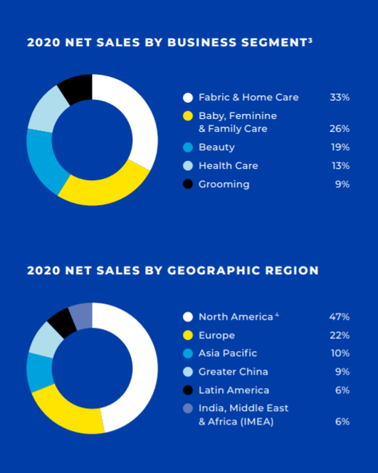
Vicks VapoRub has been a popular household name in India as well as globally, catering to a majority of the population. It has at least been heard of, if not used, by every Indian, babies and adults alike and is popular for its affordable prices and marketing and positioning strategies.
The report below aims to showcase the economic trends relevant to Vicks VapoRub. In order to make valid conclusions, primary data from 52 participants was collected through a survey and analysed further. A demand and supply analysis are followed by a section on Covid-19 aims to provide a detailed understand about Vicks VapoRub’s characteristics in a concise manner.

2. BODY:
a) Product Analysis:
Vicks VapoRub is a part of the Vicks brand of over-the-counter medicines. It is usually applied on the chest and throat in order to provide temporary relief from cold and its symptoms as well as on muscles and joints to temporarily relieve minor aches and pains. Vicks is stated to be the #1 Selling Children's Brand for Cough & Cold according to the Procter & Gamble calculation based in part on data reported by Nielsen in 2019.

The main active ingredients used as inputs for Vicks VapoRub are 4.8% Camphor, 1.2% Eucalyptus oil and 2.6% Menthol. With sizes including 5g, 10g, 25g, 50g and 100g priced at ₹21, ₹40, ₹85, ₹145 and ₹250, the unvarying blue jar of Vicks VapoRub evokes nostalgia and familiarity for many Indians. Vicks VapoRub has carved out a niche for itself as easy to apply and stainless, with a relaxing odour. As a product seen with a distinct appeal as a modern rub in place of traditional ointments that has steadily gained the Indian market from the 1960s with its strong marketing and creative advertising, it is difficult to dissociate the story of Vicks from that of the growing Indian middle class.

The product is easily available all over India in almost all general and medical stores, supermarkets and ecommerce platforms such as DMart, NetMeds etc., as well as globally in more than 74 countries and on 5 continents. Out of the people I surveyed, a great majority of 87.5% purchase Vicks VapoRub from local chemists, followed by 10% from supermarkets.

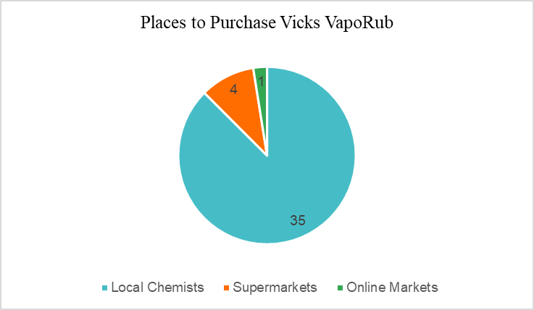

Moreover, there was a unanimous vote with all 40 people who used Vicks VapoRub felt that it is very easily available. The chart below shows the same responses, on a scale from 1 (Not at all easily available) to 5 (Very easily available).
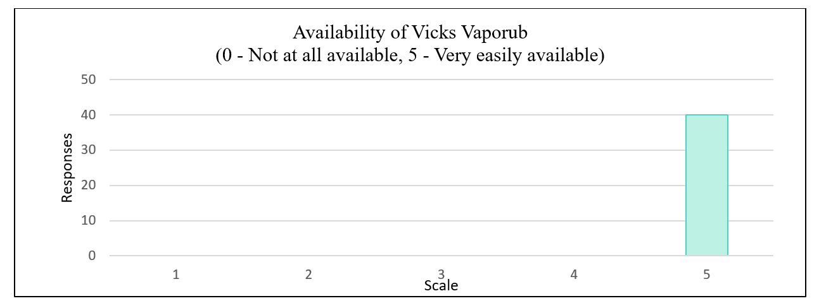

SWOT Analysis of Vicks VapoRub:
Strengths:
- Conducive environment: Vicks VapoRub’s unprecedented performance benefits from the good monsoons prevalent in India, which not only increases rural purchasing power but also demand for cold relief remedies.
- Leading market position and strong growth: The share of Vicks VapoRub to healthcare segment is 58% of sales in FY18, from 52% FY13. As of November 2020, Vicks has not only grown at a healthy pace of 9%YoY in the healthcare segment, but also reportedly increased market share in each of its sub-segments with Vicks VapoRub contributing towards 59% of healthcare sales
- Strong Marketing and Warmth Advertising: Vicks VapoRub is marketed under tagline ‘Natural, Herbal and Ayurvedic’ making it more popular among the people of India due to greater inclination towards Ayurveda. Moreover, it has pioneered the concept of Touch Therapy under the advertisement “The only thing more powerful than a mother’s touch”, and hence creating an emotional market of not selling Vicks but instead selling a mother’s love
- Highly Effective and Trusted Brand: In 2011, Vicks was branded as the 25th most trusted brand in India with continued development of more variants of products like ointments, inhaled breathing solution and liquid drops for increasing the target audience

Weaknesses:
- Application restrictions: The manufacturers warn that Vicks VapoRub should not be applied in or near the nostrils and is not to be used on children under 2 years of age due to the presence of camphor

Opportunities:
- Demographic changes: the growing preference of consumers towards purchasing over-the-counter (OTC) drugs and healthcare products is expected to augment the demand for Vicks VapoRub across the world as patients can purchase these products without a doctor’s prescription, as well as due to the increase in health problems and upper respiratory tract infections because of the Covid-19 pandemic
- Covid-19 support: Vicks donated more than 33,000 protective hygiene and ration kits to the elderly people in need and launched Vicks #ShowWeCare campaign to encourage people to care for loved ones, while maintaining safety and hygiene, which could further consolidate brand loyalty and trust

Threats:
- Strong Competition: In the rubs and balms as well as the pian-relief segment, Vicks VapoRub faces cut-throat competition from Amrutanjan, Zandu Balm and Tiger Balm. The attractiveness of natural oils and products such as eucalyptus oil and camphor balls may cause some consumers to switch to these substitutes instead of opting for Vicks VapoRub
- Higher Costs of Inputs: The low prices of Vicks VapoRub might be at a threat due to the rapid increase in the price of Menthol, which is one of the main constituents of the product
- Controversies: There have been instances reported where the application of Vicks VapoRub has led to complications in children as the ingredients used in the product were deemed as irritants which resulted in difficulty in breathing

b) Demand Analysis:
My survey was aimed to analyse the demand of balms and rubs, in particular Vicks VapoRub, keeping in mind the threat from competitors and other substitutes. Out of the 52 responses recorded, a whopping 40 preferred Vicks VapoRub followed by 7 preferring Tiger Balm. The other minorities include Zandu Balm, Axe Oil and Himalaya Cold Balm among others accounting for less than 10% of the total responses.

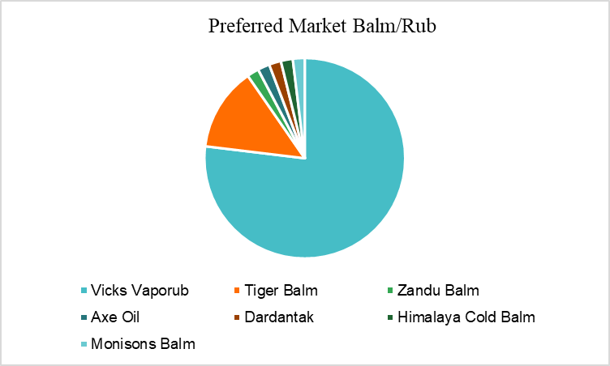

Vicks VapoRub is utilised by people of all ages, occupations and income groups. The survey was targeted towards people ranging from less than 20 to more than 60 years of age, with a majority of 57.5% consumers of Vicks VapoRub falling in the bracket of less than 20 years of age.

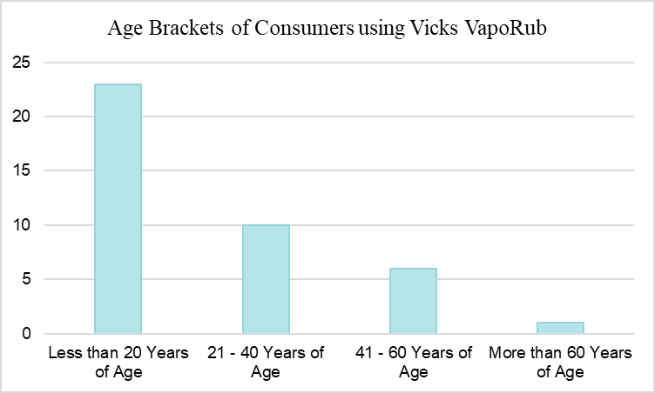
Out of the 40 people who utilised Vicks VapoRub, it was found that 80% of the consumers purchased only 0-1 bottles of the product on an average in a month, while 15% purchased 0 bottles followed by a purchase of 2-3 bottles by a mere 5% of the sample population. Considering this, the demand for Vicks VapoRub can be empirically concluded to be low. However, this could be because of the longevity of the product as one 25g bottle can last for about 2-3 months on an average for a consumer as well as the dependence of sales on the flu season.
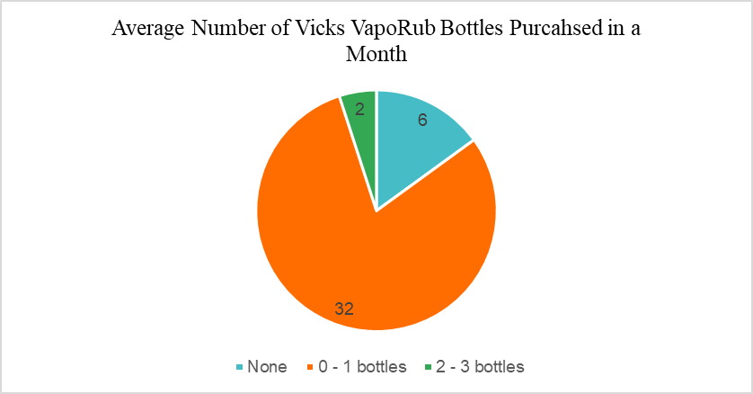

Since the majority of the people purchase Vicks VapoRub from their local chemists over supermarkets and e-commerce market, they pay a relatively low price due to bargaining power and additional discounts. We see that a significant number of consumers spent only 2% or less of their average monthly incomes on the purchase of the product. 45% of the consumers spent between ₹60 and ₹90 on one bottle of Vicks VapoRub, followed by 25% spending between ₹30 and ₹60 and 22.5% spending less than ₹30. A very low percentage of 2.5% spend more than ₹120 on a bottle, with a majority of consumers willing to spend a maximum of ₹50 to ₹100 on a bottle of Vicks VapoRub. This is in line with the reasonable pricing factor associated with the Vicks brand.
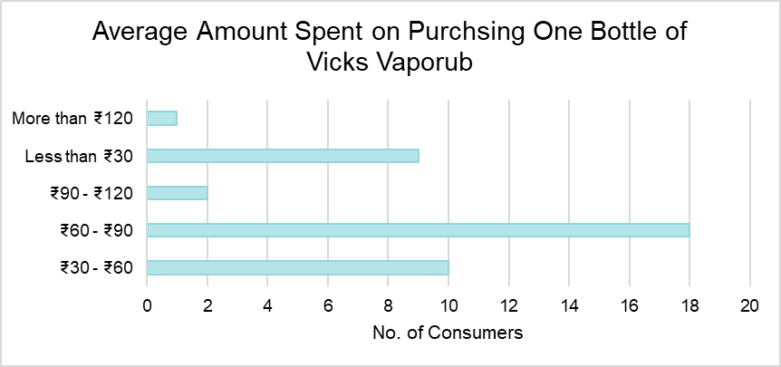

Another important part of the demand survey was to analyse whether a reduction in the price of Vicks VapoRub would lead to an increase in the quantity purchased. Assuming an average price of ₹100 of one bottle of the product, we see that a price reduction of ₹5 and ₹10 does not affect the quantity purchased, however consumers were more likely to increase the quantity purchased when a fall of ₹15 and ₹20 was stated.

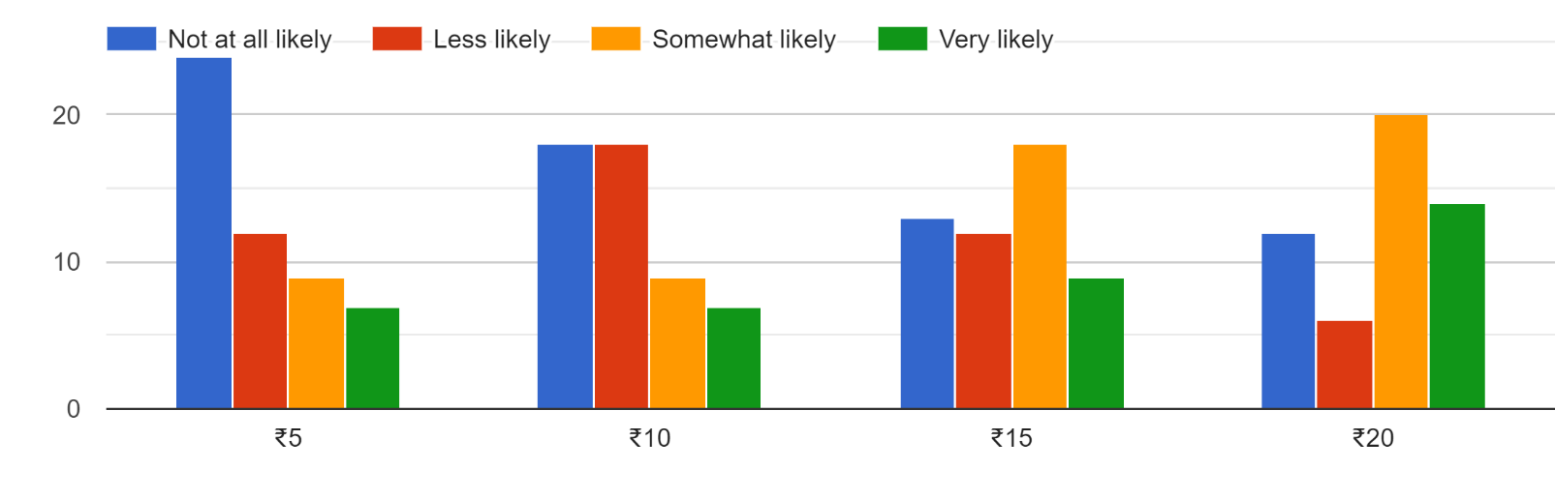

When compared with other substitutes, the demand for the product remained the same despite a price hike in Vicks VapoRub ranging from ₹5 to ₹20. Its only when the price increased by ₹25 and ₹30 that most of the consumers were less likely to still purchase Vicks VapoRub. However, even after the maximum hike assumed, some people still chose to purchase the product, thus showing Vicks’ immense brand loyalty and the trust of consumers in the well-established product.

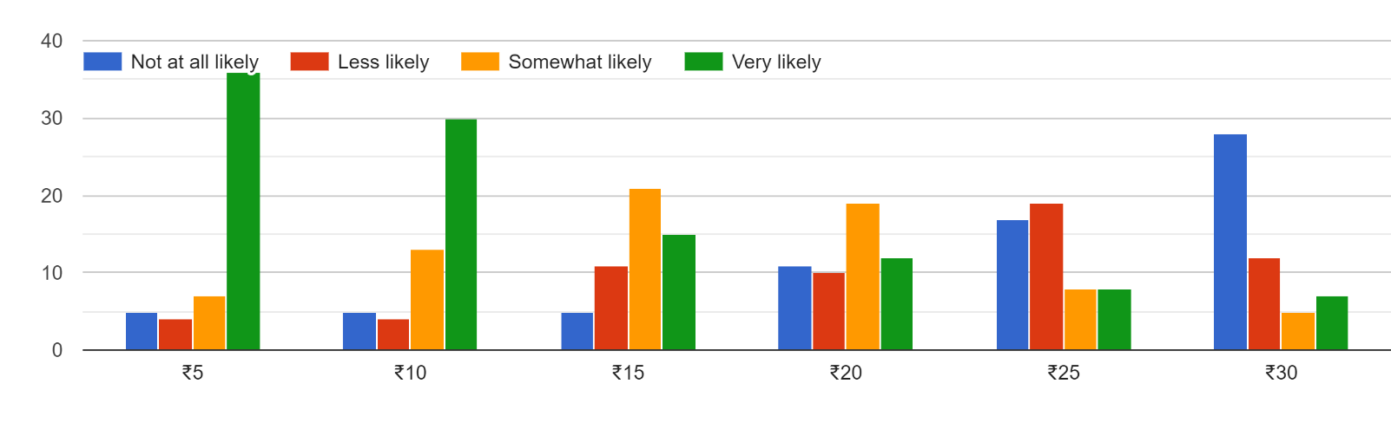

c) Industry Analysis:
Vicks VapoRub comes under the Fast-Moving Consumer Goods (FMCG) sector, under the healthcare industry. The fast-moving health goods (FMHG) industry is expanding as innovative products are emerging in the market. This industry is dominated by products like balms & rubs, medicated skin treatments, cough syrup and drops, digestives and health. It is a part of the global balm and vapor rub market which is projected to grow at a CAGR of 9.94% over the forecast period of 2021-2025. As per the latest GST revisions, Vicks VapoRub and other products quoted as “Ayurvedic” are subject to a tax rate of 12%.
Vicks VapoRub forms a majority of healthcare business, contributing to 59.5% of sales in FY20 as compared to 52.9% in FY15 as shown from the graph below:
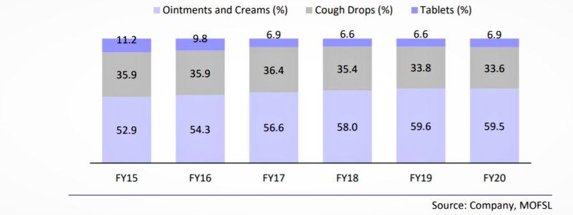
The healthcare segment itself grew by 9% YoY in 2020 to INR 9.5 billion from INR 4.1 billion in 2011 as depicted below:
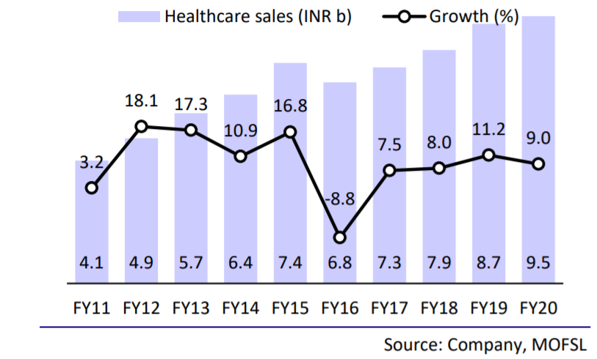

d) Supply Analysis:
Proctor and Gamble’s strong sales and rising demand is accredited to one of the most vast and complex supply chain system and ever-increasing distribution networks. In 2020, Gartner named P&G as one of five supply chain ‘Masters’, appreciating its leveraged digital capabilities and resilient supply systems. P&G’s total number of employees in 2021 was 101,000, a 2.02% increase from 2020 and a 2.06% increase from 2019. Out of these 2500+ employees are from India with 6 manufacturing plants spread across the country. As of 2020, the company has reached around 3.5m outlets which is not only significantly higher than a few years ago, but the opportunity to also grow distribution of Vicks is massive, even within the P&G universe. The unlisted company, P&G Home Products reaches over 6m outlets and Vicks has the potential to reach a large part of these outlets given the problem-solving nature of the product, its Ayurvedic efficiency, its low cost and the lack of significant shelf space required by these products.
Substitute Goods:
Based on the survey, it can be concluded that rubs and balms in general have readily available substitutes including cough syrups and drops. They face substitution threats from other natural products such as home remedies (such as drinking turmeric milk for cough) and essential oils (such as peppermint and eucalyptus). From the survey, we see that out of the 52 responses collected, although 67% of the participants favour market products like Vicks VapoRub, the remaining 33% would rather opt for natural oils and constituents. Amongst the market products available itself, although Vicks VapoRub leads the market position in the cold rubs segment, it faces competition from substitutes like Zandu Balm and Tiger Balm. In the pain relief segment, Amrutanjan acts as a substitute good. As stated and depicted before, 12 out of the 52 participants would not prefer Vicks VapoRub over other balms and rubs.

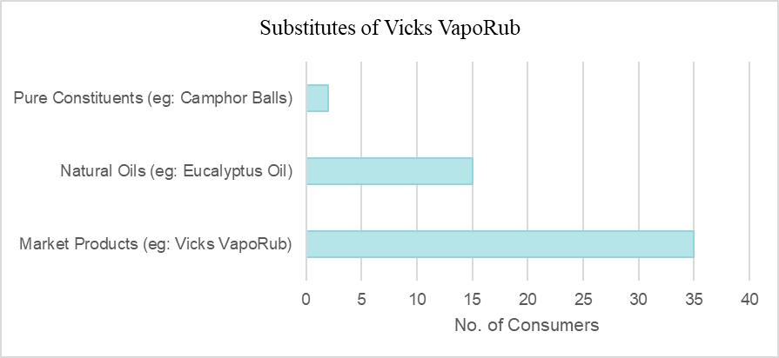
Complimentary Goods:
Based on the analysis and general reasoning, we can conclude that there is no particular good complimentary to Vicks VapoRub.

e) Determining the Price Elasticity:
Demand:
Being a very popular household name and a trusted brand since the 1960s, Vicks has consolidated its position in the healthcare segment as well as in families, in India as well as on a global level. Thus, it is not surprising that consumers who have been using Vicks VapoRub to treat common cold symptoms in the past continue to do so irrespective of fluctuations in the price, making it a habitual healthcare necessity for many. In the cold rubs and balms market, Zandu Balm and Amrutanjan follow Vicks VapoRub at the 2nd and 3rd position respectively. Given its leading market position, consistent brand loyalty along with low threat of substitutes, Vicks VapoRub is not very sensitive to the presence of substitutes. The low pricing strategy adopted by Vicks VapoRub makes it affordable for people from all income groups, including those in the rural as well as urban areas. Moreover, the percentage of average total annual income spent on purchasing the product is almost close to negligible for all income groups. This is in line with my survey results as we saw that:
1) A majority of people preferred Vicks VapoRub over other market products
2) A rise or fall in the price of Vicks VapoRub does not affect the quantity demanded by the participants
3) Despite a fall in the price of the substitutes, a majority of the participants would still purchase Vicks VapoRub
4) A majority of the participants felt that a considerable decrease in their level of income will not affect or only slightly affect their consumption of Vicks VapoRub.
Supply:
As stated earlier, given the increase in the cost of production of Vicks VapoRub due to an increase in the price of methanol, one of the main inputs to the product, the price for the rub has remained almost the same from ₹85 for 30g to ₹85 for 25g. The low cost of Vicks VapoRub gives it a competitive edge in the market, making it one of the many reasons behind opting out of any major price hikes.
All these points validate the inelasticity of both, the demand and supply of Vicks VapoRub. However, as with any other good, this product too can be considered as inelastic in the short run and elastic in the long run.

f) Determining the Income Elasticity:
As seen earlier, the low prices and easy availability of Vicks VapoRub makes it a household staple for people from all income groups. As the proportion of income of almost all consumers spent on purchasing the product is so minor, the quantity demanded is not sensitive to income level fluctuations. This is in line with our survey, as we saw that people with monthly average incomes ranging from ₹5000 - ₹100000, all consumer Vicks VapoRub. When asked whether a 30% reduction in their monthly income would affect their consumption habits, 48% of the participants stated that it would not at all do, while another 48% felt that it might do so a small extent. The percentage of people who thought that their consumption of Vicks would be affected to a great extent was just 4%. Keeping in mind the small sample size we considered and the responses we received, we can conclude that Vicks VapoRub is income inelastic.

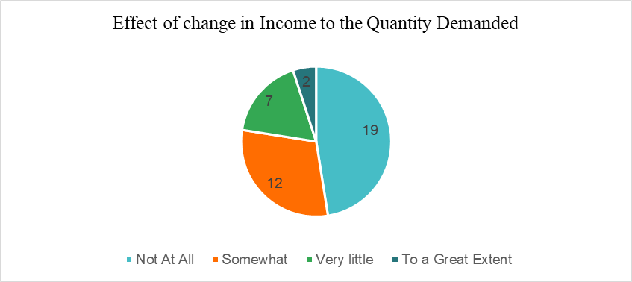

g) Determining the Cross Elasticity:
Since Vicks VapoRub does not have any complimentary goods, there is no data available to infer whether a change in price of complimentary goods would affect its demand. Since Vicks VapoRub has a leading market share of 60%, a small to moderate increase in its price will not affect the demand for its substitutes. However, if the price for Vicks VapoRub goes up substantially, the demand for its substitutes is likely to increase as well. As seen from the survey, a ₹5 - ₹20 increase in the price of one bottle of Vicks VapoRub has only a minor percentage of consumers switching to substitutes. However, a ₹30 hike can cause most of the participants to consider other rubs and balms available in the market.

h) Regression Analysis:
Based on the results of the survey obtained, keeping the price of Vicks VapoRub as the response variable, the following factors can be assumed to be the independent variables affecting the cost of Vicks VapoRub:
- Income
- No. of substitute goods
- Price of substitute goods
- Popularity
- Availability

3. IMPACT OF COVID-19:
As a result of the nationwide lockdown imposed by the Government of India in view of the Covid-19 pandemic, the operations of Proctor and Gamble were temporarily disrupted at its manufacturing, warehouse and distribution locations from second half of March 2020. The operations are said to have gradually resumed in a phased manner in line with the Government directives issued from time to time. There is no significant impact reported on the Company’s assets, capital and financial resources, profitability parameters, liquidity positions or going concern assumption as at June 30, 2020. However, the long-term outlook for the FMCG sector remains positive. The government has since introduced several initiatives to revive and boost the economy and increase demand which is expected to bounce back and grow by 6% in 2021-23. Good monsoons, government initiatives focused on rural economy, the mergence of new distribution channels coupled is expected to increase digital penetration which will create new opportunities for the FMCG industry to reach consumers.

The health care sales as of 2020 showcased strong growth despite external challenges due to the pandemic. P&G continued to win externally and grow share in the Cough & Cold category with strong offtake growth behind the strength of their portfolio which includes Vicks VapoRub. The growth was driven by strong demand creation with world-class communication across all their sub-brands to continue growing their share, along with superior go-to-market. Vicks Rubs grew penetration behind their Category Development Index program for the fourth year in a row, continuing to grow value share in the Financial Year 2019-20.

4. CONCLUSION:
Vicks VapoRub is one of the most trusted and staple brands in India, with a strong consolidation in the FMCG Healthcare Sector. It leads the market position with a 60% share and is a household name in the Indian society. It has contributed to increasing sales of Proctor and Gamble, even during the unforeseen circumstances of the Covid-19 pandemic. As per the survey, Vicks VapoRub’s brand loyalty and market outreach is accounted for by its low prices and robust advertising. It is very easily available and accessible by everyone. It has no complimentary goods but has some competition from substitutes. The demand for Vicks VapoRub is both price and income inelastic, i.e., a change in price or the level of consumer income has little to no effect on the demand for the product. Despite several controversies and government mandates, Vicks VapoRub continues to expand operations and grow year on year, maintaining its position as the No.1 cold relief balm in India and will last, as said in its tagline, “as long as a mother’s love lasts”.

5. REFERENCES:
Mike., 2019. Doan Essay. [Online]
Available at: https://doanessay12.blogspot.com/2019/05/the-vicks-business-in-india.html
[Accessed 24 September 2021]

P&G., 2020. P&G 2020 Annual Report. [Online]
Available at: https://www.annualreports.com/HostedData/AnnualReports/PDF/NYSE_PG_2020.pdf
[Accessed 24 September 2021]

Katie, S., 2019. Ahead of Cold & Flu Season Vicks® Introduces New Options for Children, Free of Additives Parents Don’t Want, But Full of the Things to Feel Better. [Online]
Available at: https://www.businesswire.com/news/home/20191016005701/en/Ahead-of-Cold-Flu-Season-Vicks%C2%AE-Introduces-New-Options-for-Children-Free-of-Additives-Parents-Don%E2%80%99t-Want-But-Full-of-the-Things-to-Feel-Better
[Accessed 24 September 2021]

Motilal, Oswal., 2019. P&G Hygiene and Healthcare. [Online]
Available at: https://bsmedia.business-standard.com/_media/bs/data/market-reports/equity-brokertips/2019-01/15470148030.29157500.pdf
[Accessed 24 September 2021]

Anon., no date. History & Marketing Strategies Of Vicks Vaporub [Online]
Available at: https://brandyuva.in/2019/07/marketing-strategies-of-vicks-vaporub.html
[Accessed 24 September 2021]

Shubham, P., 2020. Balm and Vapor Rub Market. [Online]
Available at: https://www.infiniumglobalresearch.com/survey-reports/global-balm-and-vapor-rub-market
[Accessed 24 September 2021]

Rajni, K., 2011. Vicks Vaporub: A Mother Touch Therapy. [Online]
Available at: https://www.researchgate.net/publication/329013923_Vicks_Vaporub_A_Mother_Touch_Therapy
[Accessed 24 September 2021]

Anon., no date. Procter & Gamble: Number of Employees 2006-2021 | PG. [Online]
Available at: https://www.macrotrends.net/stocks/charts/PG/procter-gamble/number-of-employees
[Accessed 24 September 2021]

6. Attached Survey Excel File:

