Q1)
Market closes near .80% down
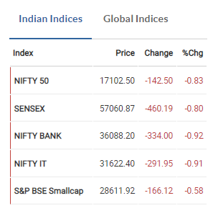

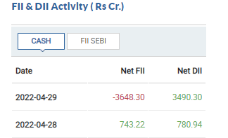
There was net selling so market was down

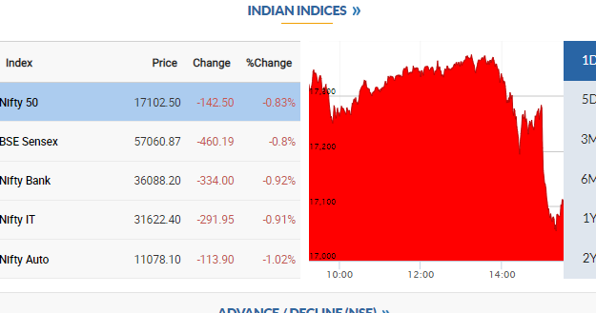
Today nifty downfall was majorly due to Nifty Bank and Nifty It

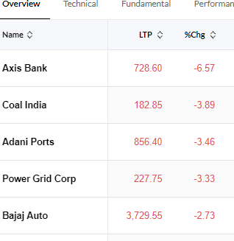
Top 5 stocks that was dragging down the nifty

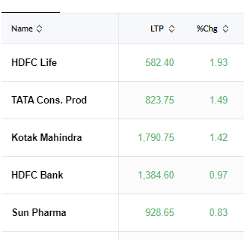
Top 5 stocks which was green today

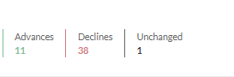
Advance to Decline



Worst performing index
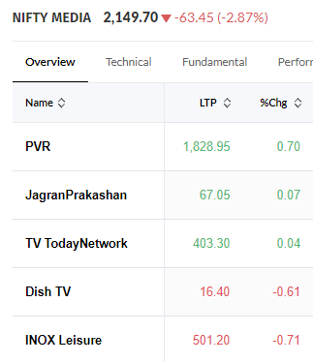
Top performing index
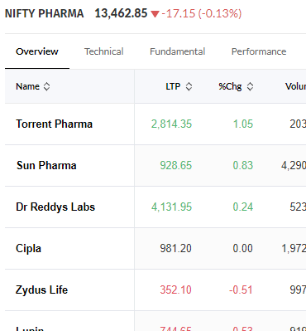
Q2)
a)FII was the seller
b)Minor change in the fear index and it is below 20 till now nothing to fear
c)HDFC LIFE,KOTAK MAHINDRA,HDFC BANK ,SUN PHARMA ,TATA CONSUMER PRODUCT
d)Nifty Pharma was the best performing index according to todays market and its stocks were TORRENT PHARMA, SUN PHARMA ,ZYDYS LIFE,CIPLA ,DR REDDY LABS
e)Nifty media was the worst performing index and its stock were PVR,DISH TV,INOX LIESURE,TV TODAY NETWORK,JAGRAN PRAKASAN

Q3)
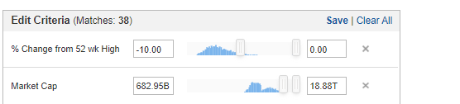

RELIANCE
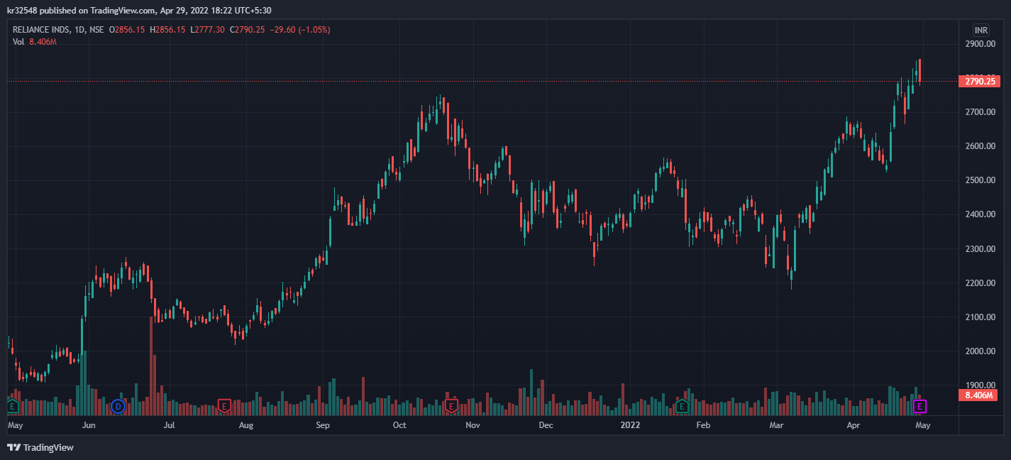

BHARTI AIRTEL
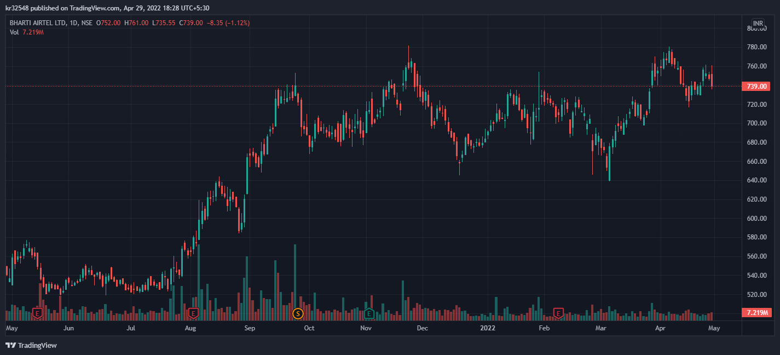

SUN PHARMA

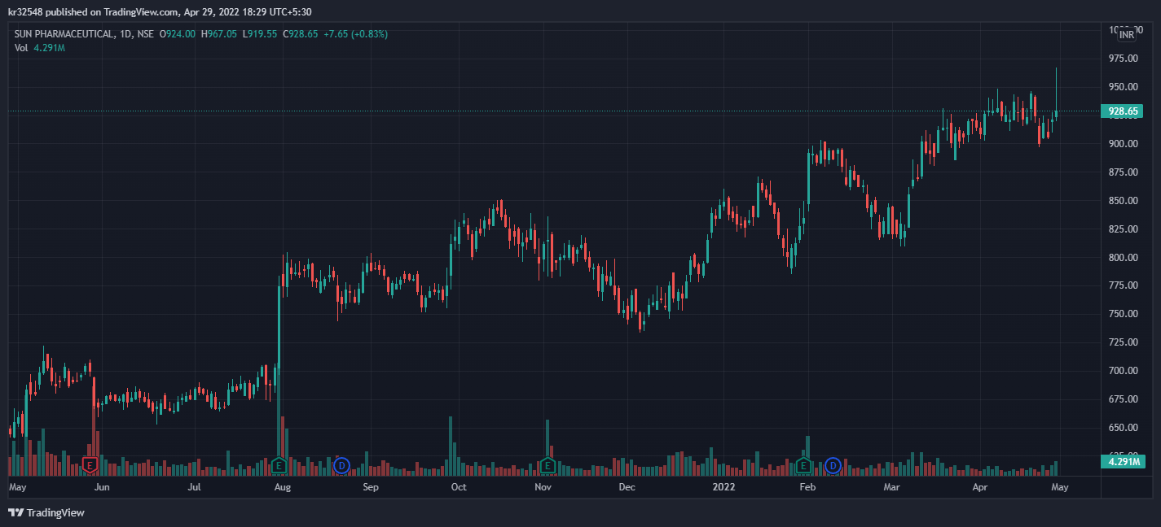

POWER GRID
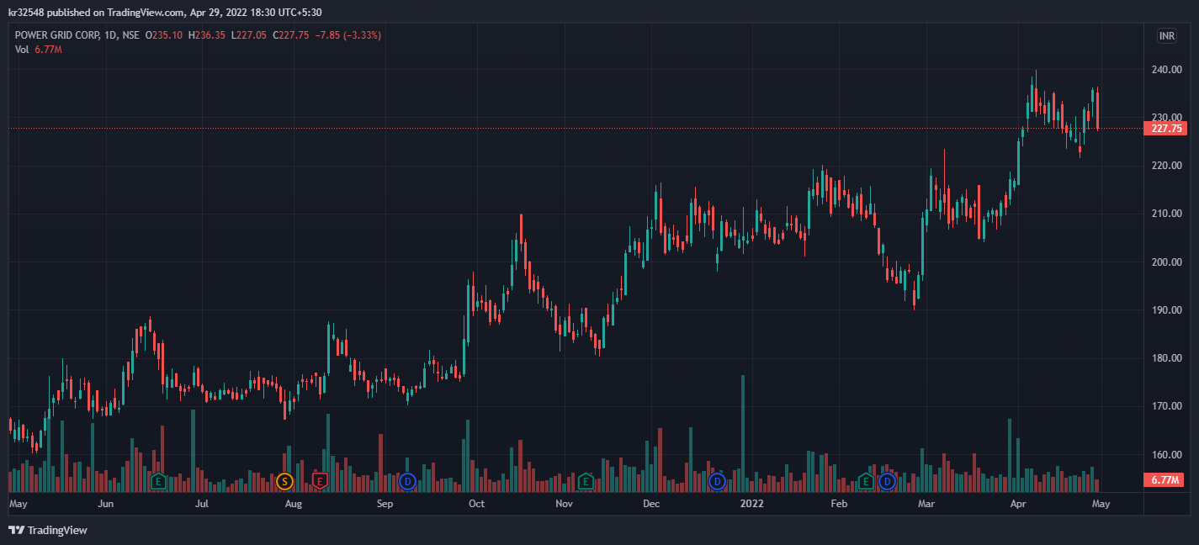

NTPC
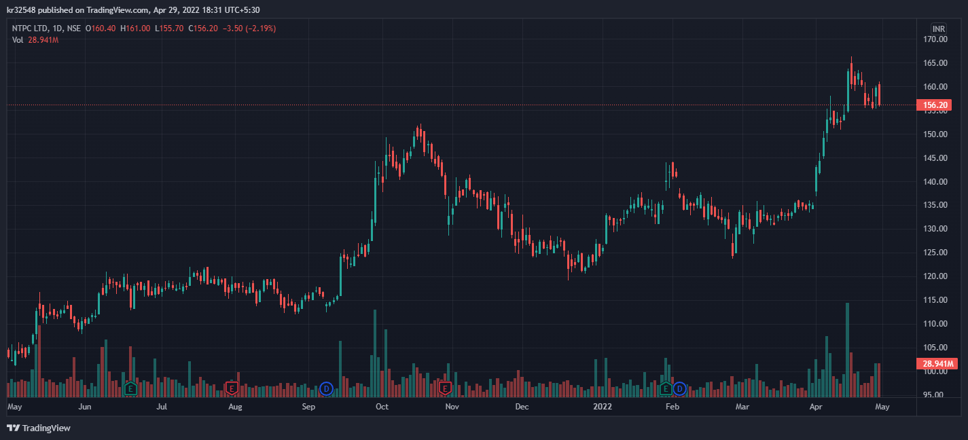

Qualification criteria:
- Chart beginning from the bottom left of the screen and ending at the top right of the screen
- Size of the candles is small
- No Circuits (Blank candles) on the chart
- No big dips in the middle of the chart
- Smooth shape (Upward trend) on the chart

