Professional Ethics Project
Report on Financial Fraud in India

submitted to
Ms. Meghana Jain
October 5, 2021

by
Dharini B Shah
704
Topic: Indian Coal Allocation Scam, 2012

I hereby declare that this report is my own and autonomous work. All sources and aids used have been indicated as such in the bibliographic details mentioned at the end.
Table of Contents
Sr. no | Topics | Page No.
 | Introduction | 3
 | Case Findings | 3
 | Current verdict | 5
 | Major law reforms | 6
 | Analysis | 6
 | Recommendations | 7
 | Conclusion | 8
 | Bibliography | 9

Introduction
The coal allocation scam, popularly known as “Coalgate scam” is a financial and political scandal that took reckoning in 2012. This scam was also called, ‘the mother of all scams’ due to the involvement of many bureaucrats and high-profile politicians, with bold statement from Dr. Manmohan Singh (then prime minister) who offered to give up his public life if found guilty in the scam. It was brought to notice by the Comptroller and Auditor General (CAG),when they accused government of illegally allocating 194 coal blocks between the years 2004 and 2009 and estimated the scam amount to be Rs. 1.86 lakh crore at the end.
India has always been blessed with abundant natural resources and has fourth largest reserves of coal deposits in the world, under the control of the government. To augment the production of coal for further development of our country, Government of India started to allocate these coal blocks to public and private individuals or enterprises for use. The legal procedure for allocating is via an auction where the highest bidder wins the captive block supervised by a screening committee who looks through the incoming proposals. In March 2012, CAG accused the government of not following this legal procedure and selling approximately 194 coal blocks to few private players and enterprises who enjoyed windfall gains while the government suffered a corresponding loss.

Case Findings:
In early 1990’s, coal mining was constrained to PSUs and under the control of government it was not efficient in meeting the needs. Hence to expand the horizons and augment the production, the government decided to allocate the coal blocks to those private companies which were not a part of the production plan of PSUs Coal India Ltd and Singareni Collieries Company Limited. Initially, 143 coal blocks were identified which was then inflated to 216. After verifying for the mining locations and the guidelines, the final list came to 194 blocks. A screening committee was set up for screening the bids and proposals and the members largely comprised of government officials from the Ministry of Coal, Ministry to Railways and the relevant state government, recommended by the government officials in charge.
Comptroller and Auditor General (CAG) of India is responsible for auditing and looking after all the receipts and expenditures of central government, state governments and autonomous bodies and corporations financed by the government.
In March 2012, the CAG draft report (performance audit focusing on allocation of coal blocks in period 2004-09) was leaked to the press where it revealed irregularities in the allocation of blocks. Later on, CAG accused the government of ‘inefficient’ allocation of coal block in that period and estimated the windfall gains to allottees at Rs. 10.7 lakh crore. The core essence of the argument was the fact that GOI had authority to allocate coal blocks by process of competitive bidding but chose not to. Here, no mention of corruption was made, only that the government could have allocate more efficiently. The story by press had a list of companies as leading beneficiaries:
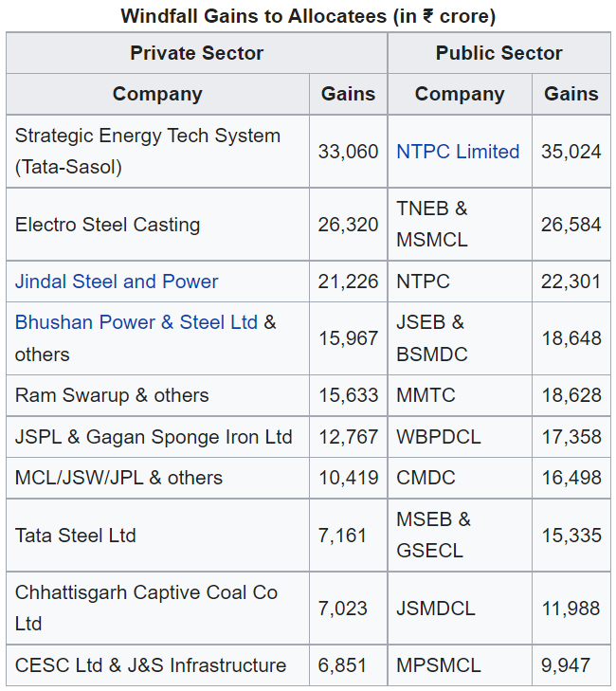
Source: https://en.wikipedia.org/wiki/Indian_coal_allocation_scam

Some of the key personalities against whom allegations surfaced were:
- S Jagathrakshakan (Minister of State for Information and Broadcasting) – part of JR Power Gen Pvt Ltd, allocated coal block in Odisha in 2007
- Subodh Kant Sahay (Tourism Minister) – persuaded PMO to allocate coal to SKS Ispat and Power Co.
- Ajay Sancheti (BJP Rajya Sabha MP) - SMS Infrastructure Ltd owner
- Vijay Darda (Congress MP) – active involvement in companies: JLD Yavatmal energy, JAS infrastructure & Power Ltd, AMR Iron & Steel Pvt Ltd
- Naveen Jindal (Congress MP) – Jindal Steel and Power got the allocation

Moving onto the timeline of the events:
May 2012: The opposition party leaders ‘Prakash Javadekar’ and ‘Hansraj Ahir’ of BJP, in response to the media leak, approached the Central Vigilance Commission (CVC) with complaints of corruption influence on the allocation which led to an enquiry by CBI and Income tax department.
June 2012: An Inter-Ministerial Group (IMG) by coal ministry was formed to decide on companies that failed to develop the allotted coal blocks. The decision was to either de-allocate the blocks or forfeit the Bank Guarantees of the allotees. Decision to deallocate 13 blocks of coal fields and forfeiture of 14 bank guarantees.
August 2012: CAG submitted the final report which had the charges that GOI had authority to auction the coal blocks but chose not to and hence the allocatees received a “windfall gain” from the program. The final report estimated the loss to exchequer at Rs. 1.86 lakh crore. Dr. Manmohan Sing rebutted this in parliament against both the charges with suitable arguments. Still unsatisfied, FIR was filed which named 12 Indian firms which initiated a criminal investigation. These FIRs were revolving around the companies exaggerating their net worth, failing to disclose coal allocations and hoarding rather than developing those coal allocations.
Sept 2012: PIL was filed in supreme court seeking to cancel the allotment of 194 coal blocks on the grounds of arbitrariness, illegality, unconstitutionality and public interest. Supreme Court directed CBI to report its findings and be independent of the government.
April 2013: The Parliamentary Standing Committee report on Coal and Steel stated in its most recent reports that all allocation of coal blocks between 1993 and 2008 was done in an unauthorized manner and accused NDA & UPA of massive corruption and recommended that the allotment of all the mines where the production is yet to start should be cancelled.
It is said that coal secretary PC Parakh was the whistle - blower on the Coalgate scam case as he informed PM of the potential fraud and objected to it in writing and pushed for auctions, but was overruled by the PM.
These were the various actions taken by different concerned committees. 157 files which were responsible for the record of allocation of coal blocks went missing, out of which 18-20 were still untraceable. The rest is said to be deposited with CBI according to the coal ministry.
Sept 2014: CBI was allegedly manipulated and used to cover the tracks of accused. After the confessed influence of government on CBI enquiry, Supreme court set up a special CBI court to try all coal block allocation cases.

Current Verdict of the case:
In September 2014, the special CBI court quashed allocation of 214 out of 218 coal blocks allocated to various companies since 1993. An additional penalty of Rs.295 was also to be paid for every tonne of coal extracted.
In March 2015, Special CBI judge took cognizance of offences taken by Dr. Manmohan Singh, M/s. HINDALCO, Subendhu Amitabh, D. Bhattacharya, Kumar Mangalam Birla, P.C. Parakh and consequently questioned and investigated them.
In April 2015, CBI filed a chargesheet against former Jharkhand chief minister Madhu Koda and thirteen others in coal block allocation case.
Case of Jharkhand’s Giridih districts coal in favour of Castron Technologies: As of October 2020, Dilip Ray, former Minister of State for Coal in NDA government, was convicted on October 6th for various offences with three year jail term. These offences are 409 (criminal breach of trust by a public servant), 120B (criminal conspiracy), 420 (cheating) of the Indian Penal Code (IPC) and various sections of the Prevention of Corruption Act, 1988.
In addition, the same punishment was extended to Pradip Kumar Banerjee and Nitya Nand Gautam (former officials of Union coal ministry) and Mahendra Kumar Aggarwalla, director of Castron Technologies Limited.
Fine of Rs.10 lakh each was imposed on all convicts and Rs. 60 lakh and Rs.10 lakh each on corporate entities, namely Castron Technologies Ltd and Castron Mining Ltd respectively.
Major reforms in laws or regulations post the event of case:
Amendment to Coal Mines (Nationalisation) Act, 1973: This Amendment would invite domestic and international companies to participate in coal block allocation process. This statue to make auction compulsory for the allocation of coal blocks after 2020, would avoid any bias or arbitrary action from the authority in power.
In addition, the Mineral laws (Amendment) Bill, 2020 is also passed that proposes to remove end-use restrictions for participating in coal mine auctions and open up the coal sector fully for commercial mining by domestic and global companies.
The Coal Mines (Special Provisions) Act, 2015 was passed by the legislature that deals with the allocation and provides the general conditions, guidelines and rules relating to the allocation of coalfields in India. In addition, it also provides for auction and allocation of mines which were cancelled by the supreme court in the light of the verdict on Coalgate scam.

Analysis of case:
As the case slowly comes to light, we see that there are many factors responsible for the scandal.
The very first one would be the selection of government officials in the screening committee whose recommendations were made by the very people in power. They comb through the proposals and bids for coal allocation. The system was opaque and there was no means to keep a check on the doings of the committee. The members of committee are linked to government, leaving the option of biasness and arbitrary open, and this is what happened in Coalgate scam. The allocation of coal blocks was done without auction or bidding, and it was just handed out to the entities that allegedly favoured the government officials personally. This led to a loss in revenue that could have been earned by the government and gain of those entities.
The coal nationalization act, in itself is a bit unclear on rules for bidding by private parties which led to the very forming of the opaque committee discussed before.
Along with the act, it was known that the states, which were ruled by opposition also strongly objected to open competitive bidding, which definitely let the power rest with the authority already in power.
Even though the coal was already allocated, the de-allocation of those suggest that no action was taken to develop the coal blocks. So, even after the biased allocation, no actual development for the country took place, only benefit was enjoyed by the allocatees. Here, the very basic purpose of captive allocation, which was to augment the production of coal was defeated.
The losses mounted up for years since the coal was distributed and since it was hoarded, no actual use came out except for the ever-rising inflation.

Another factor that led to worsening of the losses in the scandal was the CBI’s non-autonomous status. It was manipulated by the government in power to cover the tracks which pro-longed the investigation and added to the surmounting losses. If the tracks were uncovered earlier and criminals convicted, the re-allocation of coal blocks would have hastened up and more could have been recovered or some progress would have been made in the meanwhile. The more pertinent question is of the accountability. If the investigative authority is not to be trusted upon, the whole system would fall to the shambles.
These were few factors that led to the Indian coal allocation scam of 2012.

Recommendations:
When the scam was unearthed, it shook the nation. This scam was not only huge in financial capacity, but it also took a toll on people’s confidence in the democratic government. Actions were taken, but there are a lot of areas, where the process could have been more efficiently carried out.
As it was already known the CBI was linked to the government and it had undue influence, investigation by it could have been made independent from the start or a new committee dedicated to investigation of this scam be created. This would have avoided misleading and a quicker action that may have limited the losses or increased the gains would have been taken.
The opposition was not really efficient in their roles as they were more focused on resignation of former prime minister than the losses and its impact on the country. The basic idea of democracy is that people matter and nation’s welfare is the top priority and hence we have opposition. So that if government is found to misuse the power, a strong opposition brings it back.
CAG, who uncovered the matter could have been given more power to investigate, as they were already an independent authority.
The screening committee when it was formed, could have been objected to, or a more transparent approach could have been demanded. That would have prevented the offences.
The de-allocation of coal blocks led us to believe that they were undeveloped. And since they were allocated from year 1993 onwards, and by 2010, they were still undeveloped, begs the question of inefficiency. Hoarding the blocks these years or keeping in custody, only put a dent in the nation’s development which could have been avoided.
We could say that appropriate actions were taken as almost all accused were fined and sentenced for the offences, but there was definitely a scope for more efficient action.

Conclusion:
2G scam (occurred a bit earlier) was already a big negative patch on the UPA tenure (2004-2008) in India, and with Coalgate scam as its tipping point. It laid out all the wrong doings by the ruling government, the loopholes in the laws, and the overall inefficiency of the system and the influence of the corruption.
It lacked the proper transparent system by which the highest bidder could get the coal blocks which could be used for the development of the country. The scam unearthed by CAG, put a dent in the country’s progress. The laws were amended to include competitive bidding in the allocation process, which was then accepted in 2010. If we look on the positive side of the scandal, it would be the amendment of the Coal Nationalisation Act that allows the participation of the private players and international players to bid and auction for allocation of coal blocks.
Although the legal implication of the scandal was solved by Supreme Court in the favour of petitioner, this scam would forever leave a mark on the government action framework and the influence of corruption with regards to the welfare of people of the nation.

Biblography:
https://indianexpress.com/article/explained/explained-recalling-the-coal-blocks-allocation-cases-allegations-investigation-and-what-now-6723961/
https://www.longdom.org/articles/coal-is-gold-the-coalgate-scam.pdf
https://www.hindustantimes.com/cities/coal-scam-case-cbi-court-sentences-former-union-minister-dilip-ray-to-3-years-imprisonment/story-qyV6UkV6Y1K39MynFUOQ2J.html
https://en.wikipedia.org/wiki/Indian_coal_allocation_scam
https://thecompany.ninja/indian-coal-allocation-scam/
https://www.thehindu.com/news/national/coal-scam-chronology-of-events/article6350481.ece
https://www.thehindubusinessline.com/opinion/core-issues-in-the-coal-scam/article22994776.ece
https://www.outlookindia.com/website/story/the-travesty-of-justice-in-2g-coalgate-scams-shows-why-we-badly-need-a-lokpal-an/308881
https://www.indiatoday.in/india/story/explained-what-is-the-coal-scam-all-about-in-which-madhu-koda-is-held-guilty-1106352-2017-12-13
https://www.pib.gov.in/PressReleasePage.aspx?PRID=1697035
https://www.drishtiias.com/daily-updates/daily-news-editorials/coal-sector-reforms
https://economictimes.indiatimes.com/opinion/et-commentary/supreme-court-judgment-on-coal-scam-offers-manmohan-singh-some-consolation/articleshow/40958334.cms
https://blog.ipleaders.in/coalgate-scam-a-legal-picture/

