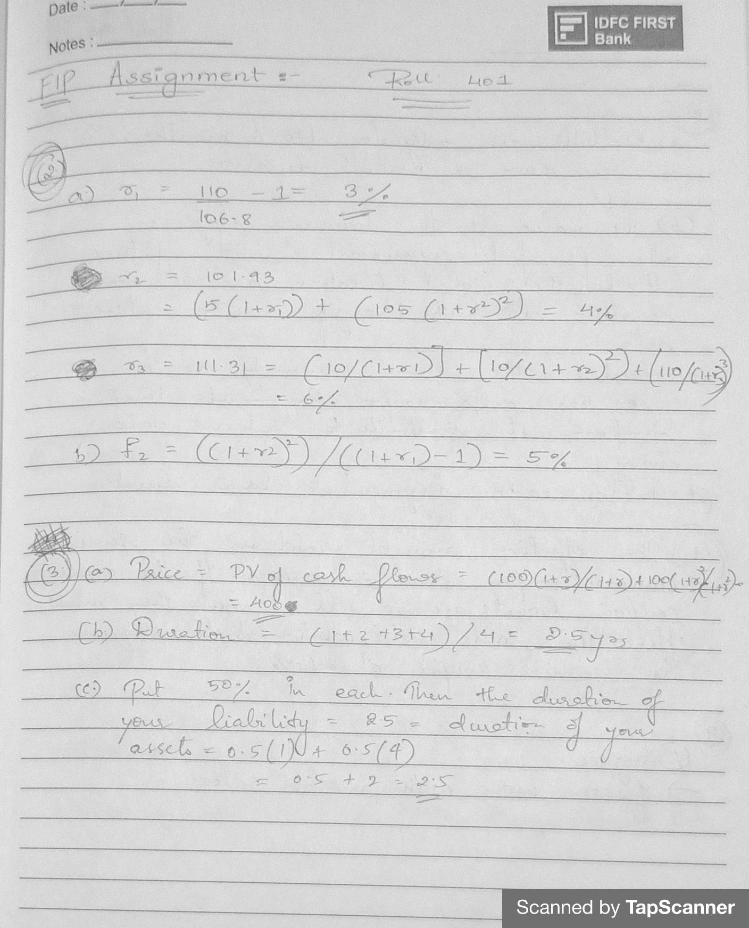

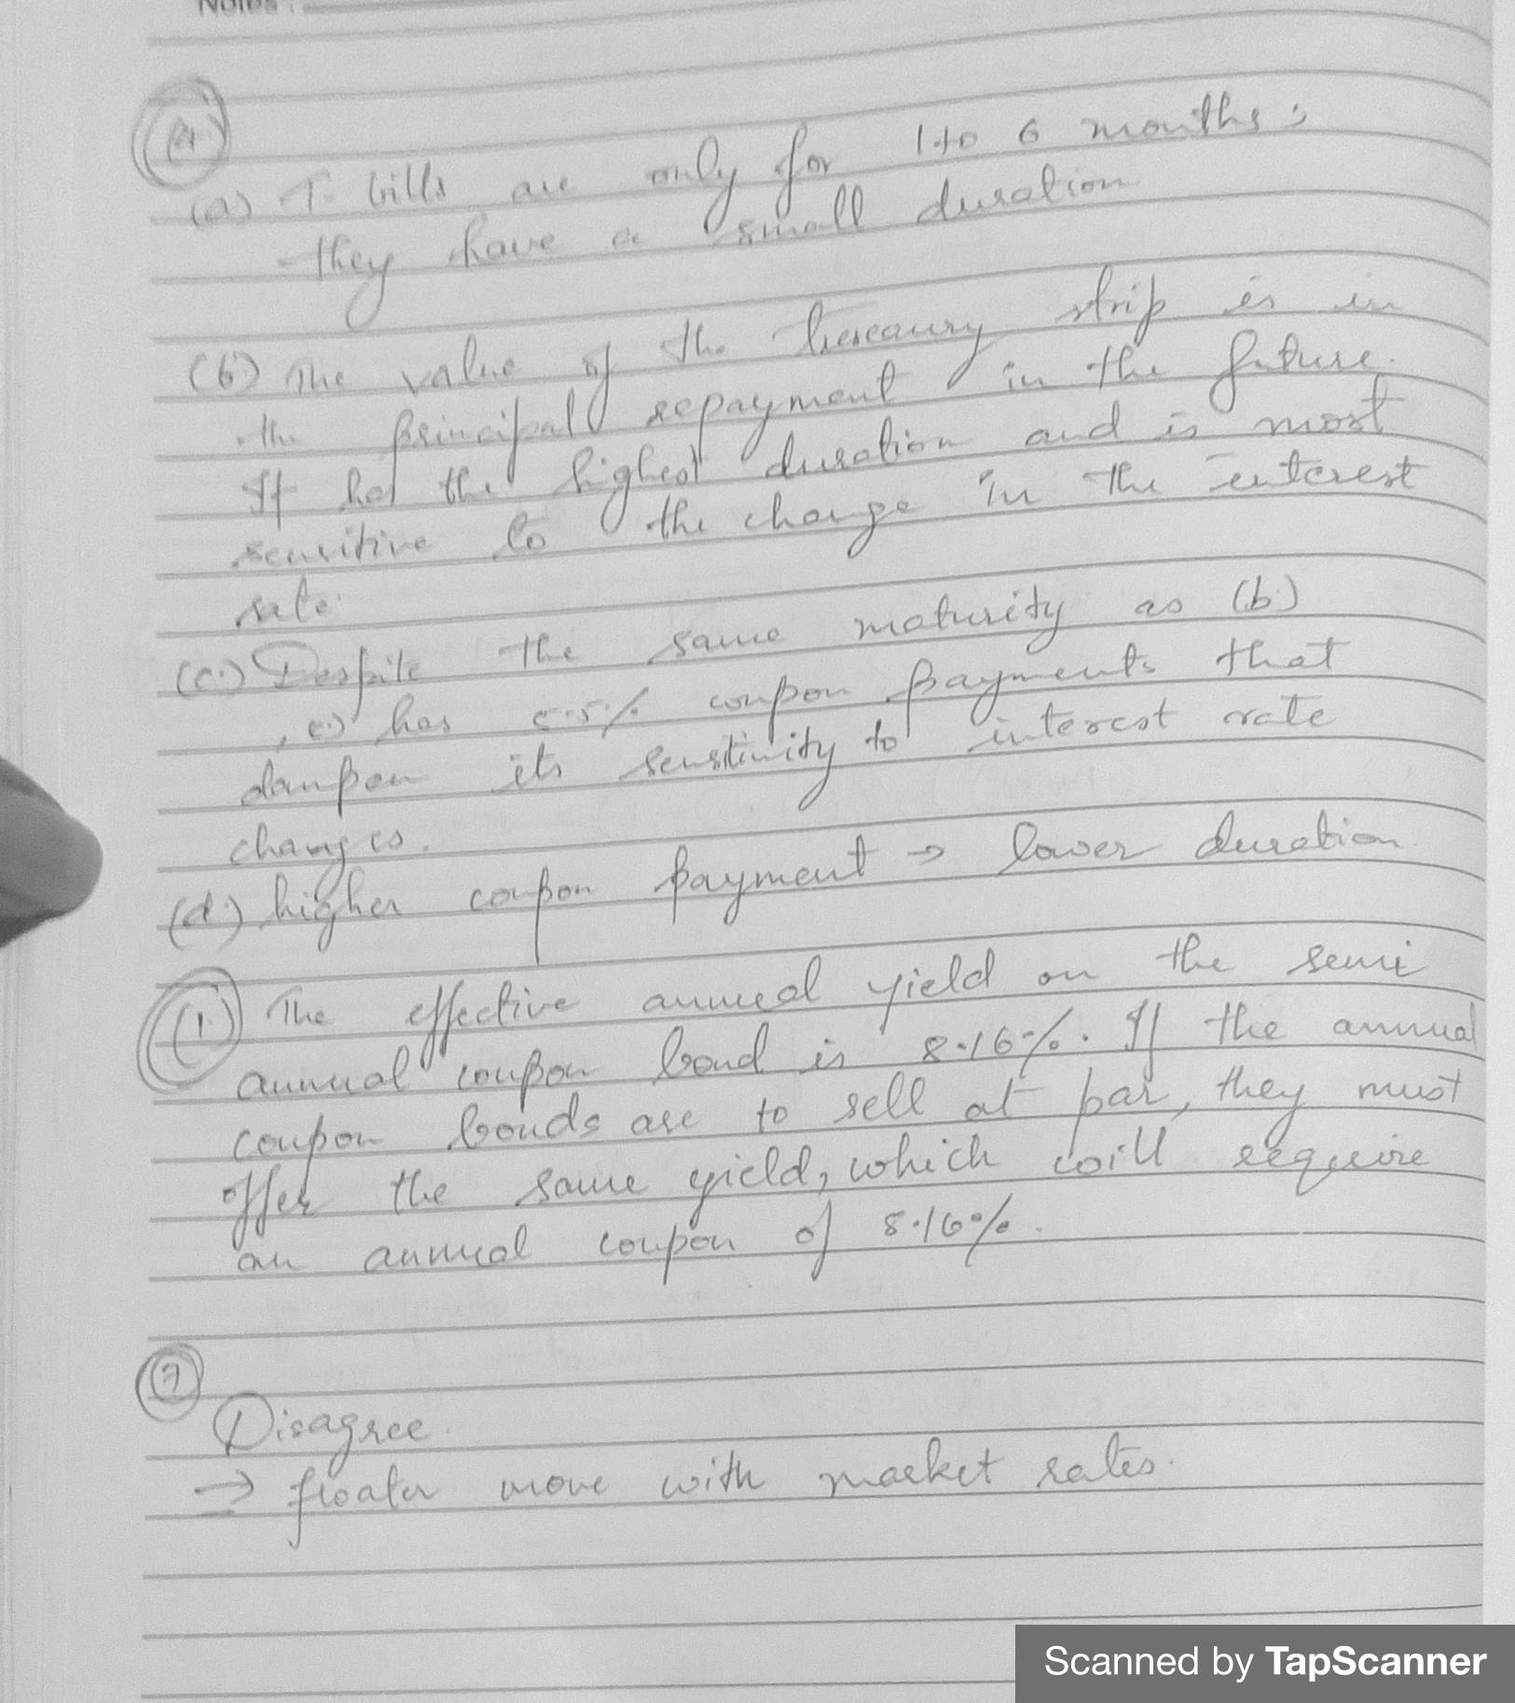
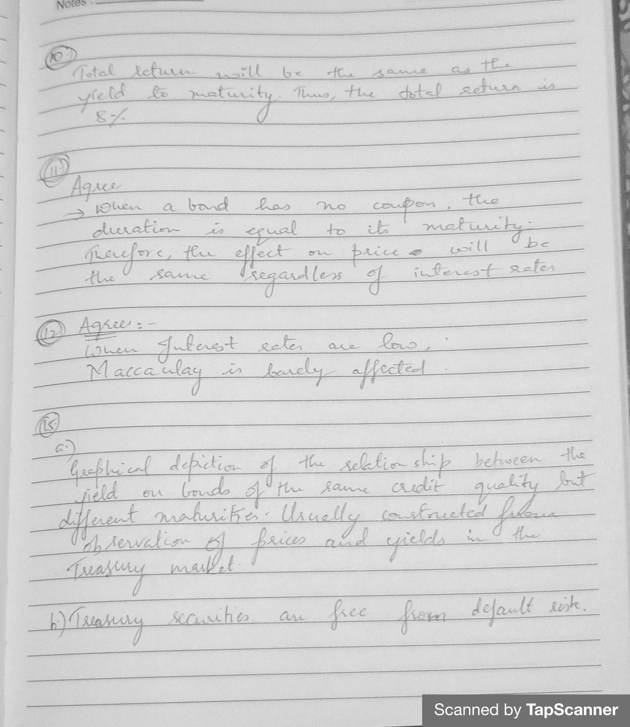

6.]
If the underwriter purchases the bonds from the corporate client, then it assumes the full risk of being unable to resell the bonds at the stipulated offering price. In other words, the underwriter bears the risk of interest rate movement between the time of purchase and the time of resale. For long maturity bonds, it is generally true that its duration is also long. Thus, bonds with long maturities are more exposed to interest rate movement risk. Therefore, the underwriter demands a larger spread (higher underwriting fees) between the purchase price and stipulated offering price.

8.]
a) We have a 10-year 6% coupon bond with a par value of $1,000 and a required yield of 15%.
Given C = 0.06($1,000) / 2 = $30, n = 2(10) = 20 and r = 0.15 / 2 = 0.075,
the present value of the coupon payments is: $305.835
The present value of the par or maturity value of $1,000 is: 235.413. Thus, the price of the bond (P) = $305.835 + $235.413 = $541.25.

if 15%, Thus the price of the bond (P) = $305.835 + $235.413 = $541.25.
if 16%, Thus the price of the bond (P) = $294.544 + $214.548= $509.09.
(509.09 - 541.25)/541.25 = -5.9%

We have a 10-year 6% coupon bond with a par value of $1,000 and a required yield of 5%.
Given C = 0.06($1,000) / 2 = $30, n = 2(10) = 20 and r = 0.05 / 2 = 0.025
Thus, the price of the bond (P) = $467.675 + $610.271 = $1,077.95.

The price of the bond (P) = $446.324 + $553.676 = $1,000.00.
The bond price falls with the percentage fall equal to
($1,000.00 - $1,077.95) / $1,077.95 = −0.072310 or about -7.23%.

We can say that there is more volatility in a low-interest-rate environment because there was a greater fall (-7.23% versus -5.94%).

9]
Assuming an annual reinvestment rate of 9.4%, or 4.7% every six months. The coupon payments are $45 every six months for five years or ten periods (the planned investment horizon). Applying equation (3.7), the total coupon interest plus interest on interest is
= 45[{(1.047) ^10 - 1}/.047 = 45(12.40162) = $558.14
Assuming that the required yield to maturity for two-year bonds is 11.2%, is accomplished by calculating the present value of four coupon payments of $45 plus the present value of the maturity value of $1,000, discounted at 5.6%. As seen below, the projected sale price is $961.53.
Projected sale price = present value of coupon payments + present value of par value =
C[{(1-(1/1+r) ^n)}/r) + [M/(1+r) ^n
45[{(1-(1/1.056) ^4)}/0.056] + [1000/1.056^4]
45[ 3.4970813] + 1000[0.8041634] = 961.53
Adding the amounts in steps 1 and 2 gives total future dollars of $558.14 + $961.53 = $1,519.67.
To obtain the semi-annual total return, compute the following:
[total future dollars / purchase price of bonds] ^1/n - 1
= [1519.67/1000] ^1/10-1
=1.042738-1
=4.2738%
Double 4.2738%, for a total return of about 8.55%.

13.]
Duration does a good job of estimating an asset's percentage price change for a small change in yield. However, it does not do as good a job for a large change in yield. The percentage price change due to convexity can be used to supplement the approximate price change using duration.

14.]
a. The portfolio duration is 9.06 as shown below:

If interest rates change by 50 basis points, the portfolio will change by approximately 4.53%.

The contribution to portfolio duration for each bond is shown in the last column of the above table.

The assumption is that the interest rates for all bonds change by the same number of basis points.

15]
a) The graphical depiction of the relationship between the yield on bonds of the same credit quality but different maturities. Usually constructed from observations of prices and yields in the Treasury market.

b) Treasury securities are free from default risk. The Treasury market is the largest and most active bond market offering the fewest problems in terms of illiquidity and infrequent trading.

