Q.1. D) D. IRR is the most reliable means of choosing between mutually exclusive projects.

Q.2. A) Market price of share/ Earning per share

Q.3. D) All of the above

Q.4) D) 1000000

Q.5) I) Sales –Costs = EBIT = 2500-1500 = 1000
Less Taxes (40% 0f 500) = 400
NOPAT = 600
ii) PV of Inflow 600/1.2 = 500
NPV = PV of Outflow – PV of Inflow
iii) NPV will go up

Q.6) Liquidity ratios
These measure the amount of liquidity (cash and easily converted assets) that you have to cover your debts, and provide a broad overview of your financial health.
The current ratio measures your company's ability to generate cash to meet your short-term financial commitments. Also called the working capital ratio, it is calculated by dividing your current assets—such as cash, inventory and receivables—by your current liabilities, such as line of credit balance, payables and current portion of long-term debts

Efficiency ratios
Often measured over a 3- to 5-year period, these give additional insight into areas of your business such as collections, cash flow and operational results

Profitability ratios: -

Net profit margin :- measures how much a company earns (usually after taxes) relative to its sales.

Return on assets: - (ROA) ratio tells how well management is utilizing the company's various resources (assets). It is calculated by dividing net profit (before taxes) by total assets.

Return on equity (ROE): - measures how well the business is doing in relation to the investment made by its shareholders.

Leverage ratios
These ratios provide an indication of the long-term solvency of a company and to what extent you are using long-term debt to support your business.

Q.7) 1. Ratio analysis does not consider the size of the company and can divert the attention from figures and statements.
2. Ratio analysis may not be useful in presenting appropriate comparison due to involvement of different accounting practice and external factors.
3. Ratio analysis may not show the true picture if there is an opportunity for management to apply bias towards few accounting policies and assumption which is called creative accounting.
4. The peculiarities of trade may make ratio analysis less useful because of difficulty to interpret few certain ratios.

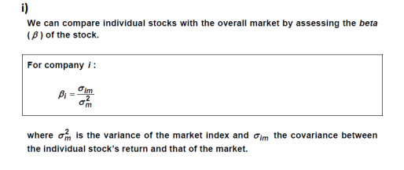
8)
ii) Different industry – inherent riskiness Geared Beta might be different because of different debt ratio Brand value Some stocks are used more for speculative purposes hence more volatile.
iii) Geared beta = Ungeared beta + (1+D/E * (1-Tax)) 1.1 = Ungeared beta + (1+1/2 * .7) Ungeared beta = 0.8148 New geared beta = 0.8148 + (1+2/2 * .7) = 1.385

10)
I)
SYSTEMATIC RISK: - Systematic risk refers to the risk inherent to the entire market or market segment. Systematic risk, also known as “undiversifiable risk,” “volatility” or “market risk,” affects the overall market, not just a particular stock or industry. This type of risk is both unpredictable and impossible to completely avoid. It cannot be mitigated through diversification, only through hedging or by using the correct asset allocation strategy
UNSISTIMATIC RISK: - unsystematic risk refers to the probability of a loss within a specific industry or security
II) Systematic risk can be defined as a type of total risk that arises as a result of various external factors such as political factors, economic factors, and sociological factors. Systematic risk is non-diversifiable in nature. This means that this type of total risk cannot be controlled or minimized or avoided by the management of an organization. A systematic risk has the tendency to disrupt not just the whole of the market but an economy too. The major sources of systematic risk are risks related to the market, purchasing power, and interest rate and the common examples of such type of risk are inflation, price movements, fluctuation in interest rates, rise in unemployment, etc.
On the other hand, unsystematic risk can be defined as a type of total risk that arises as a result of various internal factors taking place within an organization. Unsystematic risks are diversifiable in nature. This means that these types of risks can be controlled, minimized and even avoided by the management of an organization. Unsystematic risk has the tendency to disrupt the wellbeing of an organization and sometimes the industry too. The major sources of such risks are risks pertaining to finances, business, and insolvency and the common examples of the same are a higher rate of operational costs, a rise in labour turnover, etc.

11)
- The beta of a project is a measure of the systematic risk of the project relative to adiversified portfolio of all risky assets (ie the market). The market would have a beta of 1.

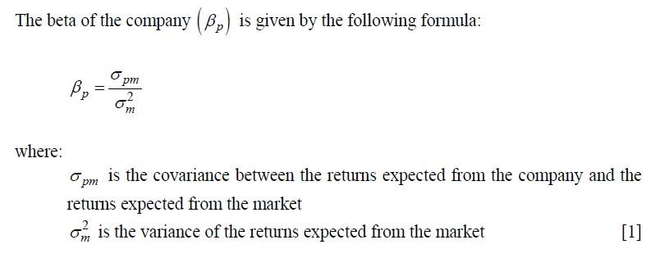

- The beta of the company may be measured by:
  - looking at the company’s historical returns on equity and comparing against market returns, but subject to significant variation for example dependent upon the time period considered
  - considering the industry beta based on a range of companies undertaking similar activities
  - estimating, based on knowledge of the company and its industry and how the industry might react to changes in the market

- A stock with a beta of 1 implies that the stock behaves in line with the market. Depending on expectations of market movements, as an aggressive investor, I may wish to invest in stocks with higher positive beta to maximize short-term gains.
A stock with a negative beta of 1 signifies that the stock behaves opposite to the market. If the market index improves, the stock will lose value and vice-versa. Is a downturn in the market is expected, low beta stocks may be attractive in the short to medium term.
- Cash

12)
Cost of equity = Risk-free rate + beta * Equity risk premium
= 7% + 1.5 * 5%
= 14.5%

Cost of debt = Cost of debt * (1-Tax Rate)
= 9% * (1 - 25%)
= 6.75%
WACC = 0.5 * 14.5% + 0.5 * 6.75%
= 10.625%
[2]

- Ungeared beta needs to be computed.

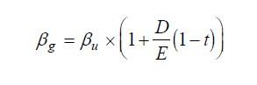
1.5 = Ungeared beta * (1 + 1/1 *(1-25%))
= Ungeared beta * 1.75

Ungeared beta = 1.5 / 1.75 = 0.857143
New cost of equity = Risk-free rate + Ungeared beta * Equity risk premium
= 7% + 0.857143 * 5%
= 11.29%

13)
Following is the date on a capital project being evaluated by management of X Ltd.

Annual Cost Saving | 40,000
Useful Life | 4 years
I.R.R. | 15%
Profitability index (PI) | 1.064
NPV | ?
Cost of capital | ?
Cost of project | ?
Pay back | ?
Salvage value | 0

Find the missing values considering the following table of discount factor only.
Discount factor | 15% | 14% | 13% | 12%
1 year | 0.869 | 0.877 | 0.855 | 0.893
2 years | 0.756 | 0.769 | 0.783 | 0.797
3 years | 0.658 | 0.675 | 0.693 | 0.712
4 years | 0.572 | 0.592 | 0.613 | 0.636
total | 2.855 | 2.913 | 2.974 | 3.03
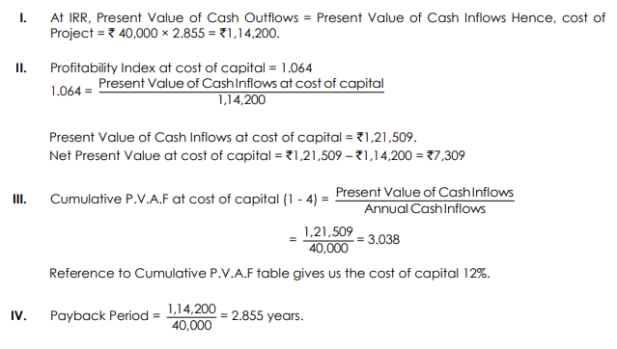

14)
i.

a)
Current Ratio:
Current ratio = 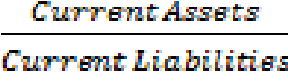

UTILITY:
1) To assess whether the company will be able to pay its bills over the next few months. It provides a comparison of an estimate of the amount of money due to be received in the short term with an estimate of the amount of money to be paid over the same period.
b) Debtors turnover period

Debtors Turnover period =× 365

UTILITY:
1) This is a measure of the average length of time taken for debtors (trade receivables) to settle their balance. It is desirable for this period to be as short as possible.

ii. The finance manager should track the quick ratio
Quick ratio = 

15
i)Investors will invest in the shares of this company:
- To diversify the portfolio( minimise systemic risk)
- To maximise return as they would be believing in earning higher returns( increasing idiosycratic risk)
- Other reasons specific to the investor eg strategic holding, personal attachment with the company, own faith and beliefs.
The suitable cost of capital is anything slightly higher than 6% (8%*0.5 + 4% * 0.5)
(ii)
Debt is cheaper than equity finance, so as gearing increases, the WACC should fall. However, increasing the proportion of debt finance increases the risk to shareholders so shareholders demand a greater return for this increased risk. Therefore beyond a certain level of gearing, the downward effect on the WACC of increasing the debt finance in the business will be more than offset by the increase in the return required by shareholders.

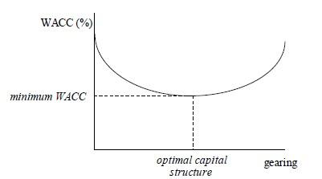
[3]

iii)
First proposition of Modigliani and Miller: The market value of any firm is independent of its capital structure.
The following are the assumptions:

- There are no taxes in the economy
- Unlimited personal and company borrowing is possible at the same rate of interest
- Debt is risk-free
- There are no agency costs
- There are no information asymmetries.

iv)

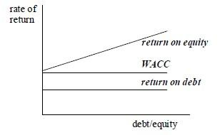

WACC remains constant as gearing increases. As gearing increases, the cost of equity increases by just enough to offset the increasing proportion of the cheaper debt.

v)
- cost of equity = risk-free return + beta * (equity risk premium)
=6% + 1.4 *5%
=6% + 7% = 13%

- Geared equity beta = Ungeared Beta * [1 + (Debt:Equity ratio) * (1 - t )]
Here the Debt:Equity ratio is based on market capitalisation, therefore,
Geared equity beta = 1.4 * [1 + (0.5/0.5) * (1 – 0.3 )]
= 1.4*(1+0.7)
=1.4*1.7
= 2.38

- Cost of equity = risk-free return + beta * (equity risk premium)
=6% +2.38*5% = 17.9%

