- For a derivative whose price at time t is f(t, St) where St is the price of the underlying asset,
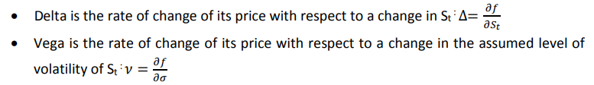
- Put-call parity states that: c + K*exp(-rτ) = p + S where c and p are the prices of a European call and put option respectively with strike K and time to expiry τ and S is the current stock price.
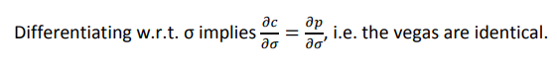

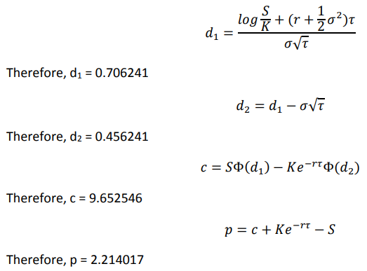
- A portfolio for which the overall delta (i.e., weighted sum of the deltas of the individual assets) is equal to zero is described as delta-hedged or delta-neutral. Such a portfolio is immune to small changes in the price of the underlying asset.
A portfolio for which the overall vega (i.e., weighted sum of the vegas of the individual assets) is equal to zero is described as vega-hedged or vega-neutral. Such a portfolio is immune to small changes in the assumed level of volatility.
- Let the required portfolio consist of x call options, y put options and z forwards.
The delta and vega for a forward are 1 and 0 respectively and there are no current cashflows.
Thus, for a single unit of each of them, we have:
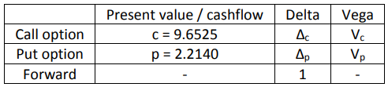
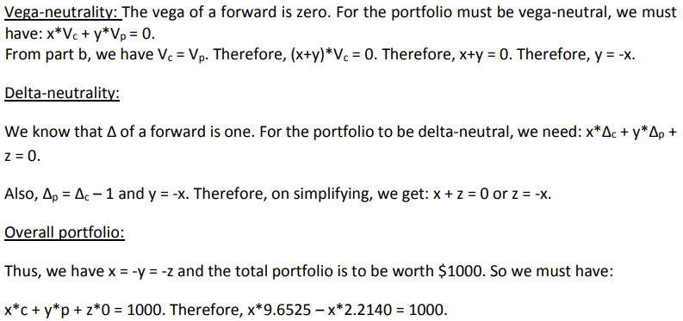
Therefore, x = 134.4, y = z = -134.4
So, our portfolio must consist of:
• Long position of 134 call options
• Short position of 134 put options
• Short position of 134 forwards

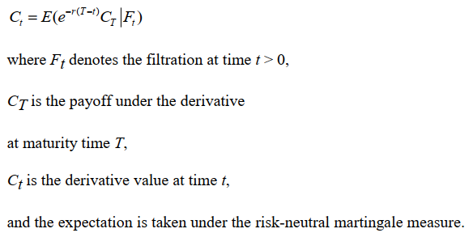

- The Black-Scholes formula returns:
d1 = 0.3441
d2 = 0.1673
N(d1) = 0.6346
N(d2) = 0.5664
- Same as European call (as the stock is non-dividend-paying), i.e., 4.66
- Using put-call parity (or otherwise):
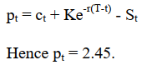
- If the stock is dividend-paying, the payment of the dividends would cause the value of the underlying asset to fall – which follows from the no arbitrage principle.
Alternatively: in valuing the option we must take account of the fact that dividends are payable on the underlying asset which do not feed through to the holder of the option.
The American call would now be more expensive than the European call due to potential early exercise opportunity.

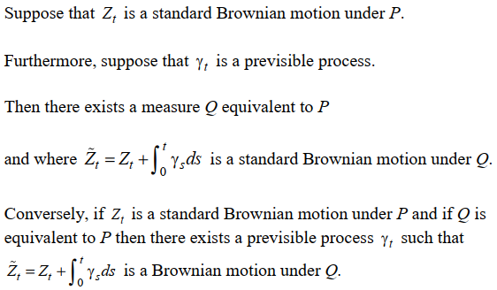
- Under the risk-neutral probability measure, the discounted value of asset prices are martingales.

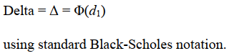

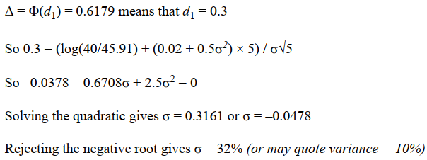

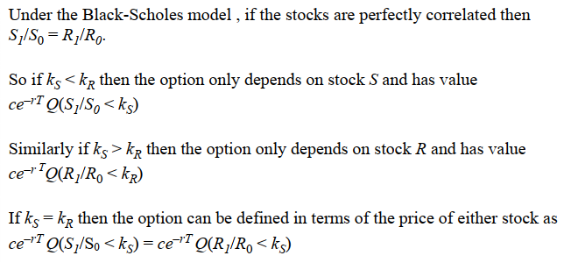
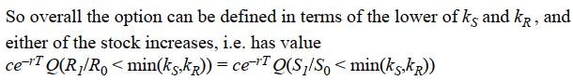

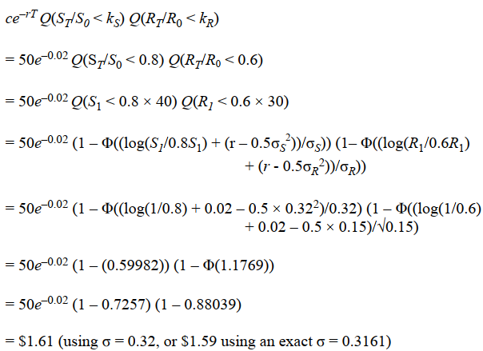

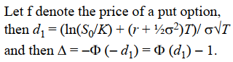
- In this case, we must have 100,000Δ= -24,830 and so Δ = -0.25

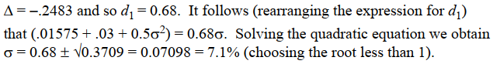

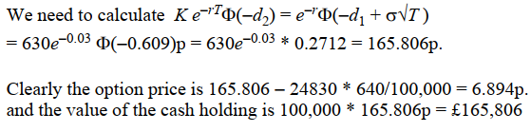

- Denote the individual derivative by f and assume this is written on an underlying security S.
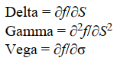
- Delta = 0.801
- The hedge is delta = 0.801 shares = and 17.91 – 0.801 * 60 = $30.15 short in cash.
- Using the approximation f(S, σ + δ) ≈ f(S, σ) + δdf/dσ, we obtain an option price ≈ 17.91 + 29.00 * 0.02 = $18.49.

- Δ is the first partial derivative of the option price with respect to the underlying asset price.
- Using the formula for the Δ, we see that Φ(d1) = 0.42074 and hence d1 =  0.2.
Solving the quadratic gives σ = 20% or 60% and rejecting the negative value gives σ = 20%.

- The PDE is the Black-Scholes PDE:
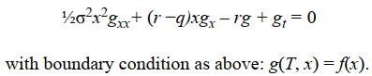

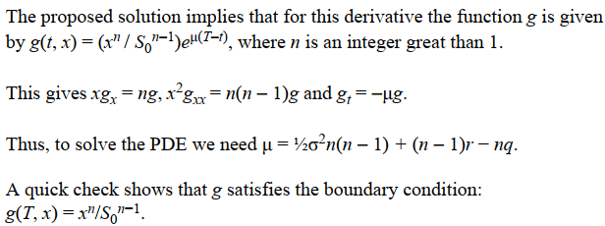

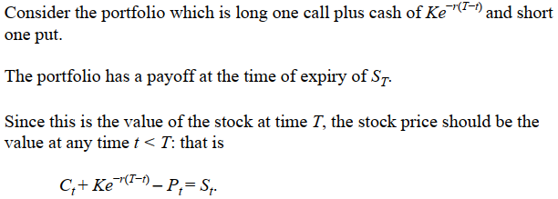
- This relationship is known as put-call parity.
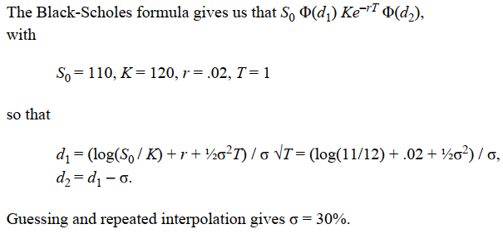

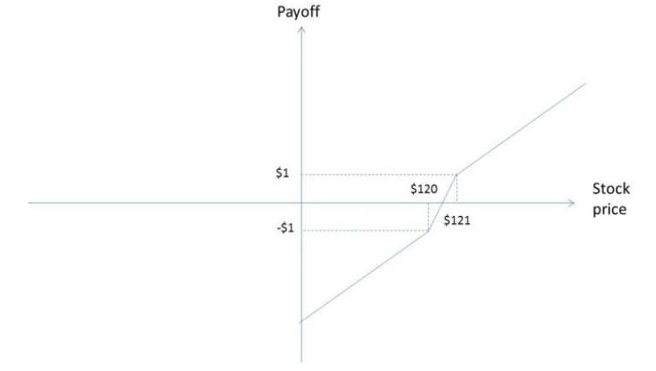

- The payoff from the portfolio, D, satisfies
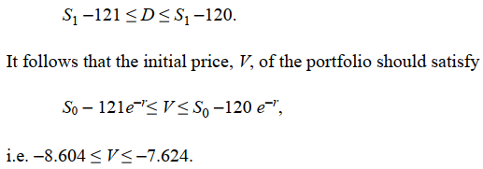
- And this implies that 17.714 ≤ P0 ≤ 18.694.
- The Black-Scholes price (using the formula in the tables) is $18.35.

