- The basis is defined as the difference between the spot and futures price. At date t, we have b(t) = S(t) −F(t)
Under the cost-of-carry model, the futures price can be expressed as F(t) = S(t) + C (t, T) −k (t, T) where C (t, T) is the net cost of carry that includes the accrued interest expense, storage and insurance costs less the accrued coupon or dividend yield. k (t, T) is the accrued convenience yield over the period [t, T]. Substituting equation (2) into equation (1) we obtain b(t) = k (t, T) −C (t, T)
Equation (3) states that the basis at date t consists of the positive accrued benefits associated with having the inventory on hand, k (t, T), less the accrued cost of carry. As time advances the basis changes. Let ∆b(t) represent the change in the basis over a small-time increment, and let ∆k (t, T) and ∆ C (t, T) represent the corresponding changes in the
convenience yield and cost of carry. Then ∆b(t) = ∆ k (t, T) −∆C (t, T)
The convenience yield is minimal for financial assets and investment commodities such as gold, or for consumer commodities in plentiful supply during the period [t, T], and the change in the basis is dictated by the change in the cost of carry term. This word is subject to change in a predictable manner. If interest rates remain constant, for example, the cost of carry term, C (t, T), gradually converges to zero.
Assume that maize stockpiles are now high across the country and that the convenience yield is minimal. The direct cost of carry determines the futures price in this scenario. S (0) = $2.06, F (0) = $2.15, and T = 3 months are the current spot and futures prices. The futures contract has a net carry of 9 cents over a three-month period, and the basis is b (0) = S (0) F (0) = $0.09. This carry shift reflects the changes in interest and storage. Assuming that this adjustment maintains steady over time, the monthly carry change should remain about 3 cents. If this assumption is correct, the base should be -6 cents in one month, -3 cents in two months, and converge to zero in the final month.
A convenience yield will be reflected in the basis for a consumer commodity that is now in short supply or is expected to be in short supply before the delivery date. Because of the possibility of major unforeseen changes in the convenience yield, the change in basis may be less predictable than the comparable change for a commodity with no convenience yield. Unanticipated imbalances between supply and demand, in particular, can cause considerable swings in the convenience yield, leading the basis to diverge from its forecast level.
When the basis approaches 0, it is said to be narrowing. When the basis advances away from zero, this is referred to as broadening. In practise, the basis seldom converges to zero smoothly. While the time series behaviour of spot and futures prices may exhibit substantial volatility, the pricing connection between the two generally results in a far more stable time series of the basis. Indeed, the volatility of the basis is typically much lower than the volatility of the spot or futures price. As we will see, the minimal base variability is critical for developing hedging strategies.
- A bullish position in a futures contract combined with a short position in a call option (covered call) (a)
The long position "protects" the investor from the payout on writing the short call, which is required if prices rise. If prices fall, the downside risk exists.
A short position in a futures contract combined with a long position in a call option (b)
A long position in a futures contract combined with a long position in a put option (protective put) (c)
A put option short position combined with a futures contract short position (d)
Profit payoffs from various techniques are depicted below.
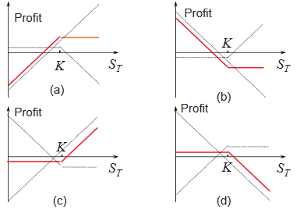
Take note of the parallels between these plots and the simple put and call techniques. To demonstrate, consider the following equation for defining put-call parity: p + S0 = c + K exp^(−rt) +D where p is the price of a European put, S0 is the price of a futures contract, c is the price of a European call, K is the strike price for both the call and put, r is the risk-free interest rate, T is the time to maturity of both the call and put, and D is the present value of the expected dividends over the life of the options.
Bull Spreads- Long and short positions on a call option, with the short position having a greater strike price (K2 > K 1).
- When prices rise between K1 and K2, the investor profits.
- This strategy reduces the investor's exposure to both upside and negative risk.
- The investor sells a call option in exchange for a portion of the upside risk.
- The expiry date for both choices is the same.
- The value of an option sold is always less than the value of an option purchased. Remember that the call price always drops as the strike price rises.
There are three types of bull spreads:
- Both calls are out of the money at first (lowest cost, most aggressive).
- Only one call is initially profitable.
- Both calls are initially profitable (highest cost, most conservative).
Bear Spreads- A bear spread may benefit an investor who expects the price to fall. The basic approach is to purchase a put with a strike price (K1) and sell another put with a strike price (K2), with K1 greater than K2.
- The strike price of the purchased put, on the other hand, will be higher than the strike price of the sold option.
Bull Spread Using Calls
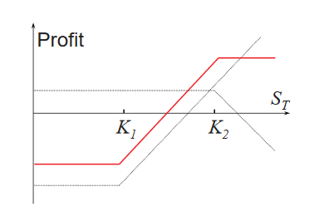
- Limit both your upward profit potential and your downside risk.
- Another sort of bear spread includes purchasing a high-strike call and selling a low-strike call.
Box Spreads- A bull call spread with strike prices K1 and K2 combined with a bear put spread with the same two strike prices.
- K2-K1 is always the whole payment. The spread's value is always the present value of the gap, (K2-K1) e(rt).
- If the value is different (not equal to the current value), there is an arbitrage opportunity.

