PAML ASSIGNMENT
Machine Learning is a field under artificial intelligence. It focuses on working with data and creating algorithms and models that learn gradually with experience and improves its accuracy. Statistical methods are accustomed to train models to make classifications and predictions. Then, based on the outputs meaningful insight is formed from the data.
There are three functions of a machine learning:
1. Descriptive: The systems use the data to explain what happened by finding patterns.
2. Predictive: The system trains itself and makes predictions on what can happen.
3. Prescriptive: The system will use the data to give out suggestions about what action can be taken.

There are 4 major categories to machine learning:
- Supervised Learning
- Unsupervised Learning
- Semi Supervised Learning
- Reinforcement Learning
Supervised Learning
Supervised Machine Learning is usually prediction with the help of models. Here, the input and the output is fed to the model and it is given an aim. The model tries to set parameters and predict the output based on statistical methods. Under supervised learning the goal is to train the model so that it can predict output when a new set of data is given to it. The models are trained using labelled data.
It can be classified in classification and Regression problems.
Examples:
- Logistic Regression
- Linear regression
- Multi-class classification
- Decision tree
- Bayesian Logic, etc.
Application
Predictive Analytics, Text recognition, Spam detection, Customer Sentiment analysis, etc.
Understanding Logistic Regression
Logistic Regression is a very popular machine learning technique. It is a supervised classification type algorithm. It is used to calculate and predict the probability of the independent variable which lies between 0 and 1. It predicts the output of a categorical dependent variable. We use a threshold value concept to make sense of the output. Example, Values above the threshold value tends to 1 and values below tends to 0.

Logistic function (sigmoid function)
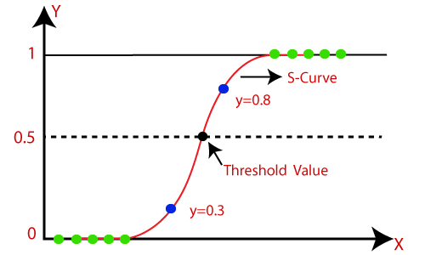

Unlike linear regression, we fit a logistic function to test the model. The sigmoid function is a mathematical function that maps the probabilities that have been predicted by the model. It maps values between 0 and 1 as probabilities can take values only between 0 and 1. The value of the variable cannot exceed these values hence a S like curve is formed which is called the logistic or sigmoid function.
Assumptions
The dependent variable is a categorical variable.
No multi-collinearity exists between the independent variables.
Logistic Regression Equation
The equation of straight line is:
$$y= b_{0}+b_{1}x_{1}+b_{2}x_{2}+…+b_{n}x_{n}$$
Y can only be between 0 and 1, hence we divide the equation by 1- y
$$\frac{y}{1-y} , 0 for y=0, and infinity for y=1$$
But we need range between -$∞ to+∞$
$$\log\left[\frac{y}{1-y}\right]= b_{0}+b_{1}x_{1}+b_{2}x_{2}+…+b_{n}x_{n}$$
The above equation is the equation for logistic regression.
Types of Logistic Regression
- Binomial: only 2 types of dependent variable. Example: 0 and 1, pass or fail, etc.
- Multinomial: 3 or more possible unordered types of dependent variable. Example: Type A, Type B or Type C.
- Ordinal: The dependent variable can have 3 or more ordered types. Example: Poor, good, very good. 0,1,2, etc.
Examples of logistic regression:
Fraud detection, diabetes prediction, etc.

Unsupervised Learning
Unsupervised machine learning is trained using unlabelled data. Here, only the input data is provided to the model. No supervision is required to train the model. Unsupervised learning is a self-learning algorithm, it can find the hidden patterns and provide with required output.
Unsupervised learning can be classified in Association and clustering problems.
Examples:
- KNN means
- K-means clustering
- Apriori algorithm
Application
Image Recognition, similarity detection, customer segmentation, product segmentation, etc.

Understanding K-Means Clustering
K-means clustering is an unsupervised learning algorithm which is usually used to solve clustering problems. Here, a cluster refers to a collection of certain data points that share certain similarities between them. A centroid refers to the centre of the cluster. We define a certain number for k which is the number of centroids. Every data point is allocated a cluster by reducing the in-cluster sum of squares and also data points in each cluster will have similarities. The means in the name refers to the averaging of data that is done to find the centroids.
The algorithm divides the unlabelled data input into k clusters and keeps repeating the process until it finds the best group oof clusters.
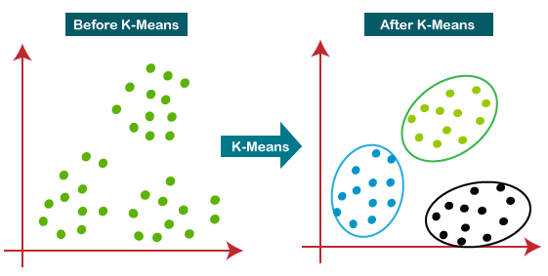

Steps for how k-means clustering works
Step 1: Decide K number of clusters
Step 2: Select random centroids
Step 3: Assign each datapoint to their closest centroid.
Step 4: Calculate variance and place a new centroid for each cluster.
Step 5: Repeat step 3
Step 6: check if reassignment is required.
Step 7: Model complete.
Understanding Image Classification and how it can be used by companies to reduce labour requirements
Image classification is the task of categorizing and assigning labels to groups of pixels within an image based on particular set of rules.
Image classification techniques are mainly of two categories: Supervised image classification and unsupervised image classification techniques.
Unsupervised Classification
It is a method where training the data is not required. With an appropriate algorithm, the right characters of an image are classified. Pattern recognition and image clustering are two main methods of classifications used. K-Means and ISO-data are two main algorithms for image classification.
With a high level of deep learning and AI excellent performance can be experienced from image classification algorithms.
If image classification is done by computers, it can process a greater number of images in a minute as compared to a human. This will eventually lead to companies saving money on labour.

Key differences between supervised and unsupervised learning
Supervised Learning | Unsupervised Learning
Input data used is labelled | Input data used is unlabelled
Input data is provided with the output | Only input data is provided
Takes feedback to check if the output is correct. | No feedback is taken.
The goal is to train the model and use it for prediction on new dataset. | The goal is to find hidden patterns and useful insights and perform analysis.
Categorized into classification and regression | Categorized into association and clustering.
Simple methods for machine learning. | Computationally Complex method.
Algorithms include Linear Regression, Logistic Regression, decision tree, etc. | Algorithms include k-means clustering, KNN, apriori algorithm.

