
statistical risk & modelling
2021

November 24, 2021
sayali dilip chinchwalkar
[ROLL NO: - 429]

- Importing data with the use of function read .csv and reading the data with the use of function head and view
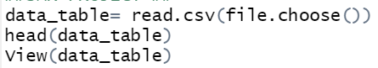

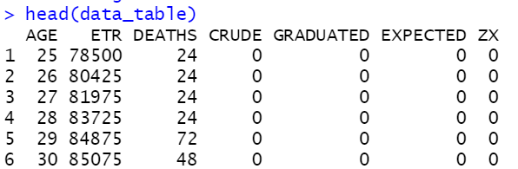
## filling the entries for crude rate.
The crude rate for each is calculate by dividing the number of deaths by the exposure to the risk.
data_table$CRUDE<- data_table$DEATHS/data_table$ETR
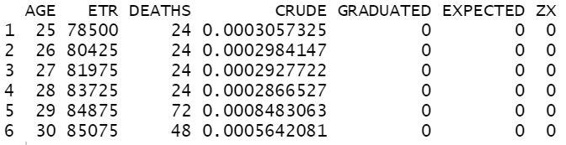
head(data_table)

- TO FILL THE ENTRIES FOR GRADUATED COLUMN
Fiiting gompertz law to the data
Basic equation of the gompertz mortality law is
$$μ\left(x\right)=BC^{x}$$
where μ(x) denotes the mortality rate at age x, In essence, the equation represents a force of mortality that increases progressively with age in such a manner that log μ(x) grows linearly.
The term B might be said to describe the ‘actuarial ageing rate’, in that its magnitude determines how fast the rate of dying will increase with the addition of extra years.

If we apply log on both sides, then it would be
Log $μ\left(x\right)=logB+xlogC$
NOW, IT has formed linear relationship between variables x and Log $μ\left(x\right)$
So, we can use lm function to fit the model
Firstly, estimating the value of parameter B &C
model_1<-lm(log(data_table$CRUDE) ~data_table$AGE)
# Crude rate of mortality is depended upon the age parameter, so here age is the independent variable.

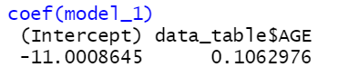
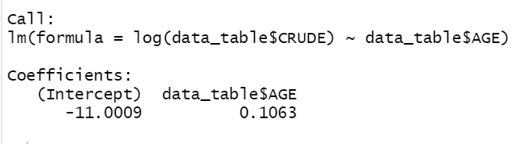
so, r has calculated the value of coefficient

parameter value of the model
Log = -11.0009 Log C = 0.1063
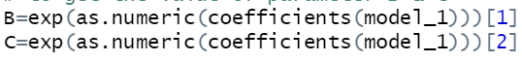
# TO REMOVE THE LOG FUCTION, WE HAVE USED EXPONENETIAL FUNCTION to estimate the value. as.numeric function to extract the numerical information from the model

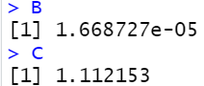
R has estimated the value of parameter

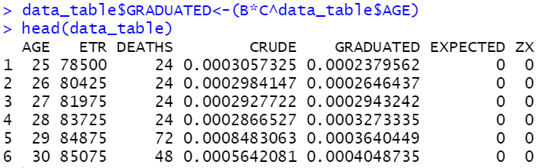

## now filling the entries of the graduated rate
Plotting crude rate vs graduated rate get the insight of the data.
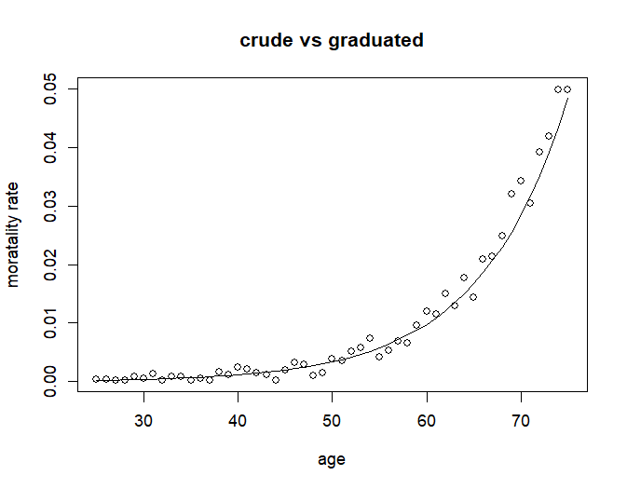

3)CHECKING FOR SMOOTHNESS
Performing test of smoothness to check the under graduation.so, to check the smoothness we have calculated 1st, 2 Nd and 3 rd. difference and for that diff () function have been used. followed this manner to calculate the difference.
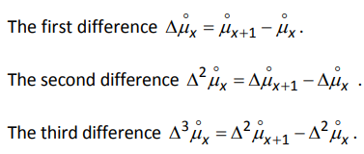
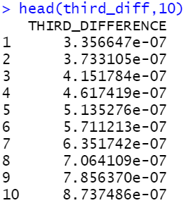
Following code have been used to find the difference with use of diff function
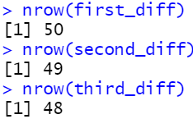

Conclusion: - The third difference of graduated quantities are small in magnitude compared with quantities themselves and they progress smoothly and regularly and true underlying rate are likely to be very close to the graduated rate.

Q.4) ENTRIES FOR EXPECTED DEATH AND ZX
Expected number of deaths at age x = exposure to the risk * graduated rates
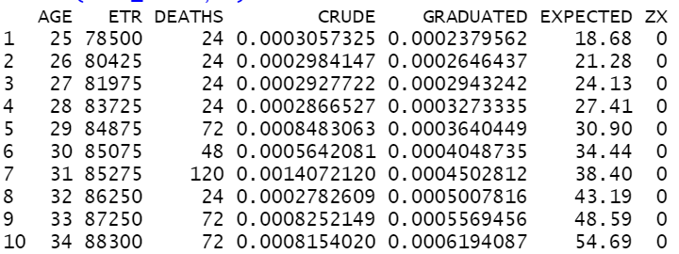
Whereas,
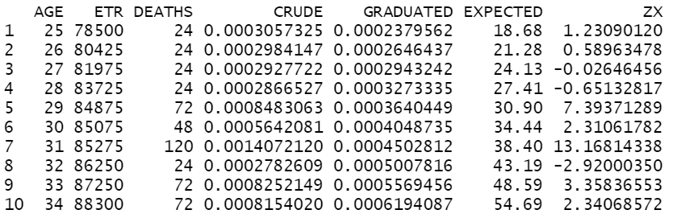
$Zx=\frac{Dx-Ex*μ^{°}}{\sqrt{Ex*μ^{°}}}$

PERFORMING CHI SQUARED TEST,
Chi2= sum ((observed -expected) ^2/expected)
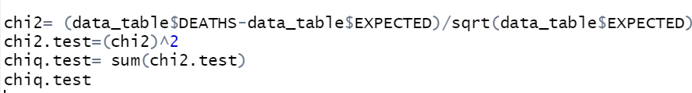
$Zx^{2}$= 2204.473
There are 51 ages, the graduated rates have been calculated by estimating 2 parameters. so, the number of degrees of freedom is 51-2= 49.
From the table, the upper 5% point for the chi square distribution with degree of freedom 49 is 66.399. The observed value od test statistic exceeds this, so we reject the null hypothesis,
So, we conclude that the mortality experience does not conform to a formula of the type assumed in the graduation. this indicates poor fit and over graduation.

5)
#a) STANDARDISED DEVIATIONS TEST
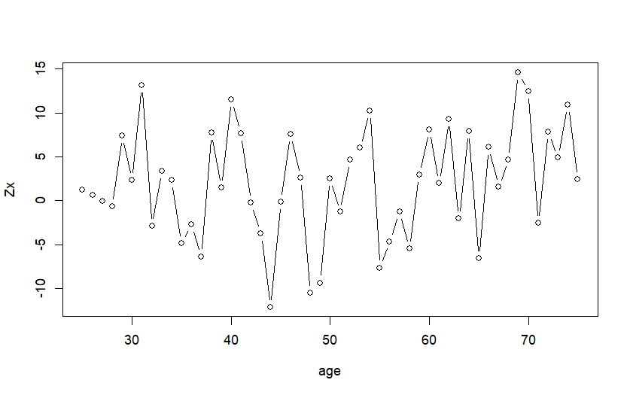

 | (-∞,-3) | (-3,-2) | (-2,-1) | (-1,0) | (0,1) | (1,2) | (2,3) | (3,∞)
expected | 0 | 1.02 | 7.14 | 17.34 | 17.34 | 7.14 | 1.02 | 0
observed | 10 | 4 | 2 | 3 | 1 | 4 | 6 | 20

#There is no such obvious pattern in plot of Zx
# Outliers are present
# Roughly equal number of positive and negative values are present
# There are 10 values in the range of (-3,2), (2,3), which indicate so it appears to be few values in the centre and too many values at the tail, which indicates the over graduation.

- OVERALL SHAPE: -
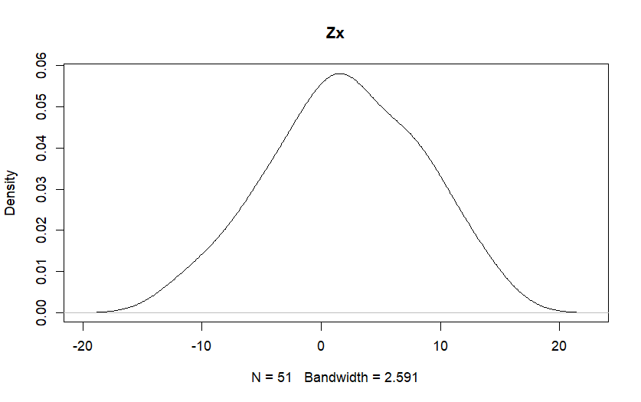
- Absolute deviation : - there are lot of values in the tails, the absolute deviations are too big which indicates the existence of duplicates.
- Outliers: - there should not be any values between the range (-∞, -3),
(3, ∞) but there are 30 values in this range, which state that’s outliers are present.
- Symmetry: - The distribution of the standardised deviations is fairly symmetrical, with 60% positive value and 40% negative values
- Final conclusion: - as the data contain the outliers, we reject the null hypothesis and which confirms that the deviations do not conform to a standard normal distribution.

b) SIGN TEST
to check whether the graduated rates are too high or too low, to identify the deficiency of the chi-squared test, i.e., failure to detect where there is an imbalance between positive and negative deviations. Under the null hypothesis sign test, state that positive sign distributed binomially.
so, firstly counting the number positive value and negative value
SO, THERE ARE 31 POSTIVE VALUE IN THE DATA,
TO FIND OUT P (p<31) using the function binom.test
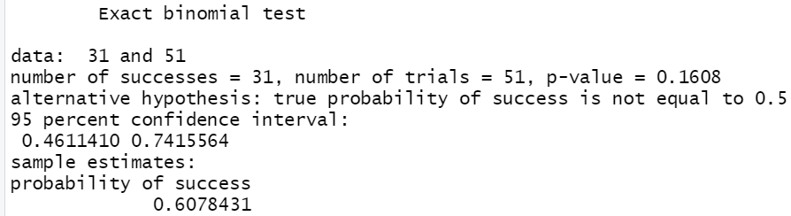
binomial_test=binom.test(31,51,0.5,alternative ="two.sided" )
Since the p -value is greater than 5%, there is insufficient evidence to reject the null hypothesis at the 5% significance level. So, we can conclude that the rates are not biased

c) CUMULATIVE DEVIATION TEST
This test can detect overall goodness of fit. It addresses the problem of the inability of the chi-squared test to detect a large positive or negative cumulative deviation over part (or the whole) of the age range.
#H0- cumulative deviation test does not provide any evidence that graduated rates are biased
#H1: -cumulative deviation test does provide evidence that graduated rates are biased
Cumulative = 18.83024
Conclusion: - This is two tailed tests, comparing the value of test statistic with 2.5% points of N (0,1) i.e., 1.96, so test statistic has exceeded the critical value we have enough evidence to reject the null hypothesis
So, cumulative deviation test does provide evidence that graduated rates are biased

D) SERIAL CORRELATION TEST: -
To test for clumping of deviations of the same sign. If clumping is present, then the graduation will have the wrong shape. If correlations are present, we would expect the effect to be strongest at adjacent ages or at ages separated by 2 or 3 years. Serial correlation is very powerful to detect the over graduation if it is present.

#H0: - Clumping of the same sign is not present
#H1: - clumping of same sign is present
z1x<-data_table$ZX[1:50]
z2x<-data_table$ZX[2:51]
h=cor(z1x, z2x)
h*sqrt (51)
h*sqrt (51)
[1] 1.055235
This value is less than the 1.6449, the upper 5% point of the standard normal distribution. So, we failed to reject the null hypothesis.

