Project Report with outputs and explanations
Rohil Goyal
Roll no 423
Part 1
The data was read into R using the read.csv() function. Crude rates were computed by dividing the deaths by the central exposed to risk at each age.
Part 2 – Gompertz Law
$$μ=BC^{x}$$
Taking log on both sides:
$$\log{μ= }logB+xlogC$$
A linear model was performed to predict log of the crude rates with respect to age.
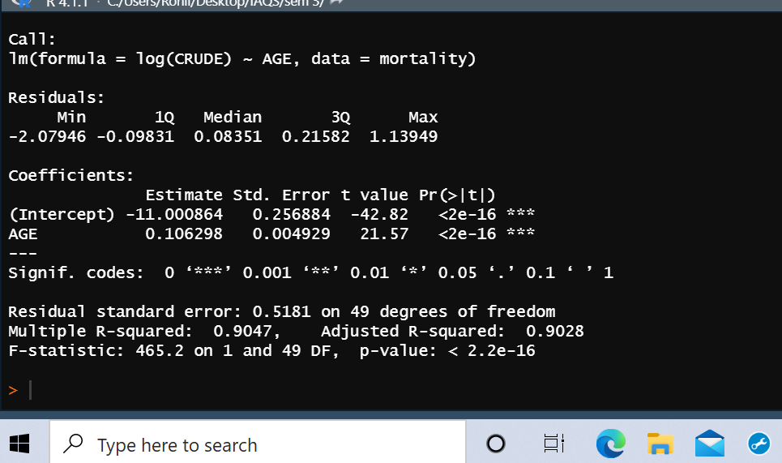
The intercepts were the estimates of logB and logC.
Exponents of the intercepts were calculated to determine the value of B and C. They were as follows:
> B
[1] 1.668727e-05
> C
[1] 1.112153
The value of these parameters was then used to estimate the graduation line.
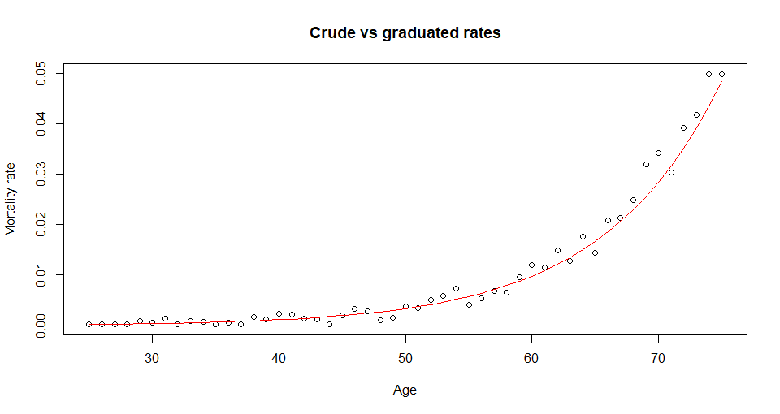
Part 3 – 3rd difference test
We ran a function to compute the third differences and then the output was combined to give us a data frame so we could easily analyze the data. The range of each of the columns was calculated and the output is as shown below.
Please note that all the values were multiplied by 10^6 for ease of visibility in trends.
> range_diff3_crude
[1] -19023.52 18881.68
> range_diff3_graduated
[1] 0.3356818 49.6201264
As clearly visible, the values for graduated rates are smaller in magnitude as compared to the values in the crude rates which indicates that the graph for graduated rates would be smoother.
Part 4 – Chi-squared test
The values of the Expected and Zx columns were filled using the required formulas. Then we ran a chi square test between crude rates and graduated rates to see goodness of fit.
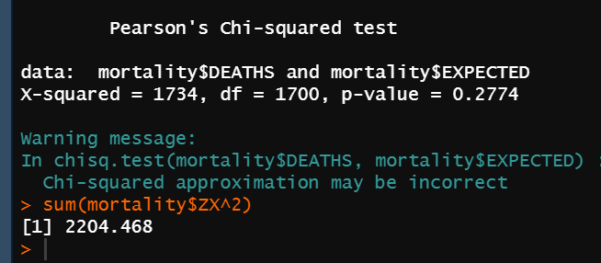
The p-value is greater than 0.05 which indicates that the model is not a good fit. We also tried summing up the square of the Zx values and the value of the test statistic is 2204.468 whereas it should be less than roughly 67.5 to be significant at the 5% level at 49 degrees of freedom. Hence our chi-square test rejects the graduation.
Part 5a – Standardised Deviations test
We compare our Zx values to a standard normal distribution. Then conducted a $χ^{2}$test using chisq.test function.

 | (-Inf, -3] | (-3, -2] | (-2, -1] | (-1, 0] | (0, 1] | (1, 2] | (2, 3] | (3, Inf)
Expected | 0 | 1.02 | 7.14 | 17.34 | 17.34 | 7.14 | 1.02 | 0
Observed | 9.996 | 3.978 | 1.989 | 3.978 | 1.020 | 3.978 | 6.018 | 19.992

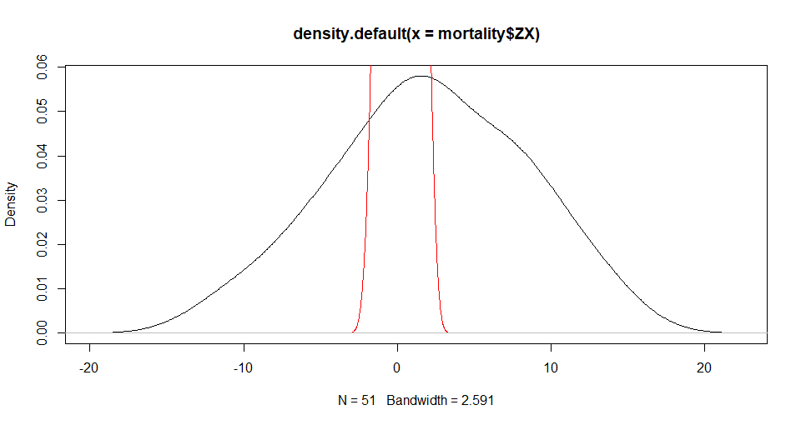
OVERALL SHAPE - The data shows that it is negatively skewed and has more values on the tail.
ABSOLUTE DEVIATIONS – The data is overgraduated and shows existence of duplicates as the absolute deviations are too big. This is proved by the fact that there are less than 50% values lying in the (-2/3 to 2/3) bin.
OUTLIERS – Too many outliers are present as close to 20% of the data lies in the (-infinity to -3) bin and 40% of the data lies in the (3 to Infinity) bin. Showing that the data has approximately 60% outliers.
SYMMETRY – The number of positive and the number of negative deviations are not close to 50% rather there are only 20 negative and 31 positive deviations. This shows that observed mortality rates do not conform to the model with the rates assumed in the graduation. The data shows nature of discrepancy.
H0 is that excessive deviations are present
H1 states that excessive deviations are not present.
$χ^{2}$test gives a p.value of less than 0.05 and as mentioned above as the p-value was very low we have insufficient evidence to reject H0 and therefore there are excessive deviations

Part 5b – Signs Test
There were 20 negative outcomes in our data.
H0 : there can be less than 20 negative values in a non-biased data
H1 : There can not be less than 20 negative values in a non-biased data
> pbinom(20.5,51,0.5) * 2
[1] 0.1607796
We accept our null hypothesis and claim that the data is not biased
Part 5c – Cumulative deviations test
> (sum(mortality$DEATHS)-sum(mortality$EXPECTED))/sqrt(sum(mortality$EXPECTED))
[1] 18.83024
The value should be less than 1.96. Since it is not so, and the value is a positive one, we can claim that the rates are not graduated enough.
Part 5d – Serial Correlations Test
The test was carried out at lag 1 and at lag 2. The first result is the answer for lag 1 and so on.
> cor(seq_1,seq_2) * sqrt(length(mortality$ZX))
[1] 1.055122
> cor(seq_3,seq_4) * sqrt(length(mortality$ZX))
[1] 0.6661249
As the test statistic value is less than 1.96, we have insufficient evidence to reject our null hypothesis hence we claim that no grouping of data exists.

