ASSIGNMENT 1 – SRM
Made By Sabyasachi Rathore
Roll No 434

Q1
i) A Stochastic Model has the capacity to handle uncertainties in the inputs applied. Stochastic models possess some inherent randomness - the same set of parameter values and initial conditions will lead to an ensemble of different outputs.
Advantages of stochastic models:
1) Stochastic models can reflect real-world economic scenarios that provide a range of possible outcomes you may experience and the relative likelihood of each.
2) By running thousands of calculations, using many different estimates of future economic conditions, stochastic models predict a range of possible future investment results showing the potential upside and downsides of each.

ii) The time spent in state H before the next visit to S has mean σ ^(-1)
Therefore a reasonable estimate for σ is the reciprocal of the mean length of each visit: = (Number of transitions from H to S)/(Total time spent in state H up until the last transition from H to S), although it would be equally valid to use the Maximum Likelihood Estimator, which is (Number of transitions from H to S)/(Total time spent in state H).
Similarly for 𝜌 .

Q2
i) Consider a Markov chain taking values in the set S = {i : i = 0, 1, 2, 3, 4}, where i represents the number of umbrellas in the place where the Actuary currently is (at home or office).
If i = 1 and it rains then he take the umbrella, move to the other place, where there are already 3 umbrellas, and, including the one he brings, therefore he will now have 4 umbrellas. Thus, p1,4 = p, because p is the probability of rain.
If i = 1 but does not rain then he do not take the umbrella, goes to the other place and find 3 umbrellas. Thus, p1,3 = 1 − p ≡ q.
However, if i=0, he must move to other place where 4 umbrellas are kept with probability
P0,4 =1
Similarly for other states. The process is depicted by the following diagram.
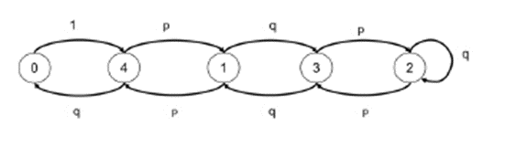
ii)
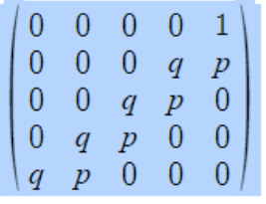
iii) For stationary distribution πP = π
Writing the equations:
π (0) = π (4).q ----1
π (1) = π (3).q + π (4).p ----2
π (2) = π (2).q + π (3).p ----3
π (3) = π (1).q + π (2).p ----4
π (4) = π (0) + π (1).p ----5
Substituting 1 in 5
π (4) =π (4).q + π (1).p => π (1) = π (4). (1-q)/ p
=> π (1) = π (4). p/ p => π (1) = π (4)
Substituting 6 in 2
π (1) = π (3).q + π (4).p => π (4) = π (3).q + π (4).p
=> π (3) = π (4).(1-p)/q => π (3) = π (4) ---7
Substituting 7 in 3
π (2) = π (2).q + π (3).p => π (2) = π (3).p/(1-q)
=> π (2) = π (3).p/(1-q) => π (2) = π (3). ----8
Substituting 6 & 7 in 4
π (3) = π (1).q + π (2).p => π (4) = π (1).q + π (4).p
=> π (1) = π (4).(1-p)/q => π (1) = π (4)
Therefore π (1)= π (2)= π (3)= π (4) = π (0)/q
But π (0) + π (1) + π (2) + π (3) + π (4) = 1, substituting in terms of π (4)
π (4).q + 4 π (4) =1
Therefore π (4) =1/(4+q) = π (1)= π (2)= π (3) and π (0) =q/(4+q)

iv) He will wet every time he happens to be in state 0 and it rains. The chance he is in state 0 is π (0). The chance it rains is p. Hence Probability that he gets wet.
P(WET) = Probability of being in state 0 and its raining
P(WET) =( 4/(4+q))p

v) P(WET) = 0.6*0.4/(4+0.4) = 5.45%
If he want the chance to be less than 1% then, clearly, he need more umbrellas. So, suppose he need N umbrellas. Set up the Markov chain as above and generalising, it is clear that
π (1)= π (2)= π (3)= π (4) …… = π (N) = π (0)/q.
But π (0) + π (1) + π (2) + π (3) + π (4) … π (N) = 1, substituting in terms of π N)
=> π (N).q + N π (N) =1
=> π (N) =
Therefore, probability of getting Wet P(WET)= p* π (0) =
For P(WET) < 1/100 =>pq/(N+q) < 1/100
N > 100*p*q – q ; given p = 0.6, q =0.4
Q3
i), ii)
Process | State Space | Time Domain
Counting Process | Discrete | Discrete or Continuous
General Random Walk | Discrete or Continuous | Discrete
Poisson Process | Discrete | Continuous
Markov Chain | Discrete | Discrete
Markov Jump | Discrete | Continuous

iii)
a) Number of times the account has been overdrawn since it was opened – Poisson Process / Counting Process
b) Status (overdrawn, in credit) of the account on the last day of each month – Markov Jump Chain/ Counting Process
c) number of direct debits paid since the account was opened – Poisson
d) Status (overdrawn, in credit) of the account at any time since the account was opened. Markov Jump Process

Q4)
i) Past history is needed to decide where to go in the chain.
If a sportsmen is at A and his/her performance reduces, you need to know what level of performance he was at the previous year to determine whether he or she drops one or two levels
ii) The B level needs to be split into two.
B+ is the level with no reduction in performance parameter last year
B- is the level with reduction in performance parameter last year
These levels are for modelling purposes and not the actual levels.
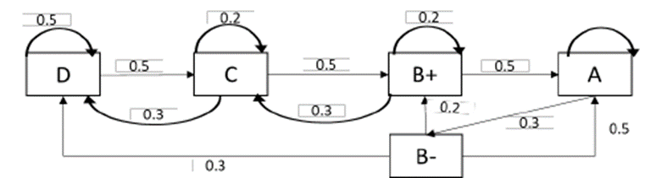
iv) The transition matrix is given by:
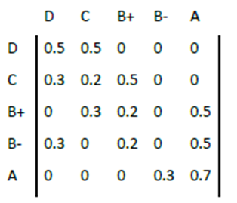
v) Stationary distribution:
The stationary distribution is the set of probabilities that satisfy the matrix equation
π = πP with and additional condition Σ𝜋𝜋𝑖𝑖 = 1
Written out fully, this set of matrix equation is
0.5𝜋𝜋𝐷𝐷+0.3𝜋𝜋𝐶𝐶+0.3𝜋𝜋𝐵𝐵− =𝜋𝜋𝐷𝐷 ---a)
0.5𝜋𝜋𝐷𝐷+0.2𝜋𝜋𝐶𝐶+0.3𝜋𝜋𝐵𝐵+ =𝜋𝜋𝐶𝐶 ---b)
0.5𝜋𝜋𝐶𝐶+0.2𝜋𝜋𝐵𝐵++0.2𝜋𝜋𝐵𝐵− =𝜋𝜋𝐵𝐵+ ---c)
0.3𝜋𝜋𝐴𝐴=𝜋𝜋𝐵𝐵− ---d)
0.5𝜋𝜋𝐵𝐵++0.5𝜋𝜋𝐵𝐵−+0.7𝜋𝜋𝐴𝐴 =𝜋𝜋𝐴𝐴 ---e)
Substituting (d) in (e)
0.5𝜋𝜋𝐵𝐵++0.5∗0.3𝜋𝜋𝐴𝐴+0.7𝜋𝜋𝐴𝐴 =𝜋𝜋𝐴𝐴
=> 𝜋𝜋𝐵𝐵+=0.3𝜋𝜋𝐴𝐴 …….(vi)
Substituting 𝜋𝜋𝐵𝐵+ 𝑎𝑎𝑎𝑎𝑎𝑎𝜋𝜋𝐴𝐴 in (c) we get
0.5𝜋𝜋𝐶𝐶+0.2∗0.3𝜋𝜋𝐴𝐴+0.2∗0.3𝜋𝜋𝐴𝐴 =0.3𝜋𝜋𝐴𝐴
=> 𝜋𝜋𝐶𝐶=0.36𝜋𝜋𝐴𝐴
Substituting 𝜋𝜋𝐵𝐵+,𝜋𝜋𝐶𝐶 𝑎𝑎𝑎𝑎𝑎𝑎𝜋𝜋𝐴𝐴 in (b)
0.5𝜋𝜋𝐷𝐷+0.2∗0.36𝜋𝜋𝐴𝐴+0.3∗0.3𝜋𝜋𝐴𝐴 =0.36𝜋𝜋𝐴𝐴 ---b)
=> 𝜋𝜋𝐷𝐷=0.396𝜋𝜋𝐴𝐴
Substituting all in Σ𝜋𝜋𝑖𝑖 = 1
𝜋𝜋𝐴𝐴+ 0.3𝜋𝜋𝐴𝐴+0.3𝜋𝜋𝐴𝐴+0.36𝜋𝜋𝐴𝐴+0.396𝜋𝜋𝐴𝐴=1
ð 𝜋𝜋𝐴𝐴 = 0.42445
ð 𝜋𝜋𝐵𝐵− = 0.12733
ð 𝜋𝜋𝐵𝐵+ = 0.12733
ð 𝜋𝜋𝐶𝐶 = 0.15280
ð 𝜋𝜋𝐷𝐷 = 0.1680 8

vi) Long run average contract value is
100% πD + 120% πC + 150% ( πB+ + πB- ) + 175% πA
= 1.4762 million USD
vii) Let mi be the number of transitions ( and years) taken to reach level A from any current level i. Then
𝑚𝑚𝐷𝐷=1+0.5𝑚𝑚𝐷𝐷+ 0.5𝑚𝑚𝐶𝐶 …..(a)
𝑚𝑚𝑐𝑐=1+0.2𝑚𝑚𝐶𝐶+ 0.5𝑚𝑚𝐵𝐵++ 0.3𝑚𝑚𝐷𝐷 .....(b)
𝑚𝑚𝐵𝐵+=1+0.2𝑚𝑚𝐵𝐵++ 0.5𝑚𝑚𝐴𝐴+ 0.3𝑚𝑚𝐶𝐶 .....(c)
𝑚𝑚𝐵𝐵−=1+0.3𝑚𝑚𝐷𝐷+ 0.5𝑚𝑚𝐴𝐴+ 0.2𝑚𝑚𝐵𝐵+ .....(c)
𝑚𝑚𝐴𝐴 = 0
from (a) we get, 𝑚𝑚𝐷𝐷=2+𝑚𝑚𝐶𝐶
substituting in (b) we get,
𝑚𝑚𝑐𝑐=1+0.2𝑚𝑚𝐶𝐶+ 0.5𝑚𝑚𝐵𝐵++ 0.3(2+𝑚𝑚𝐶𝐶)
𝑚𝑚𝐵𝐵+= 𝑚𝑚𝐶𝐶−3.2
substituting in (c) ,
𝑚𝑚𝐵𝐵+=1+0.2𝑚𝑚𝐵𝐵++ 0.5𝑚𝑚𝐴𝐴+ 0.3𝑚𝑚𝐶𝐶
𝑚𝑚𝐶𝐶−3.2=1+0.2(𝑚𝑚𝐶𝐶−3.2)+ 0.3𝑚𝑚𝐶𝐶
𝑚𝑚𝐶𝐶 = 7.12 years
Therefore, 𝑚𝑚𝐷𝐷 = 2+ 𝑚𝑚𝐶𝐶 = 9.12 years
( note: this is an expected value and need not be rounded to integer number)

Q5
i) There is an explicit dependence on the past behavior of {Yj: j≤n}
in the probability distribution of Yn+1; further, Xn is nothing
but the sum of Yj. Hence the Markov property does not hold.
ii) In part i), we show that there is explicit dependence on the past
behavior of {Yj: j≤n} and hence the Markov property does not
hold, this implies that that sequence {Yn ; n ≥ 1} does not form
a Markov chain.
iii)The transition matrix is given by:
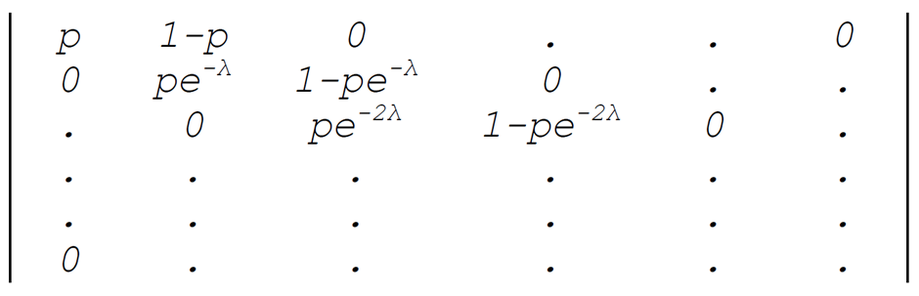
iv)
(a) The chain is time homogeneous since the transition
probabilities calculated in part i) is independent of time n.
(b) It is irreducible, since the number of errors can never go
down.
(c) There are no recurrent states; hence there can be no
stationary distribution.
Alternatively, if a stationary distribution π exists, it has
to follow:
π0p = π0
π0(1−p) + π1 pe^(−λ) = π1
π1(1−pe^(−λ))+ π2 pe^(−2λ) = π2
and so on.
Since p ≤ 1, we have π0 = 0 and then π1 = 0, etc. Hence, no
stationary distribution exists.
v) Probability of no further error is
(pe^(−jλ))n = pn e^(−njλ)

Q7
(a) The process may be expressed as a Markov chain by considering following states. Each state indicates the
current number of successive defeats.
State Number of successive defeats
1 0 – Not defeated last time
2 1 – Defeated in the last match
3 2 – Defeated in the last two matches
4 3 – Defeated in the last three matches
5 4 – Captain sacked
The transition matrix is as follows:
0.7 | 0.3 | 0 | 0 | 0
0.7 | 0 | 0.3 | 0 | 0
0.7 | 0 | 0 | 0.3 | 0
0.7 | 0 | 0 | 0 | 0.3
0 | 0 | 0 | 0 | 1

b) A Markov chain is said to be irreducible if any state j can be reached from any state i. The above process is not irreducible as the captain, once sacked, can never become the captain again.
(c)
(i) The probability of remaining the captain for exactly four matches is given by:
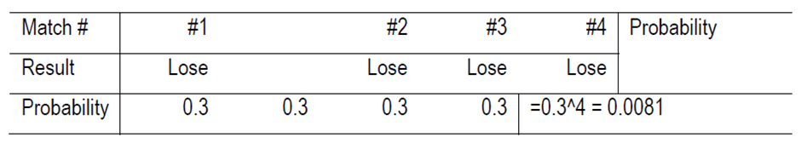
(ii) The probability of remaining the captain for exactly five matches is given by:
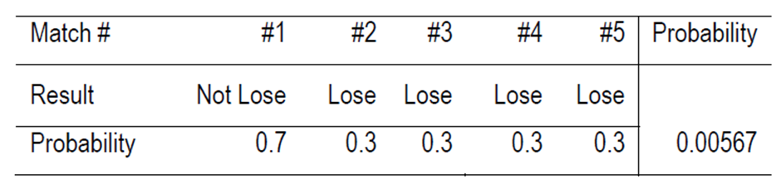
(iii) The probability of remaining the captain for exactly seven matches is given by:
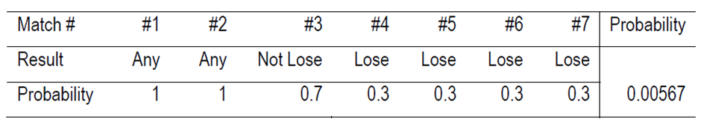
(iv) The probability of remaining the captain for exactly nine matches is given by:
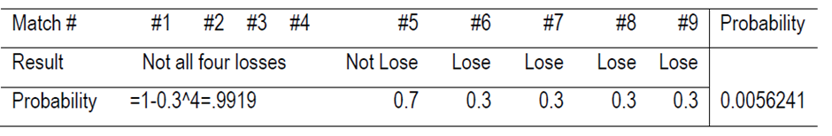
(d) Define Ni = Expected number of matches as a captain given that the current state is i. Since the captain is newly
appointed, the variable N in the question is N1 as defined here.
We have:
N1 = 1 + 0.7 x N1 + 0.3 x N2
N2 = 1 + 0.7 x N1 + 0.3 x N3
N3 = 1 + 0.7 x N1 + 0.3 x N4
N4 = 1 + 0.7 x N1
Solving the above equations; we get:
N4 = 123.46
N3 = 160.49
N2 = 171.60 and
N1 = 174.94
Therefore, E(N) is 174.94 matches.
Q9
a) The state transition diagram is set out below:
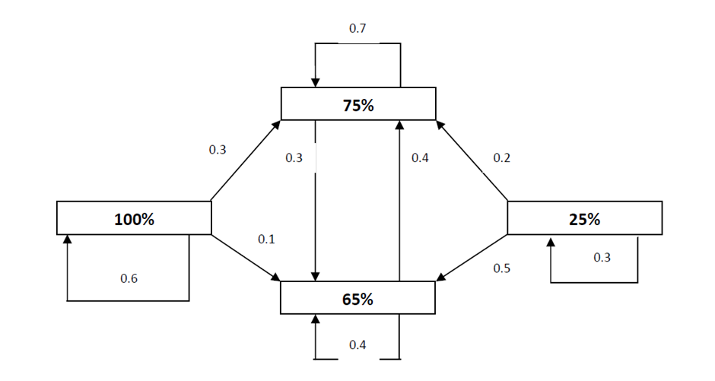
b) We are to calculate for the % of corporate buyer having a target % for XYZ of 65%
• In 2 years’ time
• Over the long-run.
The state of the system after one-year S1 = S0P
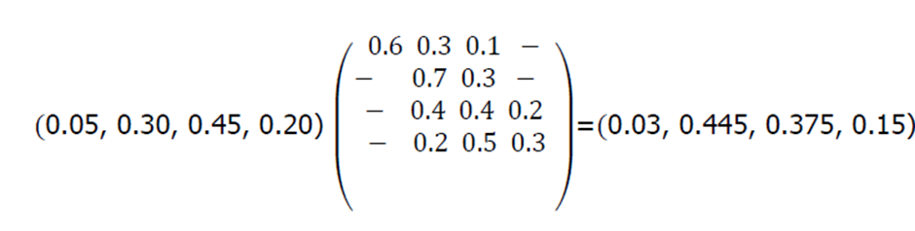
Hence the state of the system in 2 years’ time S2 = S1P
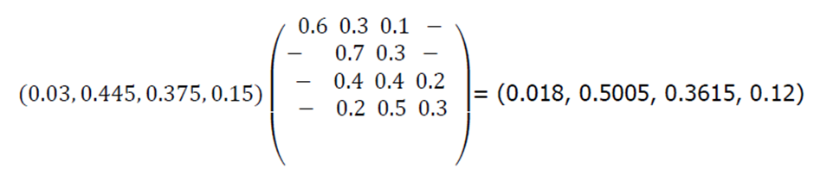
Hence the % of corporate buyer having a target % of 65% for XYZ in 2 years’ time is
36.15%.

The long run steady state can be found by solving the following equation:
S = SP
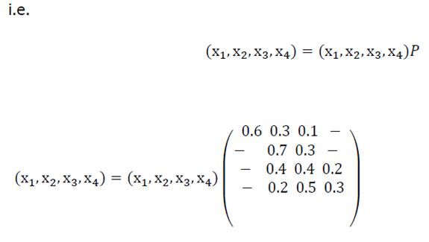
Hence, we have the five equations-
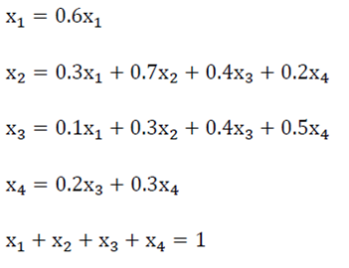
Now from the first equation above,
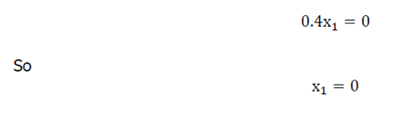
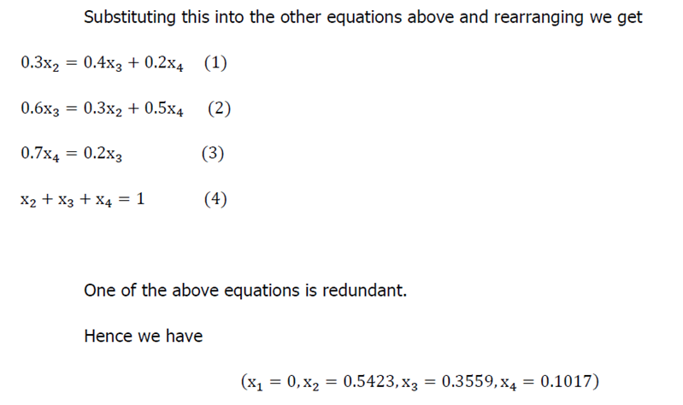

c) The steady state proportion of customers having a 65% target allocation for XYZ Ltd is 35.59%.
It is noted that the initially this proportion is 45% and it quickly drops to:
• 37.5% in one year’s time; and
• 36.2% in two years’ time
It is, therefore, likely that the steady state shall be reached in a few years’ time.
Q11
i) If each room is represented by the state, then the transition matrix P for this Markov chain is as follows:
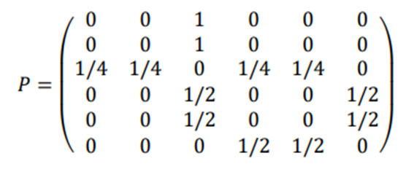
ii) The chain is irreducible, because it is possible to go from any state to any other state. However, it is not aperiodic, because for any even n, 𝑃6,1 𝑛 will be zero and for any odd n 𝑃6,5 𝑛 will also be zero. This means that there is no power of P that would have all its entries strictly positive.
iii) For P to be stationary, πP = P
Perform matrix multiplication and show that π P is equal to P
iv) We find from π that the mean recurrence time (i.e. the expected time to return) for the room 1 is 1/π(1)=12
- v) Let, ψ(i) = E(number of steps to reach state 5 | X0 = i). We have ψ(5) = 0 ψ(6) = 1 + (1/2)ψ(5) + (1/2)ψ(4) ψ(4) = 1 + (1/2)ψ(6) + (1/2)ψ(3) ψ(3) = 1 + (1/4)ψ(1) + (1/4)ψ(2) + (1/4)ψ(4) + (1/4)ψ(5) ψ(1) = 1 + ψ(3) ψ(2) = 1 + ψ(3). [1.5] We solve and find ψ(1) = 7.

Made By – Sabyasachi Rathore
Roll No. 434

