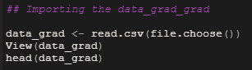
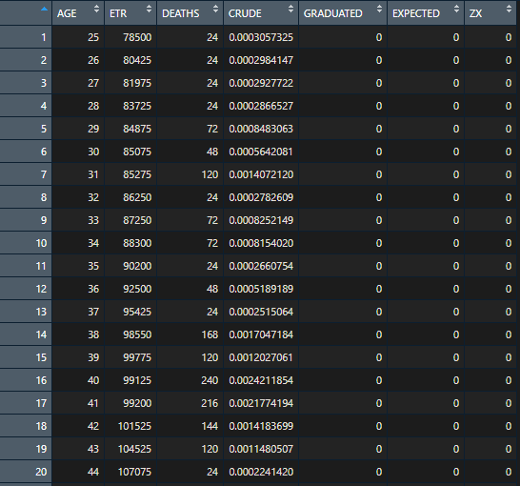
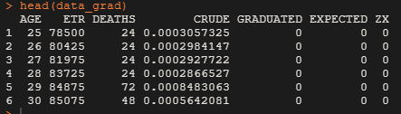

Q1. Read in the data file as a data table & fill in the entries for the CRUDE column in your table.
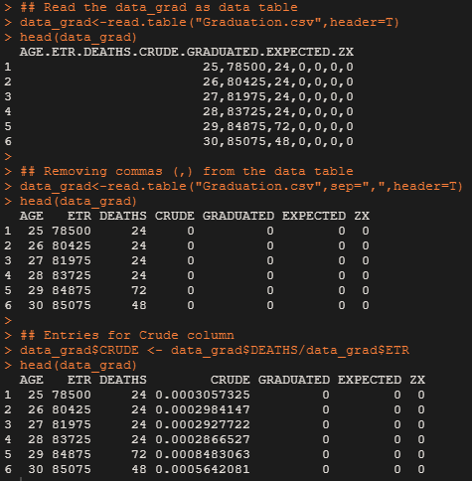

Q2. Use Gompertz law to fill entries in the GRADUATED column in the data.
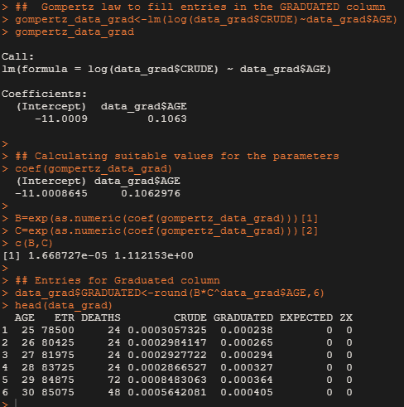

Q3. Check for smoothness by applying the third differences to the crude and graduated rates and comment on your results.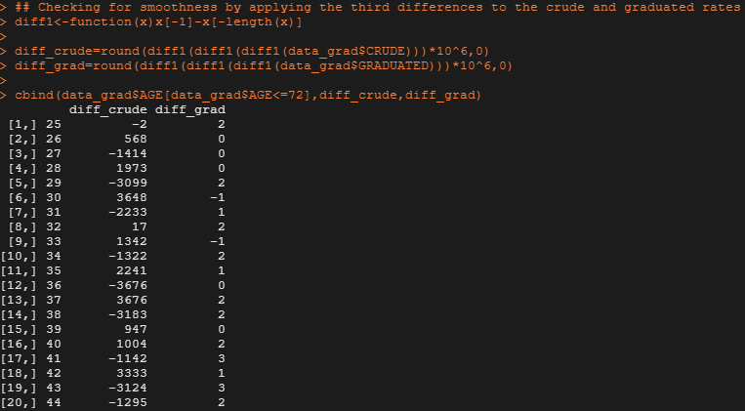
## We can see that from the table that the third differences of the
## crude rates are much larger in magnitude (max = 19024) and progress is peculiar
## This is to be expected, since they are calculated directly from the deaths,
## which contain a significant random element.
## The third differences of the graduated rates are all very small (max = 40) and progress regularly.
## This is to be expected, since they have been smoothed using a simple
## parametric formula with just two parameters.

Q4. Calculate the values in EXPECTED and ZX values in the table. Hence, perform a chi-squared test to check goodness of fit between DEATHS and EXPECTED. You should specify the degrees of freedom used.
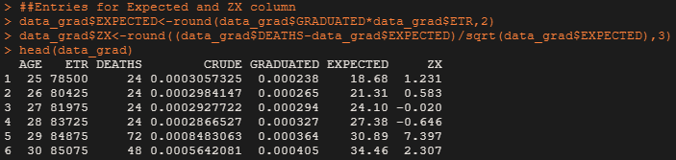
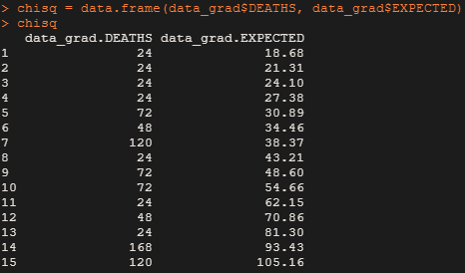
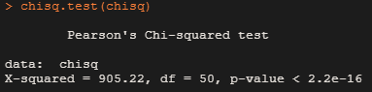

Q5. a. Perform the standardized deviations test on the individual deviations, and comment on the: i. Overall shape
ii. Absolute deviations
iii. Outliers
iv. Symmetry
v. Final conclusion about Null hypothesis
b. Perform the Signs test and give your conclusion.
c. Perform the Cumulative deviations test for the entire age range and give your conclusion.
d. Perform the Serial correlations test and give your conclusion.
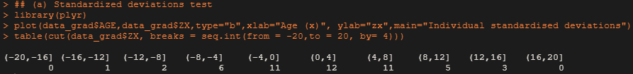

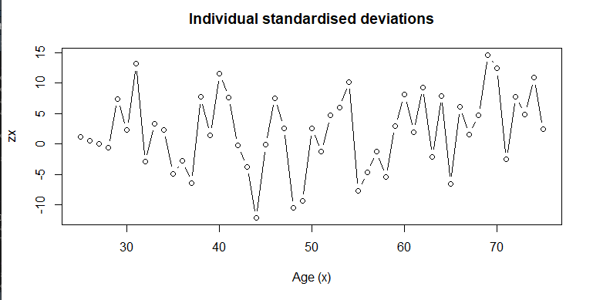
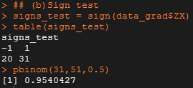
## Since it's a two tailed test, at 5% significance level,
## We accept the NULL hypothesis that the data_grad is a true representation of the underlying mortality rates.

