Introduction to Derivatives and Financial Markets Project – Report

By – Shriya Katakam, 403 (Statement 1)
and Priyanshu Mehta, 432 (Statement 2)
Hedging using futures
A hedge is taken to protect from losses rather than earn profits.
Futures are financial instruments which obligate the parties to transact on a predetermined date at a predetermined price.
Hedging using futures is investing in futures to lock into a favorable position in advance of the transaction. The main advantage for investors looking to participate in a futures contract is that it removes the uncertainty about the future price of a commodity, security, or a financial instrument.
- Short Future Hedge:
- price increase in underlying: Possibility of a loss as the future price maybe lower than the underlying price. This is also if hedge doesn’t cover cash changes.
- Price decrease in underlying: Possibility of profit as the futures price maybe higher than underlying. Gain potential if basis strengthens
- Long Future Hedge:
- Price increase in underlying: Possibility of profit as the futures price maybe higher than underlying. There exists a gain potential if the basis is weak.
- Price decrease in underlying: Possibility of a loss as the future price maybe lower than the underlying price. This is also if hedge doesn’t cover cash changes.

Statement 1
“Hedging using futures can potentially eliminate volatility for any movement in underlying hedged item”
While creating a hedge using a future at the price is predetermined any potentially volatility will be eliminated. As irrespective of the current price of the underlying item the predetermined price is fixed. Though this is possible only in a situation where Futures position would have a 100% inverse correlation to the initial position.
Hedging using futures would be in two cases Short and Long.
- Short: A futures position when one knows he will sell in the future and protect against a possibility of drop in the price of item. Now as the sale price is predetermined even if the price of the underlying falls, the sale price remains the same.

For example, if an underlying asset costing $100 now were to sold after 3 months and the futures price is $100. When the futures position is closed in three months’ time the asset is sold at $100. Even if the price of the asset fell to $98 or raised to $102.

Here the Volatility of the underlying asset is eliminated due to the predetermined price.

- Long: A futures position when one knows he will buy in the future and protect against a possibility of hike in the price of item. Now as the sale price is predetermined even if the price of the underlying rises, the buy price remains the same.

For example, if an underlying asset costing $3000 now were to be brought after 3 months and the futures price is $3000. When the futures position is closed in three months’ time the asset is bought at $3000. Even if the price of the asset fell to $2598 or raised to $4367.

Here the Volatility of the underlying asset is eliminated due to the predetermined price

---------------------------------------------------------------------------------------------------------------------------

Statement 2: Hedging using options can eliminate the downside volatility of the price movement in the underlying asset at an associated cost.
Inference: -
Let’s first begin with understanding the various aspects of the above given statement.
Part 1- Hedging using options
It quite often is the case that several businesses need to insure themselves against any form of uncertain and unpredictable price movements/fluctuations. It either could be due to some deal they are to pursue or any liability they are to repay.
Over and above businesses, some individuals too could have a part of liability which they are to repay in due course.
In all afore mentioned scenarios, hedging the uncertain and probable risk in price movements using options is the way to go.
Hedging perhaps could be put across as an investment in an instrument that protects your portfolio from adverse price movements.
A put option thus surfaces to be the best and most convenient possible hedging strategy. We’ll however come across different scenarios further touching upon various such strategies mitigating down side risk.
Part 2 - eliminate the downside volatility of the price movement in the underlying asset
Downside price movement volatility is what most businesses are concerned with since that would consist of risk of the actual returns/growth from the asset being lower than the expected return/growth. This is what companies aim to eliminate and if elimination isn’t possible, mitigate to the extent possible. Options [in addition to other derivative instruments] prove to be one of the best mediums to mitigate such unfavourable results.

Part 3 - associated cost
By associated cost, we prima facie refer to the premium amount that is charged and paid out as an option [contract entering] fee through which the insurance discussed earlier could be secured.
This fee however is lost in scenarios wherein the option isn’t exercised due to market price movements being unfavourable.
However, another point to note is that this cost is paid upfront by the holder which frees him of any potential liability. But moreover, the liability lies over the option contract writer till the contract maturity due to no upfront fees’ payment.

Let me furthermore walk you through several instances which throw some light over the above statement.
Instance 1:
[In all the following strategies, we would be aiming to eliminate the downside risk to the maximum level possible.
The investor’s mindset is assumed to bullish in nature.
Also, all strategies are formed from individual investor’s point of view since option strategies best suit this class of investors]
---------------------------------------------------------------------------------------------
Strategy name: LONGING THE STOCK and LONGING THE PUT.
*Also know as Synthetic call / Protective Put wherein goal is to limit loss due to unexpected price drop
Let’s suppose an investor named Mr. X longs [i.e., buys] an ITC share traded at 226 over the exchange. He as such does so with a bullish mindset.
However, he even believes that the stock due to a managerial conflict or a break down in company BoD, could plunge down explicitly affecting the bullish mindset previously held.
He therefore undertakes the following options strategy to eliminate ITC downside risk to the best extent possible.
- Long ITC share at INR226
- Long ITC put at Strike INR226 for INR15
Payoff table for the same – [table projecting profit at different scenarios, net of loss eliminated]
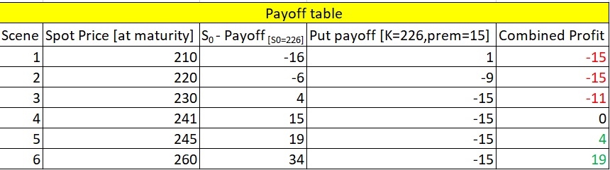
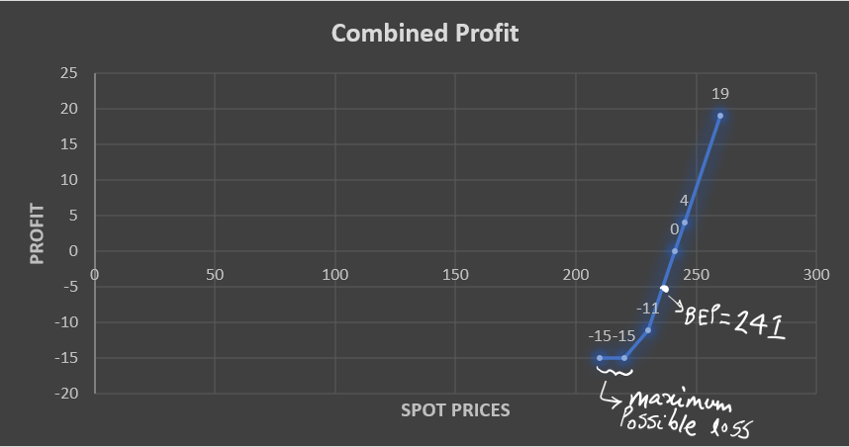
CONCLUSION: - The above profit payoff table and chart help us understand about how the loss is eliminated with limiting it to INR (15). The investor perhaps starts earning profit beyond INR 241 which is the BEP for ITC share.

Instance 2:
Strategy name: LONG lower strike call and SHORT higher strike call.
*This strategy is famously also known as Bull Call spread.
Let’s suppose that we hypothetically have another investor named Mr. Y who wishes to eliminate the down-side risk associated with price movements of HDFC Bank Ltd. He decided the same by doing some basic analysis online and providing us with the following data points-
[We understand that the spot price is INR1606 with a price volatility of 1.5%]
This helps Mr. Y easily decide the strike prices he must use for his Bull call spread on basis of the current volatility.
He therefore undertakes the following options position to eliminate HDFC Bank Ltd downside risk to the best extent possible.
- Buy HDFC call at strike 1580 for 30. [Since 1606*(1-0.015) =1581.91 and we buy ITM so taking strike 1 as 1580]
- Sell HDFC call at strike 1631 for 25. [Since 1606*(1+0.015) =1630.09 and we sell OTM so taking strike 2 as 1631]
Payoff table for the same – [table projecting profit at different scenarios, net of loss eliminated]
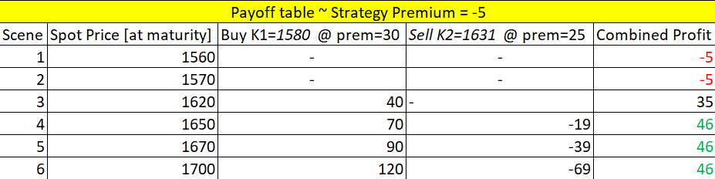
Payoff Chart consisting of minimum loss and maximum profit projection from the Bull call strategy-

CONCLUSION: - The above profit payoff table and chart help us understand about how the loss is eliminated with limiting it to INR (5). The investor i.e., Mr. Y however is able to make a maximum profit of INR46 only. This proves how option strategies are even capable of pacifying the profit potential.

***
Thank you!

