- Writing the state space in the order {Bid (B), Offer (O)}, the generator matrix is:
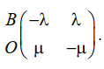
- The holding times are exponentially distributed with parameter λ in state B, and μ in state O.

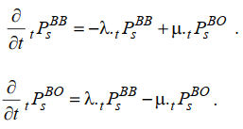
- We have a two-state model so:
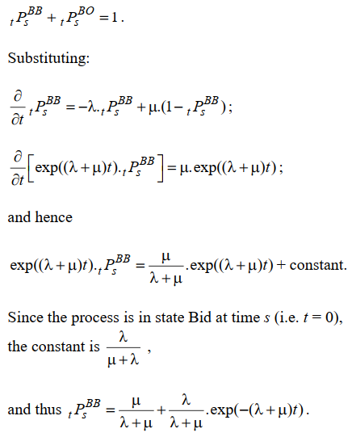

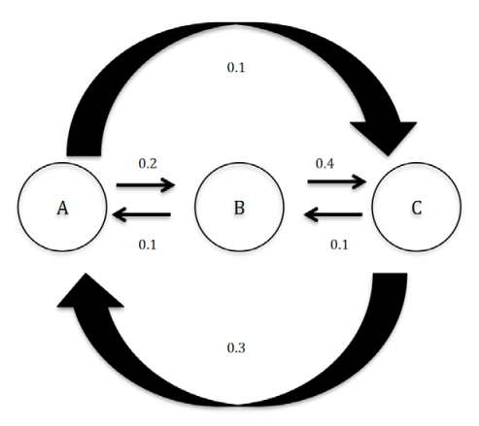

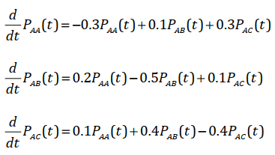

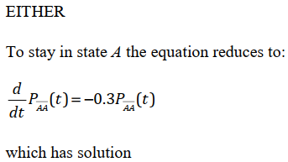
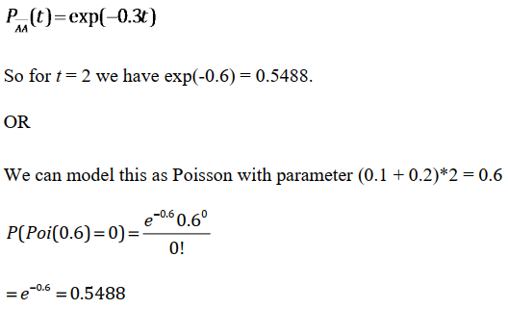
- The only paths under which the third jump is into state C are BAC, CAC
and CBC.
The probabilities of each jump are given by the ratio of the transition rates.
So, the probabilities for each path are:
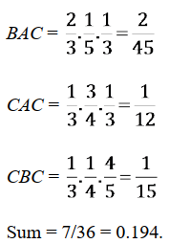

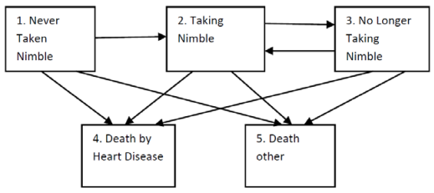
- Using the Markov assumption
OR
the Chapman Kolmogorov equation is
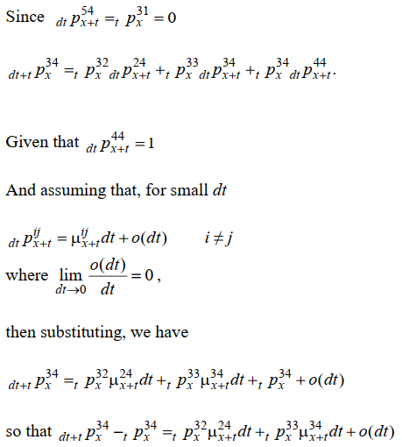

- The mean is equal to the parameter, so there are 3 calls per hour.
- The process is memoryless so the fact that Fred has not had a call for
15 minutes is irrelevant.
Expected time until next call is 20 minutes.

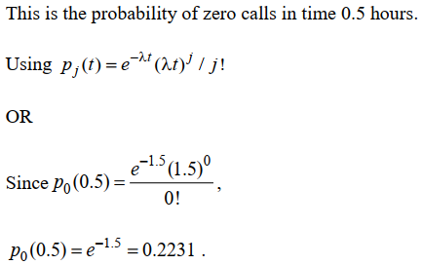
- The expected time that Fred is on the phone is the expected number of
calls times the expected length of a call.
Per hour this is 3 calls times 7 minutes = 21 minutes.
So, the probability that the phone is engaged is 21/60 = 0.35.

- EITHER
Using the Markov assumption,
OR
The Chapman Kolmogorov equation is
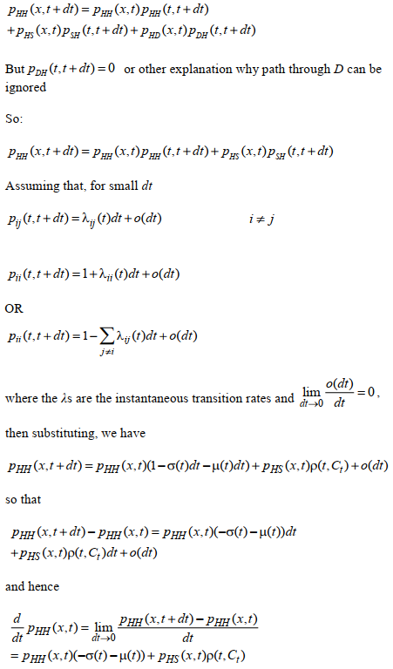

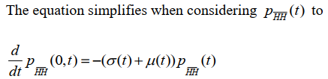
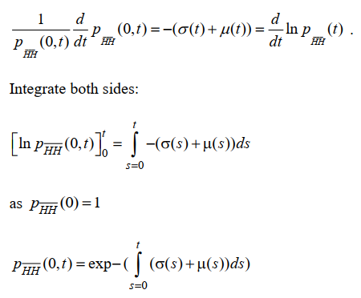
- All three processes have a discrete state space.
A Markov Chain and Markov Jump Chain both operate in discrete time but a Markov jump
Process operates in continuous time.
All have the Markov property which is
EITHER that the future development of the process can be predicted from its present state alone, without reference to its past history.
OR that
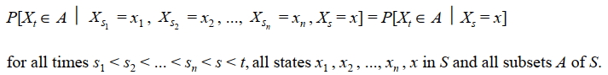
EITHER if a Markov Jump Process X is examined only at the times of its transitions, the resulting process is called the Jump Chain associated with X.
OR for a Jump Process X the Jump Chain X shows the states visited by X, taking an identical path through the state space.
The Jump Chain obeys the Markov Property and behaves as a Markov Chain except when the Jump Chain encounters an absorbing state. From that time, it makes no further transitions, implying that time stops for the Jump Chain.
The Jump Chain associated with X takes the same path through the state space as X does. However, questions about the times taken to visit a state are likely to have different answers for X and for the Jump Chain associated with X.
The Markov Jump Chain and the Markov Chain are expressed in terms of probabilities
whereas the Markov Jump Process is expressed in terms of rates.
The Markov Chain can have loops in each state, the Markov Jump process cannot and the
Markov Jump Chain only has loops on absorbing states.

- The maximum likelihood estimates of the transition intensity from state i to state j is the number of transitions from state i to state j divided by the total waiting time in state i.
To estimate the transition intensities exactly we therefore need
the total time spent in each state
OR
entry and exit times for each individual for each state,
and the total number of transitions of each type made.

Then EITHER
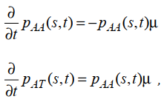
OR
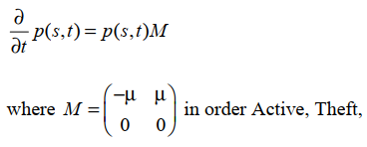
OR
Integrated forward equations:
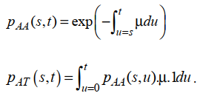
- Measure from time zero i.e., s = 0 and drop s from notation.
EITHER
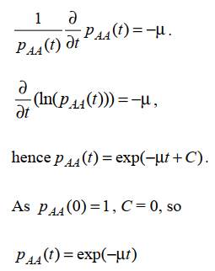
A claim occurs with cost £C if moves to state “Theft Claim”.
Hence the expected cost is C (1 exp(-µT))
OR
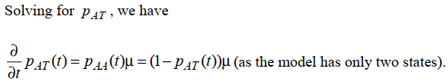
Using an integrating factor, we can write
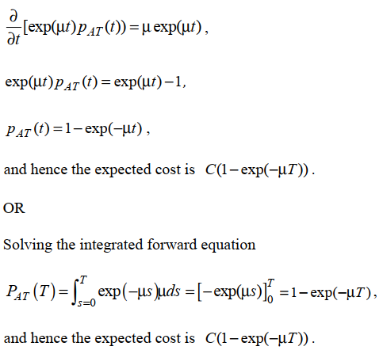

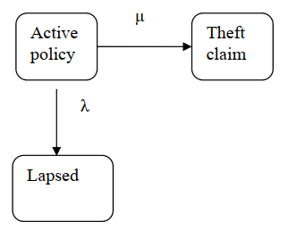

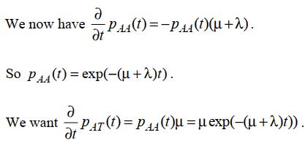

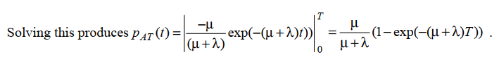
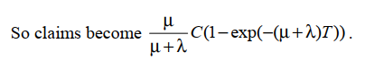

- {0,1,2,3,4….}

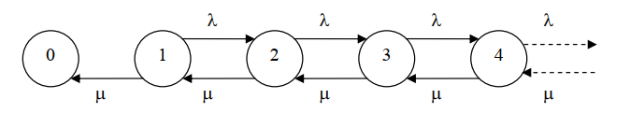
- Generator matrix
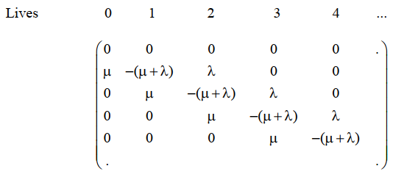
- EITHER
If a Markov jump process Xt is examined only at the times of transition, the
resulting process is called the jump chain associated with Xt
OR
A jump chain is each distinct state visited in the order visited where the time
set is the times when states are moved between.

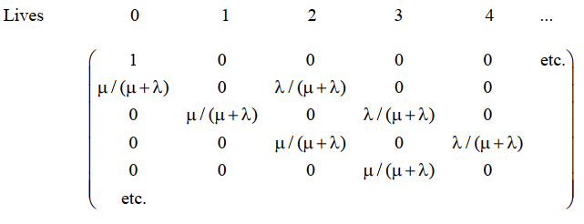

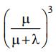

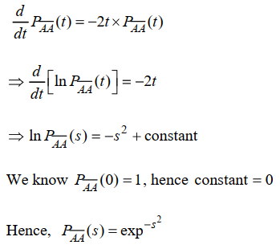
- P(in first visit to B at time T in state A at t = 0)
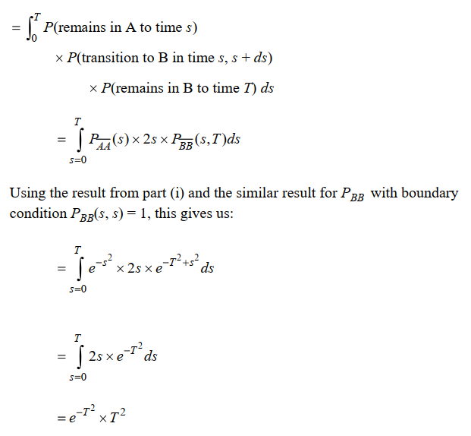

- The sketch should be shaped like:
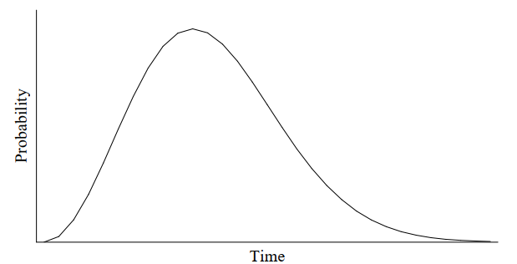
- Commentary:
- Initially probability increases from 0 at T = 0, and accelerates as the transition rate from A to B increases.
- However, as transitions increase, it becomes more likely that the process has already visited state B and jumped back to A. Therefore, the probability of being in the first visit to B tends (exponentially) to zero.
- Differentiate to find turning point:
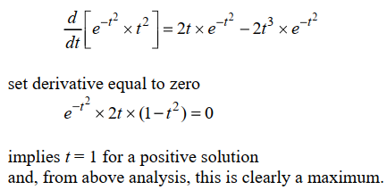

- Let Nt denote the number of claims up to time t. Since the Poisson process has stationary increments, we may take t = 0, so that the required conditional distribution is
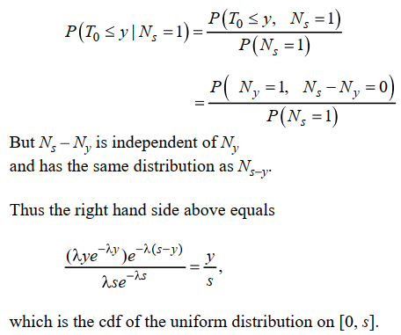
- Since holding times are independent, each having an exponential distribution, their joint density is
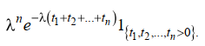
- We have, as in part (i),
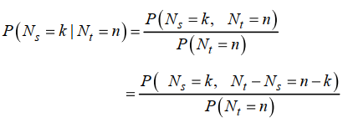
Using again that the Poisson process has stationary and independent
increments, and that the number of claims in an interval [0, t] is Poisson ( t),
we derive from above that
