1)
The Money Control Newsletter is based on the current live trading session as of 29-04-2022.
Market Action

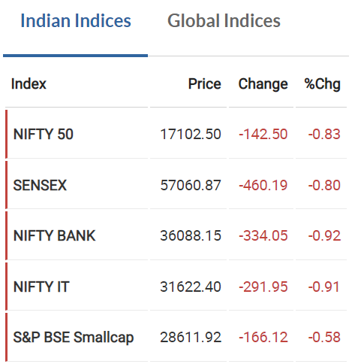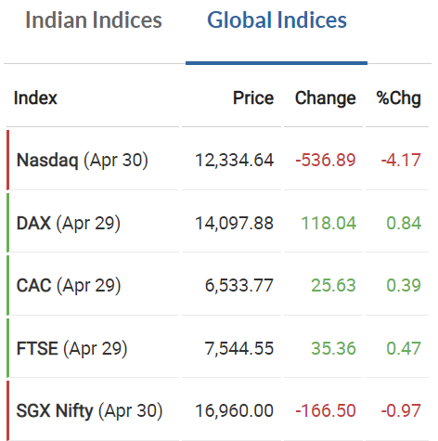
The Indian markets are down by around 0.83% as per NIFTY50. For the global markets we can see there has been a significant fall in the Nasdaq (Apr 30) equal to 4.17% and other global indexes show movements in their latest trading session.

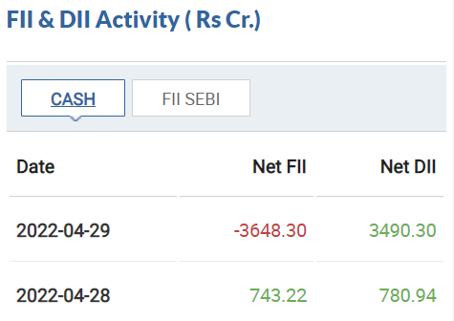
In the previous trading session net selling of FII activities outperform Net DII buying activities.

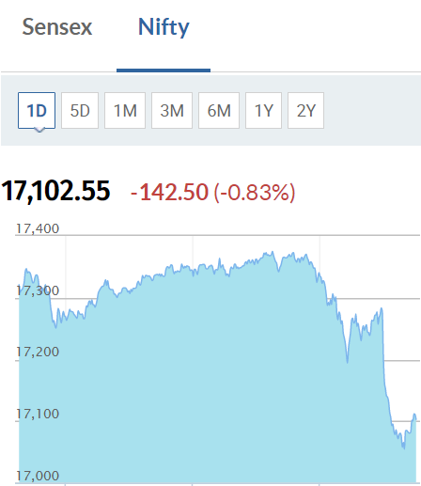
The fall that we see was mostly led by the Bank Stocks with the NIFTY BANK Index falling around 0.92%.

Top 5 Nifty 50 Losers
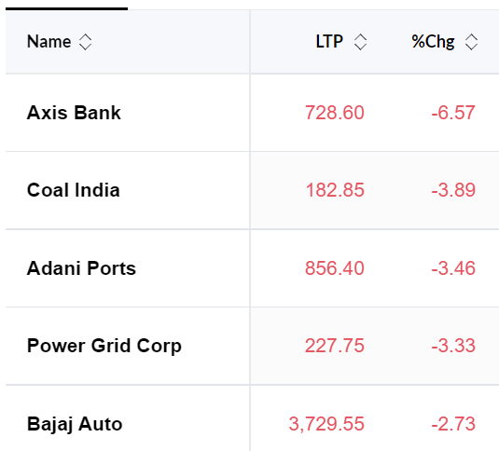
The Axis Bank has the major chunk of the falling Nifty 50 index.

Top 5 Nifty 50 Gainers
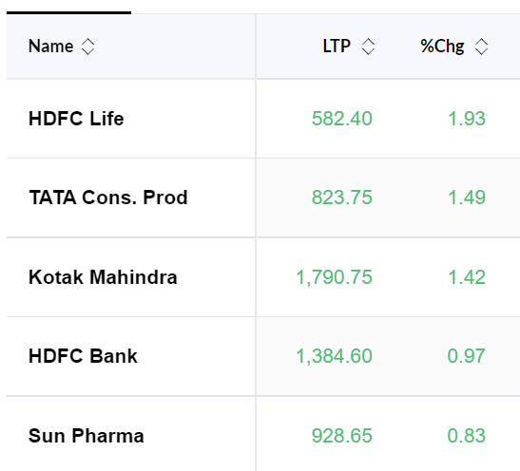
HDFC Life has gained the most in the current trading session out of the Nifty 50 index elements.

India VIX
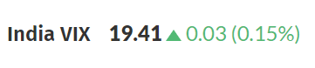
Stock Action
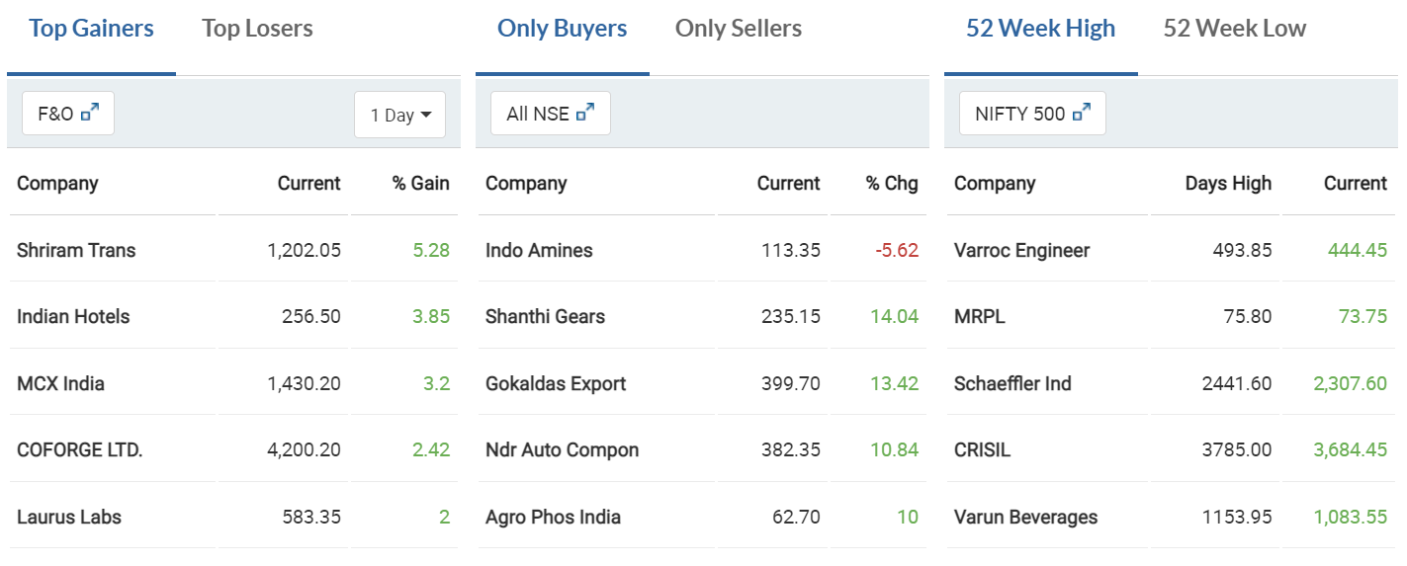

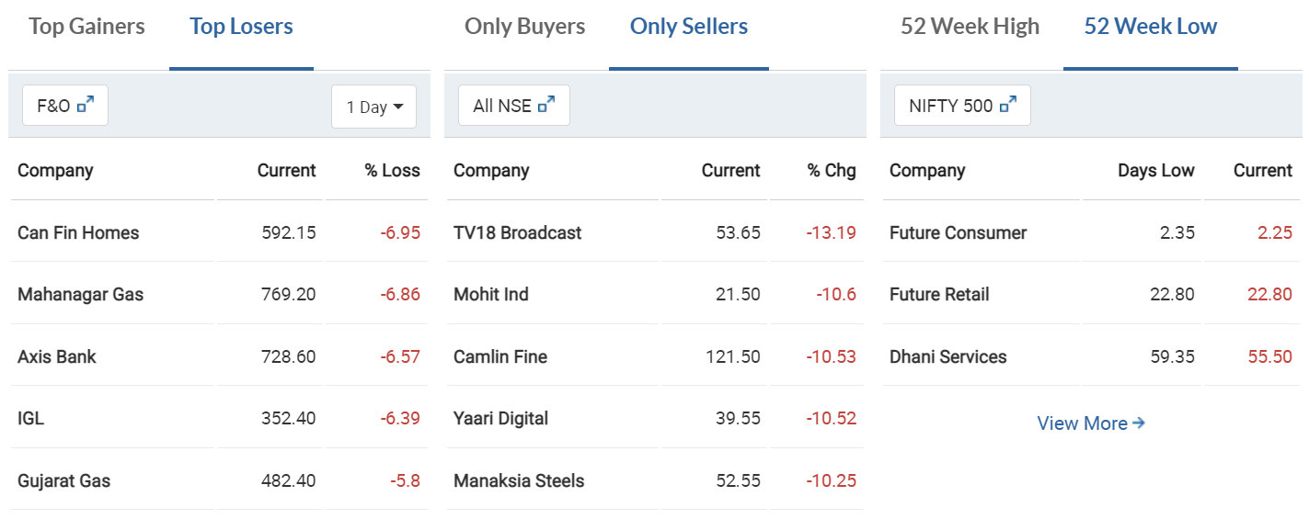

News Area

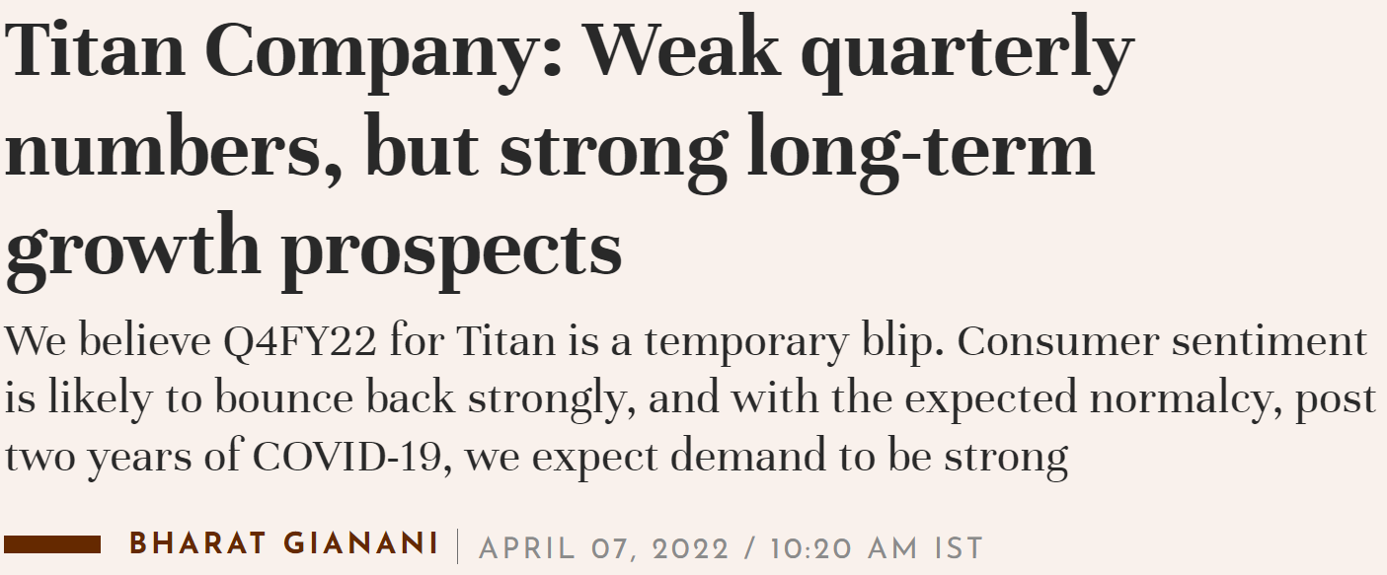
https://www.moneycontrol.com/news/business/stocks/titan-company-weak-quarterly-numbers-but-strong-long-term-growth-prospects-8327841.html

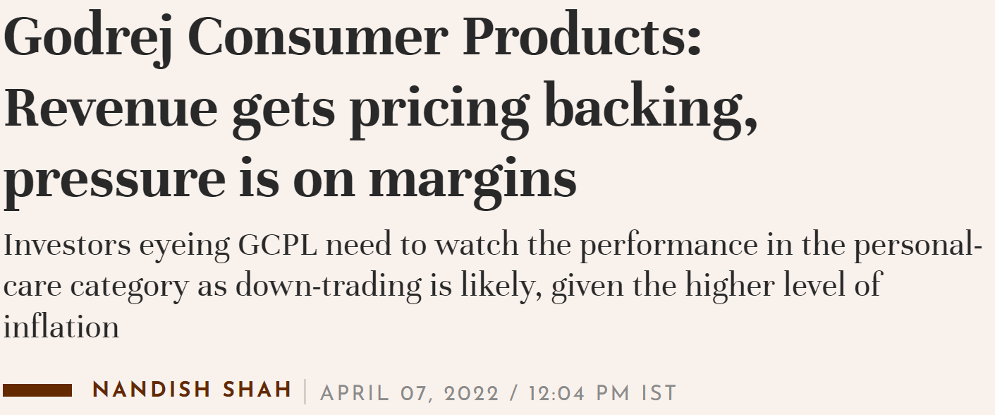
https://www.moneycontrol.com/news/business/moneycontrol-research/godrej-consumer-products-pricing-led-growth-in-revenue-but-pressure-is-on-margins-8327591.html

2)
a. The Bears
b. We witness a positive change of 0.15% in the fear index standing at 19.41, making it nothing to worry about.
c. Axis Bank has major influence over the market movement where it has fallen by 6.57%

d.
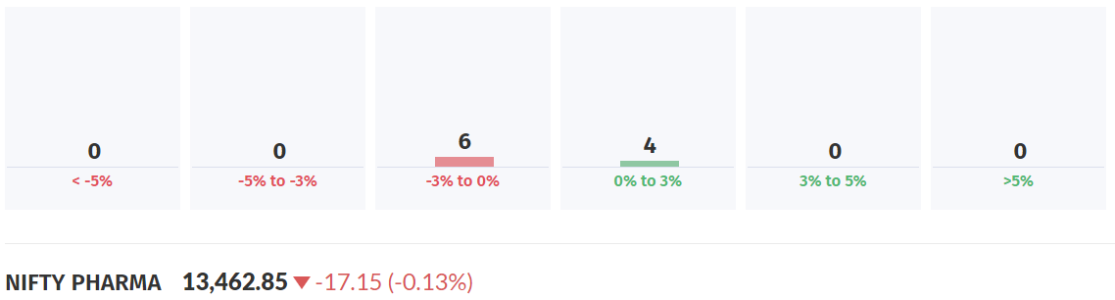
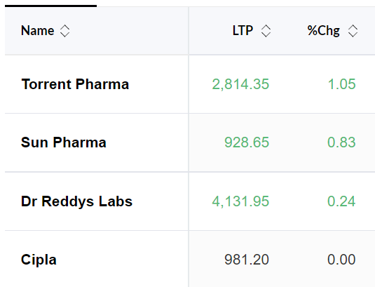
Nifty Pharma is the least hit sector in the current trading session with a fall of 0.13%. Above are the top performing stocks in the Phrama index.
e.
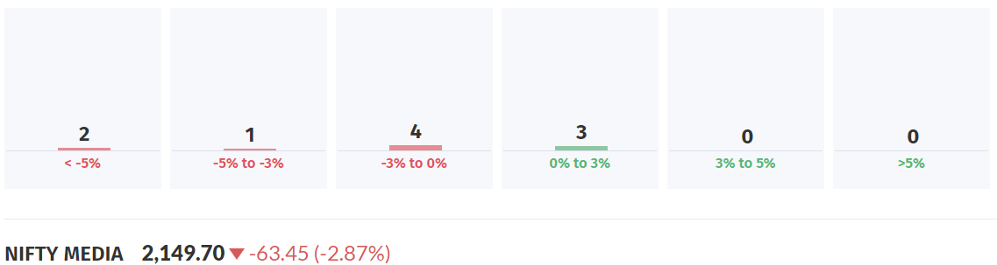
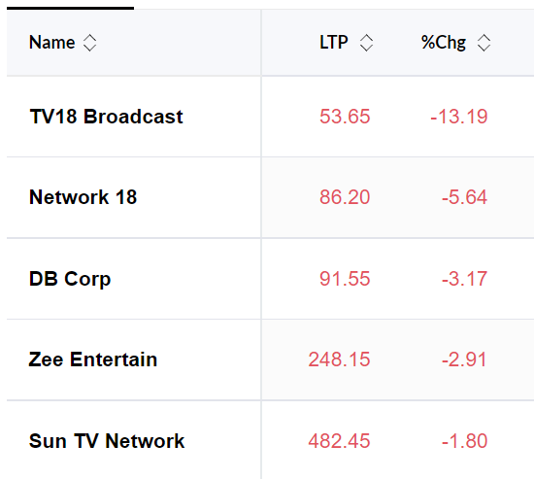
Nifty Media is the worst performing sector in the current trading session with a fall of 2.87%. Above are the worst performing stocks in the worst performing index.

Q 3)
Screening criteria used on Investing.com to screen the 52-week high stocks
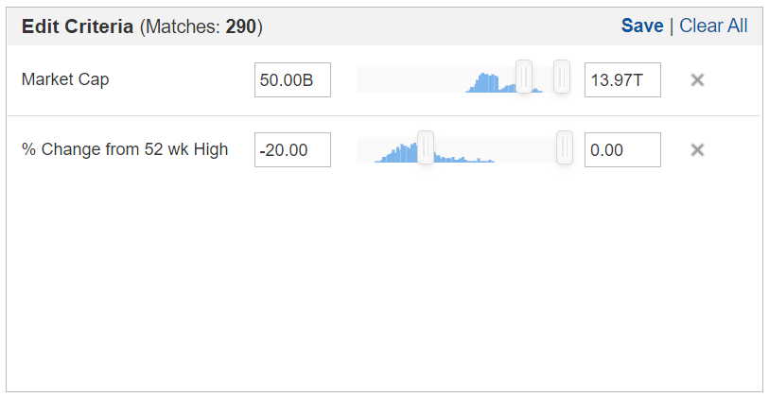
The Qualification criteria of screening 52-week high stocks are:
- The chart should be beginning from the bottom left of the screen and ending at the top right of the screen
- See to it that the sizes of the candles are small
- We should not see any big dips in the middle of the chart irrespective of the chart moving from left bottom to the top right of the screen
- The chart seen should be a smooth shaped one (upward trend)
- We have to see to it that is not circuit breakage or blank candles on the chart
Based on the criteria defined we can list down a few stocks which qualify the criteria above:
- Adani Green Energy
- Larsen and Toubro
- Adani Enterprises
- Titan Company
- Vedanta

Q 4)
