- Read in the data file as a data table & fill in the entries for the CRUDE column in your table.
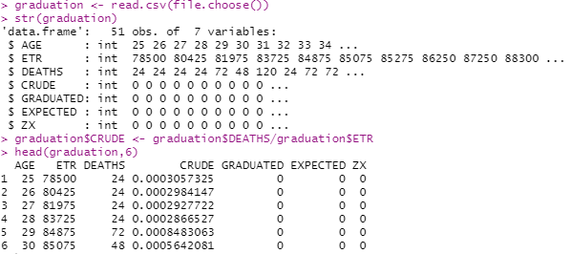
- Use Gompertz law to fill entries in the GRADUATED column in the data.
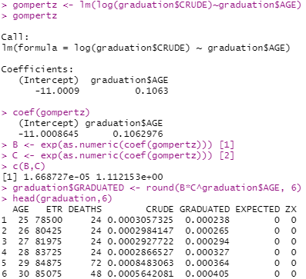
- Check for smoothness by applying the third differences to the crude and graduated rates and comment on your results.
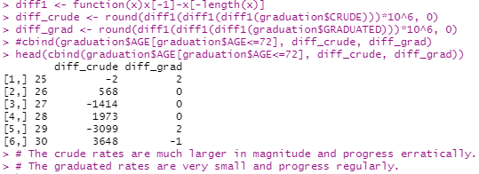
- Calculate the values in EXPECTED and ZX values in the table. Hence, perform a chi-squared test to check goodness of fit between DEATHS and EXPECTED. You should specify the degrees of freedom used.
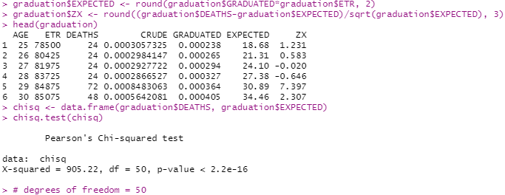

- Perform the standardised deviations test on the individual deviations, and comment on the-
- The graph is wide compared to a standard normal graph.
- The values of the absolute deviations are very high relative to the expected value.
- The lower bound is approx. -2 and the upper bound is approx. 6. IQR is 8. There are some outliers on the lower side but none on the upper side.
- The graph is positively skewed. It looks like it is centered about 2.
- The graduated rates do not represent the underlying mortality rates with accuracy.

