Paraj Shah.
Roll no 416
Assignment 1
- A
- B
- D
- C
- C
- C
- C
- C
- A
- D
- C
- B
- C
- C
- D
- C
- D
- B
- A
- B
- B
- A
- D
- C
- D
- A
- B
- C
- D

29. (a) Net Domestic Income (NDP at FC) = Compensation of workers + Operating Surplus + Mixed income of self-employed = Rs.[24,000 + 10,000 + 28,000] crores = Rs.62,000 crores, calculated using the Income Method.
(b) Gross Domestic Income (GDP at MP) = NDP at FC + Depreciation + Net Indirect Tax (Indirect Tax - Subsidies) = Rs.68,900 crores [62,000 + (-300) + (9,000 - 1,800)].
(c) NNP at FC = NDP at FC + Net Factor Income From Abroad = Rs.61,700 crores [62,000 + (-300)] Net National Income (NNP at FC) = NDP at FC + Net Factor Income From Abroad = Rs.61,700 crores . (d) NNP at Market Price (NNP at MP) = NNP at FC + Net Indirect Tax (Indirect Tax - Subsidies) = Rs. [61,700 + (9,000 - 1,800)] Rs.68,900 crores = crores.

30.

31. The entire supply of products and services that enterprises in a national economy intend to sell during a certain period is known as aggregate supply. It is the entire amount of products and services that businesses are willing to sell in the economy at a particular price level. The link between the price level and the economy's production is known as aggregate supply. Because the amount supplied grows as the price rises, the short-run aggregate supply curve is upward sloping. Firms have one fixed factor of production in the short-run (usually capital ). At a given price, the curve moves outward, increasing output and real GDP. As a result, the price level and output have a positive relationship, as seen by the short-run aggregate supply curve. Firms have one fixed factor of production in the short-run (usually capital ). At a given price, the curve moves outward, increasing output and real GDP. As a result, the price level and output have a positive relationship, as seen by the short-run aggregate supply curve.

32. i) When the creation or consumption of a product results in a cost to a third party, this is known as a negative externality. Negative externalities like air and noise pollution are frequently mentioned. The negative externality caused by consuming cigarettes to another party will be passive smoking which can cause health issues to another party as well as the individuals consuming cigarettes.
ii) A price-associated intervention would be to increase the tax levied on cigarettes so that the price increases and the consumption decreases.
A non-price associated intervention would be advertising the harmful effects of the consumption of cigarettes so that the people get aware of the effects and the consumption decreases.
iii) 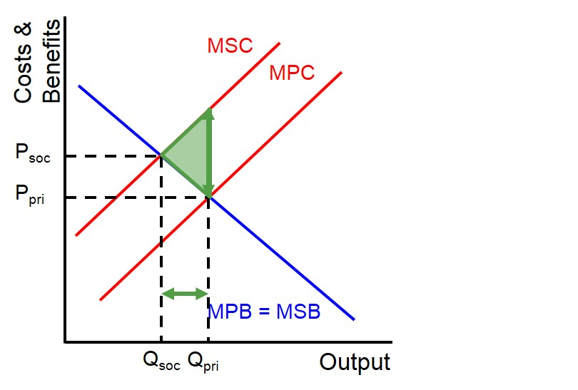
33) Actual and prospective economic growth are two different things.
The yearly percentage change in a country's real national production is used to calculate actual economic growth (GDP).
The predicted yearly change in a country's potential level of national production is assessed by potential economic growth, also known as trend growth. Long-term aggregate supply improvements create potential growth (LRAS).
34) the national income of a country can be measured by three alternative methods: (i) Product Method (ii) Income Method and (iii) Expenditure Method.
1. Product Method: National income is calculated using this technique as a flow of commodities and services. The monetary worth of all final products and services generated in an economy over the course of a year is calculated. The term "final goods" refers to items that are consumed directly rather than being employed in further manufacturing processes. Intermediate products are goods that are employed later in the manufacturing process. Because the value of intermediate products is already included in the value of final goods, we do not count the value of intermediate goods in national income; otherwise, the value of goods would be doubly counted.
To avoid duplicate counting, we may use the value-addition approach, which calculates value-addition (i.e., the value of the final good divided by the value of the intermediate good) at each step of production and then adds them together to get GDP. The sum-total is the GDP at market prices since the money value is measured at market prices. The methods outlined before can be used to convert GDP at market price into.
2. National income is calculated using the income technique as a flow of factor incomes. Labor, capital, land, and entrepreneurship are the four main components of production. Labor is compensated with wages and salaries, money is compensated with interest, land is compensated with rent, and entrepreneurship is compensated with profit.
Furthermore, certain self-employed individuals, such as physicians, advocates, and CPAs, use their labour and money. Mixed-income is the term used to describe their financial situation. NDP at factor costs is the total of all of these factor incomes.
3. Expenditure Method:
National income is calculated using this technique as a flow of spending. GDP stands for gross domestic product, which is the sum of all private consumption expenditures. Government consumption, gross capital formation (public and private), and net exports are all factors to consider (Export-Import).

