Q1
A Stochastic Model has the capacity to handle uncertainties in the inputs applied. Stochastic models possess some inherent randomness - the same set of parameter values and initial conditions will lead to an ensemble of different outputs.
Advantages of stochastic models:
Stochastic models can reflect real-world economic scenarios that provide a range of possible outcomes you may experience and the relative likelihood of each.
By running thousands of calculations, using many different estimates of future economic conditions, stochastic models predict a range of possible future investment results showing the potential upside and downsides of each.

The time spent in state H before the next visit to S has mean σ ^(-1)
Therefore a reasonable estimate for σ is the reciprocal of the mean length of each visit: = (Number of transitions from H to S)/(Total time spent in state H up until the last transition from H to S), although it would be equally valid to use the Maximum Likelihood Estimator, which is (Number of transitions from H to S)/(Total time spent in state H).
Similarly for 𝜌 .

Q2
Ans-
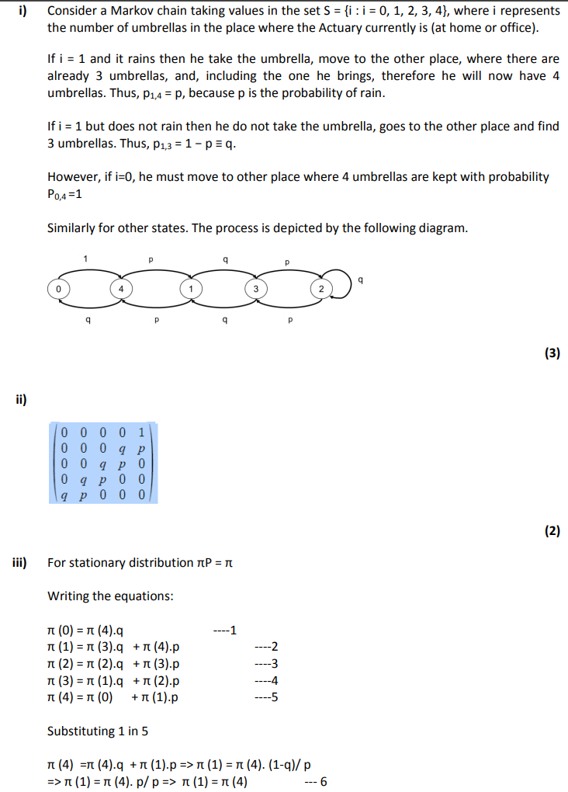
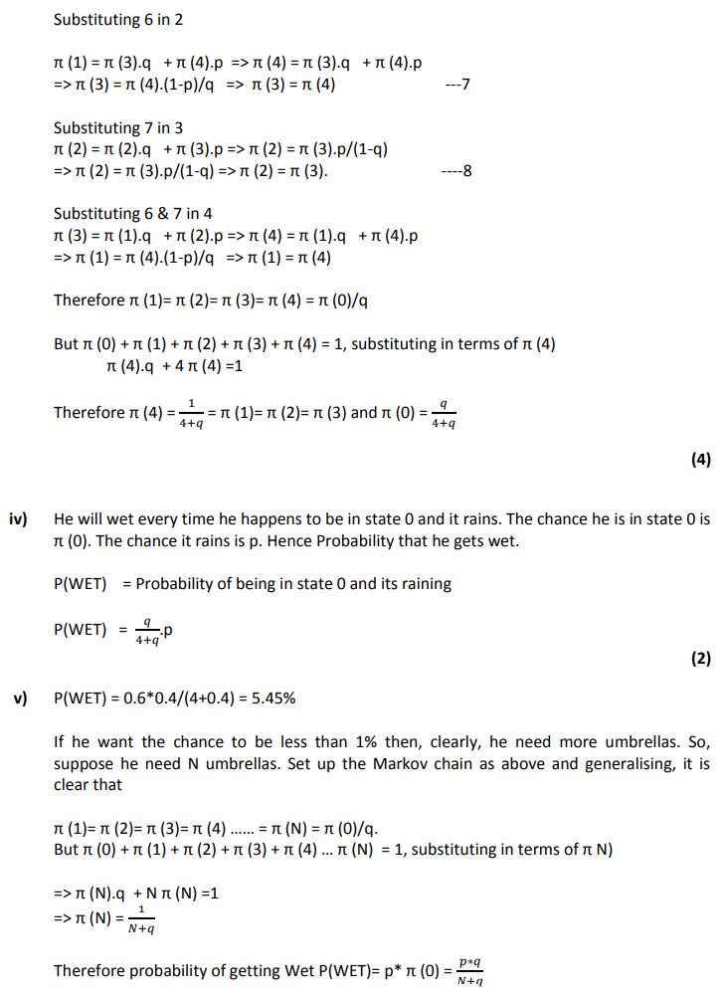
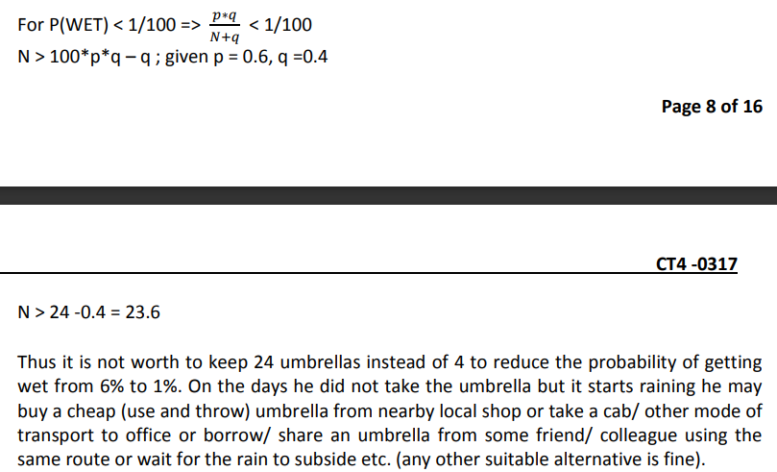

Q3
i), ii)
Process | State Space | Time Domain
Counting Process | Discrete | Discrete or Continuous
General Random Walk | Discrete or Continuous | Discrete
Poisson Process | Discrete | Continuous
Markov Chain | Discrete | Discrete
Markov Jump | Discrete | Continuous
iii)
a) Number of times the account has been overdrawn since it was opened – Poisson Process / Counting Process
b) Status (overdrawn, in credit) of the account on the last day of each month – Markov Jump Chain/ Counting Process
c) number of direct debits paid since the account was opened – Poisson
d) Status (overdrawn, in credit) of the account at any time since the account was opened. Markov Jump Process
Q4
Ans-
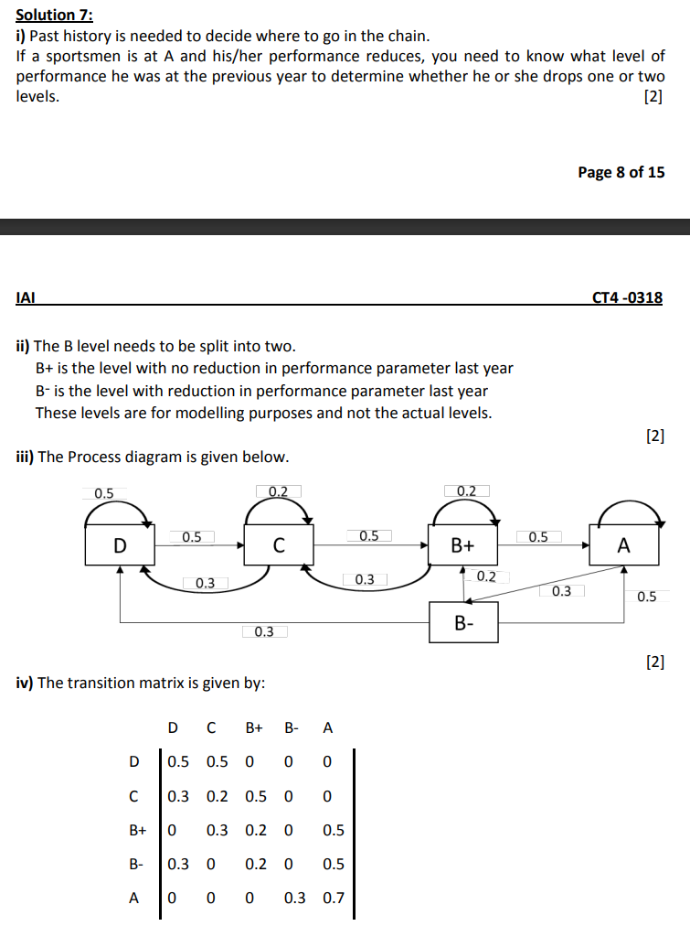
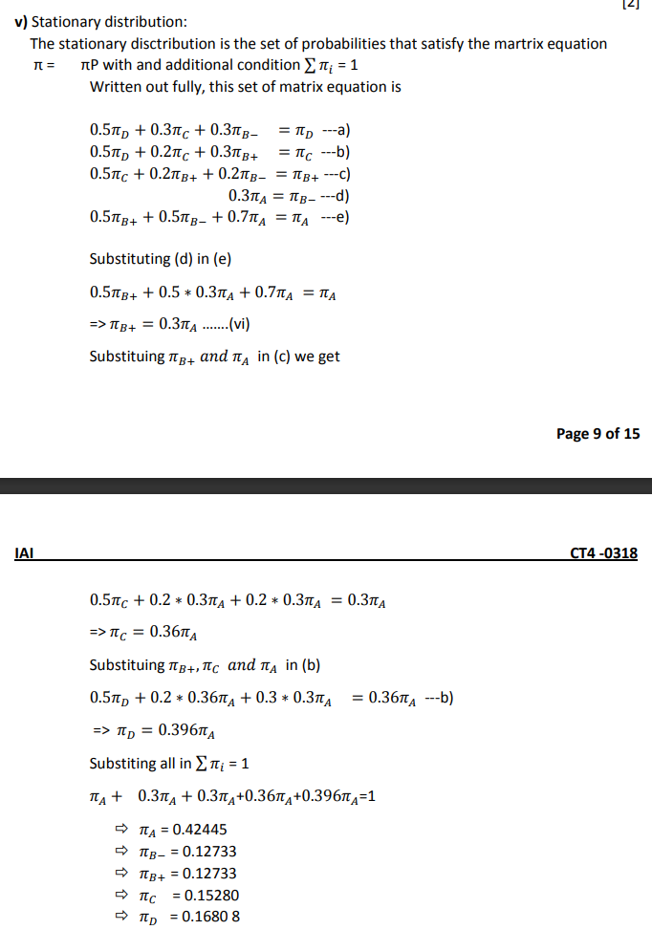
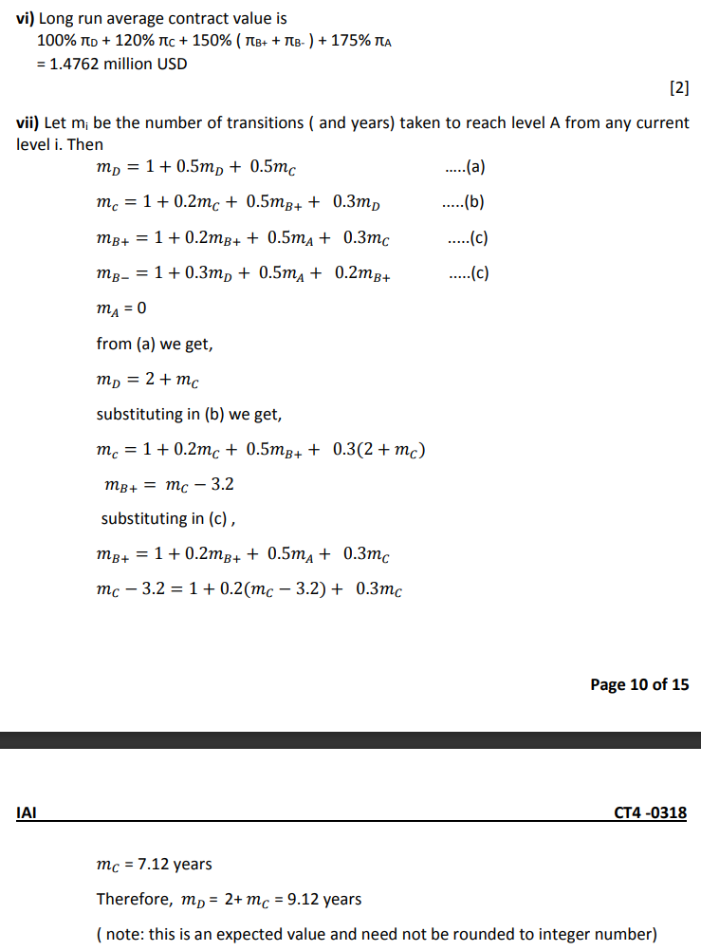
Q5
i) There is an explicit dependence on the past behavior of {Yj: j≤n}
in the probability distribution of Yn+1; further, Xn is nothing
but the sum of Yj. Hence the Markov property does not hold.
ii) In part i), we show that there is explicit dependence on the past
behavior of {Yj: j≤n} and hence the Markov property does not
hold, this implies that that sequence {Yn ; n ≥ 1} does not form
a Markov chain.
iii)The transition matrix is given by:
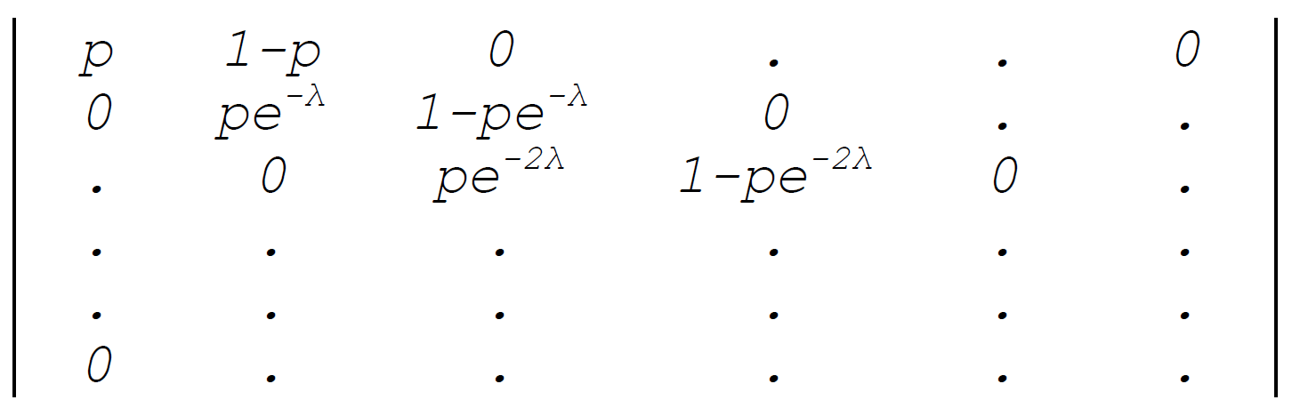
iv)
(a) The chain is time homogeneous since the transition
probabilities calculated in part i) is independent of time n.
(b) It is irreducible, since the number of errors can never go
down.
(c) There are no recurrent states; hence there can be no
stationary distribution.
Alternatively, if a stationary distribution π exists, it has
to follow:
π0p = π0
π0(1−p) + π1 pe^(−λ) = π1
π1(1−pe^(−λ))+ π2 pe^(−2λ) = π2
and so on.
Since p ≤ 1, we have π0 = 0 and then π1 = 0, etc. Hence, no
stationary distribution exists.
v) Probability of no further error is
(pe^(−jλ))n = pn e^(−njλ)
Q6
Ans-
- A stochastic model is one that recognizes the random nature of the input components.
A model that does not contain any random component is deterministic in nature.
Advantages :-
• In a deterministic model, the output is determined once the set of fixed inputs and the relationships between them have been defined. By contrast, in a stochastic model the output is random in nature − like the inputs, which are random variables.
• A deterministic model is really just a special (simplified) case of a stochastic Model.
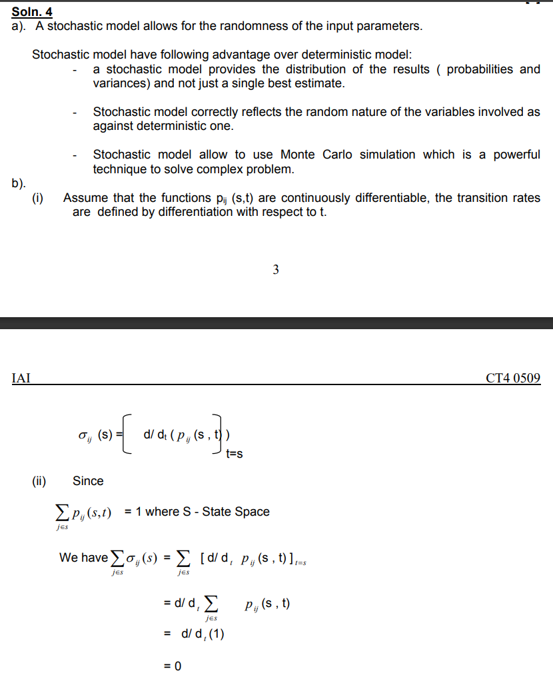

Q7
(a) The process may be expressed as a Markov chain by considering following states. Each state indicates the
current number of successive defeats.
State Number of successive defeats
1 0 – Not defeated last time
2 1 – Defeated in the last match
3 2 – Defeated in the last two matches
4 3 – Defeated in the last three matches
5 4 – Captain sacked
The transition matrix is as follows:
0.7 | 0.3 | 0 | 0 | 0
0.7 | 0 | 0.3 | 0 | 0
0.7 | 0 | 0 | 0.3 | 0
0.7 | 0 | 0 | 0 | 0.3
0 | 0 | 0 | 0 | 1
b) A Markov chain is said to be irreducible if any state j can be reached from any state i. The above process is not irreducible as the captain, once sacked, can never become the captain again.
(c)
(i) The probability of remaining the captain for exactly four matches is given by:
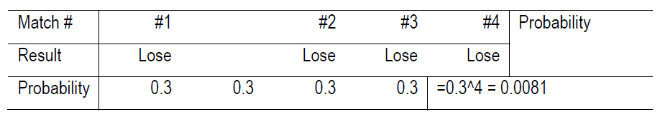
(ii) The probability of remaining the captain for exactly five matches is given by:
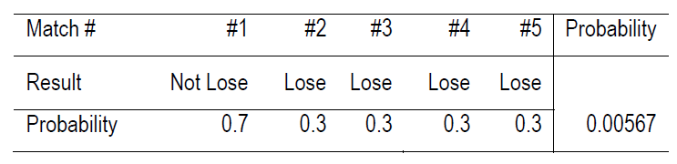
(iii) The probability of remaining the captain for exactly seven matches is given by:
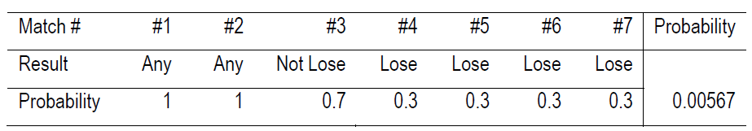 (iv) The probability of remaining the captain for exactly nine matches is given by:
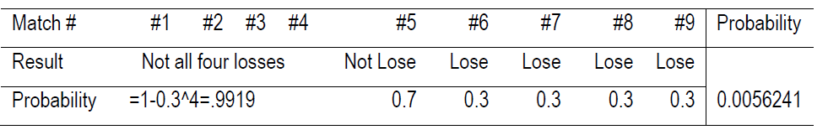 (d) Define Ni = Expected number of matches as a captain given that the current state is i. Since the captain is newly
appointed, the variable N in the question is N1 as defined here.
We have:
N1 = 1 + 0.7 x N1 + 0.3 x N2
N2 = 1 + 0.7 x N1 + 0.3 x N3
N3 = 1 + 0.7 x N1 + 0.3 x N4
N4 = 1 + 0.7 x N1
Solving the above equations; we get:
N4 = 123.46
N3 = 160.49
N2 = 171.60 and
N1 = 174.94
Therefore, E(N) is 174.94 matches.

Q8
Ans-

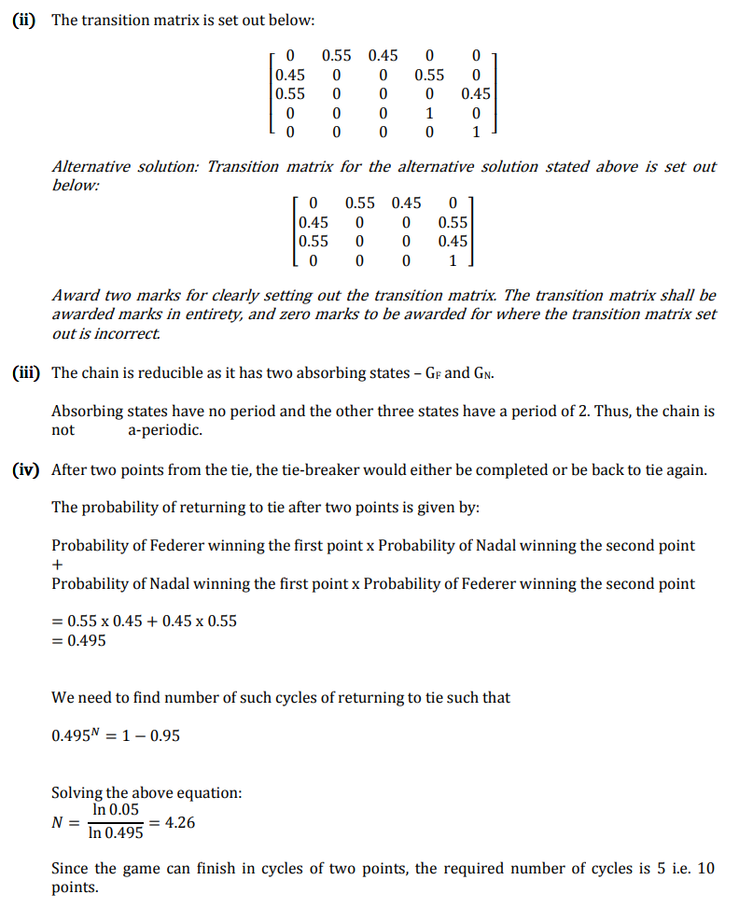
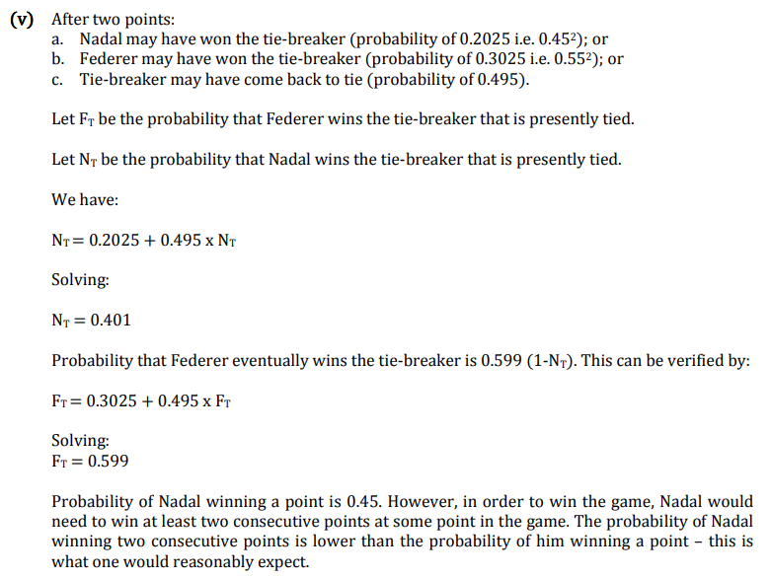

Q9
The state transition diagram is set out below:
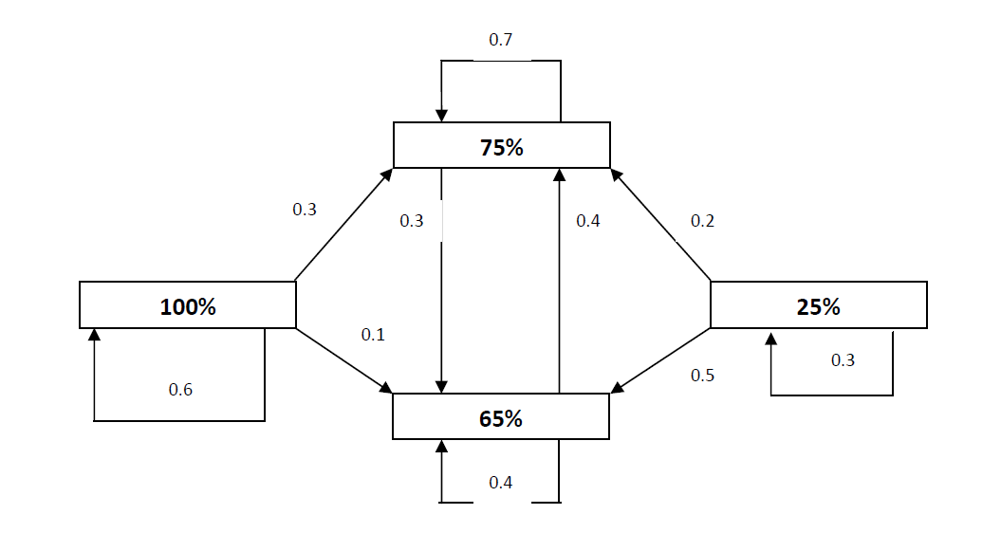
We are to calculate for the % of corporate buyer having a target % for XYZ of 65%
• In 2 years time
• Over the long-run.
The state of the system after one year S1 = S0P
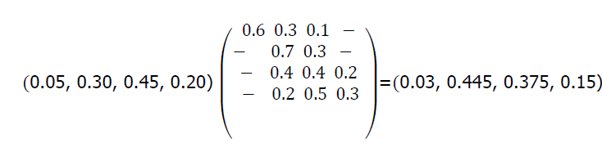
Hence the state of the system in 2 years time S2 = S1P
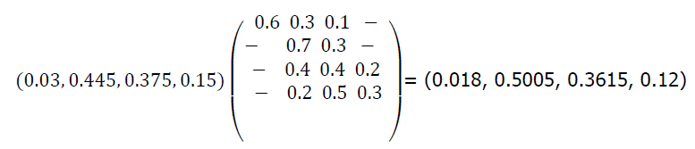
Hence the % of corporate buyer having a target % of 65% for XYZ in 2 years time is
36.15%.

The long run steady state can be found by solving the following equation:
S = SP
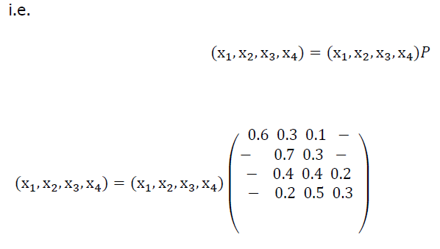
Hence we have the five equations
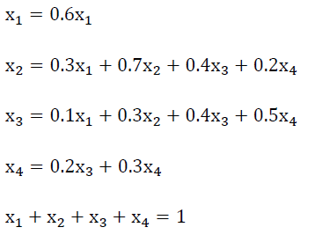
Now from the first equation above,
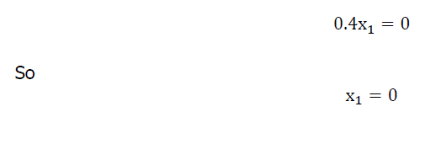
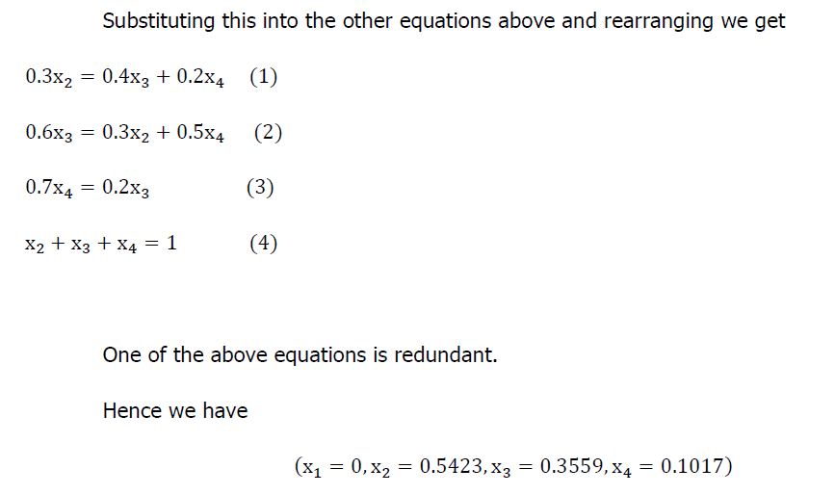
c) The steady state proportion of customers having a 65% target allocation for XYZ Ltd is 35.59%.
It is noted that the initially this proportion is 45% and it quickly drops to:
37.5% in one year’s time; and
36.2% in two years’ time
It is, therefore, likely that the steady state shall be reached in a few years’ time.
Q10
Ans-
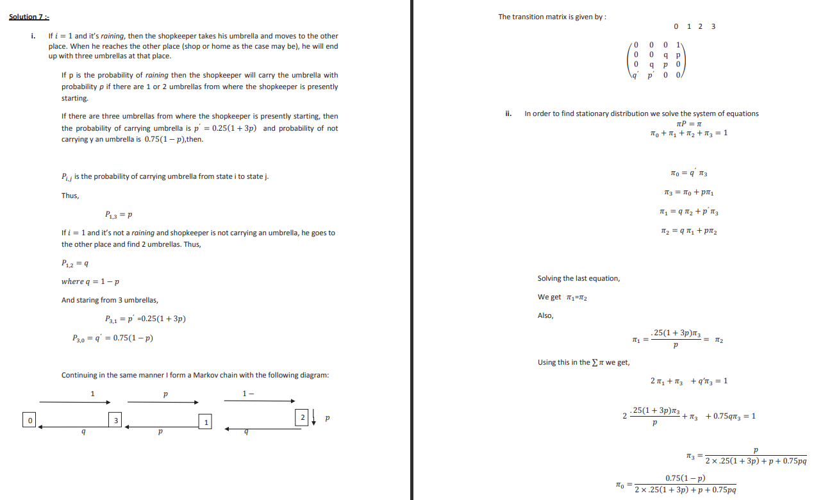
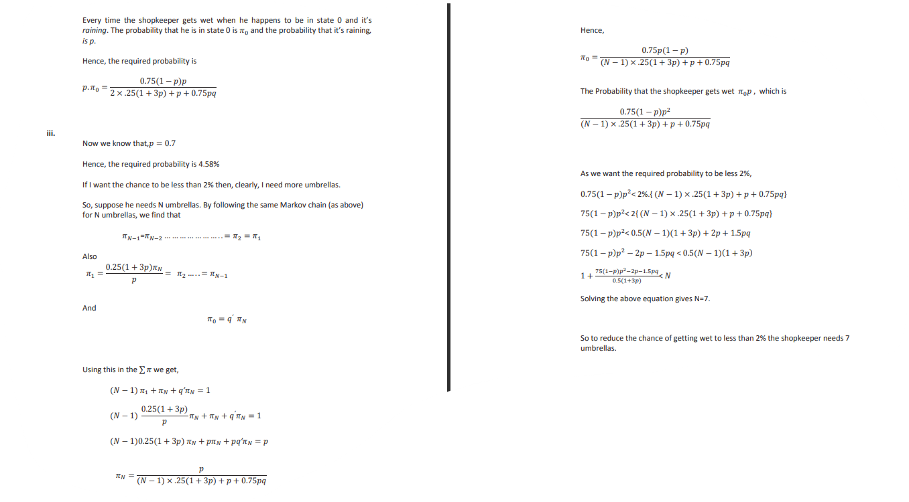

Q11
If each room is represented by the state, then the transition matrix P for this Markov chain is as follows:
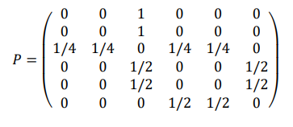
The chain is irreducible, because it is possible to go from any state to any other state. However, it is not aperiodic, because for any even n ,𝑃6,1 𝑛 will be zero and for any odd n 𝑃6,5 𝑛 will also be zero . This means that there is no power of P that would have all its entries strictly positive.
For P to be stationary, πP = P
Perform matrix multiplication and show that π P is equal to P
We find from π that the mean recurrence time (i.e. the expected time to return) for the room 1 is 1/π(1)=12
Let, ψ(i) = E(number of steps to reach state 5 | X0 = i). We have
ψ(5) = 0 ψ(6) = 1 + (1/2)ψ(5) + (1/2)ψ(4)
ψ(4) = 1 + (1/2)ψ(6) + (1/2)ψ(3)
ψ(3) = 1 + (1/4)ψ(1) + (1/4)ψ(2) + (1/4)ψ(4) + (1/4)ψ(5)
ψ(1) = 1 + ψ(3)
ψ(2) = 1 + ψ(3).
We solve and find ψ(1) = 7.

Q12
i), ii)
Process | State Space | Time Domain
Counting Process | Discrete | Discrete or Continuous
General Random Walk | Discrete or Continuous | Discrete
Poisson Process | Discrete | Continuous
Markov Chain | Discrete | Discrete
Markov Jump | Discrete | Continuous
iii)
a) Number of times the account has been overdrawn since it was opened – Poisson Process / Counting Process
b) Status (overdrawn, in credit) of the account on the last day of each month – Markov Jump Chain/ Counting Process
c) number of direct debits paid since the account was opened – Poisson
d) Status (overdrawn, in credit) of the account at any time since the account was opened. Markov Jump Process
Q13
A Stochastic Model has the capacity to handle uncertainties in the inputs applied. Stochastic models possess some inherent randomness - the same set of parameter values and initial conditions will lead to an ensemble of different outputs.
Advantages of stochastic models:
Stochastic models can reflect real-world economic scenarios that provide a range of possible outcomes you may experience and the relative likelihood of each.
By running thousands of calculations, using many different estimates of future economic conditions, stochastic models predict a range of possible future investment results showing the potential upside and downsides of each.

The time spent in state H before the next visit to S has mean σ ^(-1)
Therefore a reasonable estimate for σ is the reciprocal of the mean length of each visit: = (Number of transitions from H to S)/(Total time spent in state H up until the last transition from H to S), although it would be equally valid to use the Maximum Likelihood Estimator, which is (Number of transitions from H to S)/(Total time spent in state H).
Similarly for 𝜌 .

