- A stochastic model is one that recognises the random nature of the input components.
Stochastic models have the following advantages over deterministic models:
- To reflect reality as accurately as possible, the model should imitate the random nature of the variables involved.
- A stochastic model can provide information about the distribution of the results (e.g., probabilities, variances etc), not just a single best estimate figure.
- Stochastic models allow you to use Monte Carlo simulation, which is an extremely powerful technique for solving complex problems.
- For a time-inhomogeneous model the transition rates and are functions of t. It is certainly possible to improve the fit by using a time-inhomogeneous model in this instance.
However, If the age profile is represented by a density function f(a); then the overall average rate at which a healthy employee falls sick is = integral [f(a)σ(a)da], roughly constant for all t. The same of course applies to the overall average rate of recovery.
- Proof: Given that Increment Xt+u –Xt for every u>0 is independent of past values of Xm and nonoverlapping.
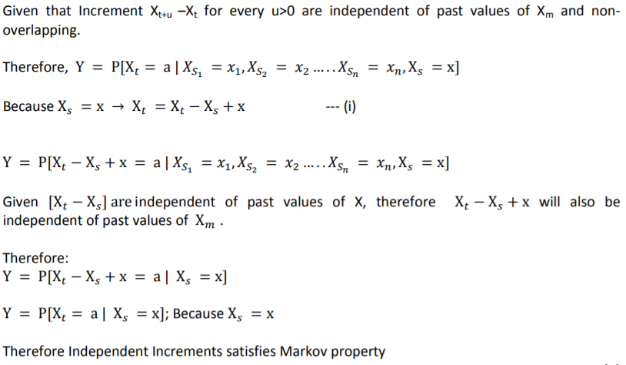

- Consider a Markov chain taking values in the set S = {i: i = 0, 1, 2, 3, 4}, where i represents the number of umbrellas in the place where the Actuary currently is (at home or office).
If i = 1 and it rains then he takes the umbrella, move to the other place, where there are already 3 umbrellas, and, including the one he brings, therefore he will now have 4 umbrellas. Thus, p1,4 = p, because p is the probability of rain.
If i = 1 but does not rain then he does not take the umbrella, goes to the other place and find 3 umbrellas. Thus, p1,3 = 1 − p ≡ q.
However, if i=0, he must move to other place where 4 umbrellas are kept with probability P0,4 =1
Similarly for other states. The process is depicted by the following diagram.
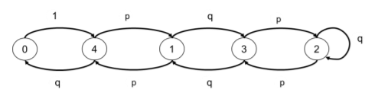

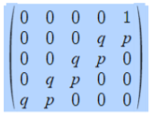
- For stationary distribution πP = π
Writing the equations:
π (0) = π (4). q ----1
π (1) = π (3). q + π (4). p ----2
π (2) = π (2). q + π (3). p ----3
π (3) = π (1). q + π (2). p ----4
π (4) = π (0) + π (1). p ----5
Substituting 1 in 5
π (4) =π (4). q + π (1). p => π (1) = π (4). (1-q)/ p
=> π (1) = π (4). p/ p => π (1) = π (4) --- 6
Substituting 6 in 2
π (1) = π (3). q + π (4). p => π (4) = π (3). q + π (4). p
=> π (3) = π (4). (1-p)/q => π (3) = π (4) ---7
Substituting 7 in 3
π (2) = π (2). q + π (3). p => π (2) = π (3). p/(1-q)
=> π (2) = π (3). p/(1-q) => π (2) = π (3). ----8
Substituting 6 & 7 in 4
π (3) = π (1). q + π (2). p => π (4) = π (1). q + π (4). p
=> π (1) = π (4). (1-p)/q => π (1) = π (4)
Therefore π (1) = π (2) = π (3) = π (4) = π (0)/q
But π (0) + π (1) + π (2) + π (3) + π (4) = 1, substituting in terms of π (4)
π (4). q + 4 π (4) =1
Therefore π (4) = 1/(4+q) = π (1) = π (2) = π (3) and π (0) = q/(4+q)
- He will wet every time he happens to be in state 0 and it rains. The chance he is in state 0 is π (0). The chance it rains is p. Hence Probability that he gets wet.
P(WET) = Probability of being in state 0 and it’s raining
P(WET) = [q/(4+q)]. p
- P(WET) = 0.6*0.4/ (4+0.4) = 5.45%
If he wants the chance to be less than 1% then, clearly, he needs more umbrellas. So, suppose he need N umbrellas. Set up the Markov chain as above and generalising, it is clear that
π (1) = π (2) = π (3) = π (4) …… = π (N) = π (0)/q.
But π (0) + π (1) + π (2) + π (3) + π (4) … π (N) = 1, substituting in terms of π N)
=> π (N). q + N π (N) =1
=> π (N) = 1/(N+q)
Therefore, probability of getting Wet P(WET)= p* π (0) = (p*q)/(N+q)
For P(WET) < 1/100 => (p*q)/(N+q) < 1/100
N > 100*p*q – q; given p = 0.6, q =0.4
N > 24 -0.4 = 23.6
Thus, it is not worth to keep 24 umbrellas instead of 4 to reduce the probability of getting wet from 6% to 1%. On the days he did not take the umbrella but it starts raining he may buy a cheap (use and throw) umbrella from nearby local shop or take a cab/ other mode of transport to office or borrow/ share an umbrella from some friend/ colleague using the same route or wait for the rain to subside etc. (any other suitable alternative is fine).
- i) and ii)
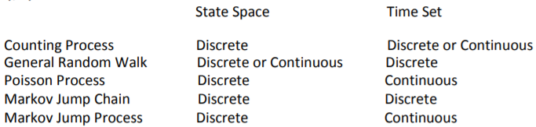
iii)
- Number of times the account has been overdrawn since it was opened – Poisson Process / Counting Process
- Status (overdrawn, in credit) of the account on the last day of each month – Markov Jump Chain/ Counting Process
- Number of direct debits paid since the account was opened – Poisson
- Status (overdrawn, in credit) of the account at any time since the account was opened. Markov Jump Process.

- Past history is needed to decide where to go in the chain.
If a sportsman is at A and his/her performance reduces, you need to know what level of performance he was at the previous year to determine whether he or she drops one or two levels
- The B level needs to be split into two.
B+ is the level with no reduction in performance parameter last year
B- is the level with reduction in performance parameter last year
These levels are for modelling purposes and not the actual levels.
- The Process diagram is given below.
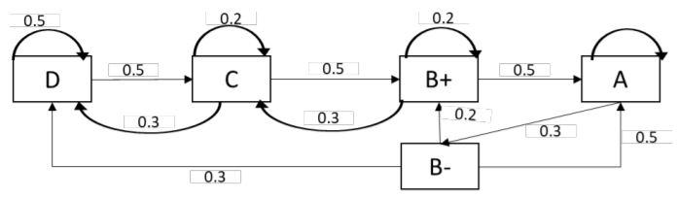
- The transition matrix is given by:
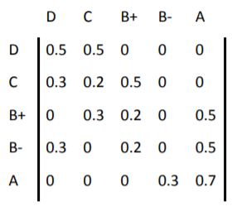
- Stationary distribution:
The stationary distribution is the set of probabilities that satisfy the matrix equation
π = πP with and additional condition ∑ 𝜋𝑖 = 1
Written out fully, this set of matrix equation is
0.5𝜋𝐷 + 0.3𝜋𝐶 + 0.3𝜋𝐵− = 𝜋𝐷 ---a)
0.5𝜋𝐷 + 0.2𝜋𝐶 + 0.3𝜋𝐵+ = 𝜋𝐶 ---b)
0.5𝜋𝐶 + 0.2𝜋𝐵+ + 0.2𝜋𝐵− = 𝜋𝐵+ ---c)
0.3𝜋𝐴 = 𝜋𝐵− ---d)
0.5𝜋𝐵+ + 0.5𝜋𝐵− + 0.7𝜋𝐴 = 𝜋𝐴 ---e)
Substituting (d) in (e)
0.5𝜋𝐵+ + 0.5 ∗ 0.3𝜋𝐴 + 0.7𝜋𝐴 = 𝜋𝐴
=> 𝜋𝐵+ = 0.3𝜋𝐴 ……. (vi)
Substituting 𝜋𝐵+ and 𝜋𝐴 in (c) we get
0.5𝜋𝐶 + 0.2 ∗ 0.3𝜋𝐴 + 0.2 ∗ 0.3𝜋𝐴 = 0.3𝜋𝐴
=> 𝜋𝐶 = 0.36𝜋𝐴
Substituting 𝜋𝜋𝐵𝐵+, 𝜋𝐶 𝑎𝑎𝑎𝑎𝑎𝑎 𝜋𝐴 in (b)
0.5𝜋𝐷 + 0.2 ∗ 0.36𝜋𝐴 + 0.3 ∗ 0.3𝜋𝐴 = 0.36𝜋𝐴 ---b)
=> 𝜋𝐷 = 0.396𝜋𝐴
Subsisting all in ∑ 𝜋𝑖 = 1
𝜋𝐴 + 0.3𝜋𝐴 + 0.3𝜋𝐴+0.36𝜋𝐴+0.396𝜋𝐴=1
𝜋𝐴 = 0.42445
𝜋𝐵− = 0.12733
𝜋𝐵+ = 0.12733
𝜋𝐶 = 0.15280
𝜋𝐷 = 0.16808
- Long run average contract value is
100% πD + 120% πC + 150% (πB+ + πB-) + 175% πA = 1.4762 million USD
- Let mi be the number of transitions (and years) taken to reach level A from any current level i. Then
𝑚𝐷 = 1 + 0.5𝑚𝐷 + 0.5𝑚𝐶 …. (a)
𝑚𝑐 = 1 + 0.2𝑚𝐶 + 0.5𝑚𝐵+ + 0.3𝑚𝐷 .... (b)
𝑚𝐵+ = 1 + 0.2𝑚𝐵+ + 0.5𝑚𝐴 + 0.3𝑚𝐶 .... (c)
𝑚𝐵− = 1 + 0.3𝑚𝐷 + 0.5𝑚𝐴 + 0.2𝑚𝐵+ .... (c)
𝑚𝐴 = 0
from (a) we get,
𝑚𝐷 = 2 + 𝑚𝐶
substituting in (b) we get,
𝑚𝑐 = 1 + 0.2𝑚𝐶 + 0.5𝑚𝐵+ + 0.3(2 + 𝑚𝐶)
𝑚𝐵+ = 𝑚𝐶 − 3.2
substituting in (c),
𝑚𝐵+ = 1 + 0.2𝑚𝐵+ + 0.5𝑚𝐴 + 0.3𝑚𝐶
𝑚𝐶 − 3.2 = 1 + 0.2(𝑚𝐶 − 3.2) + 0.3𝑚𝐶
𝑚𝐶 = 7.12 years
Therefore, 𝑚𝐷 = 2+ 𝑚𝐶 = 9.12 years
(Note: this is an expected value and need not be rounded to integer number)

- There is an explicit dependence on the past behaviour of {Yj: j≤n} in the probability distribution of Yn+1; further, Xn is nothing but the sum of Yj. Hence the Markov property does not hold.
- In part i), we show that there is explicit dependence on the past behaviour of {Yj: j≤n} and hence the Markov property does not hold, this implies that that sequence {Yn; n ≥ 1} does not form a Markov chain.
- The transition matrix is given by:
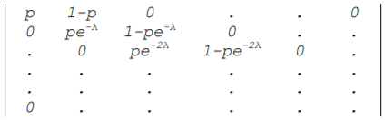

- The chain is time homogeneous since the transition probabilities calculated in part i) is independent of time n.
- It is irreducible, since the number of errors can never go down.
- There are no recurrent states; hence there can be no stationary distribution.
Alternatively, if a stationary distribution π exists, it has to follow:
π0p = π0
π0(1−p) + π1 pe^−λ = π1
π1(1−pe^−λ) + π2 pe^−2λ = π2
and so on.
Since p ≤ 1, we have π0 = 0 and then π1 = 0, etc. Hence, no stationary distribution exists.
- Probability of no further error is
(pe^−jλ) n = pn e^−njλ

- A stochastic model allows for the randomness of the input parameters.
Stochastic model has following advantage over deterministic model:
  - a stochastic model provides the distribution of the results (probabilities and variances) and not just a single best estimate.
  - Stochastic model correctly reflects the random nature of the variables involved as against deterministic one.
  - Stochastic model allows to use Monte Carlo simulation which is a powerful technique to solve complex problem.

- Assume that the functions pij (s,t) are continuously differentiable, the transition rates are defined by differentiation with respect to t.
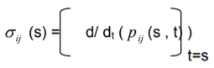
- Since
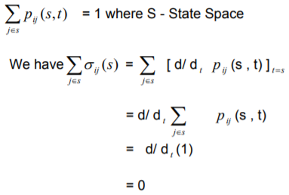

- The process may be expressed as a Markov chain by considering following states. Each state indicates the current number of successive defeats.
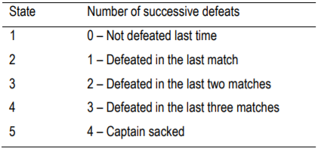
The transition matrix is as follows:
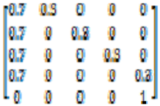
- A Markov chain is said to be irreducible if any state j can be reached from any state i. The above process is not irreducible as the captain, once sacked, can never become the captain again.

- The probability of remaining the captain for exactly four matches is given by:
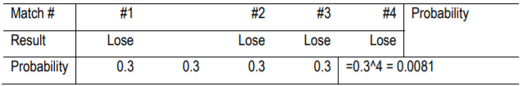
- The probability of remaining the captain for exactly five matches is given by:
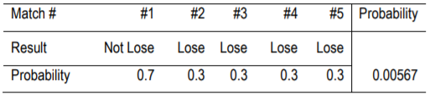
- The probability of remaining the captain for exactly seven matches is given by:
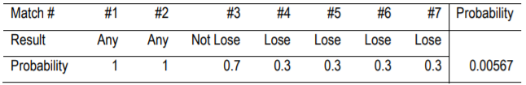
- The probability of remaining the captain for exactly nine matches is given by:
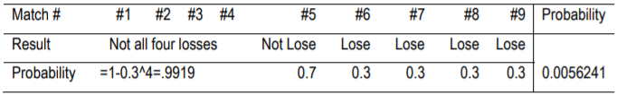
- Define Ni = Expected number of matches as a captain given that the current state is i. Since the captain is newly appointed, the variable N in the question is N1 as defined here.
We have:
N1 = 1 + 0.7 x N1 + 0.3 x N2
N2 = 1 + 0.7 x N1 + 0.3 x N3
N3 = 1 + 0.7 x N1 + 0.3 x N4
N4 = 1 + 0.7 x N1
Solving the above equations; we get:
N4 = 123.46
N3 = 160.49
N2 = 171.60 and
N1 = 174.94
Therefore, E(N) is 174.94 matches.

- The score currently stands at ‘Tie’. Whosever wins the next point will move into a ‘Lead’. If the player in ‘Lead’ wins the subsequent point as well, he would win the tie-breaker. However, if the player in ‘Lead’ loses the next point, the score would be back at ‘Tie’.
Since the probability of moving to the next state does not depend on the history prior to entering the state, Markov property holds.
The state space is defined as follows:
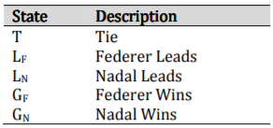
- The transition matrix is set out below:
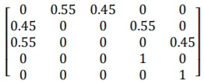
- The chain is reducible as it has two absorbing states – GF and GN.
Absorbing states have no period and the other three states have a period of 2. Thus, the chain is not a-periodic.
- After two points from the tie, the tie-breaker would either be completed or be back to tie again.
The probability of returning to tie after two points is given by:
Probability of Federer winning the first point x Probability of Nadal winning the second point
+
Probability of Nadal winning the first point x Probability of Federer winning the second point
= 0.55 x 0.45 + 0.45 x 0.55
= 0.495
We need to find number of such cycles of returning to tie such that
0.4953^N = 1 - 0.95
Solving the above equation:
N = ln 0.05 / ln 0.495 = 4.26
Since the game can finish in cycles of two points, the required number of cycles is 5 i.e., 10 points.
- After two points:
- Nadal may have won the tie-breaker (probability of 0.2025 i.e., 0.452); or
- Federer may have won the tie-breaker (probability of 0.3025 i.e., 0.552); or
- Tie-breaker may have come back to tie (probability of 0.495).
Let FT be the probability that Federer wins the tie-breaker that is presently tied.
Let NT be the probability that Nadal wins the tie-breaker that is presently tied.
We have:
NT = 0.2025 + 0.495 x NT
Solving:
NT = 0.401
Probability that Federer eventually wins the tie-breaker is 0.599 (1-NT). This can be verified by:
FT = 0.3025 + 0.495 x FT
Probability of Nadal winning a point is 0.45. However, in order to win the game, Nadal would need to win at least two consecutive points at some point in the game. The probability of Nadal winning two consecutive points is lower than the probability of him winning a point – this is what one would reasonably expect.

- The state transition diagram is set out below:
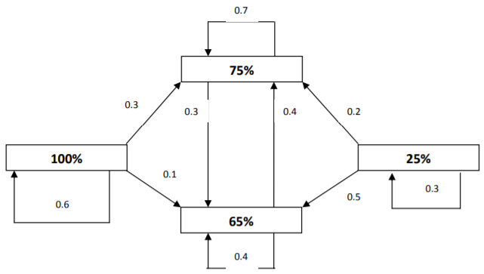
- We are to calculate for the % of corporate buyer having a target % for XYZ of 65%
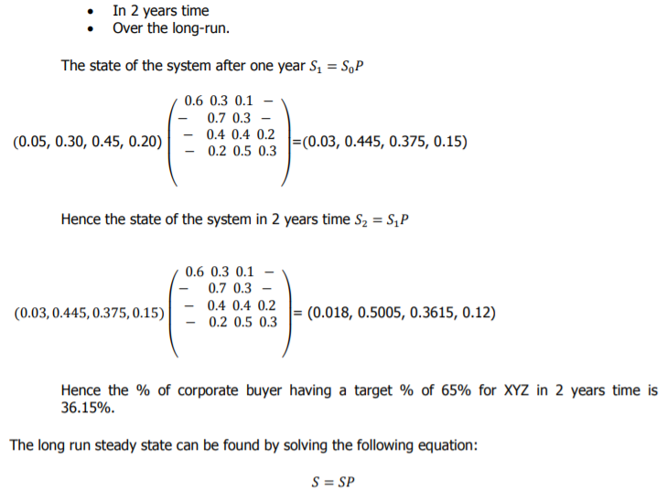
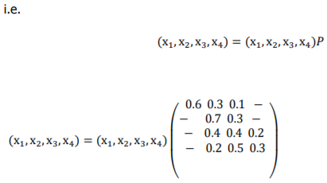
Hence, we have the five equations
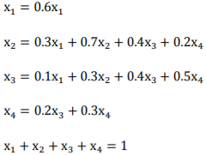
Now from the first equation above,
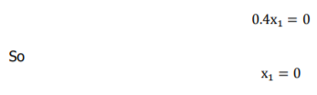
Substituting this into the other equations above and rearranging we get
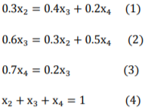
One of the above equations is redundant.
Hence, we have
- The steady state proportion of customers having a 65% target allocation for XYZ Ltd is 35.59%.
It is noted that the initially this proportion is 45% and it quickly drops to:
- 37.5% in one year’s time; and
- 36.2% in two years’ time
It is, therefore, likely that the steady state shall be reached in a few years’ time.

- If i = 1 and it’s raining, then the shopkeeper takes his umbrella and moves to the other place. When he reaches the other place (shop or home as the case may be), he will end up with three umbrellas at that place.
If p is the probability of raining, then the shopkeeper will carry the umbrella with probability p if there are 1 or 2 umbrellas from where the shopkeeper is presently starting.
If there are three umbrellas from where the shopkeeper is presently starting, then the probability of carrying umbrella is p’ = 0.25(1+3p) and probability of not carrying y an umbrella is 0.75(1-p), then
Pij is the probability of carrying umbrella from state i to state j.
Thus,
P1,3 = p
If i = 1 and it’s not a raining and shopkeeper is not carrying an umbrella, he goes to the other place and find 2 umbrellas. Thus,
P1,2 = q
Where q = 1 – p
And staring from 3 umbrellas,
P3,1 = p’ = 0.25(1+3p)
P3,0 = q’ = 0.75(1-p)
Continuing in the same manner I form a Markov chain with the following diagram:
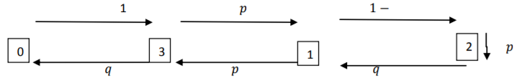
The transition matrix is given by:
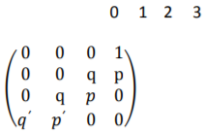
- In order to find stationary distribution, we solve the system of equations
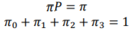
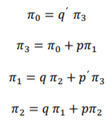
Solving the last equation,
Also,
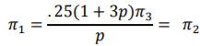
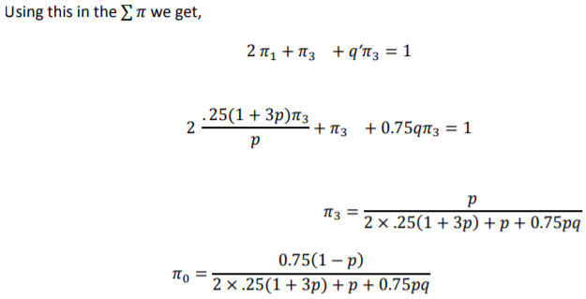
Every time the shopkeeper gets wet when he happens to be in state 0 and it’s raining. The probability that he is in state 0 is and the probability that it’s raining, is p.
Hence, the required probability is
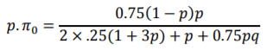
- Now we know that, p = 0.7
Hence, the required probability is 4.58%
If I want the chance to be less than 2% then, clearly, I need more umbrellas.
So, suppose he needs N umbrellas. By following the same Markov chain (as above) for N umbrellas, we find that
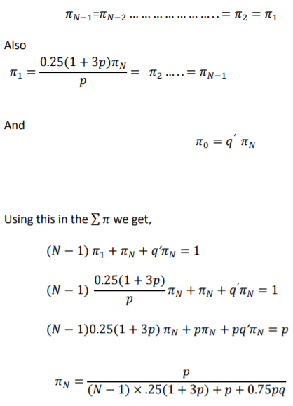
Hence,
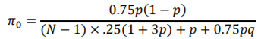
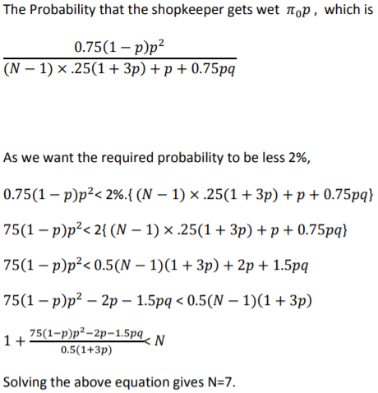
So, to reduce the chance of getting wet to less than 2% the shopkeeper needs 7 umbrellas.

- If each room is represented by the state, then the transition matrix P for this Markov chain is as follows:
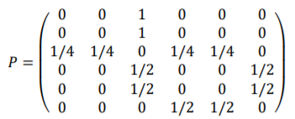
- The chain is irreducible, because it is possible to go from any state to any other state. However, it is not aperiodic, because for any even n, 𝑃6,1 𝑛 will be zero and for any odd n 𝑃6,5 𝑛 will also be zero. This means that there is no power of P that would have all its entries strictly positive.
- For P to be stationary,
πP = P
Perform matrix multiplication and show that π P is equal to P
- We find from π that the mean recurrence time (i.e., the expected time to return) for the room 1 is 1/π (1) =12

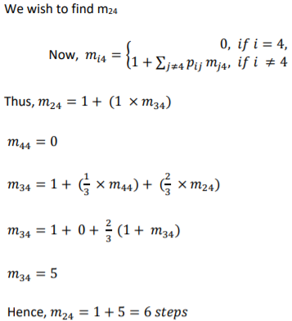

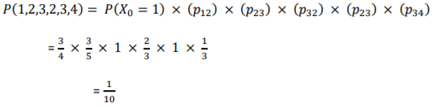

- Data: RSRRSSSSRRSRSSRSRSRRSSSRRSSRRR
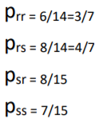

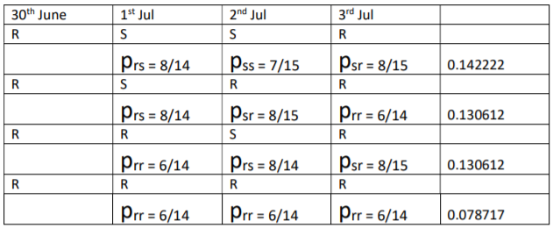
Total = 0.482164

- Here, μ = 3
“Some policies “means “1 or more policies” i.e., 1 minus the “zero policies” probability:
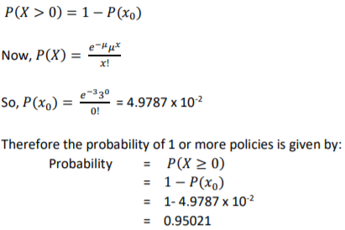
- The probability of selling 2 or more, but less than 5 policies is:
