8/29/2021
BUSINESS ECONOMICS – PROJECT
Topic – Printing Ink
Name – Sannidhya Upadhyay
Roll. No. – 40

INDEX

 | TOPIC | Page No.
1. | INTRODUCTION | 2
2. | Body | 5
3. | Conclusion | 21
4. | Bibliography | 23

EXCEL SHEET:
https://docs.google.com/spreadsheets/d/1jccRjGEHa854u3vT3PdMwhfbdOpFJ7FN/edit?usp=drivesdk&ouid=100947178775108867567&rtpof=true&sd=true
*(Please download the excel and then open it, for viewing all the data)

INTRODUCTION

Aim: Doing a well-researched and detailed in-depth analysis of my product Printing Ink with the help of some statistical evidence.

My allotted product is Printing Ink.
Printing inks, are widely used to colour surfaces such as newspaper, books and magazines, etc., to produce an image, text or design.
I applied Microeconomic concepts to the product and with the use of survey method I collected primary data. With the help of primary data, I made an analysis about my product.
I received 40 responses from the people of the same occupation and area.
While collecting primary data I excluded Consumers age.

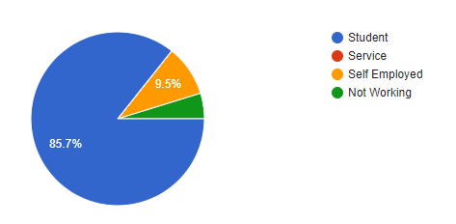

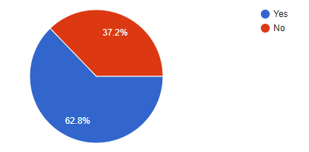

While I was surveying only 62.8% people had printers at home.
Majority of them prefer HP ink over any other brands like Splashjet and Epson.

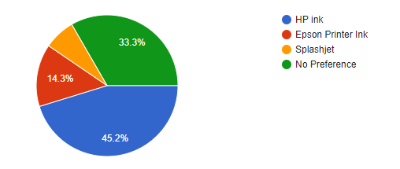

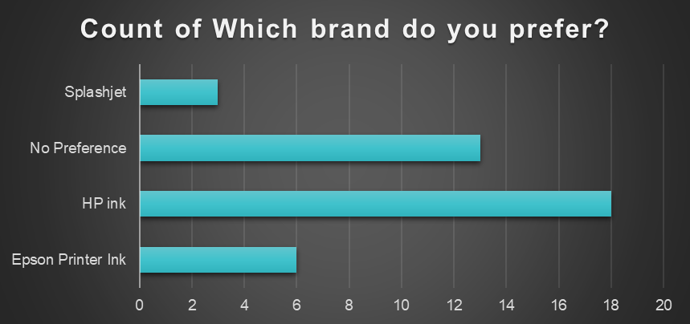

All Consumers who had printers at home were satisfy with their brand. In this chart the remaining 31% are those people who does not own any printer.

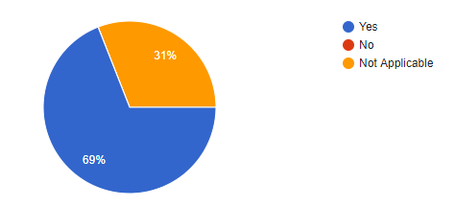

BODY

Product: Printing Ink

Type of good:
My product comes under the category of Normal goods which means increase in income causes an increase in demand. It has a positive income elasticity of demand. Normal good can be income elastic or income inelastic.

Features:
Printing inks, refer to a liquid or paste, are widely used to colour surfaces such as newspaper, books, magazines, cardboard and ceramic tiles to produce an image, text or design.
There are different types of Printing Inks in the Market:
- Solvent-based
- Water-based
- Oil-based
- UV
- UV-LED
Types of Process:
- Lithographic Printing
- Flexographic Printing
- Gravure Printing
- Digital Printing,
It is used for various things mainly for Packaging, Commercial and Publication, Textiles.

Pricing:
Based on the data that I have collected the prices for Cartridges varies a lot.
There are different types of printing inks, having different price ranges and each of them have a different purpose.
Price range for the consumers who buys the cartridges at home:

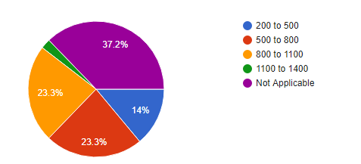

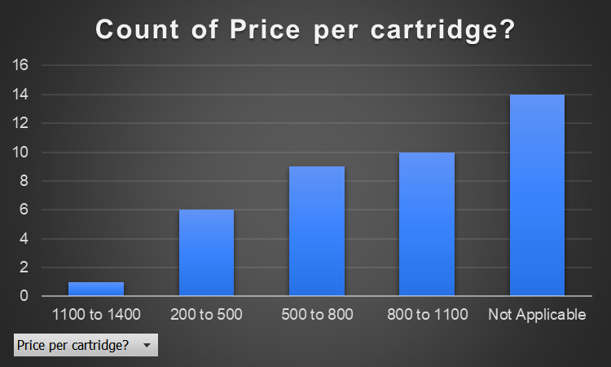

Based on data that I have collected for Consumers who does not own a printer at home:
- Amount paid for 1 Black and White copy in their area:

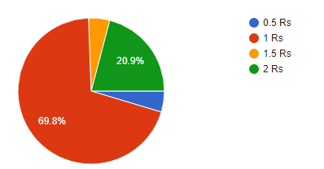

- Amount paid for 1 Color copy in their area:

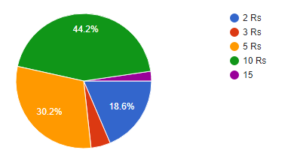

From this we can say that on an average the price for Black and White copy is
1 Rs and Color copy is 10 Rs.

Availability:
Printing inks are available at big Stationary/Xerox/tech shops and online stores.
Based on the data collected the number of shops which provides with printing facilities in consumer’s locality:

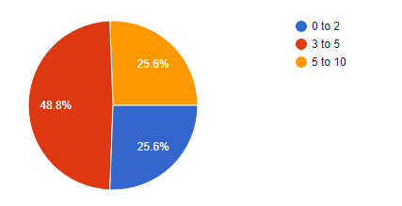

SWOT Analysis:

Strengths:
- Association with Major brands
- Global Coverage
- Compatible with current printing technology
- Huge market potential

Opportunities:
- Produce innovative products
- Emerging applications like smart packaging
- Low cost functionality
- Improving machine possibilities like faster printing

Weaknesses:
- Tech challenges with the ink formulations
- Lack of marketing expertise
- Expensive
- Technology is still in premature state

Threats:
- Price wars with competitors
- Competitor has new, innovative product or services.
- Competitors have better distribution channels
- Durability
- Toxicity issues

Demand for the Product

Based on the data collected the
Number of cartridges does Consumer buys on an average monthly basis:

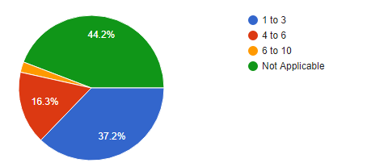

Number of times Consumer goes out for printing (does not own a printer)

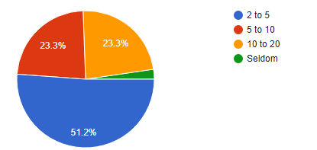

DEMAND CURVE

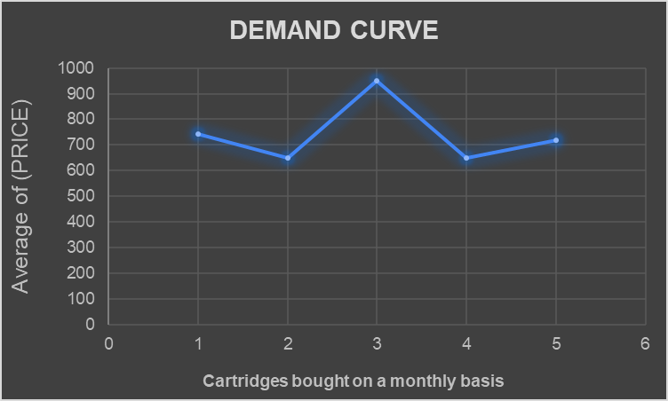

[ Based on data collected]

This graph represents the Demand curve for my product.
On the Y-axis we have the Price per Cartridge, and
On the X-axis we have the Quantity Demanded for the product on a monthly basis.

Rate of Change

From the chart given above we can say that when prices fall the demand for the product increases from 2qty (Average of 1 to 3) to 5qty (Average of 4 to 6).
After that prices increased with that demand also increased from 5qty (Average of 4 to 6) to 8qty (Average of 6 to 10).

Demand curve for Colour copy

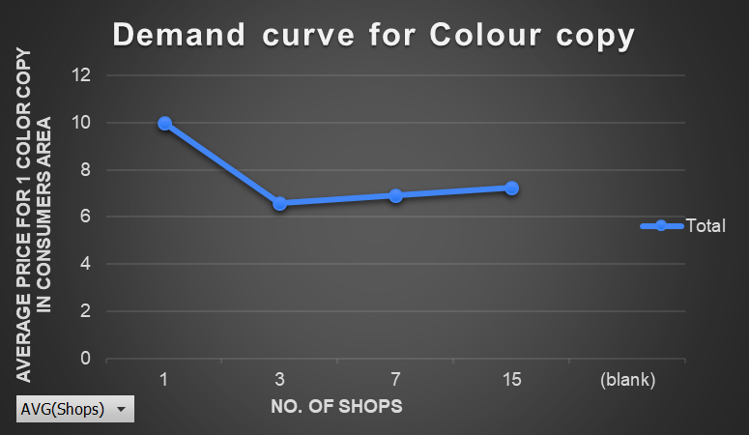

Demand curve for Black and White copy

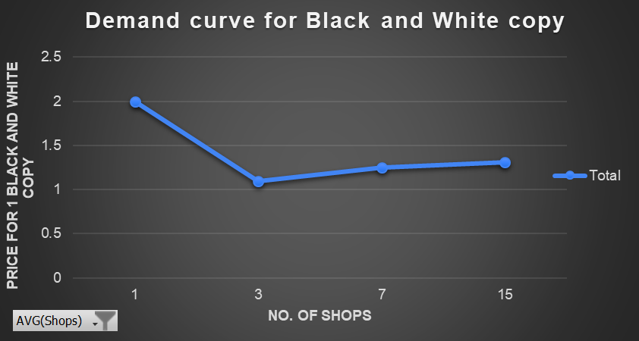
[ Based on data collected]

Change in Demand with respect to Total Expenditure

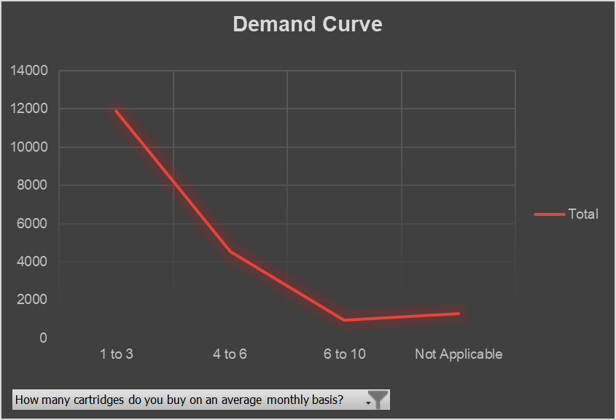

On the Y-axis we have the Total expenditure, and
On the X-axis we have the Quantity Demanded for the product on a monthly basis.

Market/Industry analysis

The Global printing inks market size was valued at USD 19.2 billion in 2020 and the market is expected to witness moderate growth at a compound annual growth rate (CAGR) > 2% from 2021 to 2028.

Due to the COVID-19 impact in the first half of 2020, various manufacturing plants were shut down, and the demand for packaging has declined. Thus, this affected the consumption of printing inks in the Packaging sector.

Main Growth drivers for this sectors:
- Flexible packaging
- Commercial printing
- Publishing
- Packaging sector

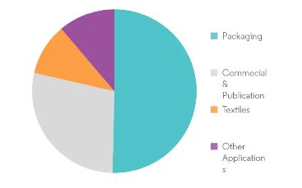

Market Dynamics

From many research reports the Global printing inks market is expected to witness a significant rise of CAGR >2.5% during the forecast period to reach $23,881.9 million by 2023.

It is likely to spike the demand for printing inks worldwide during the forecast period because of the importance of printed materials in various end-use industries such as Packaging, Labelling (According to the research report the labels and packaging was the largest and fastest growing market by application during 2013 – 2016) and Advertising.

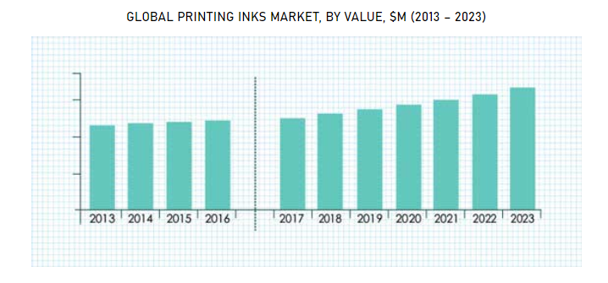

GST on Printing Industry

- Printing of all goods like Newspapers, Books, Journals and Periodicals have 12% GST rate.
- Manufacturing services like Publishing, Printing and Materials recovery services have 18% GST rate.
- Newsprint, in rolls or sheets have 5% GST rate.
- Brochures, Leaflets and similar printed matter have 5% GST rate.
- Cartons, Boxes and paper board have 12% GST rate.
- Exercise book, Graph book, & Laboratory note book and Notebooks have 12% GST rate.

Supply of the product

Number of the sellers
Printing inks can be bought at both online, stationary/tech shops.

Available Substitutes:
Substitute goods or substitutes are at least identical, similar, or comparable two products that could be used for the same purpose by the same consumers.
If you want to save on Ink cartridges so you buy Ink alternatives like Chinese clones.
You can also buy third party inks which should be compatible with your printer.

Complementary Products:
Complementary goods refer to two or more items that are usually consumed simultaneously.
Complementary products with Printing Ink:
- Printers
- Newspaper

Price Elasticity of the Product

I calculated Price elasticity of my product with the data I collected. Here row labels are the average prices for the various price ranges.
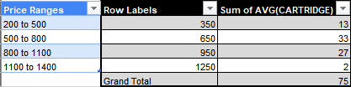

After inserting all the required values, I found Total revenues and Marginal revenue,
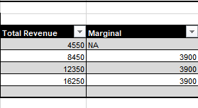

With this I calculated % Change in Price and % Change in Quantity

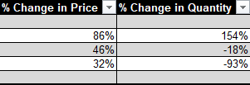

Price Elasticity

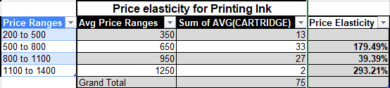
*Table in Excel

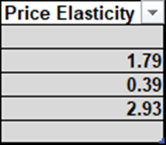

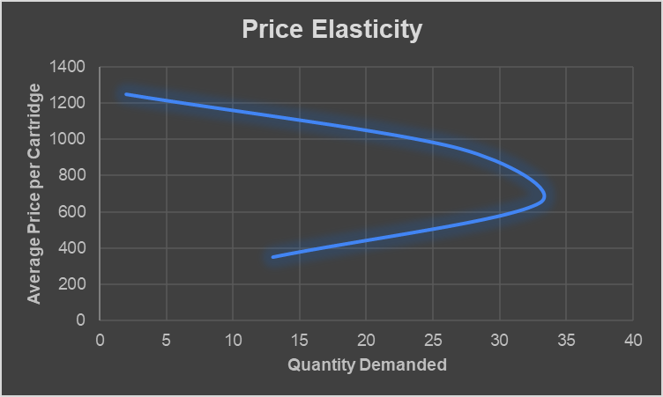

Based on data collected and this graph of Price Elasticity

Prices | Elasticity
1250 to 950 | Relatively Elastic
950 to 650 | Relatively Inelastic
650 to 350 | Relatively Elastic

CONCLUSION

After completing my analysis, I witnessed real world/practical scenario where I collected primary data through google forms and used that data to find some important Microeconomics topics.

This was a very small basic analysis for product printing inks from which we cannot understand the whole sector for that we need lots and lots of data and various different parameters.

During this analysis Demand curve and Price elasticity for the product was the trickiest part of all.

Effect of Covid-19
There are still many people/consumers who prefer to print from shops. According to the survey this graph shows us the number of times a consumers have gone out for printing (Before Pandemic) on an average in a year.

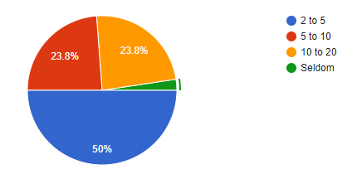

(During Pandemic)

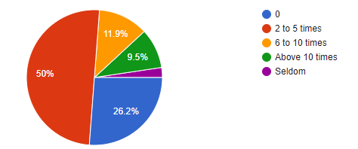
By comparing both the graphs we can clearly see that during pandemic 1/4th of the consumers avoided any printing related work to be done from outside.
Due to this pandemic the demand for printing drastically fall in first half of the year 2020. But now it is stabilizing and can reach new heights due to its main driver which is Packaging sector.

References
- Global Printing Inks Market Size, Share, Development, Growth and Demand Forecast to 2023
www.psmarketresearch.com

- PRINTING INKS MARKET - GROWTH, TRENDS, COVID-19 IMPACT, AND FORECASTS (2021 - 2026)
www.mordorintelligence.com

- My Survey Form
https://docs.google.com/forms/d/186KKZIZRKgV_tSMAdHqM5BvOm4WSYe53jreH5Hha6mU/edit#responses

