Statistical Modelling in R
Assignment
Roll no 11

# Importing necessary libraries library(rpart) library(rpart.plot) library(tidyverse) library(caTools)
library(caret) library(MASS)
1.
Code:

# Creating sample to split the msc data into testing and training data samp = sample.split(msc$Grade, 0.7)

train = msc %>% subset(samp == T) # Creating training dataset test = msc %>% subset(samp == F) # Creating testing dataset

tree = rpart(Grade ~ ., data = train) # Defining the model with Grade as explanatory variable
rpart.plot(tree, box.palette = "RdYlGn", main = "Decision Tree") # Plotting the decision tree

# Assigning predicted values to a new column in the testing dataset. test["Predicted.Grade"] = predict(tree, test, type = "class")

# Building confusion matrix and checking accuracy. confusionMatrix(test$Predicted.Grade, test$Grade)

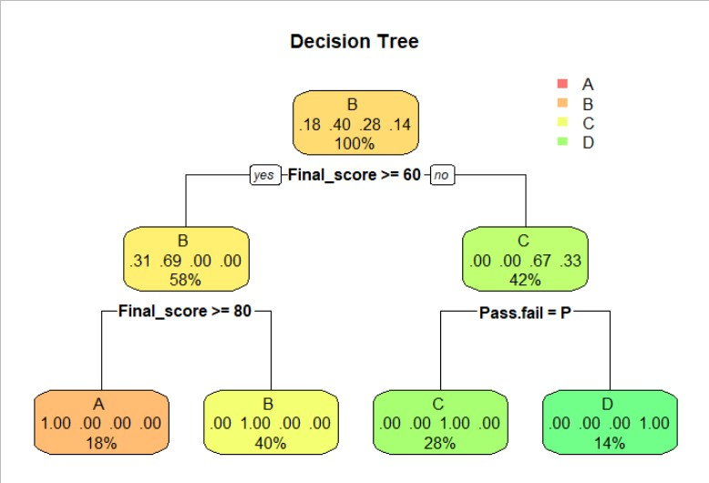
Output:

Confusion Matrix and Statistics

Reference Prediction A B C D A 6 0 0 0
B 0 13 0 0
C 0 0 8 0
D 0 0 0 5

Overall Statistics

Accuracy : 1
95% CI : (0.8911, 1)
No Information Rate : 0.4062 P-Value [Acc > NIR] : 3.03e-13

Kappa : 1 Mcnemar's Test P-Value : NA Statistics by Class:
Class: A Class: B Class: C Class: D

Sensitivity | 1.0000 | 1.0000 | 1.00 | 1.0000
Specificity | 1.0000 | 1.0000 | 1.00 | 1.0000
Pos Pred Value | 1.0000 | 1.0000 | 1.00 | 1.0000
Neg Pred Value | 1.0000 | 1.0000 | 1.00 | 1.0000
Prevalence | 0.1875 | 0.4062 | 0.25 | 0.1562
Detection Rate | 0.1875 | 0.4062 | 0.25 | 0.1562
Detection | 0.1875 | 0.4062 | 0.25 | 0.1562
Prevalence  Balanced Accuracy | 1.0000 | 1.0000 | 1.00 | 1.0000

2.
# Defining an initial model
model = glm(Final_score ~ ., data = train)

# Running step AIC to check for best model stepAIC(
model, scope = list(
upper = ~ Exam1 * Exam2 * Exam3 * Exam4 * Final_score * Grade * Pass.fail, lower = ~ 1
),
direction = "forward"
)

# Using model with lowest AIC from step AIC. final_model = glm(
formula = Final_score ~ Exam1 + Exam2 + Exam3 + Exam4 + Grade + Pass.fail + Exam3:Grade + Exam2:Exam3 + Exam4:Pass.fail + Exam1:Grade + Exam2:Exam4 + Exam4:Grade + Exam2:Pass.fail + Exam2:Exam4:Pass.fail,
data = train
)

summary(final_model)

# Prediction of final scores
final_pred = predict.glm(final_model, test, type = "response")

# Running t-test to test if the mean predicted values are different from actual values
t.test(final_pred, test$Final_score)

Output:

Call:
glm(formula = Final_score ~ Exam1 + Exam2 + Exam3 + Exam4 + Grade + Pass.fail + Exam3:Grade + Exam2:Exam3 + Exam4:Pass.fail + Exam1:Grade + Exam2:Exam4 + Exam4:Grade + Exam2:Pass.fail + Exam2:Exam4:Pass.fail, data = train)

Deviance Residuals:
Min 1Q Median 3Q Max
-13.175 -2.239 0.000 2.626 11.089

Coefficients: (2 not defined because of singularities) Estimate Std. Error t value Pr(>|t|)
(Intercept) 97.583069 6.361748 15.339 < 2e-16 ***

Exam1 | -0.003353 | 0.038274 | -0.088 0.930535
Exam2 | 0.392310 | 0.445833 | 0.880 0.383015
Exam3 | -0.530283 | 0.253665 | -2.090 0.041578 *
Exam4 | 2.981650 | 0.850815 | 3.504 0.000962 ***
GradeB | -37.715882 | 7.104749 | -5.309 2.43e-06 ***
GradeC | -39.383299 | 6.554371 | -6.009 1.99e-07 ***
GradeD | -91.943123 | 7.500678 | -12.258 < 2e-16 ***
Pass.failP | NA | NA NA | NA

Exam3:GradeB | 0.644920 | 0.306719 | 2.103 0.040453 *
Exam3:GradeC | 0.059195 | 0.280526 | 0.211 0.833718
Exam3:GradeD | 2.354691 | 0.436383 | 5.396 1.78e-06 ***
Exam2:Exam3 | 0.027260 | 0.007117 | 3.830 0.000352 ***
Exam4:Pass.failP | -3.663756 | 0.928866 | -3.944 0.000245 ***
Exam1:GradeB | 0.103407 | 0.046206 | 2.238 0.029619 *
Exam1:GradeC | 0.009528 | 0.049871 | 0.191 0.849241
Exam1:GradeD | -0.412450 | 0.165083 | -2.498 0.015738 *
Exam2:Exam4 | -0.157981 | 0.128296 | -1.231 0.223828
Exam4:GradeB | -0.267402 | 0.389496 | -0.687 0.495487
Exam4:GradeC | 0.608206 | 0.390877 | 1.556 0.125891
Exam4:GradeD | NA | NA NA | NA
Exam2:Pass.failP | -1.019049 | 0.430253 | -2.368 0.021688 *
Exam2:Exam4:Pass.failP 0.185424 0.128608 1.442 0.155479
---
Signif. codes: 0 ‘***’ 0.001 ‘**’ 0.01 ‘*’ 0.05 ‘.’ 0.1 ‘ ’ 1
(Dispersion parameter for gaussian family taken to be 25.68751) Null deviance: 29436.3 on 71 degrees of freedom
Residual deviance: 1310.1 on 51 degrees of freedom AIC: 457.21
Number of Fisher Scoring iterations: 2

Welch Two Sample t-test

data: final_pred and test$Final_score
t = 0.49697, df = 61.849, p-value = 0.621
alternative hypothesis: true difference in means is not equal to 0 95 percent confidence interval:
-8.243648 13.698429
sample estimates: mean of x mean of y 61.81552 59.08812

