

EXCEL AND FINANCIAL MATHEMATICS PROJECT

nehul jain

ROLL NO-33

Date

20-02-2022

Company name

Universal swap project estimation alterium poor

Teacher’s name
KEVIN SIR AND DEVARSHI SIR

SUMMARY

UNIVERSAL SWAP
Universal swap is a cryptocurrency exchange which uses a decentralized network protocol. It is fourth largest cryptocurrency exchange overall by daily trading volume.
It operates in four coins – ETH, BTC, USDC & Alternium.
Under this project we are given various information regarding universal swap ~ R & D Expenses, Introductory Costs, Market Potential and Share, Pricing and Unit cost, New Participants, Server facilities and Costs, G & A Expenses, Working capital, Equity and Debt, Tax rates, Macro Data, Cost of capital.
Universal swap is launching new coin Alternium on its platform for which it is intending to create a new liquidity pool. As it turns out, it has proved to be a highly profitable business. It has increased its market capital from $650 million in 2019 to around $22 billion in 2022. It cites easy facilitation, transparency, its unique algorithm and the huge spike of interest in the cryptos leading to huge volumes as its reason of success.
Cash flow after taxes (CFAT) is a measure of financial performance that shows a company's ability to generate cash flow through its operations. It is calculated by adding back non-cash charges such as amortization, depreciation, restructuring costs, and impairment to net income.
Subtract the income tax liability, state and federal. The result is the Cash Flow After Taxes. Another method of calculating CFAT is: CFAT = Net Income + Depreciation + Amortization + Other Non-Cash Charges.
TAX RATE – 10%





THE NET PRESENT VALUE AND INTERNAL RATE OF RETURN
NET PRESENT VALUE (NPV) - Net present value (NPV) is the difference between the present value of cash inflows and the present value of cash outflows over a period of time. NPV is used in capital budgeting and investment planning to analyze the profitability of a projected investment or project. NPV is the result of calculations used to find today’s value of a future stream of payments.
ACCORDING TO THE NPV THAT IS NET PRESENT VALUE 37022.74
THE PROJECT IS OUTSTANDING FOR INVESTING AND THE OVER-
ALL REVENUE AND EXPENSES OF THE PROJECT IS ALSO GOOD
SO IT’S A GREAT OPPURTUNITY TO INVEST IN

IRR

(INTERNAL RATE OF RETURN)
The Internal Rate of Return (IRR) is the discount rate that makes the net present value (NPV) of a project zero. In other words, it is the expected compound annual rate of return that will be earned on a project or investment.

FORMULA
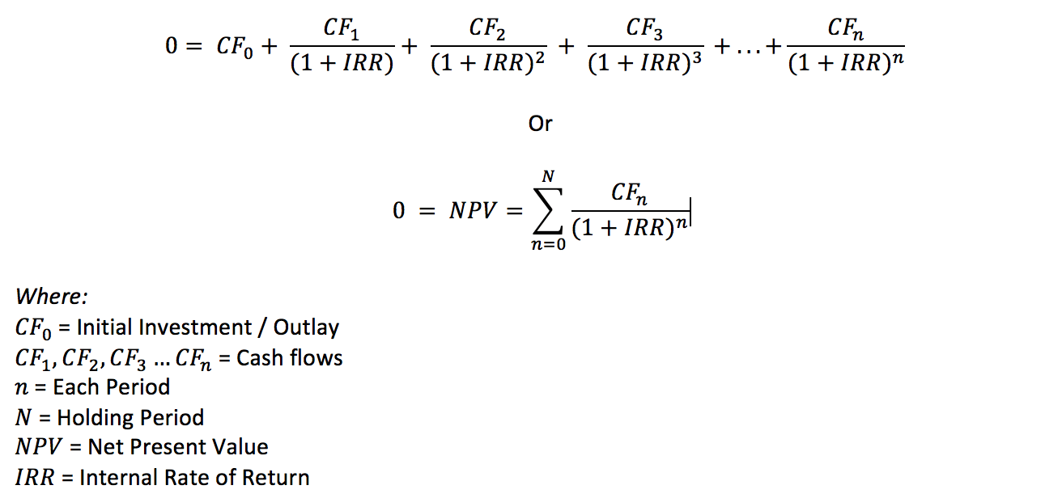

THE IRR OF THE PROJECT TELLS US THAT THE PROJECT IS VIABLE TO INVEST IN WHERE IRR OF THE PROJECT IS
174.909%.

OTHER THAN THAT BY LOOKING AT THE OVERALL ESTIMATIONS DONE THE PROJECT IS AN OUTSTANDING OPPURTUNITY FOR UNIVERSAL SWAP TO PUT THEIR MONEY INTO THE PROJECT

THANK YOU


