- 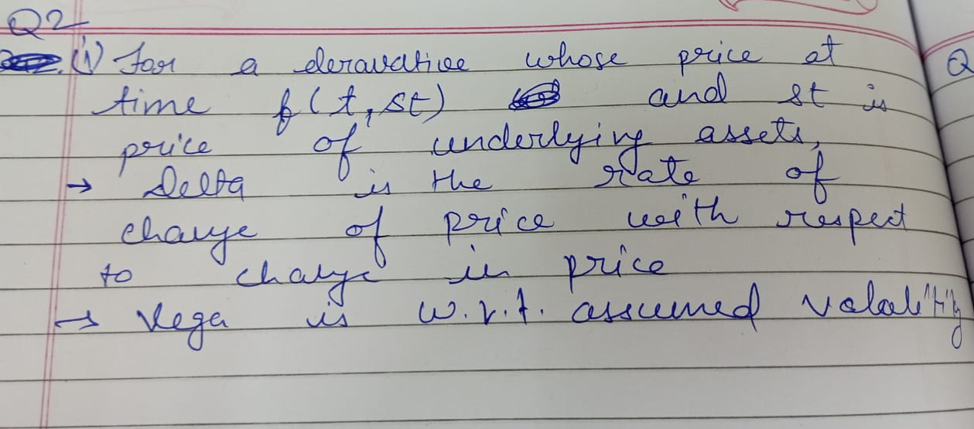
- 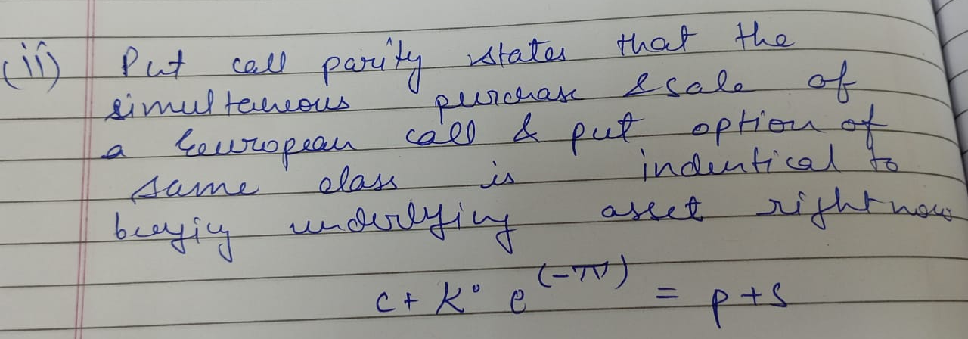

- 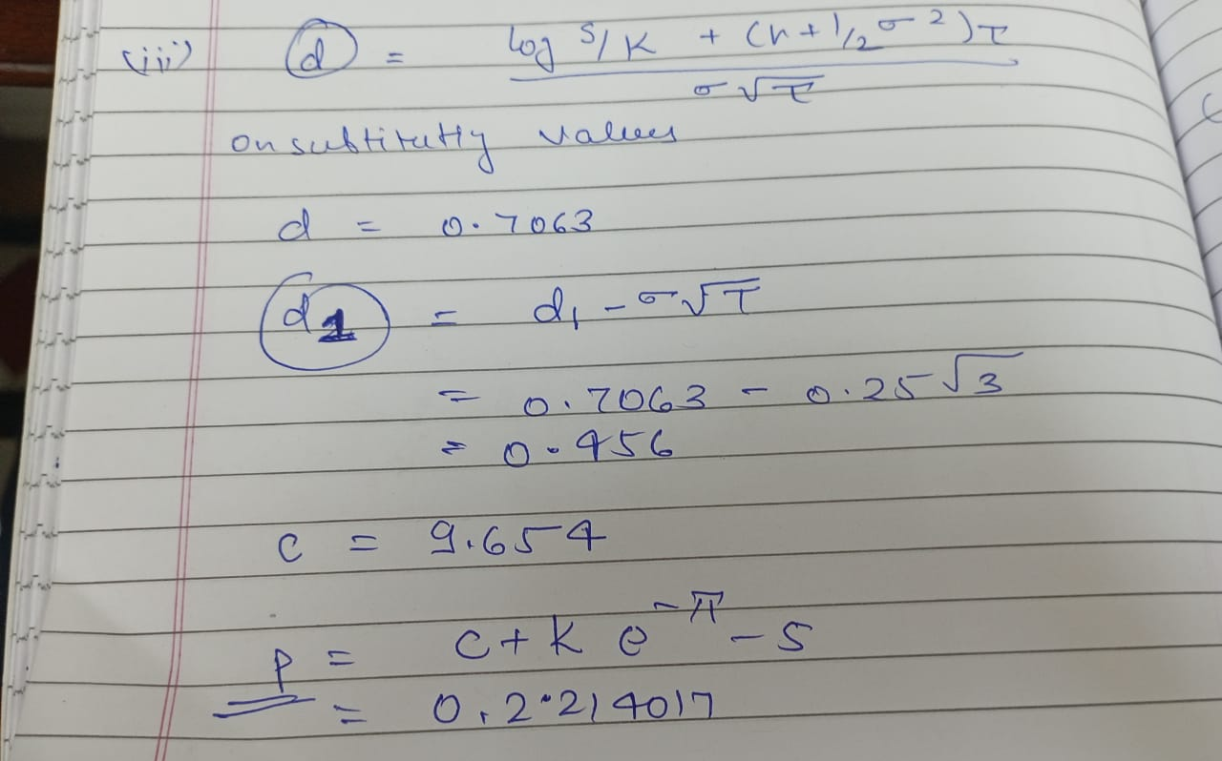
A portfolio for which the overall delta (i.e., weighted sum of the deltas of the individual assets) is equal to zero is described as delta-hedged or delta-neutral. Such a portfolio is immune to small changes in the price of the underlying asset.
A portfolio for which the overall vega (i.e., weighted sum of the vegas of the individual assets) is equal to zero is described as vega-hedged or vega-neutral. Such a portfolio is immune to small changes in the assumed level of volatility.
- Let the required portfolio consist of x call options, y put options and z forwards.
The delta and vega for a forward are 1 and 0 respectively and there are no current cashflows.
Thus, for a single unit of each of them, we have:
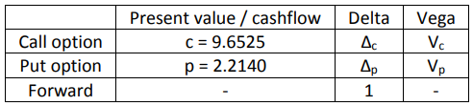
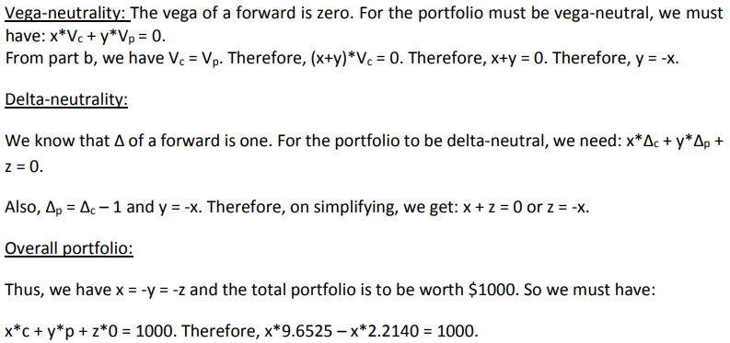
Therefore, x = 134.4, y = z = -134.4
So, our portfolio must consist of:
• Long position of 134 call options
• Short position of 134 put options
• Short position of 134 forwards

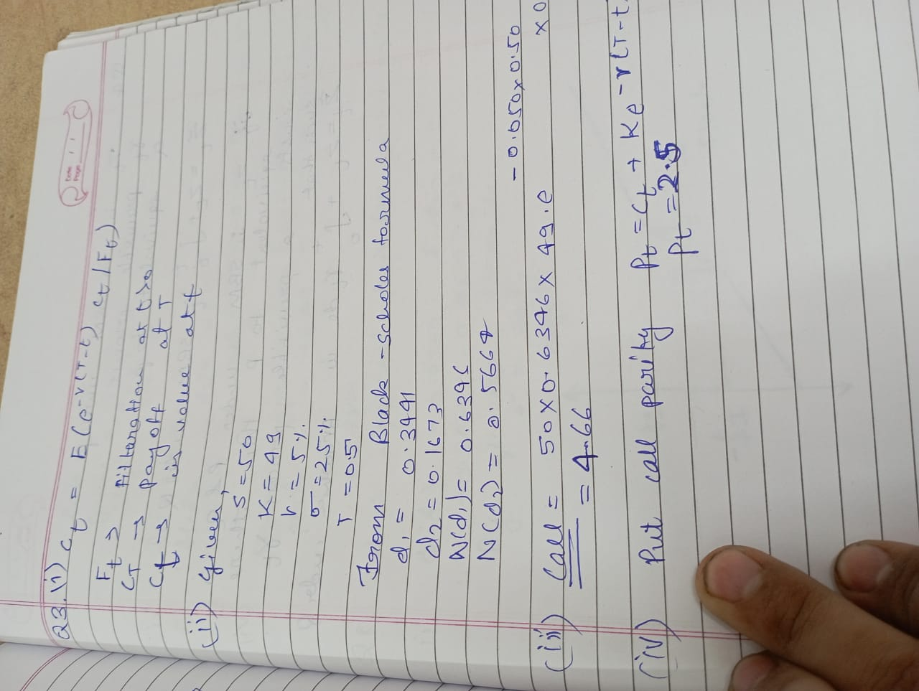
If the stock is dividend-paying, the installment of the profits would cause the esteem of the basic resource to drop – which takes after from the no arbitrage principle. Alternatively: in esteeming the alternative we must take account of the reality that profits are payable on the fundamental resource which don't bolster through to the holder of the option. The American call would presently be more costly than the European call due to potential early work out opportunity.

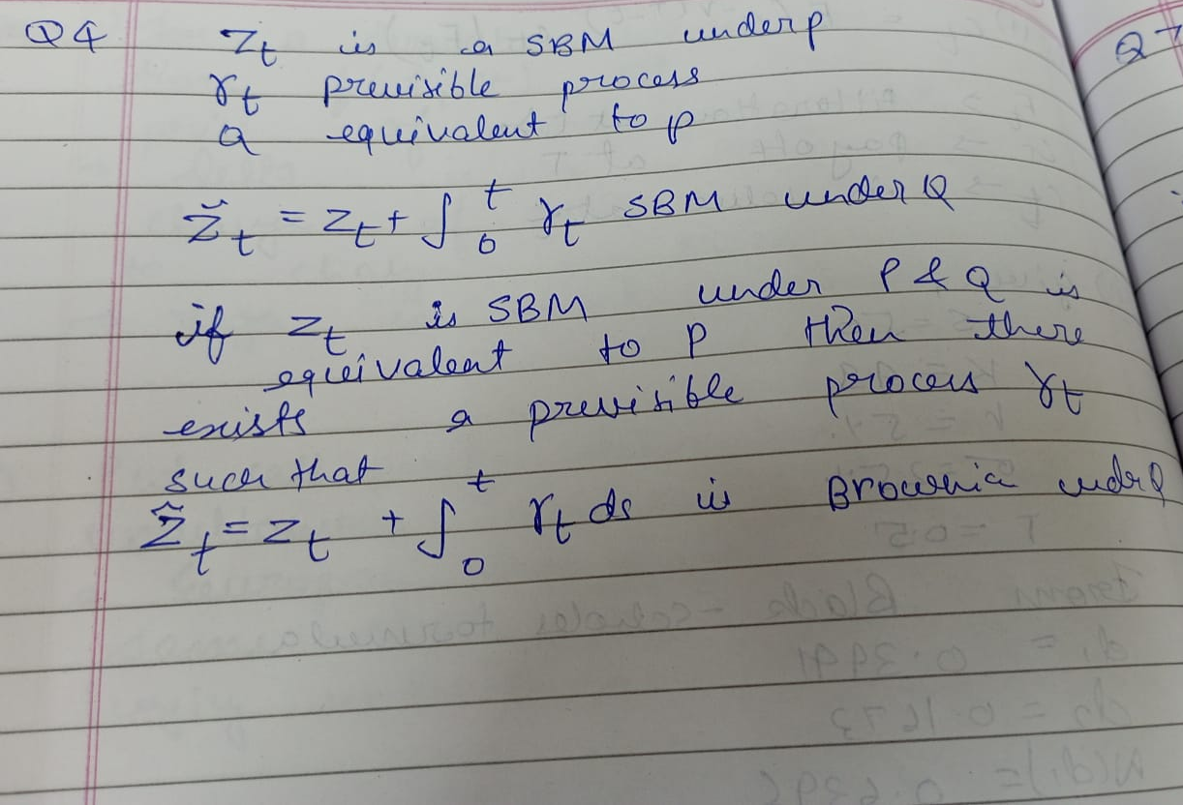
- Under the risk-neutral probability measure, the discounted value of asset prices are martingales.

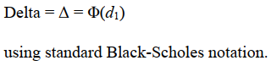

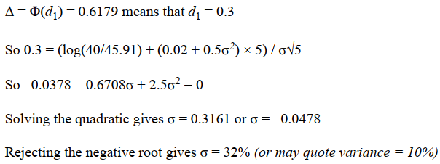

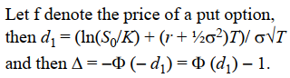
- In this case, we must have 100,000Δ= -24,830 and so Δ = -0.25

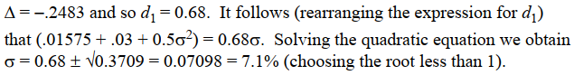

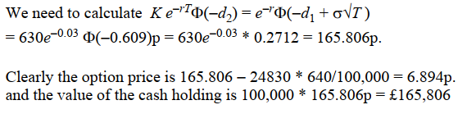

- Denote the individual derivative by f and assume this is written on an underlying security S.
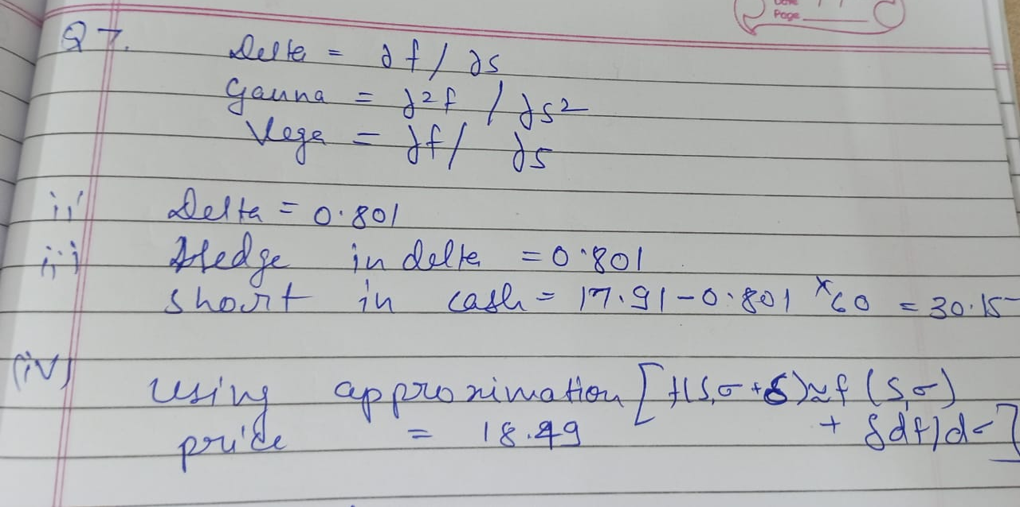
- Using the approximation f(S, σ + δ) ≈ f(S, σ) + δdf/dσ, we obtain an option price ≈ 17.91 + 29.00 * 0.02 = $18.49.

- 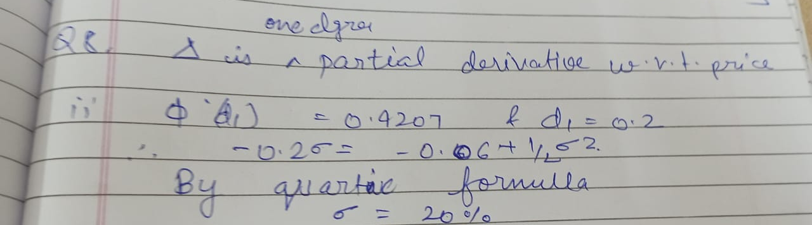
- Using the formula for the Δ, we see that Φ(d1) = 0.42074 and hence d1 =  0.2.
Solving the quadratic gives σ = 20% or 60% and rejecting the negative value gives σ = 20%.

- The PDE is the Black-Scholes PDE:
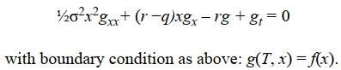

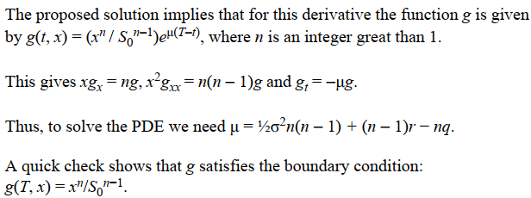

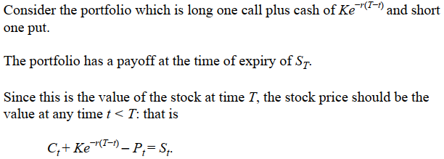
- This relationship is known as put-call parity.
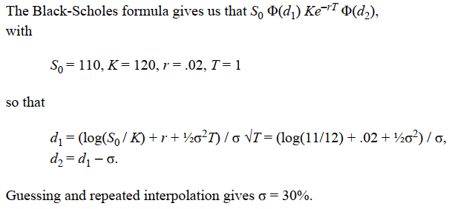

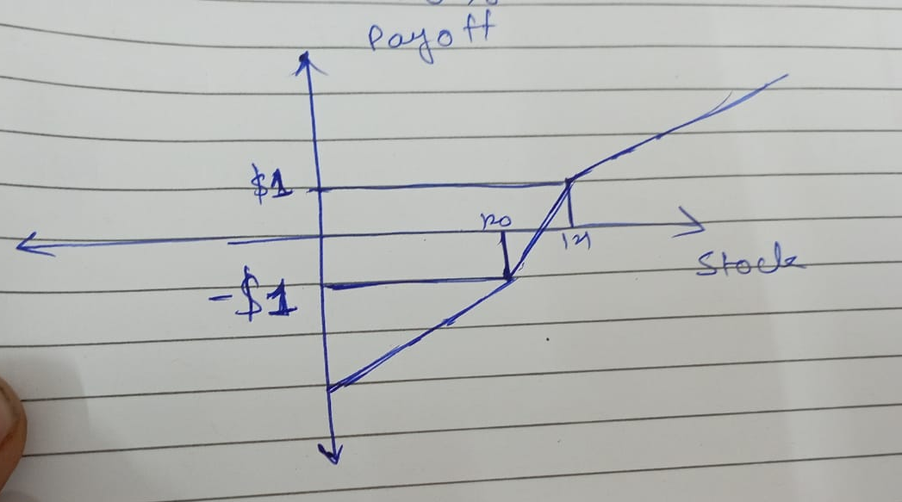

- The payoff from the portfolio, D, satisfies
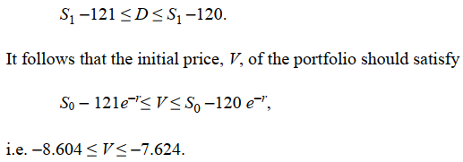
- And this implies that 17.714 ≤ P0 ≤ 18.694.
- The Black-Scholes price (using the formula in the tables) is $18.35.

