CP2 SEPTEMBER 2016 PAPER 1
AUDIT TRAIL
OBJECTIVE
The objective of this model is to model for the new investment product launched by Life Co . The product should provide an estimate of the returns an investor could achieve by investing in this product.

DATA
A data set having 100 simulations of a discrete time series B_{t} has been provided . These simulations are of 20 years that is from time 0 to time 20 . This data is taken from an external company .

PARAMETERS
Some key information given by Life Co is
- The term of the investment
- Average investment amount
- The initial charge applied on the investment amount
- The drift and diffusion coefficients , mu and sigma respectively
- A higher diffusion cofficient

DATA CHECKS
- Simulations above have been checked for following normal distribution . The check has been through the increments i.e. the difference between two simulations following normal distribution , B_{t+1 -} B_{t ,} t representing the time
- In columns B to V ie from time 0 to time 19 , increments have been taken taken . A sample of formula has been shown here - Data!C5-Data!B5 in the Data Checks worksheet
- Data has also been checked for the first column being 0 , by taking square of the B column of Data in the Y column of Data Checks Worksheet
- A histogram has been made and is displayed in the Charts worksheet of the increments to accurately display the normal bheaviour of increments
SCENARIO 1
Stock Price – Base
Simulations have been performed using diffusion coefficient using 7%

The formula used is as follows :
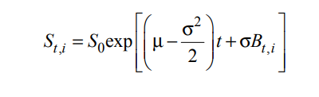
S_{t} is the stock price at time t
S₀ is the base price
Mu is the drift coefficient
Sigma is the diffusion coefficient
B_{t} is the time series

In the columns Y2 to Y5 , average , maximum , minimum and standard deviation has been calculated
Rank has been calcualted in the W column

