Objective
The objectives of the model are as follows:
- Modeling the annual returns of the investment product to understand their range and the absolute final value with an investor could achieve.
- A second scenario where a higher drift coefficient is used.

Data
The data received was provided by an external company specialising in Economic Scenario Generators. The data is 100 simulations of the discrete time series of the annual values.
The cell range A3 to V104 of the ‘Data’ worksheet contains this data.
The company has not provided any evidence of checks performed on the simulations the following checks were made
- Checking if the annual returns followed normal distribution
- Checking if $B_{0}$ is 0
These data checks were made in the ‘Data Checks’ worksheet.
The column V of the ‘Data Checks’ worksheet contains the necessary checks to check whether $B_{0}$is 0. A simple in built excel ‘IF’ and ‘COUNTIF’ functions were used over the column B of the ‘Data’ Sheet so reflect if the cell value was zero and to count the number of cells where the cell value was not zero.
The annual returns for the 100 simulations were calculated as a difference of the $B_{t}$ and $B_{t-1}$ values from the ‘Data’ worksheet in the range A1 to T101 of the ‘Data Checks’ worksheet. The mean and the standard deviation of the data were calculated by using standard excel functions. The standard deviation was calculated using the sample standard deviation formula. The mean of the data must be as close as possible to 0 and the standard deviation must be as close to 1 as possible. These conditions were met by the data.
Further a curve was plotted to check if the data formed a bell curve. For the same a frequency table needed to be made. The range of the data was found by calculating the minimum and the maximum of the data. The was followed by defining the class length in the cell D115. The maximum of the data was taken as the start point and the class intervals were constructed in the cell range C116 to D159. The frequency for the same was calculated in the range E116 to E159 by using the COUNTIF function.
The calculated frequencies were used, and the histogram was plotted. As the curve was a bell curve the data conformed to normality.

Parameters
The parameters were defined as required.
Initial charge, time duration, average initial investment, mu, sigma, $S_{0}$ in the range A1 to B8.
Assumptions
- The money will be invested in a fund, which can be assumed to exactly match the performance of an index known as the ASE 100.
- The inflation remains constant over the time period.
Scenario 1
Over the range A1 to V101 100 scenarios of the investment fund values were made from t = 0 to t = 20, using the below formula.
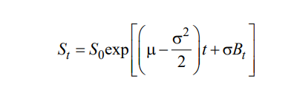
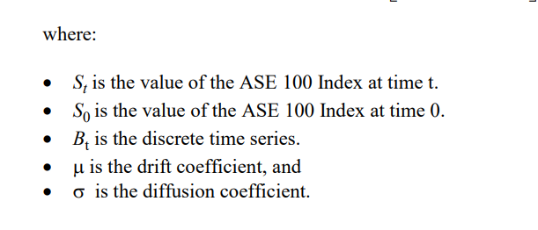
The various coefficients were defined as follows.
- $S_{0}$ mu, sigma as defined in the ‘Parameters’ worksheet
- $B_{t}$ from the ‘Data’ worksheet according to the time and simulation number

